**The Application of DMAIC Method in a Manufacturing Industry for Improving Process Performance - A Case Study**

Harpreet Singh

Former Assistant Professor in Department of Mechanical Engineering

GNIEM Naushehra, Hoshiarpur, India

[Harpreetbajaj9@gmail.com](mailto:Harpreetbajaj9@gmail.com)

Kultar Singh Saini

Assistant Professor in Department of Mechanical Engineering

UIET SBBSU Jalandhar, 144030 India

[Kultarsingh355@gmail.com](mailto:Kultarsingh355@gmail.com)

**ABSTRACT: The idea of making such kind of DMAIC method has taken from the increasing demand of the industry economical and efficiency. In this method I tried to give increasing the production. It is a basic tool for solving and widely used in lean manufacturing.The DMAIC is an improvement cycle and used to improve optimizing and stabilizing business process designs. It is closed loop technology for continuous improvement of manufacture unit. It is business improvement approach to find out and eliminates the problems and causes of defects in manufacturing units. DMAIC is five step methodology define, measure, analyse, improve and control. Now days DMAIC technique is widely used in industries to solve their problems in an effective manner. It is defined as a set of statistical tool adopted with the quality management to construct a framework for process improvement. The DMAIC study is also known as a system driven technique of management that results study problem structure, generic problem solving tasks, diagnostics problem solving, remedial problem solving etc.**

**Keyword:- Define, Measure, Analyse, Improve, Control and DMAIC.**

**I. INTRODUCTION**

A muffler is a device that used for reducing the amount of noise emitted by the exhaust of an internal combustion engine. Mufflers are attached with in the exhaust system of most internal combustion engines, otherwise the muffler is not actually designed to serve any primary exhaust function. Muffler is engineered as an acoustics soundproofing device designed to reduce the loudness of the sound pressure created by the engine. A non – avoidable side effect of muffler use to increase of back pressure that decrease engine efficiency. This of the because of the reason that the engine exhaust must share the same complex exit pathway built inside the muffler as the sound pressure that the muffler is designed to mitigate. To reduce noise in the engine, muffler is assembled with the exhausted manifold of the engine. Firstly the exhaust gases enter in the muffler through the mouth then it goes to the catalytic converter after the filtration process. Catalytic converter convert harmful gases coming out from

exhaust into harmless gases and also reduces the noise by reducing the velocity of the gases, then the gases passes through the inner sub assembly which allows

sufficient amount of gases to get through tail plate. There is a problem of rejection in the muffler plant due to that large number of lots are rejected. Poor quality of the product causing highly dissatisfied internal customer productivity loss and it also interrupt the whole line process. Rejection rate for the month of February was calculated from the monthly performance data sheet and found nearly about 8.21% in the muffler plant. In order to reduce the rejection rate, first identify the product and process parameters the affect the whole process. With the help of Define, Measure, Analyze, Improve and control methodology the problem of muffler rejection could be removed [15].

**II. METHODOLOGY**

DMAIC is a formed and highly disciplined methodology for reducing process variation to ensure customer satisfaction, cost reduction and profitability of the organization. States the fundamental plan behind the six sigma philosophy is to monitor the process continuously and aims at elimination reduction of defects or failures from the manufacturing process {7}. States that defect can be defined as any deviation in the performance of the critical to quality (CTQ) characteristics.

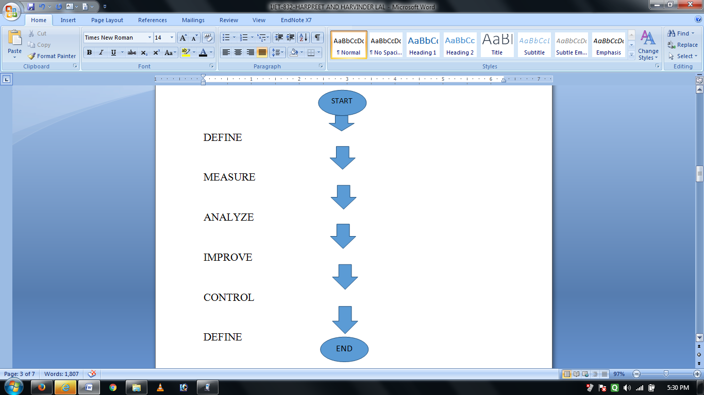

**A.DEFINE**

In define phase illustrate the problem of the muffler rejection in the muffler manufacturing plant. The case study charter is a tool that include planning, initializing, executing, controlling and surviving the study. Firstly of all set the standard procedure for the work before proceeding. We know that DMAIC technique provide a systematics and structured five way steps problem solving approach. In the define phase set the project charter for each and every step than the goal and clearly give the description of title of the problem for which we will proceed. Than to explained the expected financial benefit of the case study and the voice of the quality control department and their requirement [15]. The main purpose of a case study charter is to find out or instigate a six sigma project by defining its benefits and project variable.

**A. MEASURE**

In the measure activity. It involve collection the data and to find the rejection and plotting that in to pareto chart [5]. After collecting all the data find out the reason behind the problem. The measure phase includes all the basics behind the problem like how much rejection is in the muffler plant and from where it is coming. Than draw pareto chart which includes the total rejection of muffler plant step by step. It should include all the feasible factors that affect the whole line flow.

**B. ANALYZE**

In the last phase of collection the data found all the problem of rejection from where it is coming that parts are blanking body A rolling, TIG welding, MIG welding and shot blasting. Now analyse all the basics root and causes of the problems by using two major basic tool for collecting the results that are fish bone diagram and the brainstorming technique [5]. By using these technique we will find the relevant causes of the specified problem and give them particular reason from where these are coming. Find the possible causes that may be affecting the muffler. Use fishbone diagram foe every separate problem part and find the basic root of the problem than discuss the causes and effect of that problem on the muffler. But the brainstorming should be include all the possible causes. These two tools are the most effective tools to find out the hidden basic behind the problems.

**C. IMPROVE**

In the fourth step of the improvement phase we have to find out and the remedial action for the causes that we have discussed earlier so again focusing on them we are going to give the action plan for the specified problems [8]. On the bases of brainstorming the improvement must investigate the necessary knowledge. Our focus should be on better cheaper and faster growth.

**D. CONTROL**

After the removal of all the defects control phase shows that there is an ultimate control over the rejection of muffler [13]. Data of rejection after implementation and the consolidated in Table 1. The research work concentrated on deploying DMAIC methodology with quality tools to find out the root causes that eliminate the defects. The improper parameter of TIG welding.

**Table 1.**

|  |  |  |  |  |  |  |
| --- | --- | --- | --- | --- | --- | --- |
| **Weeks** | **TIG welding** | **Blanking**  **Body A** | **Rolling** | **MIG welding** | **Shot blasting** | **Others** |
| 1st | 217 | 97 | 54 | 60 | 14 | 8 |
| 2nd | 164 | 83 | 62 | 63 | 9 | 7 |
| 3rd | 176 | 77 | 61 | 55 | 11 | 10 |
| 4th | 182 | 89 | 58 | 38 | 11 | 11 |
| 5th | 137 | 66 | 46 | 44 | 9 | 6 |
| Total | 876 | 412 | 281 | 260 | 54 | 42 |

**III. CONCLUSION**

MIG welding and rolling were successfully changed that result improvement in the quality of weld. Result showed that rejection rate was controlled from 8.21% to 4.81% and total saving in cost of rupees 940, 800/- of rejected pieces has been achieved. The sigma level increased from 2.89 to 3.16 and the process yield was increased from 91.73% to 95.19%.

**IV. RESEARCH IMPLICATIONS**

(i) The DMAIC approach may improve the existing products or service to a level which they are capable of but product or service overall performance may be limited by design.

(ii) The result depends upon the proper product and process input-output parameters.

(iii) Time frame is less “do you want it fast or do u want it right?” for better result step by step process is quite lengthy and take more time.

(iv) This cycle depend upon the man power for a single person it is quite difficult and it will take long time.

**V. FUTURE SCOPE**

The study can be further extended to solve the problems regarding any field. It gives you an effective path to collect the information about the problem step. It is an easy and simple method and being used in lot of firms and industries to solve their live problems. It is widely used in engineering and can be used in other fields like marketing, waste management, finance, hospitals, social, science and etc.

**REFERENCES**

[1]. Bhanpukar A., Bangar A., Goyal S. and Agrawal P., *Implementation of six sigma program for lean manufacturing to reduce the rework waste in transformer manufacturing unit by eliminating defect of leakage from bushing in oil filled transformation*, International Journals Of Mechanical And Industrial Engineering (IJMIE)*,* 2012. **1(**3): p. 6-11.

[2]. DeolShubhdeep., *Energy saving by DMAIC – a case study in milk processing plant GNDEC Ludhiana*, (2014). (T- 1004).

[3]. Ganguly K., *Improvement process for rolling mill through the DMAIC six sigma approach*, International journal for quality research, 2012. **6**(3): p, 221-231.

[4]. Gopalsamy BM, Mondal B., Ghosh S., *Taguchi method and ANOVA: an approach for process parameter optimization of hard machining of hardened steel,* Journal science India research, 2009. **68**(8): p.636-695.

[5]. Joshi A and jugulakar I.M., *Investigation and analysis of metal casting defects and detect reduction by using quality control tools*, Proceeding of IRF international conference, 2014. **6(**8): p.86-91.

[6]. Kuncer, Derturk U, Spenhoff E., *DMAIC guide quick guide*, DW-0001-1187-5.

[7]. Kumaravadivel A and Natarajan U., *Empirical study on employee job satisfaction upon implementing six sigma DMAIC methodology in Indian foundry-A case study,* International journals of engineering and science and technology, 2010. **3**(4): p.164-184.

[8]. Kumar S, Satsangi P.S and Prajapati D.R., *Six sigma an excellent tool for process improvement – a case study,*  International journal of scientific & engineering research2011. **2**(9): p. 2229-5518.

[9]. Kumar V. and Khandujar, *Application of six sigma methodology in SSI: a case study,* International Journal of Current Engineering And Technology*,* 2013. **3**(3): p. 971-976.

[10]. Methew. C, Koshy J and Verma. D., *Study of forging defects in integral axle arm,* International journal of engineering and innovative technology (IJEIT)*,* 2013*.* **2**(7): p. 322-326.

[12]. Naga M. Phanisastry, Devi M Devaky and Reddy E Siva, *Application of six sigma for process improvement and variation reduction of automobile batteries,* Science insights: an international journal*,*2011.**2(**1): p. 25-31.

[13]. Pius AjuThottuungaland, Sijo MT., *Controlling measure to reduce rejection rate due to forging defects*, International journal of scientific and research publication, 2014*.* **3**(3): p.1-6.

[14]. Singh Gurmeet, *Application of six sigma DMAIC approach on manufacturing industry of Ludhiana: a case of GNDEC Ludhiana,* 2014. (T-999).

[15]. Singh R., *Improving the quality of manufacturing unit by applying DMAIC approach-A case study”. GNDEC Ludhiana,* 2014. (T-1031).

[16]. S. D. Sunil, *Energy saving using DMAIC approach in milk plant”-a case study GNDEC Ludhiana*, 2013. (T-972).

[17]. Srinivasm K Muthub S Prasad N K. Satheeshd G., *Reduction of point line defects in shock absorber through six sigma DMAIC phases,* 12th global congress on manufacturing and management (GCMM), 2014. **97**: p.1755-1764.

[18]. Yamashita K., *Implementing of lean manufacturing to Xyz Company in Minneapolis area*, American psychological association, 2010. **2**: p. 1-44