**A Laboratory Study on the Influence of Lime on Silica Fume Treated Marine Clay Subgrade Flexible Pavements under Cyclic Pressures**

B. Satyanarayana

*Research Scholar, University College of Engineering*

*JNTUK Kakinada, Andhra Pradesh, India.*

[*satya41@gmail.com*](mailto:satya41@gmail.com)

D. Koteswara Rao

*Professor of Civil Engineering& Director, Faculty Development Centre,*

*JNTUK Kakinada, Andhra Pradesh, India.*

[*dr.dkrjntuk@gmail.com*](mailto:dr.dkrjntuk@gmail.com)

N. S. Pramod Kumar

*PG (G.T.E) Student, Department of Civil Engineering, University College of Engineering,*

*JNTUK Kakinada, Andhra Pradesh, India.*

*nsspramod@gamil.com*

**Abstract--Marine clay is highly deformable soil in nature, available along the coastal corridor. Marine clays are highly deformable and possess moderate swelling behavior. Marine clays are moderate in expansive nature due to the presence of chlorite, illite, kaolinite. The natural water content of the marine clay is always greater than its liquid limit. The properties of marine clay differ significantly in moist and dry conditions. Due to the poor engineering characteristics of these marine clay soil deposits causes several problems in pavement design and has potential to destroy building foundations in almost all countries. These problems are due to its soil moisture. Providing soil moisture is the best thing to reduce the damages that are caused due to marine clay. Marine clays are fully saturated, soft and sensitive which possess low density and low shear strength due to which they are consolidated over a period of time. The present study deals with the experimental work on the Influence of Lime on Silica Fume treated Marine Clay subgrade flexible pavement under cyclic pressures**.

**Key words— Marine Clay, Silica Fume, Lime, OMC, MDD, CBR, Cyclic Pressures, Deformation, Atterberg Limits, Grain Size distribution.**

I.INTRODUCTION

Transportation play a vital role in the development of any country. In every country, transportation consumes large portion of budgets in case of maintenance and replacement of pavement. Methods for maintaining pavement and reducing cost of construction can help in maintaining better road networks which helps the transportation department. Modern pavements are expected to provide high level safety to the users. Pavements are designed according to the empirical approach which helps in selecting appropriate soil and pavement parameters. Variations in the thickness sub base can occur and are to be expected gradually over short distances depending on the geological conditions of the surface soil. Higher variations in sub grade soil characteristics may lead to poor performance of pavements which cost in higher maintenance estimates. To minimize these problems, some of the methods have been developed to minimize the variability in sub grade characteristics. The soil formed in the ocean bed as well as located on shore can be classified as marine clay. The properties of saturated marine clay may vary considerably from moist soil to dry soil. Marine clay is microcrystalline in nature, it contains clay minerals like chlorite, illite, kaolinite and non-clay minerals like quartz and feldspar are present in marine soil. Marine clay impose great problems in pavement design due to uncertainty associated with their performance. Marine clays tend to swell when wetted and may shrink when dried. These volume changes may create problems in structures that come in to their contact.Several remedial measures like soil replacement, pre-wetting, moisture control, chemical stabilization have been done in various degrees ofsuccess. Unfortunately the limitation of these techniques questioned their adaptability in all conditions. So, work is being done all over, to evolve more effective and practical treatment methods, to alleviate the problems caused to any structures laid on marine clay strata.The comprehensive review of literature says that a considerable amount of work, related to strength characteristics , deformation characteristics and consolidation characteristics has been carried out worldwide almost for 50 years. From the various contributions, the investigation on marine clay conducted by S. Narasimharao et al.,(1987,1996), Mathew et al., (1997), Investigation on chemical stabilization has been conducted by (Petry and Armstrong, 1989; PrasadaRaju, 2001) revealed that electrolyte like potassium chloride, calcium chloride and ferric chloride may be effectively used in place of conventionally used lime because of their readiness to dissolve in water and supply adequate cations for cation exchange.

Babu T. Jose, A. Sridharan and [Benny Mathews Abraham](https://www.researchgate.net/profile/Benny_Abraham) (1988) reported the engineering properties of Cochin marine clays and concluded that these marine clays are characterized by high Atterberg limits and natural water contents. They are moderately sensitive with liquidity indices ranging over 0.46 to 0.87.The grain size distribution shows almost equal fractions of clay and silt size with sand content varying around 20%. The pore water has low salinity which results in marginal changes in properties on washing. Consolidation test results showed a preconsolidation pressure of up to about 0.5 kg/cm with high compression indices.. These clays have very low undrained shear strength. . Aswanikumar and Mehata (1998) reported by the laboratory investigation that the stabilize granulated blast furnace slag is used in road construction and concluded that the load carrying capacity has been improved on addition of fly ash when lime and cement has been used as admixture. Narasimha Rao et al., (1996) stated that the permeability (k) values shows an enormous improvement by using lime column technique and the permeability value was improved up to 23times. This shows good promise for improving the soft coastal deposits and the offshore deposits. Phani Kumar and Radhey Sharma (2004) reported that fly ash can be used as additive in improving the engineering characteristics of soils. They observed that there is decrease in plasticity and hydraulic conductivity and increase in penetration resistance of blends with increase in Fly ash content.

C.N.V Satyanaraya reddy et al (2008) presented a case study in marine clay related to the heaving of the ground due to the shear displacement of marine clay. This effect was took place in railway stacking yard of Vishakhapatnam port area, and different methods were analyzed in this study to control the shear displacement in stacking yard at marine soil displacements.

Basak and Purkayastha (2009), reported that the engineering characteristics of marine clay collected from Visakhapatnam, India and the physical, chemical and mineralogical properties were presented and the strength, stiffness of the soil matrix were established. e. Improving the strength of soil by stabilization technique was performed by Rajasekhar.G and NarasimhaRao.S (2000) and Supakji N, Sanupong B et.al (2004), Dr. D. Koteswara Rao(2011, 2012) and further, made suitable for construction of foundations over it and also for the flexible pavement sub grades. Dr. D. Koteswara Rao(2011) studied the efficiency of calcium chloride, potassium chloride, GBFS with marine clay and the test results concluded that load carrying capacity of marine clay foundation bed has been improved.

Dr. D. Koteswara Rao (2012) studied the efficiency of lime and rise husk ash treated marine clay and the test results concluded that the ultimate load carrying capacity of the treated marine clay model flexible pavement has been compared with untreated marine clay model flexible pavement. Dr.D.Koteswara Rao(2013)studied the efficiency of Vitrified Polish Waste with marine clay and the test results concluded that marine clay can be used as pavement sub grade if this VPW treated marine clay is treated with optimum percentage of chemicals or by reinforcing the pavement.

Dr.D. Koteswara Rao (2014), presented the efficiency of steel slag for improving the properties of marine clay to use it as subgrade for foundation beds.

Wong et al., (2014) reported that when marine Clay treated with Calcium chloride-Cement mixture the bearing capacity of the Marine Clay improved greatly.

Nor Zurairahetty Mohd Yunus et al.., (2015) presented the efficiency of lime for improving the strength and compressibility behavior of the marine clay (Iskandar Malaysian Region), Int.J.of GEOMATE. Aminatho Maro et al., (2016) presented report that Marine Clay when treated with varied percentages of Biomass silica rubber mixture possesses higher strength properties when compared to the Marine Clay treated with only Biomass Silica (SH85). Dr. Kalpana V. Maheshwari et al., (2016) observed that Marine Clay when treated with different percentages of murram soil the settlements and swelling reduced as the percentage of morrum increased.

Bijina Blessy T. (2016) presented the effect of chemical and physical combine methods for improving the strength characteristics of the marine clay (IJERT).

Mohammed Ali Mohammed Al-Bared and Amanaton Marto (2017) Presented A review on the geotechnical and engineering characteristics of marine clay and the modern methods Viz., Cement grouting, Chemical Additive and Environmental friendly additive are used for improving the properties of marine clay. Among the above three, the authors have presented cement stabilization is the best method for improving the properties of marine clay, (MJFAS).

Dr.D. Koteswara Rao and Y. SaiEswar (2018) presented the efficiency of Calcium Carbide and other chemicals for improving the consolidation characteristics of marine clay.

Dr. D. Koteswara Rao and Ch. Ajay Kumar (2018) presented a laboratory investigation on the efficiency of lime and silica fume on improving the properties of the expansive soil for flexible pavements subgrades.

Dr. D. Koteswara Rao and K. Pradeep (2018), presented the importance of using Phosphogypsum and lime for improving the properties of Kakinada marine clay to suite it as a subgrade for flexible pavements.

II. OBJECTIVES OF THE STUDY

The objectives of the present experimental study are

* To determine the properties of the Marine clay.
* To evaluate the performance ofMarine clay the when treated with Silica Fume as an admixture and lime as an additive.
* To study the performance of un-treated and treated marine clay sub grade flexible pavements under cyclic pressures.

III. MATERIALS USED

*3.1 Marine Clay*

The Marine clay used in this study is obtained ata depth of 0.5m to 1m in Kakinada Sea Ports Limited, Kakinada which is located on east coast of India at a latitude of 160 56' North and longitude of 820 15' East.

*3.2 Silica Fume*

The Silica Fume used in this study is collected from GRR ASSOCIATES, Visakhapatnam, Andhra Pradesh.

Table 3.1 Physical Properties of Silica Fume

|  |  |
| --- | --- |
| **PROPERTY** | **VALUE** |
| **Particle size(typical)** | **<1m** |
| **Bulk density**  **As Produced**  **Slurry**  **Densified** | **130-430kg/m3**  **1320-1440kg/m3**  **480-720kg/m3** |
| **Specific Gravity** | **2.5** |
| **Surface Area** | **13,000-30,000m2/kg** |

Table 3.2 Chemical Composition of Silica Fume

|  |  |
| --- | --- |
| **Constituents** | **Composition(%)** |
| **SiO2** | **93.68** |
| **K2O** | **0.27** |
| **Na2O** | **0.36** |
| **Fe2O3** | **0.88** |
| **MOISTURE** | **0.79** |
| **+45 MICRON** | **2.42** |
| **Al2O3** | **0.70** |

Courtesy to GRR Associates, Vizag

*3.3 Geotextile*

The geotextile used in this study is PP woven geotextile-GWF-40-220, manufactured by GARWARE –WALL ROPES LTD, Pune, India. The tensile strength of woven Geotextile is 62.00kN/m for warp and 46.00kN/m for weft.

*3.4 Aggregates*

The size of Road aggregate used in this study is inbetween 40-20 mm, confirming WBM-III standards was used for the preparation of the base course in the investigation of the modal flexible pavements.

*3.5 Gravel*

The Gravel used in this study is collected from Surampalem, East Godavari District, Andhra Pradesh, India. The gravel is well graded gravel and used as sub-base course in all model flexible pavements.

Table 3.3 Properties of Gravel

|  |  |  |
| --- | --- | --- |
| **Sl. No** | **Property** | **Values** |
| **1** | **Specific gravity** | **2.65** |
| **2** | **Grain size Distribution** | |
| **Gravel (%)** | **63** |
| **Sand (%)** | **28** |
| **Silt &soil (%)** | **9** |
| **3** | **Compaction properties** | |
| **Maximum dry density (g/cc)** | **19.96** |
| **OMC (%)** | **11.48** |
| **4** | **Atterberg limits** | |
| **Liquid limit (%)** | **28** |
| **Plastic limit (%)** | **16** |
| **Plasticity index (%)** | **6** |
| **5** | **Soaked CBR (%)** | **16** |

IV. LABORATORY TEST RESULTS

*PROPERTIES OF MARINE CLAY (MC)*

*Visual characteristics of soil*

The following properties were observed from visual classification in dry condition.

Colour -- Black in colour

Odour -- Odour of decaying vegetation

Texture -- Fine grained

|  |  |  |  |
| --- | --- | --- | --- |
| **S.No** | **Property** | **Symbol** | **MC Value** |
| **1** | **Gravel (%)** |  | **0** |
| **2** | **Sand (%)** |  | **6** |
| **3** | **Fines (%)** | **Silt** | **27.4** |
| **Clay** | **66.6** |
| **4** | **Liquid Limit(%)** | **WL** | **73** |
| **5** | **Plastic Limit(%)** | **WP** | **40.65** |
| **6** | **Plasticity Index (%)** | **IP** | **32.35** |
| **7** | **Soil Classification** | **----** | **CH** |
| **8** | **Specific Gravity** | **G** | **2.63** |
| **9** | **Free Swell (%)** | **FS** | **120** |
| **10** | **Optimum Moisture Content (%)** | **O.M.C** | **34.81** |
| **11** | **Maximum Dry Density (g/cc)** | **M.D.D** | **1.398** |
| **12** | **CBR (soaked) (%)** | **----** | **0.827** |

Table 4.1 Properties of Marine clay

Figure 4.1 Compaction curve of Untreated Marine clay

Figure 4.2 CBR curve for Untreated Marine Clay

Table 4.2 OMC and MDD values of % variation with Silica Fume

|  |  |  |  |  |
| --- | --- | --- | --- | --- |
| **S.No** | |  | | --- | | **MIXPROPORTIN** | | **WATERCONTENT(%)** | **DRY DENSITY (gm/cc)** |
| **1** | **100%SOIL** | **34.81** | **1.398** |
| **2** | **84%SOIL+16% SILICA FUME** | **29.5** | **1.426** |
| **3** | **83% SOIL+17% SILICA FUME** | **33.3** | **1.437** |
| **4** | **82% SOIL+18% SILICA FUME** | **30.3** | **1.453** |
| **5** | **81% SOIL+19% SILICA FUME** | **30.1** | **1.432** |
| **6** | **80% SOIL+20% SILICA FUME** | **28.3** | **1.426** |

Figure 4.3 OMC and MDD Values of Marine Clay Treated with various % of Silica Fume

Figure 4.4 Curve showing variation of MDD with % variation of Silica Fume

Table 4.3: Variation of soaked CBR values with Silica Fume (%)

|  |  |  |
| --- | --- | --- |
| **S.No** | **MIX PROPORTION** | **SOAKED CBR (%)** |
| **1** | **100% SOIL** | **0.827** |
| **2** | **84% SOIL+16% Silica Fume** | **3.72** |
| **3** | **83% SOIL+17% Silica Fume** | **4.23** |
| **4** | **82% SOIL+18% Silica Fume** | **4.81** |
| **5** | **81% SOIL+19% Silica Fume** | **4.67** |
| **6** | **80% SOIL+20% Silica Fume** | **4.01** |

Figure 4.5 CBR Values of Marine Clay Treated with various % of Silica Fume

Fig 4.6 Curve showing Variation of CBR with %variation of Silica Fume

*Discussion-1*

As per IRC 37-2001, 2012 the subgrade soil should possess the minimum CBR value of 6%. In the present study silica fume treated marine clay has exhibited the CBR value of 4.81% which is les as per codes of practice. To achieve required CBR value as per codes of practice, an attempt has been taken to improve the CBR of silica fume treated marine clay with the percentage variation of lime to suite it as subgrade for flexible pavements.

Table 4.4 Variation of OMC and M.D.D values of Lime (%) with Silica Fume Treated Marine Clay

|  |  |  |  |
| --- | --- | --- | --- |
| **S.No** | **MIX PROPORTION** | **WATER CONTENT(%)** | **DRY DENSITY (g/cc)** |
| **1** | **MC + 18% SF +6% LIME** | **31.6** | **1.443** |
| **2** | **MC + 18% SF+7% LIME** | **30.2** | **1.484** |
| **3** | **MC + 18% SF+8% LIME** | **32** | **1.513** |
| **4** | **MC + 18% SF+9%LIME** | **31.8** | **1.493** |
| **5** | **MC + 18% SF+10% LIME** | **31.3** | **1.482** |

Figure 4.7 Curve showing MDD values with %variation of Lime

Table 4.5 Variation of CBR values of Lime(%) with Silica Fume Treated Marine Clay

|  |  |  |
| --- | --- | --- |
| **S.No** | **MIX PROPORTION** | **SOAKED CBR (%)** |
| **1** | **MC + 18% SF +6% LIME** | **8.00** |
| **2** | **MC + 18% SF+7% LIME** | **8.64** |
| **3** | **MC + 18% SF+8% LIME** | **9.39** |
| **4** | **MC + 18% SF+9% LIME** | **8.79** |
| **5** | **MC + 18% SF+10% LIME** | **8.27** |

Figure 4.8 Curve showing CBR values with % variation of lime

*Discussion-2*

From the above study, 18% silica fume treated marine clay has exhibited the CBR value of 9.8% on addition of 8% lime as an optimum. Hence this treated marine clay is suitable as subgrade for flexible pavements as per IRC 37-2001, 2012 codes of practice.

Table 4.6 Properties of Treated and Untreated Marine Clay

|  |  |  |  |  |
| --- | --- | --- | --- | --- |
| **S.No** | **PROPERTY** | **MC** | **MC + 18% SF** | **MC + 18% SF + 8%**  **LIME** |
| **1** | **Liquid**  **Limit (%)** | **73** | **66.39** | **42.8** |
| **2** | **Plastic**  **Limit(%)** | **40.65** | **41.4** | **24.25** |
| **3** | **Plasticity Index (%)** | **32.35** | **24.99** | **18.55** |
| **4** | **Soil Classification** | **CH** | **CH** | **CH** |
| **5** | **Specific Gravity** | **2.63** | **2.72** | **2.75** |
| **6** | **Optimum Moisture Content(%)** | **34.81** | **30** | **32** |
| **7** | **Maximum Dry Density**  **(g/cc)** | **1.398** | **1.453** | **1.513** |
| **8** | **CBR (%)** | **0.827** | **4.81** | **9.39** |

V. CYCLIC PLATE LOAD TEST

Cyclic plate load tests are more significant for determining the ultimate load carrying capacity of the pavements. Cyclic plate load tests were conducted in the laboratory on untreated and treated marine clay subgrade flexible pavements using model tanks.

A circular model tank made of steel with a diameter of 60cm and height of 50 cm is used in this study. In this study a model flexible pavement is prepared with treated and untreated marine clay as subgrade of 20cm thickness over which 5cm thick gravel sub base and 5 cm WBM-III is provided with suitable degree of compaction.

*5.1 Test Procedure* A model flexible pavement is prepared in the model tank by providing 3 layers viz. subgrade, sub base, and base course for untreated and treated marine clay flexible pavement conditions.

*5.1.1 Preparation Of Subgrade*The marine clay passing through 4.75 mm IS Sieve was used and compacted in layers of 2cm thickness at O.M.C to a total compacted thickness of 20cm for untreated and treated marine clay model flexible pavement. For the untreated marine clay, water was mixed directly with the soil corresponding to the OMC of the natural marine clay. For the silica fume treated marine clay the weight of the dry mixes were taken corresponding to the M.D.D of marine clay and marine clay is compacted at O.M.C without any lumps. For further treatments, the required quantity of silica fume was spread on the pulverized soil and mixed thoroughly, until there was uniform mix of silica fume with the soil without any lumps. Further, the required quantity of lime was mixed thoroughly with already mixed soil-silica fume mix at OMC corresponding to the untreated marine clay.

*5.1.2 Preparation of Sub Base* On the prepared marine clay subgrade, the gravel mixed with water at OMC was laid in layers of 2.5 cm compacted thickness to a total thickness of 5cm. The sub base layer was compacted to MDD and OMC of gravel.

*5.1.3 Preparation of Base Course* On the prepared sub base, two layers of WBM-III each of 2.5 cm compacted thickness, was laid to a total thickness of 5 cm and the gravel used as a binding material the spreading of WBM-III as base course for the model flexible pavement. Prepared Flexible pavement is placed at the center of the loading frame of compression testing machine. A metal plate of 10 cm diameter is placed on the Model flexible pavement through which loading is done. Two dial gauges of least count 0.01mm were arranged to obtain deformations. A hydraulic jack of 5 tone capacity is placed on the metal plate.In Singly reinforced system a woven geotextile is used as reinforcement and separator between subgrade and sub base course. In case of doubly reinforced flexible pavement first layer is provided as reinforcement and separator between sub grade and sub base for offering more pressures on the reinforcement flexible pavement system.Cyclic plate load was carried out on untreated and treated marine clay model flexible pavements corresponding to tire pressures of, 500kPa, 560kPa, 630kPa, 700kPa, 1000kPa at O.M.C as per IRC codes of practice.Each pressure increment was applied until there is no further change in deformations in between the consecutive cycles. The test is continued until the failure to record the ultimate pressure of untreated and treated flexible pavement.

MODEL TANK

Plate 1 Experimental set up for conducting cyclic plate load test

Untreated / treated marine Clay

10cm dia circular plate

Proving ring

Dial gauge

Extension rod

WBM sub course

Gravel sub base Geotextile

Loading frame

WBM sub course

WBM sub course

5 cm

5 cm

20 cm

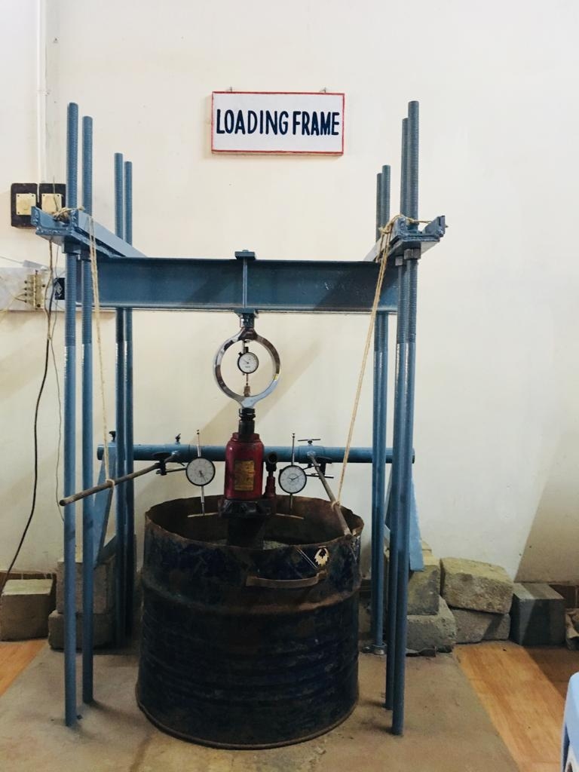 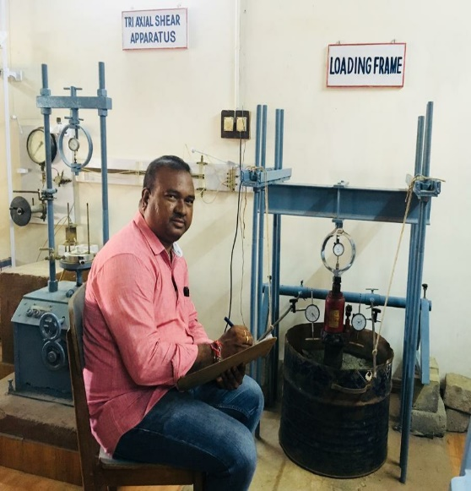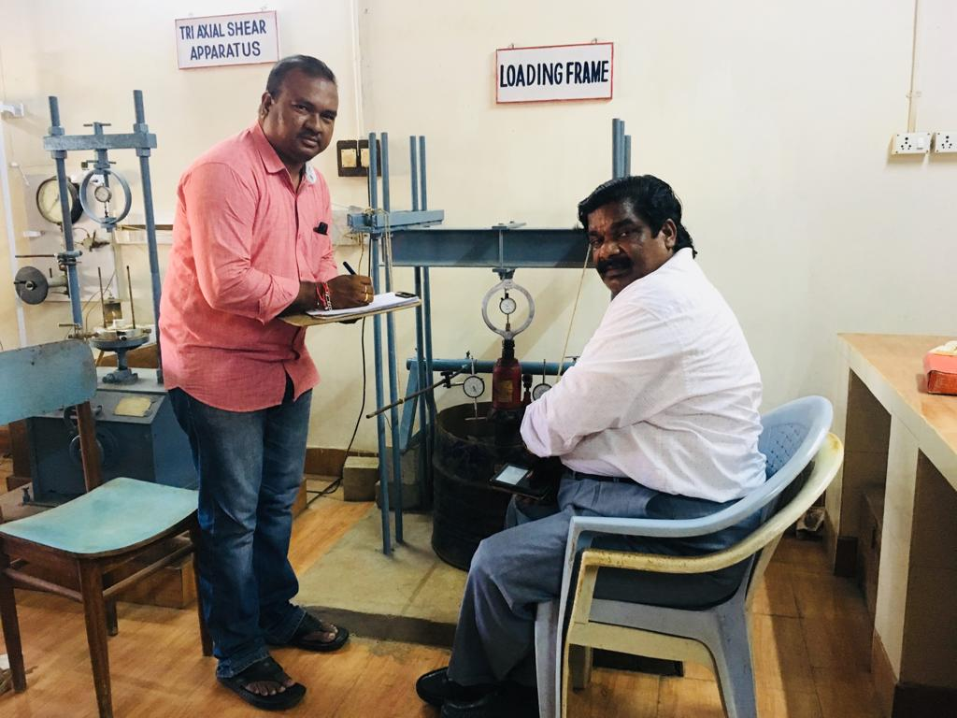 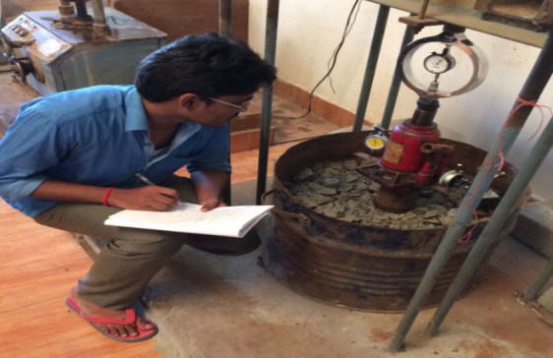 Plate 3 Authors is conducting cyclic plate load test

*5.2 Cyclic Plate load test results*

a). Table 5 and Fig 5.1 Present the load carrying capacity of the marine clay under cyclic pressures. The marine clay has exhibited the load carrying capacity of 70kPa at 2.98mm settlement.

Figure 5.1 Cyclic Plate Load test results of Marine Clay

b). Table 5 and Fig 5.2 Present the load carrying capacity of the untreated marine clay subgrade flexible pavement under cyclic pressures. The untreated marine clay subgrade flexible pavement has exhibited the load carrying capacity of 630kPa at 2.5mm settlement.

Figure 5.2 Cyclic Plate Load test results of Un-treated Marine Clay subgrade flexible pavement

c). Table 5 and Fig 5.3 present the load carrying capacity of the treated marine clay subgrade flexible pavement under cyclic pressures. The treated marine clay subgrade flexible pavement has exhibited the load carrying capacity of 1000kPa at 2.3mm settlement

Figure 5.3 Cyclic plate load test results of Treated Marine Clay subgrade flexible pavement

d). Table 5 and Fig 5.4 show the result of geotextile reinforced treated marine clay subgrade flexible pavement, exhibited the ultimate cyclic pressure of 1400kPa at 2.1mm settlement.

Figure 5.4 Cyclic plate load test results of Treated Marine Clay subgrade flexible pavement reinforced with geotextile

e). Table 5 and Fig 5.5 show the result of doubly reinforced treated marine clay subgrade flexible pavement, exhibited the ultimate cyclic pressure of 2200kPa at 1.6mm settlement. In this experiment the two layers geotextile has been provided viz. the first layer has been provided subgrade and sub base and the second and provided in between sub base and base course.

Figure 5.5 Cyclic plate load test results of Treated Marine Clay subgrade flexible pavement reinforced with geo textile

Table 5 Results of Cyclic Plate Load Test of Un-treated and treated Marine Clay Subgrade Flexible Pavements under cyclic pressures

|  |  |  |  |  |  |
| --- | --- | --- | --- | --- | --- |
| **S.No** | **Type of Subgrade** | **Sub-Base** | **Base**  **course** | **Pressure(kPa)** | **Settlement**  **(mm)** |
| **1** | **Marine Clay** | **-----** | **-----** | **70** | **2.98** |
| **2** | **Untreated marine clay subgrade flexible pavement** | **Gravel** | **WBM-III** | **630** | **2.5** |
| **3** | **18% silica fume and 8% lime treated marine clay subgrade flexible pavement** | **Gravel** | **WBM-III** | **1000** | **2.3** |
| **4** | **Treated Marine Clay subgrade flexible pavement with geotextile as reinforcement(singly reinforced) & separator in between subgrade and sub base** | **Gravel** | **WBM-III** | **1400** | **2.1** |
| **5** | **Double geotextile reinforced Treated Marine Clay subgrade flexible pavement.** | **Gravel** | **WBM-III** | **2200** | **1.6** |

*Discussion 3*

It has been observed from the laboratory cyclic plate load test results that the doubly reinforced flexible pavement has exhibited maximum cyclic pressure than the remaining untreated and treated flexible pavements.

VI. CONCLUSIONS

* It is noticed from the laboratory test results that the liquid limit of the marine clay has been decreased by 9.05% on addition of 18% silica fume and further liquid limit of silica fume treated marine clay has been decreased by 41.36% with an optimum of 8% lime addition when compared with untreated marine clay.
* It is observed from the laboratory test results that the plasticity index of the marine clay has been improved by 21.42% on addition of 18% silica fume and further plasticity index of silica fume treated marine clay has been improved by 42.65% with the addition of 8% lime as an optimum when compared with untreated marine clay.
* It is found from the laboratory test results that the Maximum Dry Density of the marine clay has been improved by 3.93% on addition of 18% silica fume and further maximum dry density of silica fume treated marine clay has been improved by 8.22% when 8% lime is added with respect to untreated marine clay.
* It is observed from the laboratory test results that the C.B.R. value of the marine clay has been improved by 482.62% on addition of 18% silica fume as an optimum and further C.B.R. value has been improved by 1035.42% when 8% lime is added with respect to untreated marine clay.
* It is noticed from the laboratory test results of cyclic plate load test that the ultimate pressure of treated marine clay subgrade flexible pavement has been increased by 249.20% with respect to untreated marine clay subgrade flexible pavements.
* It is noticed from the laboratory test results of cyclic plate load test that the total deformations of treated marine clay subgrade flexible pavement has been improved by 36% with respect to untreated marine clay subgrade flexible pavements.

REFERENCES

[1]. Rao M.S., Sridharan.A and Chandrakaran.S (1992), Physico chemical effects on the engineering behaviour of Indian marine clays. Proc. IITSeminar on problems of lowland development, Saga University, Saga japan.265-272.

[2]. G.V.R. PrasadaRaju (2001), Evaluation of Flexible Pavement Performance with Reinforcement and Chemical Stabilization of Expansive Soil Sub-grade, Ph.D. Thesis, Kakathiya university, Warangal, (T.S, India).

[3]. S. Narasimha Rao and Paul K. Mathew (1996), Permeability studies on Marine Clays stabilized with Lime column, International Journal of Offshore and Polar Engieering, Vol.6,No3,sep1996(ISSN 1503-5381).

[4]. Ashwani Kumar and H. S. Mehta (1998), Laboratory Investigations on Use of Stabilized Granulated Blast Furnace Slag in Roads, Indian Highways, December 1998.

[5]. Rajasekharan.G and NarasimhaRao.S (2000), Strength Characteristics of Lime treated Marine Clay, Journal of Ground Improvement, Vol.3, pp-127-136.

[6]. J.Chu, Myint Win Bo, M.F.Chang and V.Choa(2002) Consolidation characteristics and Permeability properties of Singapore Marine Clay. Journal of Geotechnical and Geo environmental Engineering, Vol.128, No.9, Sep., 2002, pp.724-7323.

[7]. Supakij N, Sanupong B et al (2004), "Strength Development of Soft Marine Clay Stabilized with Cement and Fly Ash", Kasetsart J. (Nat.Sci.) 38:539-552.

[8]. Koteswara Rao. D (2004), the performance studies on Geo-grids reinforcement in the flexible pavements construction, IGC-2004.

[9] C.N.V Satyanaraya reddy et al (2008) presented a case study in marine clay related to the heaving of the ground due to the shear displacement of marine clay, IGC-2008, Bangalore, pp: 614-616.

[10]. Basack and Purkayastha (2009)"Engineering properties of marine clays from the eastern coast of India." Journal of Engineering and Technology Research Vol.1 (6), pp.109-114, September, Shridharan 2009.

[11]. Koteswara Rao. D et al., (2011), The effect of reinforcement on GBFS and lime treated marine clay for foundation soil beds IJEST, Vol.3, No.3. March., 2011.

[12]. Koteswara Rao. D et al., (2012), A Laboratory study on the stabilization of marine clay using saw dust and lime, IJESAT, July 2012.

[13] Dr. D. Koteswara Rao (2013), presented the affect of vitrified polish waste on improving the properties of marine clay, IJEIT, Vol-2, Issue -11, May 2013 [14] Dr. D. Koteswara Rao (2014), presented the affect of steel slag for improving the properties of marine clay for foundation beds, 2nd International Conference,Trivandrum, IMMM,2014, vol.2,pp 267-273, Issue -11, 17th -19th December2014. [15] Nor Zurairahetty Mohd Yunus et al (2015), presented performance of lime treatd marine clay on strength and compressibility characteristics, Int. J. of GEOMATE, June (2015). Vol.08, No.2 (SI.No.16), pp: 1232-1238.

[16] Bijina Blessy T. (2016) presented the effect of chemical and physical combine methods for improving the strength characteristics of the marine clay (IJERT), vol.5, issue. 08, August 2018 [17 ] Mohammed Ali Mohammed Al-Bared and Amanaton Marto (2017) Presented A review on the geotechnical and engineering characteristics of marine clay and the modern methods, MJFAS, vol.13, No.4, 2017, pp: 826-832.

[18] Dr. D. Koteswara Rao and Y. SaiEswar (2018), presented the efficiency of Calcium Carbide and other chemicals for improving the consolidation characteristics of marine clay, IJTIMES, vol.4, issue. 08, August 2018.

[19] Dr. D. Koteswara Rao and Ch. Ajaykumar (2018), presented a laboratory investigation on the efficiency of expansive soil treated with silica fume and lime as subgrade for flexible pavements, IJTIMES, vol. 4, issue.08, August 2018.

[20] Dr. D. Koteswara Rao and K.Pradeep (2018), presented improving the properties of marine clay using Phosphogypsum and lime as subgrade for flexible pavements, IJTIMES, vol.4, Issume. 08, August 2018.

[21]. IS: 2720 part- 4 (1975): Grain size analysis.

[22]. IS: 2720 part- 5 (1970): Determination of Liquid limit and Plastic limit.

[23]. IS: 2720 part- 6 (1972): Determination of Shrinkage limit.

[24]. IS: 2720 part- 6 (1974): Determination of Dry density and Optimum moisture content.

[25]. IS: 2720 Part-10 (1973): Determination of Unconfined compressive strength.

[26].IS: 2720 Part-16 (1979): Determination of California bearing ratio.

[27].IS: 2720 part-40 (1977): Determination of Free Swell Index.

AUTHORS BIOGRAPHIE

*Author 1:*

B. Satyanarayana, Research Scholar, Department of Civil Engineering, University College of Engineering, JNTUK Kakinada, East Godavari District-533003, Andhra Pradesh, India



B. Satyanarayana

Research Scholar

University College of Engineering

JNTUK Kakinada, Andhra Pradesh, INDIA.

*Author 2:*

Dr. D Koteswara Rao is working as a Professor of Civil Engineering & Director, Faculty Development Centre, Jawaharlal Nehru Technological University Kakinada. He is a “Triple Hat-Trick Best Teacher Awardee” from the Department of Civil Engineering, University College of Engineering, JNTUK Kakinada. He was awarded the “University Meritorious teacher award -2013” by the University authorities and also received the National Best Teacher award-2013. Recently he was awarded “the State Best Teacher Award-2017” by the Government of Andhra Pradesh, India.He has published 41 research and review papers in various International& national journals and conferences. He has guided about 50 post graduate projects and four research scholars are working under his guidance. He is a leading consulting member in the fields of Surveying, Transportation and Geotechnical Engineering.



Dr. D. Koteswara Rao

Professor of Civil Engineering & Director

Faculty Development Centre

JNTUK Kakinada, Andhra Pradesh, INDIA.

*Author 3:*

N.S.Pramod Kumar, P.G student, Geo- Technical Engineering Division, Department of Civil Engineering, University College of Engineering, JNTUK Kakinada, East Godavari District-533003, Andhra Pradesh, India.



N. S. Pramod Kumar

Post-Graduation Student

University College of Engineering

JNTUK Kakinada, Andhra Pradesh, INDIA.