*R.Jothi Chitra*

*Department of Electronics and Communication Engineering*

*Velammal Institute of Technology, Chennai,Tamilnadu, India*

*asuresh.bsnl@gmail.com*

[1]

E Slot Reconfigurable Microstrip Patch Antenna using PIN diode for Wireless Application

***Abstract*— A frequency reconfigurable E-shaped microstrip patch antenna with wideband characteristics is proposed. The antenna is capable of operating at four different frequency bands. The antenna structure consists of two E-shaped slots embedded on the patch and two RF PIN diodes are placed on the appropriate position. In this work, two different types of PIN diodes BAR6304 and MPP4203 PIN diodes are used for analysis. Ansoft HFSS software is used for simulation and simulated results are presented.**

*Index Terms*— E-shaped slot, frequency reconfigurable, microstrip patch antenna, PIN diode

# INTRODUCTION

N

owaday, frequency reconfigurable antenna finds wide attention in wireless communication systems due to its extraordinary features. To achieve frequency reconfigurability, switches such as RF PIN diode, varactor diode and MEMS are commonly used. In [1], a frequency reconfigurable patch antenna using switchable slots for circular polarization diversity with two PIN diodes which radiate either at right hand circular polarization or left hand polarization has been analyzed. Moreover this antenna resonates only at 4.64GHz. Further, a reconfigurable microstrip antenna which produces linear, right hand circulation polarization and left hand circular polarization using independently biased PIN diodes is presented [2]. Though it produces both linear and circular polarization, this antenna resonates only at 1.59GHz.

Consequently, in [3] a frequency reconfigurable U slot microstrip patch antenna which resonates from 2.6 to 3.35GHz using trimmer is discussed. Further, in [4], a polarization reconfigurable E shaped patch antenna which is capable of switching its polarization from right hand circular polarization to left hand circular polarization for wideband application is analyzed. It is known form [5], the radiation characteristics remain unchanged in frequency reconfigurable antenna though

its operating frequency changes. In [6], a frequency reconfigurable microstrip patch switchable to slot antenna with five RF PIN diodes positioned in the slot to resonate at

eight different frequencies is presented.

Further in [7], a reconfigurable slot antenna for switchable multiband operation in a wide frequency range with five RF diode switches which radiate from 6-10.GHz is discussed. We designed [8], a double U-slot microstrip patch antenna for WiMAX application. In [9], in order to increase the gain, we designed a double L-slot microstrip patch antenna array for both WiMAX and WLAN application. Further in [10], a frequency reconfigurable antenna with six MPP4203 RF PIN diode has been incorporated in the ground plane which radiate for eight different frequencies. Since six PIN diodes are used the antenna design becomes more complex. In [11], U shaped frequency reconfigurable antennas with three PIN diodes are placed at different positions in the slot present between two patches of the antenna, which resonate at four different frequencies. In [12], a compact frequency reconfigurable circular patch antenna with an arc-shaped slot loaded in the ground layer was proposed for multiband wireless communication applications with five PIN diodes mounted on the arc-shaped slot. This antenna resonates for six different frequency bands. Consequently in [13], a wideband slot antenna for both frequency and pattern reconfigurable characteristics was designed. Two PIN diodes are located in the slots to achieve frequency reconfigurability and another two additional PIN diodes are inserted in the feed line to achieve the pattern reconfigurability. Though the antenna achieves frequency and pattern reconfigurability but the antenna radiates only for two frequency bands. Further in [14], simple and compact frequency reconfigurable antennas with six PIN diodes are designed. Six PIN diodes are positioned symmetrical at the non radiating edges to resonate from 2.35 to 3.43GHz. Therefore, it is evident from the review of the literature instead of using multiple antennas for different application inside the wireless devices, a single antenna must cover all wireless system is needed.

In this work, a new configuration of E-slot frequency reconfigurable antenna is designed. The antenna consists of two E shaped slots with two RF PIN diodes placed at appropriate position on the patch. The antenna is analyzed with BAR6304 and MPP4203 PIN diodes. The patch produces nearly omnidirectional radiation pattern for all switching conditions. The antenna is capable of resonate at four different frequency bands with two RF PIN diodes. The rest of the section is organized as follows: Section II covers the reconfigurable antenna design. Results and discussions are described in Section III. Section IV depicts the conclusion.

# Antenna Design

The configuration of proposed E-shaped slot frequency reconfigurable antenna with BAR6304 PIN diode is illustrated in Figure 1. Figure 2 depicts the E-shaped slot frequency reconfigurable antenna with MPP4203 PIN diode. These two structures are fabricated on FR4 substrate with thickness of 1.5mm, relativity permittivity of 4.4 and loss tangent of 0.02. The length and width of E-shaped patch are 26mm and 12mm respectively. The length of feed line is 8mm and width of the feed is 6mm. The antenna is fed with the aid of a 50Ω microstrip feed line. In both the structure the switch SW1 is placed on the upper slot and the switch SW2 is placed on the lower slot of E arm. The proposed antenna performance has been analyzed using ANSOFT HFSS simulation software. Parametric optimization has been carried out.

Two E-shaped slots embedded in the patch with two PIN diodes placed on the E-slot not only produce wide impedance but also achieve multiband operation. PIN diodes are used as switching elements.

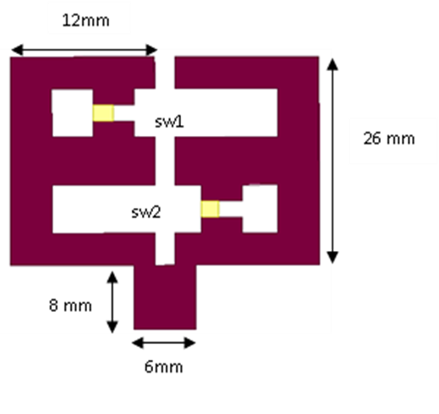

Figure 1. Geometry of E-slot frequency reconfigurable antenna with BAR6304 PIN diode

The equivalent circuit for MPP4203 PIN diode in forward bias consists of series inductance L1 =0.45nH and series resistance of R1 =3.5Ω and the reverse bias equivalent circuit consists of shunt Capacitance C1 = 0.08pf and shunt resistance R2 = 3.5Ω with series inductance L1 = 0.45nH. The equivalent circuit for BAR6304 PIN diode consists of forward resistance R= 2.1 Ω and the reverse bias consists of a capacitance C= 0.17pf. For different switching condition, the effective length of the slot is changed and thus the antenna resonates at different frequencies.

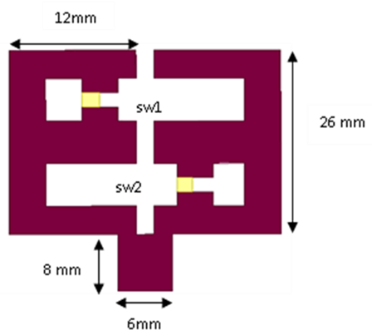

Figure. 2. Geometry of E-slot frequency reconfigurable antenna with MPP4203 PIN diode

Table I gives the diode switching configuration of E-slot. When the switches SW1 and SW2 are switched ON the antenna resonates at 2.8 to 6.8 GHz. When both the switches SW1 and SW2 are switched OFF the antenna resonates at 4.4 to 6.

TABLE I

Diode Switching Configuration of E-Slot Frequency Reconfigurable Antenna with BAR6304 PIN Diode

|  |  |  |  |
| --- | --- | --- | --- |
| Frequency | SW1 | SW2 | Resonant Frequency(GHz) |
| F1 | ON | OFF | 2.4-6.8 |
| F2 | OFF | ON | 4-4.6 |
| F3 | ON | ON | 2.8-6.8 |
| F4 | OFF | OFF | 4.4-6.6 |

Table II list the diode switching configuration of E-slot reconfigurable antenna with MPP4203 PIN diode. When the switches SW1 and SW2 are switched ON the antenna resonates at 3 to 4.2 GHz. When both the switches SW1 and SW2 are switched OFF the antenna resonates at 3 to 4 GHz. When SW1 is in ON condition and SW2 is in OFF condition the antenna resonates at 2.8 to 4.2GHz.

TABLE II

Diode Switching Configuration of E-Slot Frequency Reconfigurable Antenna with MPP4203 PIN Diode

|  |  |  |  |
| --- | --- | --- | --- |
| Frequency | SW1 | SW2 | Resonant Frequency(GHz) |
| F1 | ON | OFF | 3-4.2 |
| F2 | OFF | ON | 2.9-4.2 |
| F3 | OFF | OFF | 3-4 |
| F4 | ON | OFF | 2.8-4.2 |

# Results And Discussions

In this section, optimizedsimulated results of return loss and radiation pattern of E-slot frequency reconfigurable microstrip patch antenna with BAR6304 and MPP4203 PIN diodes are presented.

## BAR6304 PIN DIODE

Parametric optimization has been carried out in E-slot reconfigurable microstrip patch antenna with BAR6304 PIN diode. Parametric optimization has been performed by varying the position of two switches. The position of two switches SW1 and SW2 are varied at A=22mm B=11.5mm, A=24mm B=13.5mm, A=24mm B=13.5mm, A=26mm B=13.5mm, A=22mm B=15.5mm, A=24mm B=15.5mm and A=24mm B=15.5mm. At A=22mm and B=15.5mm better impedance and multiband operation is achieved. Figure 3, 4, 5, 6 shows the optimized simulated return loss of E-slot reconfigurable antenna for various switching condition at F1, F2, F3, F4 respectively. The simulated return loss for all the frequency bands is less than -10dB.

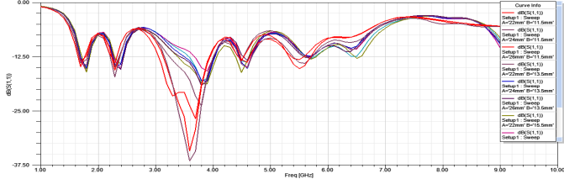

Figure 3. Optimized simulated return loss of E-slot frequency reconfigurable antenna with BAR6304 PIN diode at F1

In Figure 3, at F1 the E-slot frequency reconfigurable antenna resonates from 3 to 4GHz with return loss value of -37dB. From Figure 4, it is seen that at F2 switching condition the E-slot frequency reconfigurable antenna supports frequency bands from 4.4 to 6.6GHz with return loss value of -44dB.

In Figure 5, at F3 the E-slot frequency reconfigurable antenna resonates at dual band frequencies from 2.2 to 2.8GHz with return loss value of -37dB and from 3.2 to 4GHz with return loss value of -13dB.From Figure 6, at F4 switching condition the E-slot frequency reconfigurable antenna supports frequency bands from 3.6 to 6GHz with return loss value of -30dB.

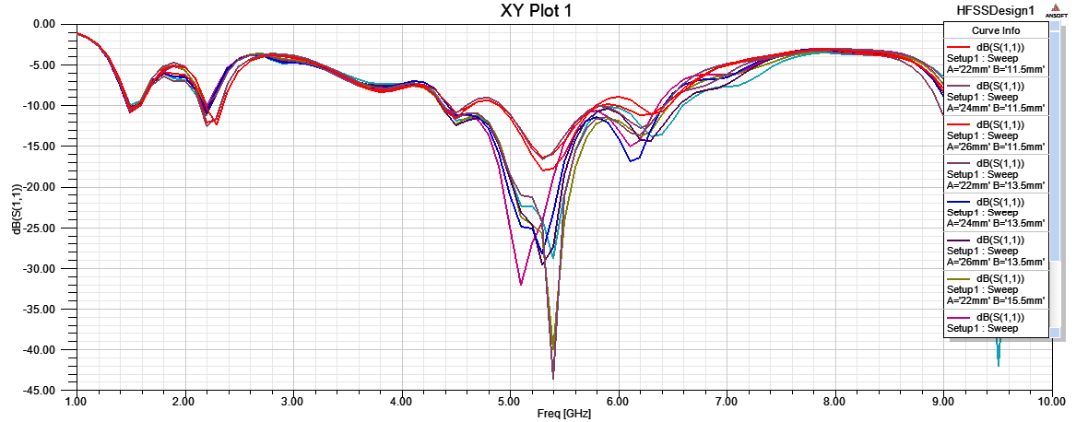

Figure 4. Optimized simulated return loss of E-slot frequency reconfigurable antenna with BAR6304 PIN diode at F2

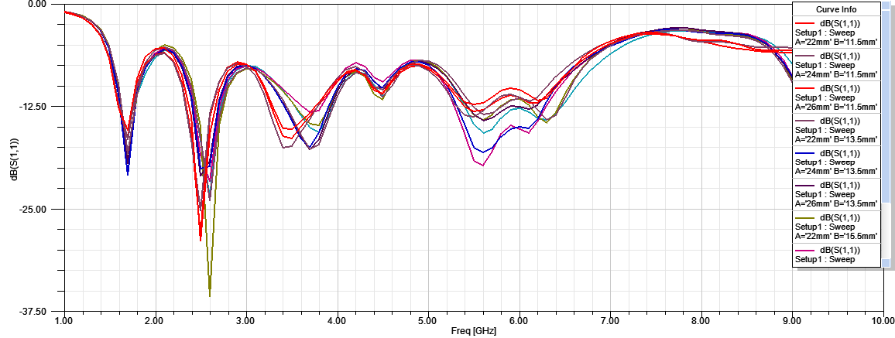

Figure 5. Optimized simulated return loss of E-slot frequency reconfigurable antenna with BAR6304 PIN diode at F3

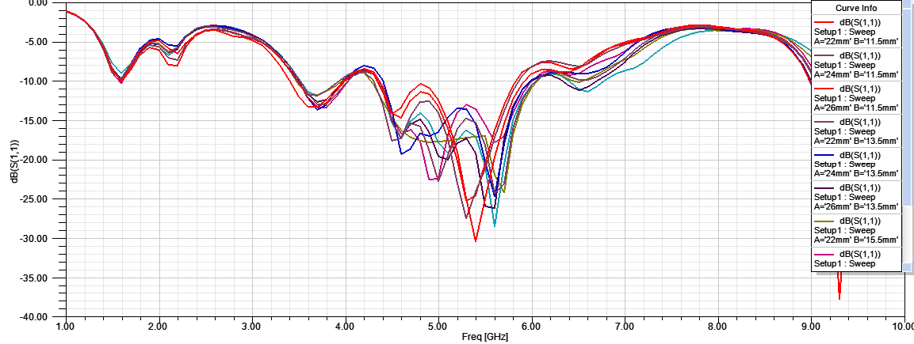

Figure 6. Optimized simulated return loss of E-slot frequency reconfigurable antenna with BAR6304 PIN diode at F4

Figure 7 shows the optimized simulated radiation pattern of E- slot frequency reconfigurable microstrip patch antenna. From the figure it is observed that radiation pattern is nearly omnidirectional and stable for the considered design antenna. Since only two switches are used in E-slot reconfigurable antenna, radiation loss is also reduced. Table III depicts the return loss value of E-slot frequency reconfigurable antenna with BAR6304 PIN diode. From the table it is inferred that at F3 switching condition the antenna radiates at dual band frequencies.

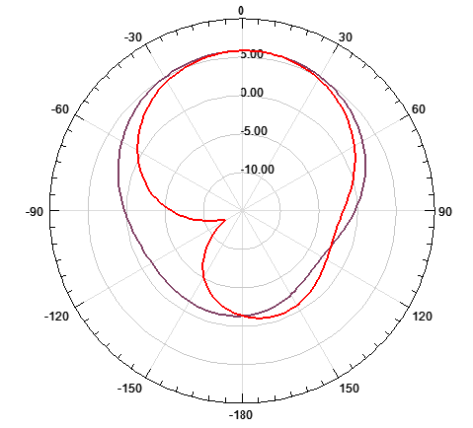

Figure 7. Optimized simulated radiation pattern of E-slot frequency reconfigurable antenna with BAR6304 PIN diode at F2

TABLE III

Return Loss Value of E-Slot Frequency Reconfigurable

Antenna with BAR6304 PIN Diode

|  |  |  |
| --- | --- | --- |
| Frequency | Frequency range(GHz) | Return loss(dB) |
| F1 | 3-4 | -37 |
| F2 | 4.4-6.6 | -44 |
| F3 | 2.2-2.8 & 3.2-4 | -37 & -13 |
| F4 | 3.6-6 | -30 |

## MPP4203 PIN DIODE

The BAR6304 PIN diode in E-slot reconfigurable antenna is replaced by MPP4203 PIN diode and parametric optimization has been carried out by changing the position of the two diodes. The optimized simulated return loss of E-slot frequency reconfigurable antenna with MPP4203 PIN diode with different switching condition at F1, F2, F3, F4 are shown in Figure 8, 9, 10, 11 respectively. In Figure 8, at F1 the E-slot frequency reconfigurable antenna with MPP4203 PIN diode resonates from 3 to 4.2GHz with return loss value of -44dB. From Figure 9, at F2 switching condition the E-slot frequency reconfigurable antenna supports frequency bands from 2.9 to 4.2GHz with return loss value of -44dB.

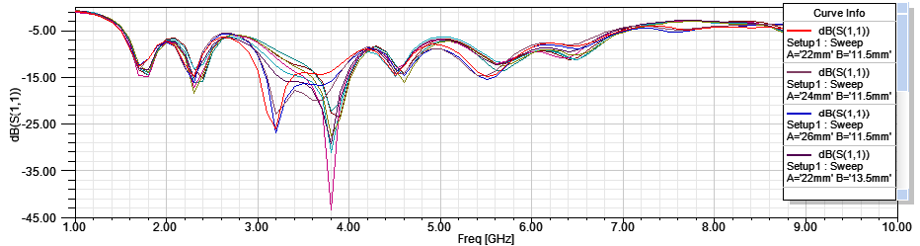

Figure 8. Optimized simulated return loss of E-slot frequency reconfigurable antenna with MPP4203 PIN diode at F1

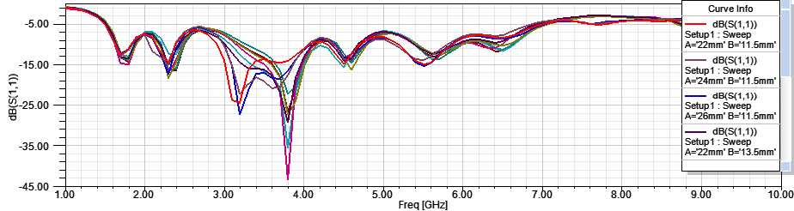

Figure 9. Optimized simulated return loss of E-slot frequency reconfigurable antenna with MPP4203 PIN diode at F2

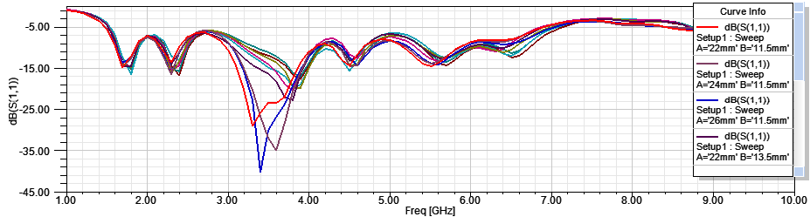

Figure 10. Optimized simulated return loss of E-slot frequency reconfigurable antenna with MPP4203 PIN diode at F3

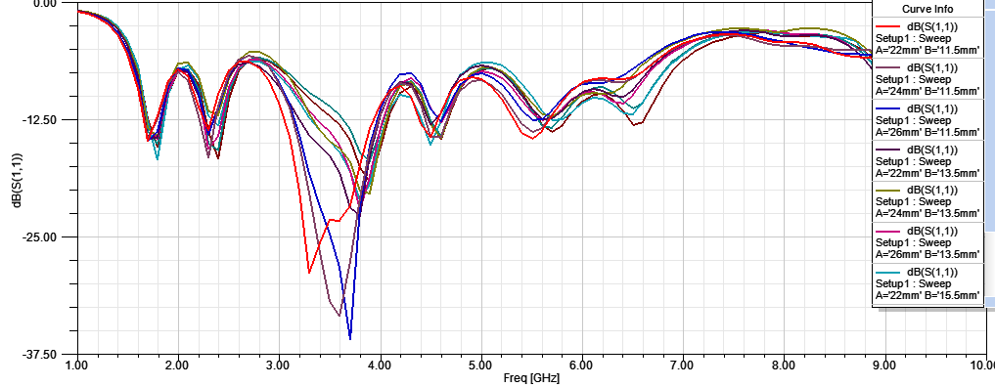

Figure 11. Optimized simulated return loss of E-slot frequency reconfigurable antenna with MPP4203 PIN diode at F4

In Figure 10, at F3 the E-slot frequency reconfigurable antenna resonates from 3 to 4GHz with return loss value of -38dB. From Figure 11, at F4 switching condition the E-slot frequency reconfigurable antenna supports frequency bands from 2.8 to 4.2GHz with return loss value of -37dB. Table IV depicts the return loss value of E-slot frequency reconfigurable antenna with MPP4203 PIN diode.

|  |  |
| --- | --- |
| Description: C:\Users\suresh\AppData\Local\Microsoft\Windows\Temporary Internet Files\Content.Word\radiation pattern.tiff  (a) | Description: C:\Users\suresh\AppData\Local\Microsoft\Windows\Temporary Internet Files\Content.Word\radiation pattern.tiff  (b) |
| Description: C:\Users\suresh\AppData\Local\Microsoft\Windows\Temporary Internet Files\Content.Word\radiaion pattern.tiff  (c) | Description: C:\Users\suresh\AppData\Local\Microsoft\Windows\Temporary Internet Files\Content.Word\radiation.tiff  (d) |

Figure 12. Optimized simulated radiation pattern of E-slot frequency reconfigurable antenna with MPP4203 PIN diode at

(a)F1(b) F2 (c) F3 (d) F4

Figure 12 shows the optimized simulated radiation pattern of E-slot frequency reconfigurable antenna with MPP4203 PIN diode with different switching condition at F1, F2, F3, F4. From the figure it is observed that for all the switch condition the radiation pattern is omnidirectional.

TABLE IV

Return Loss Value of E-Slot Frequency Reconfigurable

Antenna with MPP4203 PIN Diode

|  |  |  |
| --- | --- | --- |
| Frequency | Frequency range(GHz) | Return loss(dB) |
| F1 | 3-4.2 | -44 |
| F2 | 2.9-4.2 | -44 |
| F3 | 3-4 | -38 |
| F4 | 2.8-4.2 | -37 |

# Conclusion

In this work, an E-slot reconfigurable antenna with BAR6304 and MPP4203 PIN diodes for multiband application are presented. The designed E-slot reconfigurable antenna with BAR6304 and MPP4203 PIN diodes resonates at four different frequencies for different switching condition. The radiation efficiency of the antenna ranges from 53% to 59%. The antenna meets the optimum value of VSWR and return loss. The antenna is compact and it also enhances the bandwidth. Also it achieves Multiband operation. The frequency reconfigurable antenna is well suited for cognitive radio systems.

# Acknowledgment

The author would like to thank Velammal Institute of Technology for providing facilities in their research Lab.

References

1. Fan Yang and Yahya Rahmat-Samil, “ A Reconfigurable Patch Antenna using Switchable slots for circular polarization Diversity,”*IEEE Microwave and Wireless Components Letters*.,vol.12, pp. 96-98, Mar 2002.
2. Y.J.Sung, T.U.Jang and Y.S.Kim, “ A Reconfigurable Microstrip Antenna for Switchable Polarization, ”*IEEE Microwave and Wireless Components Letters*.,vol.14, pp. 534-536, Nov 2004.
3. Shing-Lung Steven Yang, Ahmed A. Kishk and Kai-Fong Lee, “Frequency Reconfigurable U-slot Microstrip patch Antenna,” *IEEE Trans. Antennas Propagat.*,vol.7, pp.127-129, Jan 2008.
4. Ahmed Khidre, Kai-Fong Lee, Fan Yang, and Atef Z. Elsherbeni, “Circular Polarization Reconfigurable Wideband E-shaped Patch Antenna for Wireless Applications,” *IEEE Trans. Antennas Propagat.*, vol. 61, pp. 960–964, Feb. 2013.
5. Y.Cai, Y.JayGuo and A.R.Wiley, “ A frequency-reconfigurable quasi-yagi dipole antenna,” IEEE Antennas Wireless Propag. Lett., vol.9, pp.883-886, 2010.
6. Huda A. Majid, Mohamad Kamal Abdul Rahim, Mohamad Rijal Hamid, Noor Asniza Murad and Mohd Faizal Ismail, “ Frequency Reconfigurable Microstrip Patch slot Antenna, ”*IEEE Antennas and Wireless Propagation*, vol. 12, pp. 218-220, Jan 2013
7. Lev Pazin and Yehuda Leviatan J. Wang, “Reconfigurable Slot Antenna for Switchable Multiband Operation in a wide Frequency,” *IEEE Antennas Wireless Propag. Lett*., vol.12, pp.329-332, Feb 2013.
8. R.Jothi Chitra, Sugunya.A and V.Nagarajan, “Design of double U-slot microstrip patch antenna for WiMAX applications, *IEEE International Conference on Green Technologies*, pp. 130- 133, Dec 2012.
9. R.Jothi Chitra and V.Nagarajan, “Double L-slot microstrip patch antenna array for WiMAX and WLAN applications, ” *Elsevier Journal of Computers and Electrical Engineerin*g, vol.39, pp.1026-1041, Apr 2013.
10. R.Jothi Chitra and V.Nagarajan, “ Frequency Reconfigurable antenna using PIN diodes,” *Twentieth IEEE National Conference on Communications (NCC 2014)* , IIT , Kanpur, Mar 2014.
11. Isra Nazir, Inam Elahi Rana, Noorul Anu Mir and Kanwal Afreen, “Design and Analysis of a Frequency Reconfigurable Microstrip Patch Antenna switching between Four Frequency Bands,” *Progress in Electromagnetics Research C*, Vol.68, pp.179-191, 2016.
12. Yao Chen, Longfang Ye, Jianliang Zhuo, Yanhui Liu, Liang Zhang, Miao Zhang and Qing Huo Liu, “ Frequency Reconfigurable circular patch Antenna with an Arc-Shaped slot ground controlled by PIN diodes*,” International journal of Antennas and Propagations*, pp.1-7, 2017.
13. Lipingltan,Caixia Wang, Wenmei Zhang,Runbo Ma and Qing Sheng Zeng, “Design of Frequency and Pattern Reconfigurable wideband slot Antenna,” *International Journal of Antenna and Propagation*, pp.1-7,2018.
14. Abdelheq Boukarkar, Xian Qi Lin, Yuan Jiang, Xiao Fan Yang, “A Compact frequency Reconfigurable 36-states patch antenna for wireless Applications,” IEEE Antennas and Wireless Propagation Letters, Vol.17, pp.1349-1353, 2018.

1. R. Jothi Chitra is with Electronics and Communication Engineering Department, Velammal Institute of Technology, India (email:asuresh.bsnl@gmail.com)