A Fuzzy Controlled Zeta DC-DC Converter for PV Based Applications

T. Arunkumari, V. Indragandhi*, R. Raja Singh

*Department of Energy and Power Electronics,*

*School of Electrical Engineering, VIT Vellore, India.*

*\*indragandhi.v@vit.ac.in*

**Abstract: In this manuscript a zeta converter with extreme voltage ratio module is proposed. The projected converter has the feature of stable frequency and output even though disturbance occurs. It also achieves high static voltage, high efficacy, low voltage strain and less switching loss. The voltage doubler technique is implemented in the designed converter. With reduced duty cycle the high voltage conversion is achieved. The proposed zeta converter is controlled by fuzzy controlled technique. The function of the power converter underneath Continuous Conduction Mode (CCM) is explained. The 30 V is boosted up to 220 V. The simulation of the proposed model is done with MATLAB Simulink.**

**Keywords: Continuous Conduction Mode, Duty Cycle, Fuzzy Controller, High Voltage Conversion, Switching loss.**

I.INTRODUCTION

The usage of natural source such as Photo Voltaic (PV) has been raised sequentially, due to global warming and the demand of fossil fuels. PV schemes utilize the solar vitality to harvest electrical energy. On the other hand, the produced DC source voltage by a PV scheme is very less. To handle this downside, converters develop a significant section of natural source [1-3]. Hence, different DC converters through extreme voltage conversion ensure been projected for solar schemes. Conventional converter was utilized for high voltage conversion with limited duty range. Due to occurrence of the high losses in active and passive, the efficacy and the static gain are restricted [4, 5].

To exceed the limits, several DC models such as the IBC [6], soft-switching mode [7], coupled-inductive schemes [8] and VM technique [9-12] designed which is capable to deliver extreme static gain. It is perceptible that other schemes converter depends on the mixture of this topography in current years [13-17]. Amongst these design each has their own merits and de-merits.

Many techniques have been implemented for high voltage conversion technique such as inductive coupling method, switched capacitor method, voltage doubler method and voltage multiplier techniques. All the above methods have advantages and disadvantages. The common drawbacks in all those techniques are the size of the system is increased. Recently, various VMC design have been offered in [10-12]. A new VMC structure has been projected in [10]. A new scheme of VM has been presented in [11-12]. It is essential to remind that the source current of designed models in is sporadic and it is a limitation. Also, the static gain of this topography is stable and cannot be synchronized. Hence, these cannot be exploited in PV schemes due to their restriction to follow the MPP. Then voltage lift technique has been proposed and it is implemented for boost converter [18-20]. In this paper the voltage lift technique is implemented for zeta converter. The model is depicted in Fig.1



Fig.1 Overview of conversion system

Here the manuscript contains, a new voltage lift dc converter with PV is projected which can overawed the exceeding stated limitations of the conventional converters. In section II the function of the designed model in CCM mode is explained. In section III the analysis of the proposed model is detailed. Section IV deals with converter control fuzzy logic. In section V simulation results are explained. Section VI is followed with conclusion.

II. OPERATION OF THE PROPOSED CONVERTER

The designed model is depicted in the Fig. 2. Few conventions are made to streamline the circuit designs and operation of the projected circuit.

1. The proposed circuit operates under CCM at the stable state condition.
2. Semiconductor strategies are considered as ideal in nature.
3. The capacitor utilized has high storage voltage and hence the capacitors are assumed to be constant. Hence the input capacitor and the output capacitor are considered as equal.



Fig.2 proposed converter

* 1. *Continuous conduction mode:*

The proposed converter conducts in two modes. They are switch off and switch on mode. They turn on and turn off modes are portrayed in fig. 3 and fig.4

Mode I [t0-t1]: When the ${ S}_{1}$ switch, is crooked ON, diode $D_{1}$ and $D_{2}$ is crooked ON. The voltage $V_{in}$ is delivered to $L_{1}$ and ${V_{C3}-V}_{C2}{-V}_{C1}$ is delivered to ${ L}_{2}$. These inductors help in storing the energy. The Output capacitor $C_{0}$ discharges the obligatory energy to the capacity for its operation. When the Mosfet switch off, this mode ends.



Fig.3 Turn On mode of proposed converter

Mode II [t1-t2]: When the ${ S}_{2}$, is crooked OFF, the diodes $D_{1}$ and $D_{2}$ are in OFF condition. The capacitors are indicted by the inductor L1 and L2. The load receives the energy by discharging mode of the capacitor. This operation tops when Mosfet is crooked ON. The next cycle continues.



Fig.4 Turn Off mode of proposed converter

The key active waveform is characterized in fig. 5. The total capacitive voltage is equivalent as voltage at output terminal of the model.

$V_{o}=V_{C1}+V_{C2}+V_{C3}+V_{C0}$ (1)



Fig.5 operational waveform

III ANALYSIS OF THE PROPOSED CONVERTER:

In this section the examination of the model is derived. The parameter values of the inductor and capacitor is analysed. The voltage gain and duty cycle are calculated in this section.

* 1. *Calculation for Voltage gain :*

In the stable state, the normal voltage crosswise inductor $L$ is zero. Thus



(2)

During ON condition, the voltage thru $C_{1}$ is identical to the voltage across $C_{s}$. Since ${ C}_{s}$, and $C_{1}$ are sufficiently large,

 (3)

The inductor current $I_{l}$, upsurges thru switch on time and drops thru switching off period. The voltage transferral gain of lift circuit is given as,

 (4)

From here we can attain,

 (5)

The converter output voltage is given by,

 (6)

As utilizing the voltage doubler, the converter gain is given as

 (7)

* 1. *Duty cycle calculation:*

The proposed converters of voltage varies due to the duty cycle control. And also it is dependent on elements in the circuit. The output of the designed converter is given as,

 (8)

 (9)

* 1. *Inductor Selection:*

The inductance values are identified with the help of input current ripples i.e. ${ ∆I}_{L1} an d {∆I}_{L2}$.

$L_{1}=\frac{D*{2v}_{in}}{f.{∆I}_{L1}}$ (10)

(11)

(12)

* 1. *Capacitor Selection:*

Voltage ripple (${∆v}_{c}$) is used to calculate the capacitance value. The ripple value is obtained by the 10% of the input voltage value. The capacitive ripple current is obtained using eq.14 and the ripple current is 0.113 A. The formula to obtain the capacitor value is given by,

${ c}_{1}=c_{2}=c_{3}=\frac{I_{0}}{f.{∆v}_{c}}$ (13)

The ripple voltage is obtained by,

${ ∆v}_{c}=\frac{v_{in}}{1-d}*10\%$ (14)

The ripple capacitive current is attained by,

(15)

* 1. *Output capacitor:*

The output capacitor $c_{0}$ is designed as same as boost converter design. To calculate the output capacitor frequency $f_{c}$, output power ${ p}_{0}$, output voltage ${ v}_{0}$ and output ripple voltage ${ ∆v}_{0}$. 1% of output voltage is equivalent to production ripple voltage. The capacitance is calculated using

(16)

* 1. *Component stress:*

The component design purpose the switch current $i_{1}$ and $i_{2}$ at the turn ON and end of turn ON is found using below equation. On taking the theoretical efficiency value $94 \%$. Here the RMS current of the switch ${ (i}_{rms}$). The comparison is of the converter is detailed in table 1.

${ i}_{1}=\left(\frac{p_{0}}{{η*v}_{in}}-\frac{{∆I}_{L}}{2}\right)+\left(i_{0}-\frac{{∆I}_{L}}{2}\right)$ (17)

$i_{2}=\left(\frac{p_{0}}{{η*v}_{in}}+\frac{{∆I}_{L}}{2}\right)+\left(i_{0}+\frac{{∆I}_{L}}{2}\right)$ (18)

$$i_{rms}=\sqrt{\frac{1}{3}.\left(i_{1}^{2}+i_{1}^{2}+i_{1}.i_{2}\right).d} (19)$$

The output current ${(i}_{0}$) is same as diode current ${ i}_{D1}$, $i_{D2}$ and $i_{D0}$

${ i}_{0}={ i}_{D1}={ i}_{D1}={ i}_{D1}=\frac{p_{0}}{v_{0}}$ (20)

Table 1-Evaluation of the designed converter and conventional zeta converter:

|  |  |  |
| --- | --- | --- |
| **Parameters** | **Zeta converter** | **Proposed topology** |
| **Input current** | **discontinuous** | **constant** |
| **Number of switches** | **1** | **1** |
| **Capability of usage of PV** | **no** | **yes** |
| **Cost** | **low** | **average** |
| **Output voltage** | **constant** | **variable** |
| **Voltage gain** | $$V_{0}=\frac{D}{1-D}×V_{in}$$ | $$V_{0}=\frac{2D}{1-D}×V_{in}$$ |
| **Ripple voltage** | **>3** | **0.75** |
| **Ripple current** | **-** | **0.113** |

IV. FUZZY LOGIC CONTROLLER

Fuzzy-Logic Controller (FLC) is one of the most booming applications of fuzzy theory, implemented by Zadeh in 1965 [2]. Its best features are the usage of linguistic variables relatively than numerical contents. Linguistic variables are utilized as normal variables are such as small and large, which is represented as fuzzysets. It is an addition of a crisp set which exhibits the membership or non-member ship function. Fuzzy sets permits specific function which defines that an element may belong or may not belong to the set.

The FLC is utilized to control the zeta converter operation. This fuzzy is utilized for any other control operation. The main concept of fuzzy is the rules. The rules should be defined first according to the converter operation. Here in this design, the error values are given as input to the fuzzy converter. The change in error is created by delay unit. The fuzzy output is compared with relational operator and it is given to the gate of the MOSFET. The fuzzy block is depicted in Fig. 6

FLC consists of three main blocks namely fuzzification, FIS and defuzzification. In first process the data is converted to linguistic variable. There are two methods they are, Mamdani and Sugeno. Scheme of membership function shown in Fig. 7, Fig. 8 and Fig. 9 respectively. To attain crunchy output diverse defuzzification approaches can be utilized e.g., centre of gravity. Rule base and data base are given to decision making. The converter rules for fuzzy controller is depicted in Table. 2 and surface plot is represented in Fig. 10



Fig.6 Fuzzy Block

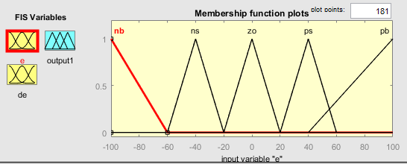 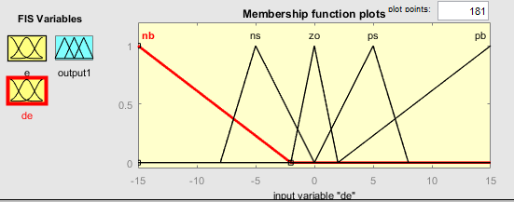Fig.7 Input error membership Fig.8 Input change in error membership

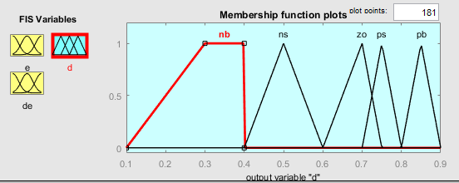 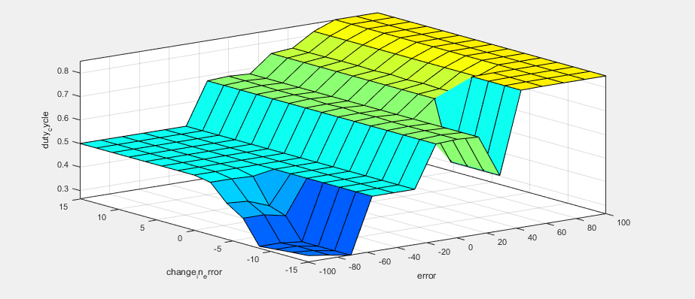Fig.9 Output duty membership Fig.10 Surface plot of fuzzy

Table:2- Fuzzy Rule for proposed converter

|  |  |  |  |  |  |
| --- | --- | --- | --- | --- | --- |
| ERR | NB | NS | Z0 | PS | PB |
| NB | nb | ns | ns | ns | ns |
| NS | ns | ns | ns | ns | ns |
| Z0 | zo | zo | zo | zo | zo |
| PS | ps | ps | ps | ps | ps |
| PB | pb | pb | pb | pb | pb |

V. SIMULATION RESULTS

The zeta converter with voltage lift technique proposed is tested with Matlab Simulink. The 30 V input is enhanced up to 170 V. The key benefit of the designed converter is its one switch, condensed size, increased efficiency, less duty cycle, high voltage boost up with reduced ripple value. The generated voltage and current consequences are portrayed in the Fig. 11 & Fig 15. The ripple and peak over values are reduced. The enactment of the converter is better associated to other zeta converters. The waveforms of other components are depicted from the Fig. 12-14. The converter parameters are represented in Table. 3

 

Fig.11 Output voltage Fig.12 Diode 1 voltage

 

Fig.13 Diode 2 voltage Fig.14 Capacitor 2 voltage



Fig.15 Inductor 1 current

Table:2-converter parameters:

|  |  |
| --- | --- |
| **Components** | **Parameter** |
| Input power | 30 V |
| Output power | 170 V |
| Input current | 5 A |
| Output current | 0.5 A |
| Inductor L1, L2 | 205e-6, 180e-6 µH |
| Capacitor C1, C2 | 2.2e-6 µF |
| Capacitor C0 | 40e-6 µF |
| Resistor | 400 Ω |

VI.CONCLUSION

Here, a voltage doubler zeta converter is proposed. The CCM mode operation is explained in detail with the waveform. The mathematical expression for the projected converter is derived and analysed through the simulation results. Also the designed converter is associated with conventional Zeta converter in the basis of ripple, efficiency and gain. In this designed converter the duty limit attained is 0.73 and the ripple source current is reduced to 0.113 A. The main advantage such as reduced size of the converter, reduced number of switch, reduced ripple current is attained. This converter has high efficiency while switching and conduction loss is less. The efficiency attained is stable on comparing to other converters. This converter is suitable for PV energy conversion and it is also suitable to connect to the inverter source. This can be analysed through hardware results in future.

REFERENCES

1. Hosseini, S.H., Alishah, R.S. and Kurdkandi, N.V., 2015, June. Design of a new extended zeta converter with high voltage gain for photovoltaic applications. In *Power Electronics and ECCE Asia (ICPE-ECCE Asia), 2015 9th International Conference on* (pp. 970-977). IEEE.
2. Alishah, R.S., Nazarpour, D., Hosseini, S.H. and Sabahi, M., 2013. Design of new power electronic converter (PEC) for photovoltaic systems and investigation of switches control technique. In *Proc. 28th Power System Conf.(PSC)* (pp. 1-8).
3. Pan, C.T., Lai, C.M. and Cheng, M.C., 2010. A novel integrated single-phase inverter with auxiliary step-up circuit for low-voltage alternative energy source applications. *IEEE Transactions on Power Electronics*, *25*(9), pp.2234-2241.
4. Huang, Y., Shen, M., Peng, F.Z. and Wang, J., 2006. $ Z $-Source Inverter for Residential Photovoltaic Systems. *IEEE Transactions on Power Electronics*, *21*(6), pp.1776-1782.
5. Ye, Y.M. and Cheng, K.W.E., 2013. Quadratic boost converter with low buffer capacitor stress. *IET Power Electronics*, *7*(5), pp.1162-1170.
6. Abdel-Rahim, O., Orabi, M., Abdelkarim, E., Ahmed, M. and Youssef, M.Z., 2012, February. Switched inductor boost converter for PV applications. In *Applied Power Electronics Conference and Exposition (APEC), 2012 Twenty-Seventh Annual IEEE* (pp. 2100-2106). IEEE.
7. Chen, C., Wang, C. and Hong, F., 2009, January. Research of an interleaved boost converter with four interleaved boost convert cells. In *Microelectronics & Electronics, 2009. PrimeAsia 2009. Asia Pacific Conference on Postgraduate Research in* (pp. 396-399). IEEE.
8. Park, S.H., Park, S.R., Yu, J.S., Jung, Y.C. and Won, C.Y., 2010. Analysis and design of a soft-switching boost converter with an HI-bridge auxiliary resonant circuit. *IEEE Transactions on Power electronics*, *25*(8), pp.2142-2149.
9. Li, W., Lv, X., Deng, Y., Liu, J. and He, X., 2009, February. A review of non-isolated high step-up DC/DC converters in renewable energy applications. In *Applied Power Electronics Conference and Exposition, 2009. APEC 2009. Twenty-Fourth Annual IEEE* (pp. 364-369). IEEE.
10. Pan, Z., Zhang, F. and Peng, F.Z., 2005, March. Power losses and efficiency analysis of multilevel dc-dc converters. In *Applied Power Electronics Conference and Exposition, 2005. APEC 2005. Twentieth Annual IEEE* (Vol. 3, pp. 1393-1398). IEEE.
11. Qian, W., Cao, D., Cintrón-Rivera, J.G., Gebben, M., Wey, D. and Peng, F.Z., 2012. A switched-capacitor DC–DC converter with high voltage gain and reduced component rating and count. *IEEE Transactions on Industry Applications*, *48*(4), pp.1397-1406.
12. Abutbul, O., Gherlitz, A., Berkovich, Y. and Ioinovici, A., 2003. Step-up switching-mode converter with high voltage gain using a switched-capacitor circuit. *IEEE Transactions on circuits and systems I: Fundamental theory and applications*, *50*(8), pp.1098-1102.
13. Arunkumari, T. and Indragandhi, V., 2017. An overview of high voltage conversion ratio DC-DC converter configurations used in DC micro-grid architectures. *Renewable and Sustainable Energy Reviews*, *77*, pp.670-687.
14. Hsieh, Y.P., Chen, J.F., Liang, T.J. and Yang, L.S., 2012. Novel high step-up DC–DC converter with coupled-inductor and switched-capacitor techniques. *IEEE Transactions on Industrial Electronics*, *59*(2), pp.998-1007.
15. Li, W., Li, W., Ma, M., Deng, Y. and He, X., 2010, November. A non-isolated high step-up converter with built-in transformer derived from its isolated counterpart. In *IECON 2010-36th Annual Conference on IEEE Industrial Electronics Society* (pp. 3173-3178). IEEE.
16. Laird, I., Lu, D.D.C. and Agelidis, V.G., 2009, November. High-gain switched-coupled-inductor boost converter. In *Power Electronics and Drive Systems, 2009. PEDS 2009. International Conference on* (pp. 423-428). IEEE.
17. Zhao, Y., Li, W., Deng, Y. and He, X., 2011. Analysis, design, and experimentation of an isolated ZVT boost converter with coupled inductors. *IEEE transactions on power electronics*, *26*(2), pp.541-550.
18. Savakhande, V., Bhattar, C.L. and Bhattar, P.L., 2017, April. A voltage-lift DC-DC converter using modular voltage multiplier cell for photovoltaic application. In *Circuit, Power and Computing Technologies (ICCPCT), 2017 International Conference on* (pp. 1-7). IEEE.
19. Savakhande, V.B., Bhattar, C.L. and Bhattar, P.L., 2017, February. Voltage-lift DC-DC converters for photovoltaic application-a review. In *Data Management, Analytics and Innovation (ICDMAI), 2017 International Conference on* (pp. 172-176). IEEE.
20. Shahir, F.M., Babaei, E. and Farsadi, M., 2017. Voltage-Lift Technique Based Non-isolated Boost DC-DC Converter: Analysis and Design. *IEEE Transactions on Power Electronics*.