sp_get_distributor

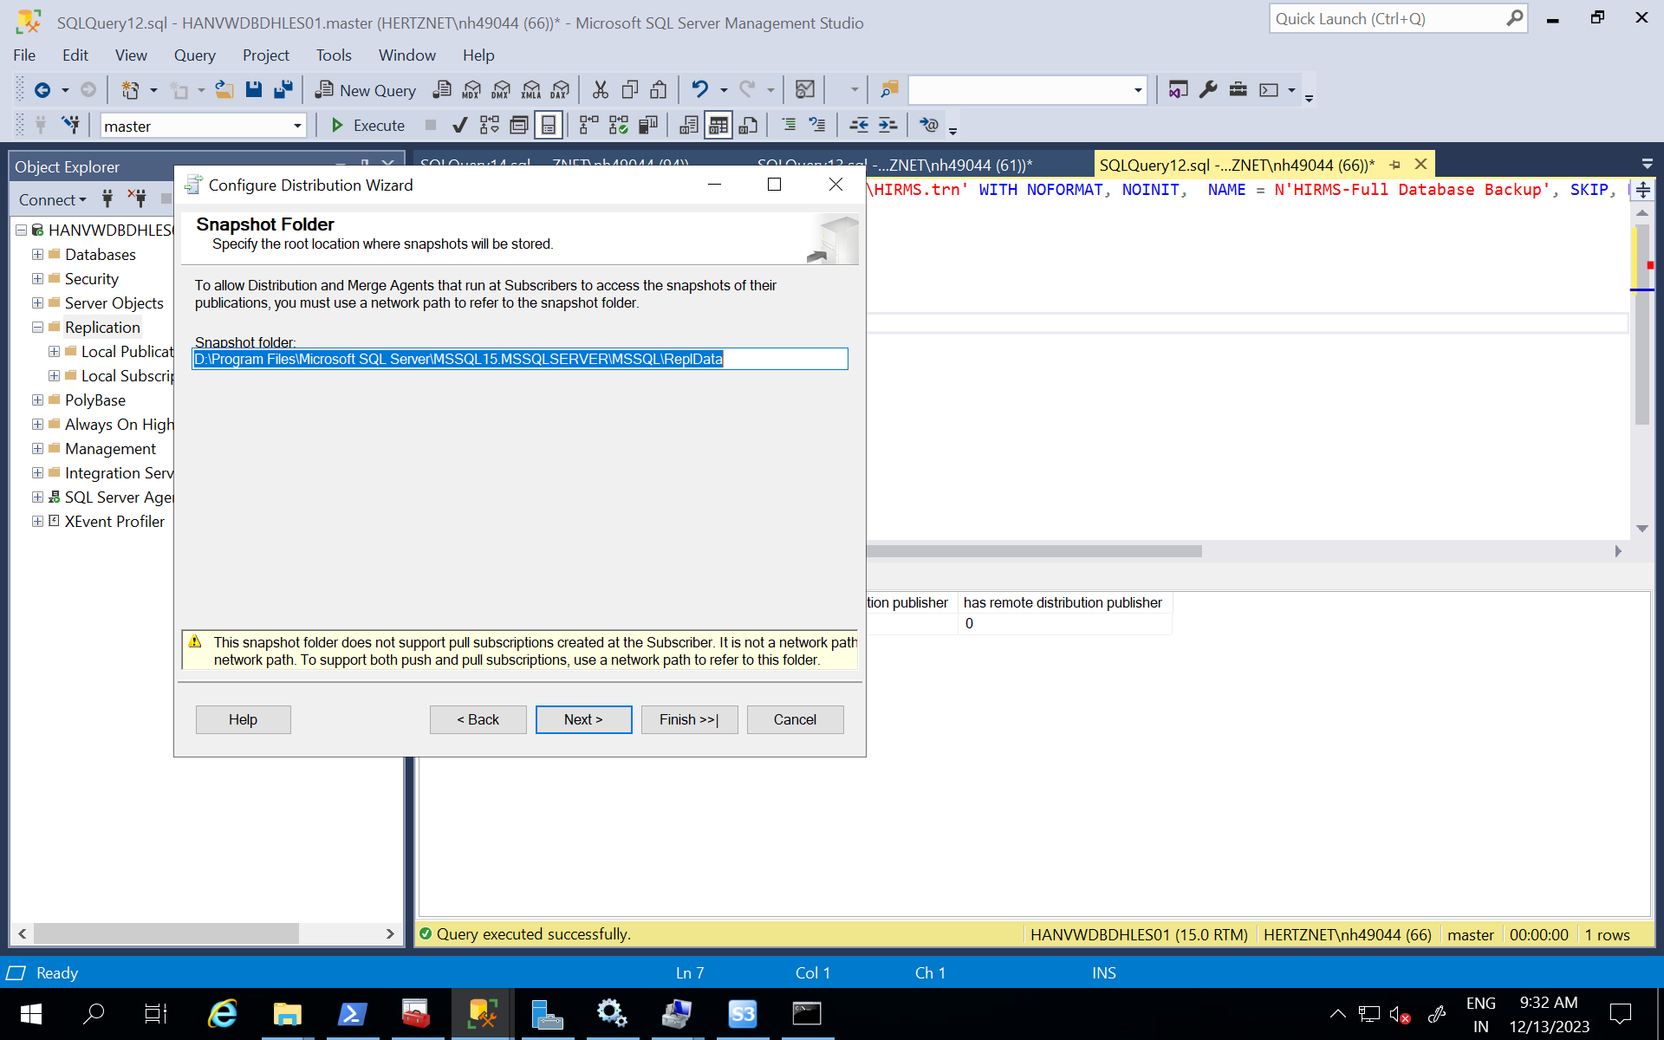

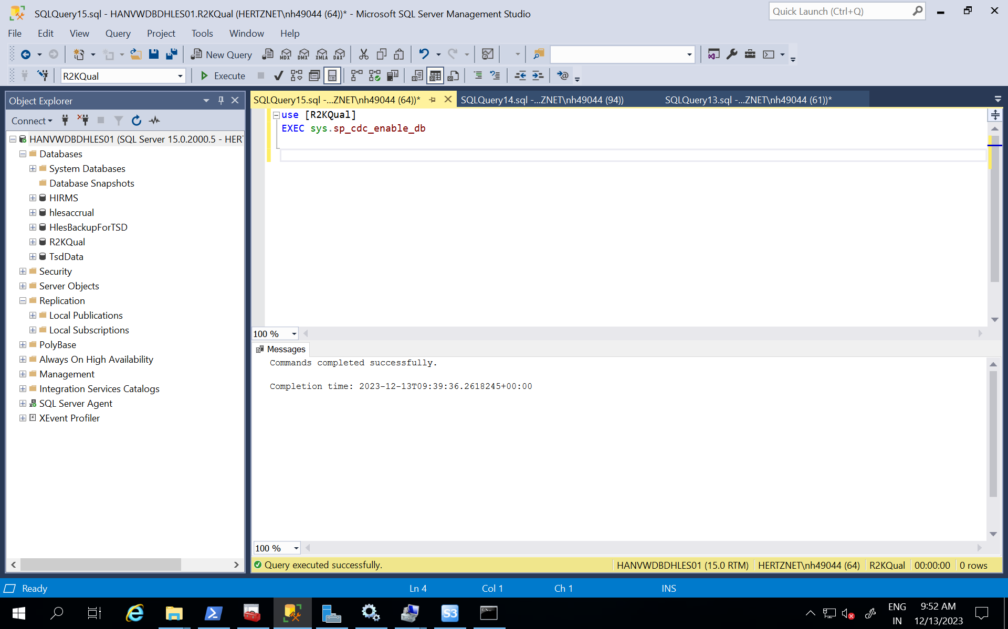

exec sys.sp_cdc_enable_table

@source_schema = N'DBO',

@source_name = N'BSGROUPMATRIX',

@role_name = NULL

GO

exec sys.sp_cdc_enable_table

@source_schema = N'DBO',

@source_name = N'BSMATRIX',

@role_name = NULL

GO

exec sys.sp_cdc_enable_table

@source_schema = N'DBO',

@source_name = N'CCO',

@role_name = NULL

GO

exec sys.sp_cdc_enable_table

@source_schema = N'DBO',

@source_name = N'CCOCREDIT',

@role_name = NULL

GO

exec sys.sp_cdc_enable_table

@source_schema = N'DBO',

@source_name = N'CCOMANDEF',

@role_name = NULL

GO

exec sys.sp_cdc_enable_table

@source_schema = N'DBO',

@source_name = N'CCOSURCHARGE',

@role_name = NULL

GO

exec sys.sp_cdc_enable_table

@source_schema = N'DBO',

@source_name = N'CCOTYPE',

@role_name = NULL

GO

exec sys.sp_cdc_enable_table

@source_schema = N'DBO',

@source_name = N'CEMP01',

@role_name = NULL

GO

exec sys.sp_cdc_enable_table

@source_schema = N'DBO',

@source_name = N'CFUEL',

@role_name = NULL

GO

exec sys.sp_cdc_enable_table

@source_schema = N'DBO',

@source_name = N'CLAIMOFFICE',

@role_name = NULL

GO

exec sys.sp_cdc_enable_table

@source_schema = N'DBO',

@source_name = N'CNAMES',

@role_name = NULL

GO

exec sys.sp_cdc_enable_table

@source_schema = N'DBO',

@source_name = N'CODES',

@role_name = NULL

GO

exec sys.sp_cdc_enable_table

@source_schema = N'DBO',

@source_name = N'CORPORATIONS',

@role_name = NULL

GO

exec sys.sp_cdc_enable_table

@source_schema = N'DBO',

@source_name = N'LOCBILLTO',

@role_name = NULL

GO

exec sys.sp_cdc_enable_table

@source_schema = N'DBO',

@source_name = N'LOCREFCO',

@role_name = NULL

GO

exec sys.sp_cdc_enable_table

@source_schema = N'DBO',

@source_name = N'LOCREPLOCS',

@role_name = NULL

GO

exec sys.sp_cdc_enable_table

@source_schema = N'DBO',

@source_name = N'PARTNERS',

@role_name = NULL

GO

exec sys.sp_cdc_enable_table

@source_schema = N'DBO',

@source_name = N'PROFILEEVENTS',

@role_name = NULL

GO

exec sys.sp_cdc_enable_table

@source_schema = N'DBO',

@source_name = N'SERVHIST',

@role_name = NULL

GO

exec sys.sp_cdc_enable_table

@source_schema = N'DBO',

@source_name = N'SETUP',

@role_name = NULL

GO

exec sys.sp_cdc_enable_table

@source_schema = N'DBO',

@source_name = N'SETUP_GDD',

@role_name = NULL

GO

exec sys.sp_cdc_enable_table

@source_schema = N'DBO',

@source_name = N'SYSTEM',

@role_name = NULL

GO

Make sure master and msdb permissions are set else you will get below error:

Check in master and ,msdb –user name dms user which is [IRHLES] on HANVWDBDHLES01.

[9:58 PM] Nelsen, Kyle

RetCode: SQL_ERROR  SqlState: 42000 NativeError: 229 Message: [Microsoft][ODBC Driver 17 for SQL Server][SQL Server]The SELECT permission was denied on the object 'fn_dblog', database 'mssqlsystemresource', schema 'sys'. Line: 1 Column: -1 [1022502]

[9:58 PM] Nelsen, Kyle

Access to TLOG is not permitted. For allowing CDC - grant user with sysadmin privileges.