**INDUSTRIAL TRAINING REPORT**

**Online Course on “Web Development”**

Submitted in partial fulfillment of the

Requirements for the award of

**Degree of Bachelor of Technology in Computer Science & Engineering**



­

Submitted By

**Name:** Sandeep Kumar Shukla

**University Roll No.:** 1729010140

**SUBMITTED TO:**

**Department of Computer Science & Engineering**

ABESIT GHAZIABAD

**DECLARATION**

I hereby declare that the Industrial Training Report entitled Web Development is an authentic record of my own work as requirements of Industrial Training / Online Training / Online Certification Course during the period from May, 2020 to August, 2020 for the award of degree of B.Tech. (Computer Science & Engineering) ABESIT, Ghaziabad.



**Sandeep Kumar Shukla**

**1729010140**

**Date: 14/09/2020**

**CERTIFICATE**

This is to certify that **Mr. Sandeep Kumar Shukla** has completed Online Course “**The Complete 2020 Web Development Bootcamp**” on June 8, 2020 from Udemy as a Partial Fulfillment of Degree of Bachelor of Technology in Computer Science & Engineering. He was trained in the field of Web development (MEAN Stack).

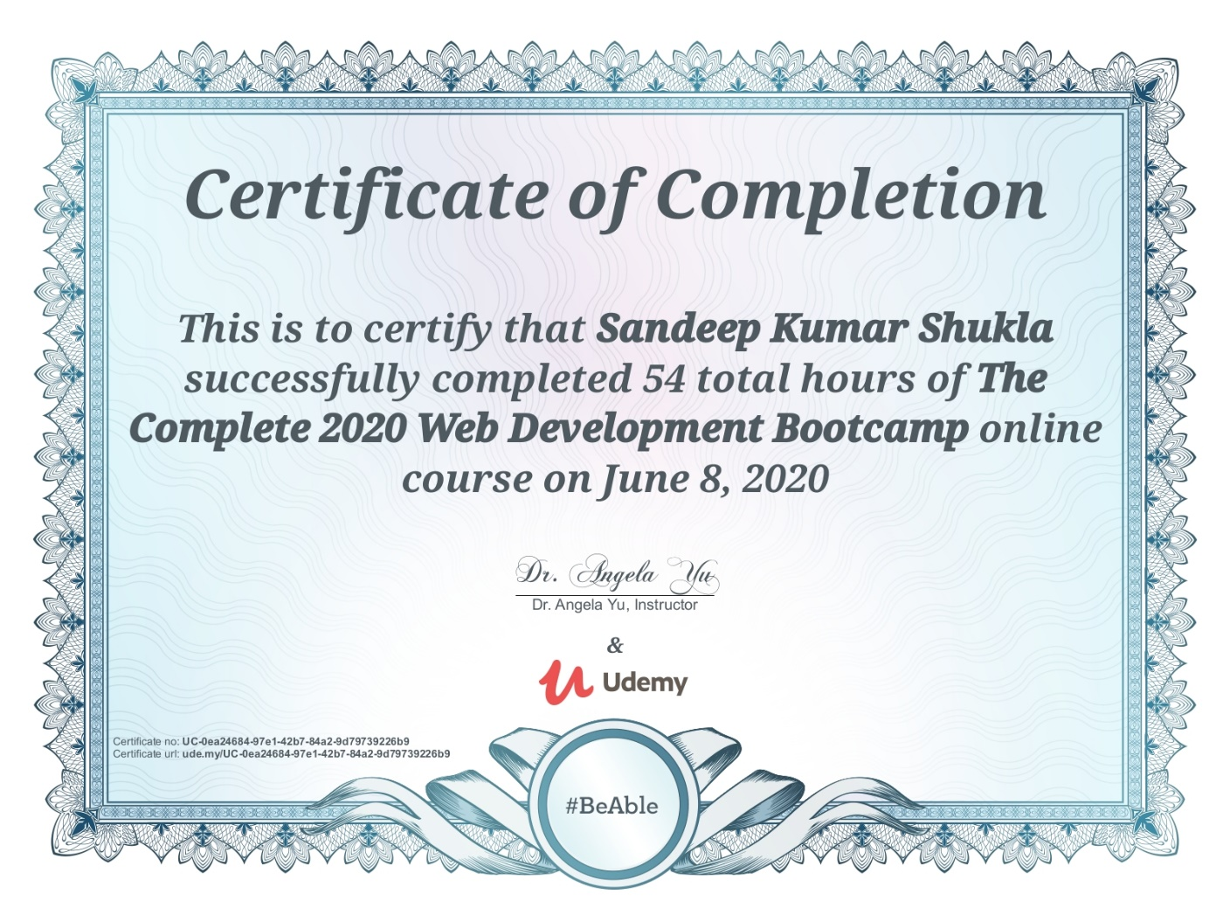

**ACKNOWLEDGEMENT**

I would like to express my heartfelt gratitude to **Udemy** for providing such a great online platform which help me gain immensely enriching my professional experience. The successful completion of my online course would not have been possible without the dedicated support from all family members. I would also like to thank my teachers for their love and support.

**Sandeep Kumar Shukla**

( i )

**About Company**

Udemy, Inc. is an American online learning platform aimed at professional adults and students. It was founded in May 2010 by Eren Bali, Gagan Biyani, and Oktay Caglar.

As of Jan 2020, the platform has more than 35 million students and 57,000 instructors teaching courses in over 65 languages. There have been over 400 million course enrollments. Students and instructors come from 180+ countries and 2/3 of the students are located outside of the U.S.

Students take courses largely as a means of improving job-related skills. Some courses generate credit toward technical certification. Udemy has made a special effort to attract corporate trainers seeking to create coursework for employees of their company. As of 2020, there are more than 130,000 courses on the website.

The headquarters of Udemy is located in San Francisco, CA with offices in Denver, CO; Dublin, IE; Ankara, TR; Sao Paulo, BR; and Gurgaon, IN.

( ii )

**Table of Contents**

|  |  |  |
| --- | --- | --- |
| **S.No.:** | **Chapters** | **Page No.** |
|  | Acknowledgement | i |
|  | About Company | ii |
|  | Table of Contents | iii |
|  | **Chapter – 1: Introduction** |  |
| 1.1 | Web Developing | 1 |
| 1.2 | Several Aspects Of Web Developing | 1 |
| 1.3 | Process | 2 |
|  | **Chapter – 2: Summary of the Course** |  |
| 2.1 | Front – end Development | 3 |
| 2.2 | Back – end Development | 5 |
| 2.3 | Databases | 6 |
| 2.4 | Deployment | 6 |
|  | **Chapter – 3: Tools & Technology Used** |  |
| 3.1 | Tools & Technology Used | 7 |
|  | **Chapter – 4: Snapshots** |  |
| 4.1 | My Personal Site | 8 |
| 4.1.1 | Results & Discussions | 8 |
| 4.2 | My CV | 9 |
| 4.2.1 | Results & Discussions | 9 |
| 4.3 | Dice Game | 10 |
| 4.3.1 | Results & Discussions | 10 |
| 4.4 | Register and Login using Database (MongoDB) | 11 |
| 4.4.1 | Results & Discussions | 11 |
|  | **Appendix** |  |
|  | References | i |
|  | Other Certificates | i-ii |

( iii )

**Chapter 1**

* 1. **Web Developing**

As technology advances internet is becoming ever popular. Website has become an essential part. Often website of an institution is used as major requirements to rate it. Website is a collection of related web pages, including multimedia content, typically identified with a common domain name, and published on at least one web server. A website may be accessible via a public Internet Protocol (IP) network, such as the Internet, or a private local area network (LAN), by referencing a uniform resource locator (URL) that identifies the site. Websites can have many functions and can be used in various fashions; a website can be a personal website, a commercial website for a company, a government website or a non-profit organization website. Websites are typically dedicated to a particular topic or purpose, ranging from entertainment and social networking to providing news and education. All publicly accessible websites collectively constitute the World Wide Web, while private websites, such as a company’s website for its employees, are typically a part of an intranet. Web development is a broad term for the work involved in developing a web site for the Internet (World Wide Web) or an intranet (a private network). Web development can range from developing the simplest static single page of plain text to the most complex web-based internet applications (or just ‘web apps’) electronic businesses, and social network services. A more comprehensive list of tasks to which web development commonly refers, may include web engineering, web design, web content development, client liaison, client-side/server-side scripting, web server and network security configuration, and e-commerce development. Among web professionals, “web development” usually refers to the main non-design aspects of building web sites: writing markup and coding..

* 1. **Several Aspects Of Web Developing**

Before developing a web site once should keep several aspects in mind like:

➢ What to put on the web site?

➢ Who will host it?

➢ How to make it interactive

➢ How to secure the source code frequently?

➢ Will the web site design display well in different browsers?

➢ Will the navigation menus be easy to use?

➢ Will the web site loads quickly?

➢ How easily will the site pages print?

**(1)**

* 1. **Process**

These are the steps considered while developing a webpage:



**(2)**

**Chapter 2**

1. **Summary of the Course**
   1. **Front – end Development**

* Web development fundamentals
  + Understand how websites work and how HTML, CSS and

JavaScript contribute.

* + Understand how the internet works.
  + Start coding with HTML, CSS, and JavaScript.
  + Learn and understand git, GitHub and version control.
  + Use the Unix command line to become a power user and

write bash commands.

* + Learn key troubleshooting and debugging skills to apply to

your projects.

* HTML 5
  + Learn the anatomy of HTML syntax to structure your

websites.

* + Understand the HTML boilerplate and HTML doctypes.
  + How to structure text in HTML.
  + How to structure HTML lists to create unordered and ordered

lists.

* + How to insert images using HTML
  + How to create hyperlinks using anchor tags.
  + Understand how to use HTML tables for content.
  + How to use tables for layout.
  + Learn HTML best practices.
  + Understand about HTML forms and create a simple contact

me form.

* + HTML Divs and how to separate content for CSS styling.
* CSS 3
  + Understand what are cascading style sheets and how you can

use it to style your website.

* + How to use CSS selectors and properties.
  + Learn about how to use inline, internal and external CSS.
  + Understand CSS coding best practices.
  + Learn about CSS sizing methods.
  + Learn the anatomy of CSS syntax and structure.
  + CSS specificity and implementing style hierarchy.
  + Class vs. Ids and how to target each.
  + CSS display and how to implement layout.
  + How to use CSS static, relative and absolute positioning

systems.

* + Font styling using CSS and web safe fonts.

**(3)**

* + Centering elements using CSS.
  + Website design fundamentals and typography.
  + How to use CSS float and clear.
  + How combine CSS selectors and understand selector priority.
* BOOTSTRAP 4
  + Learn the fundamentals of implementing responsive web

design.

* + How to use Balsamiq to mockup and wireframe websites.
  + The fundamentals of UI design for websites.
  + How to install the Bootstrap framework.
  + Understanding the Bootstrap grid layout system.
  + How to use bootstrap containers to layout your website

easily.

* + Learn to use other Bootstrap components such as buttons.
  + Adding symbols using Font Awesome.
  + Learn to use Bootstrap carousels.
  + Add Bootstrap cards to your website.
  + Using Bootstrap navigation bars.
* JAVASCRIPT ES6
  + The Fundamentals of Code
  + Starting code with alerts and prompts.
  + Understand Variables and Data Types in JavaScript
  + Variable naming in JS
  + Working with strings and numbers
  + Randomisation and logical operators
  + Loops, collections and Conditionals.
  + Functions and invocation patterns
  + Discussion of ECMAScripts
  + Intermediate JavaScript
  + Learn to use JS Expressions, Operators, Statements and

Declarations

* + Object-Oriented Programming
  + JS Objects and Prototypes
  + `This`, Scope and Closures
  + Objects and Prototypes
  + Refactoring and Debugging
* Document Object Model (DOM)
  + Learn the tree structure of HTML based websites.
  + Traverse through the document using object notation.
  + Separation of concerns and coding best practices.
  + Manipulate and change the HTML elements using your
  + understanding of the DOM.
* JQuery
  + Installing and using the jQuery framework.
  + Learning about jQuery functionality
  + Introduction to functions in jQuery
  + Manipulating text, styles and attributes with jQuery

**(4)**

* + Create animations and customisations with jQuery
  + Use your jQuery knowledge to make your website interactive
  + Responding to user initiated events with jQuery
* The UNIX Command Line
  + How to use basic bash commands in a Unix/Linux Terminal.
  + How to manipulate files and folders without needing a

graphical user interface.

* + How to download and install to your computer using

command line.

* Git Github and Version Control
  + Using git for version control and collaboration
  + Git forking, branching and cloning
  + Using GitHub as a remote repository
  + Checkout and rolling back changes with git
  + Using git and GitHub with Xcode
  1. **Back – end Development**
* Node.js
  + Explore the components of back-end development, working

with an MVC framework

* + Apply concepts like data types, objects, methods, object oriented

programming, and classes in the context of backend development.

* + Server-Side JavaScript
  + Using Node on the command line
  + NPM
  + JavaScript Build Processes
  + Event Loop and Emitters
  + File System Interaction
  + Modules
  + Native Node drivers
* Express.js
  + Understand how to install and use express in Node

applications

* + Creating Node and Express based servers
  + RESTful Routing with Express
  + Understand and use middleware for Node applications
* Application Program Interfaces (APIs)
  + Understand what APIs are and how they work.
  + HTTP in Depth
  + Calling APIs
  + Reading API documentation
  + Basic API Authentication
  + Server to server communication
  + JSON vs. XML, sending data over the wire.

**(5)**

* EJS
  + Understand what EJS does and how to use it with Node and

Express.

* + Templating with EJS
  + Running code in EJS templates
  + Passing data from server to template and vice versa
  + Creating layouts/partials with EJS
  1. **Databases**
* Database Fundamentals
  + Data Relationships
  + Designing a Data Model
  + Relational Databases
  + Alternative Databases
  + Entity Relationship Modelling (ERM) and Object Relational
  + Mapping (ORM)
* SQL Databases
  + Working with Database Schemas
  + Create-Read-Update-Destroy (CRUD)
  + Database Joins
  + Querying SQL databases
* NoSQL Database with MongoDB and Mongoose
  + Serialization
  + How to model NoSQL data
  + Document Databases (MongoDB)
  + Create-Read-Update-Destroy (CRUD)
  + NoSQL Best Practices
  + Mongo Shell and command line use
  + Installing MongoDB
  + Mapping relationships with MongoDB
  + Using an object-data modelling library (Mongoose) to work

easily with your data.

* 1. **Deployment**
* Deployment
  + Understand hosting and deployment.
  + Hosting static websites with GitHub Pages.
  + Deploying server based applications with Heroku.
  + Deploying Databases with Mongo Atlas.

**(6)**

**Chapter 3**

1. **Tools & Technology Used**
   1. **Tools & Technology Used**

* HTML 5
* CSS 3
* Bootstrap 4
* Javascript ES6
* DOM Manipulation
* jQuery
* Bash Command Line
* Git, GitHub and Version Control
* Backend Web Development
* Node.js
* NPM
* Express.js
* EJS
* REST
* APIs
* Databases
* SQL
* MongoDB
* Mongoose
* Authentication
* Firebase
* Web Design
* Deployment with GitHub Pages, Heroku and MongoDB Atlas

**(7)**

**Chapter 3**

1. **Snapshots**
   1. **My Personal Site**

**Click here(👉)** [**https://sandeepini.live/**](https://sandeepini.live/)

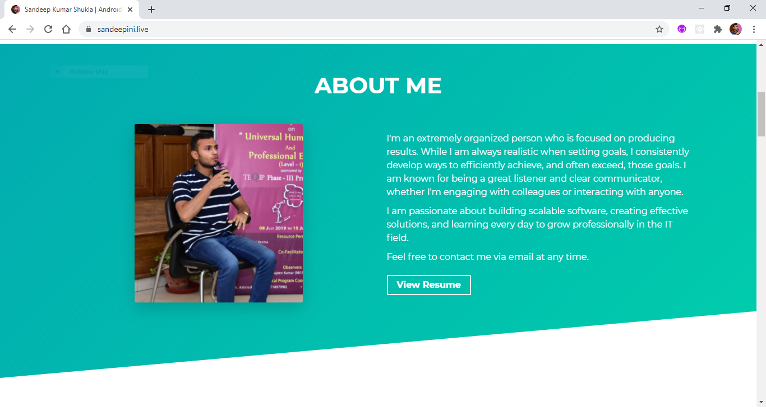

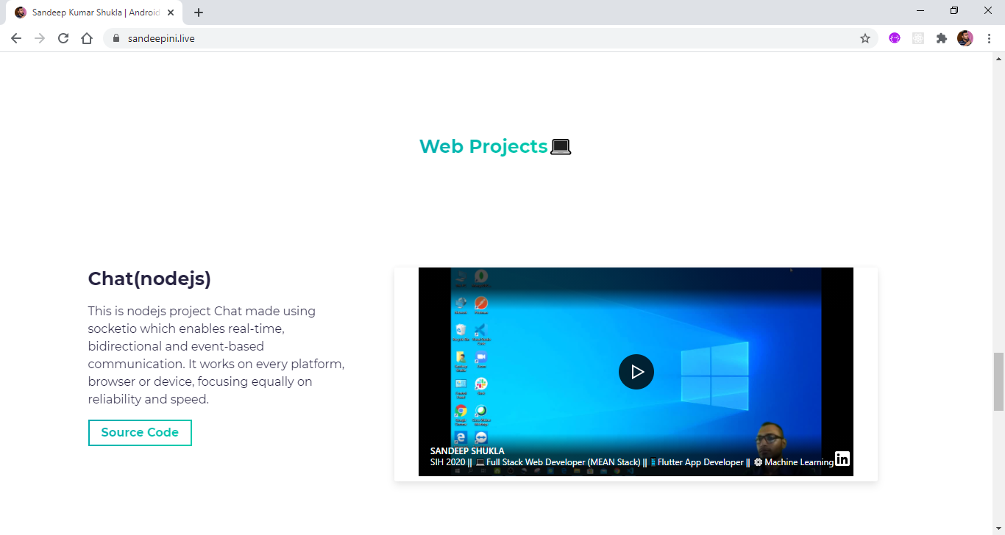

* + 1. **Results & Discussions**
* Deployed on netlify
* Uses domain of name.com

**(8)**

* 1. **My CV**

**Click Here (👉)** [**https://sandeepinigithub.github.io/cv2/**](https://sandeepinigithub.github.io/cv2/)

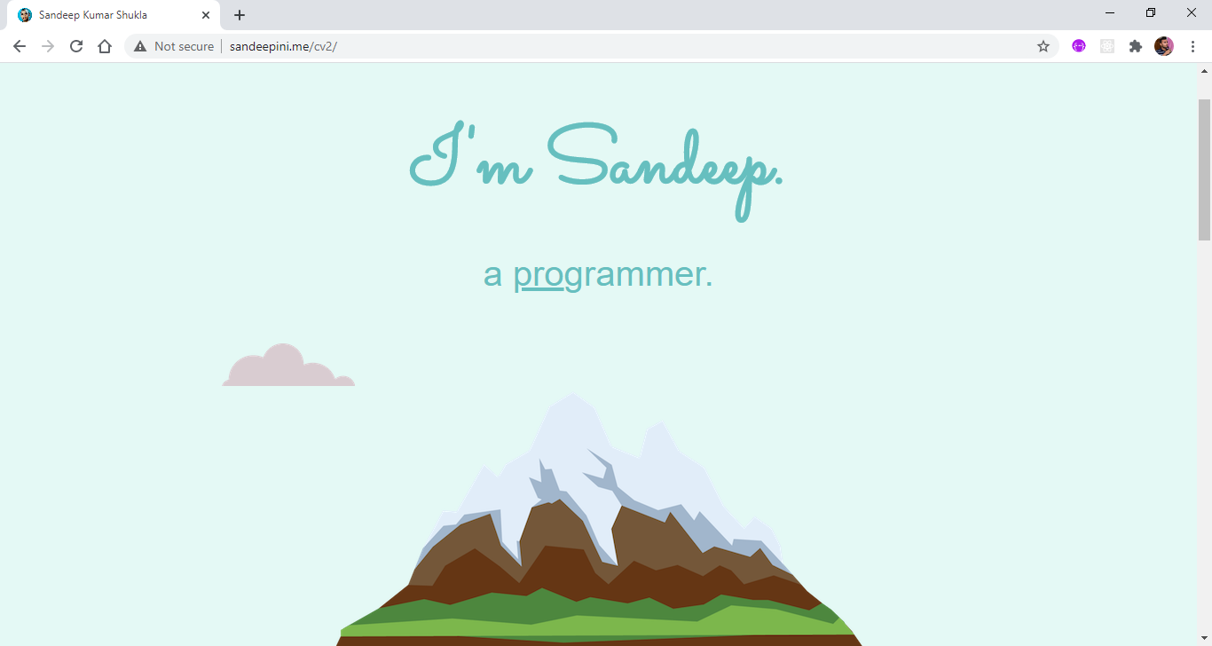

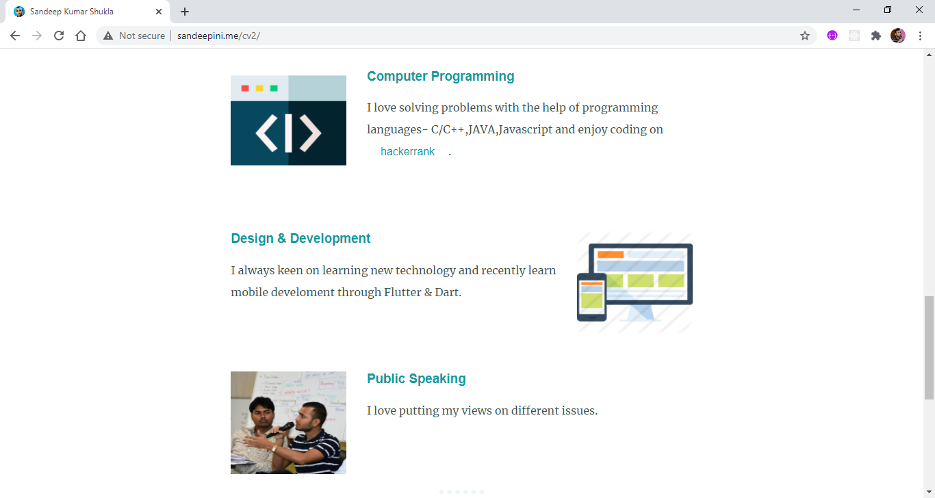

* + 1. **Results & Discussions**
* Deployed on Github
* Uses basic of Html and CSS
* While deploying this project learn a lot about github and git version

**(9)**

* 1. **Dice Game**

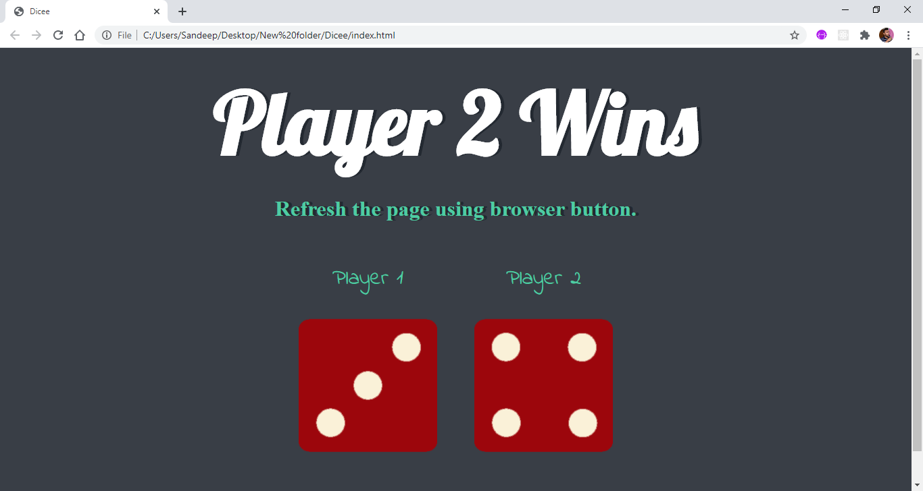

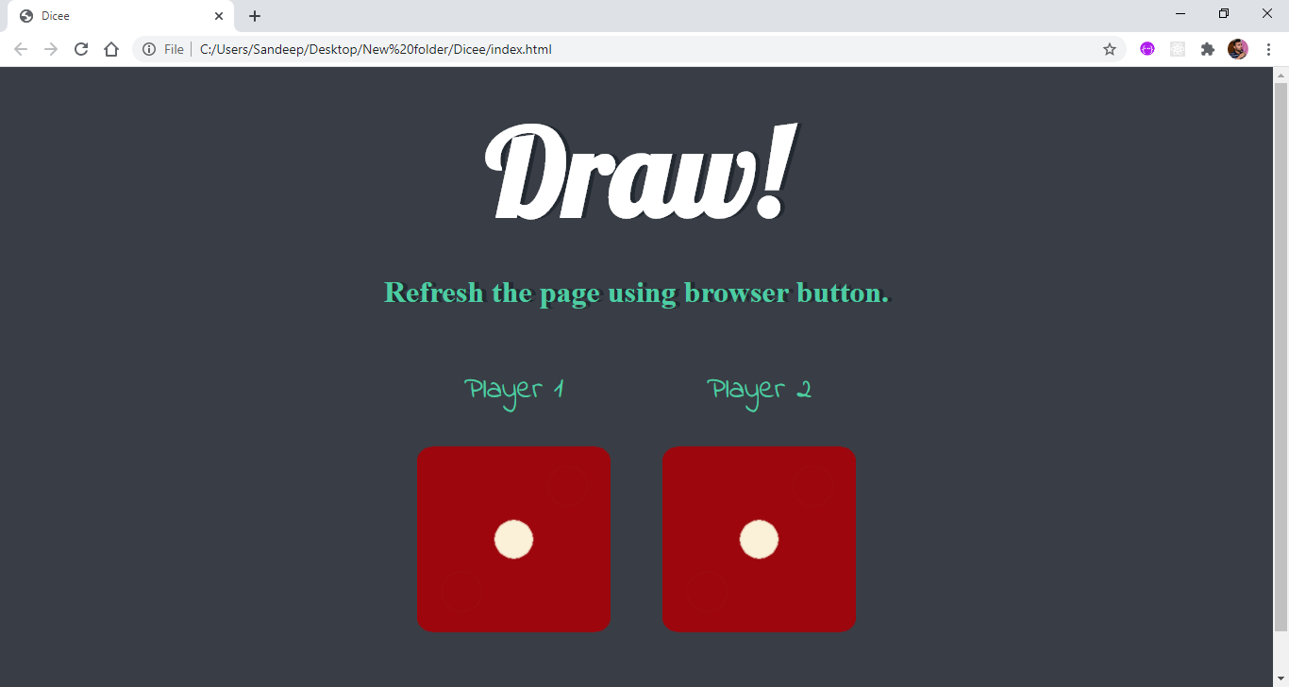

* + 1. **Results & Discussions**
* Learn about random number concept

**(10)**

* 1. **Register and Login using Database (MongoDB)**

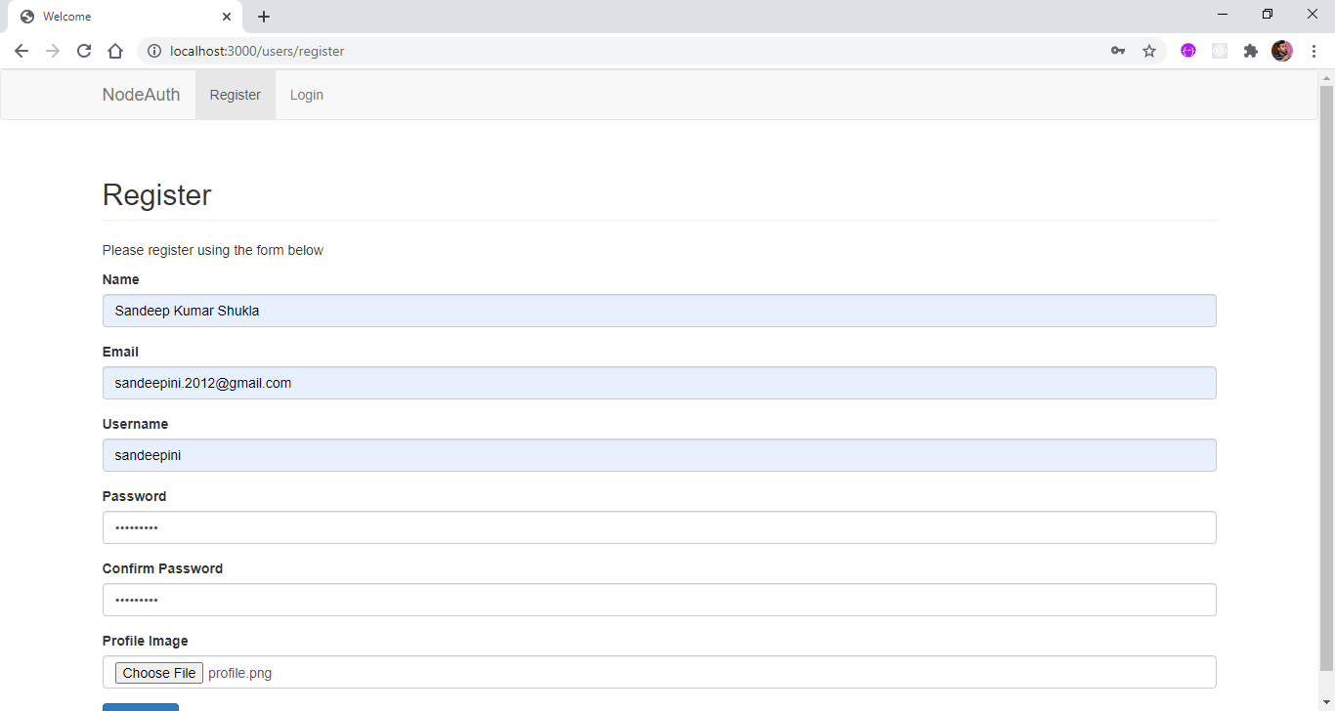

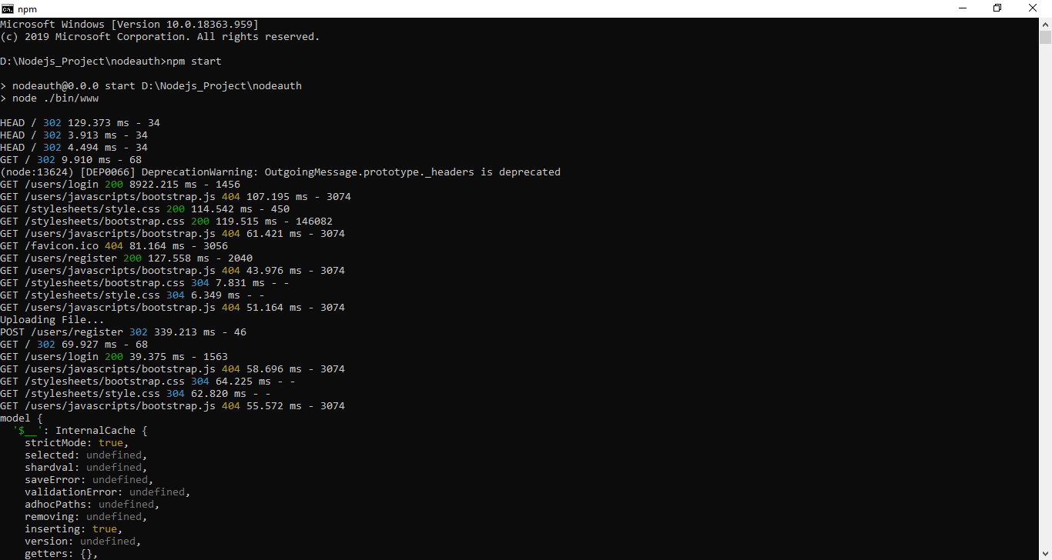

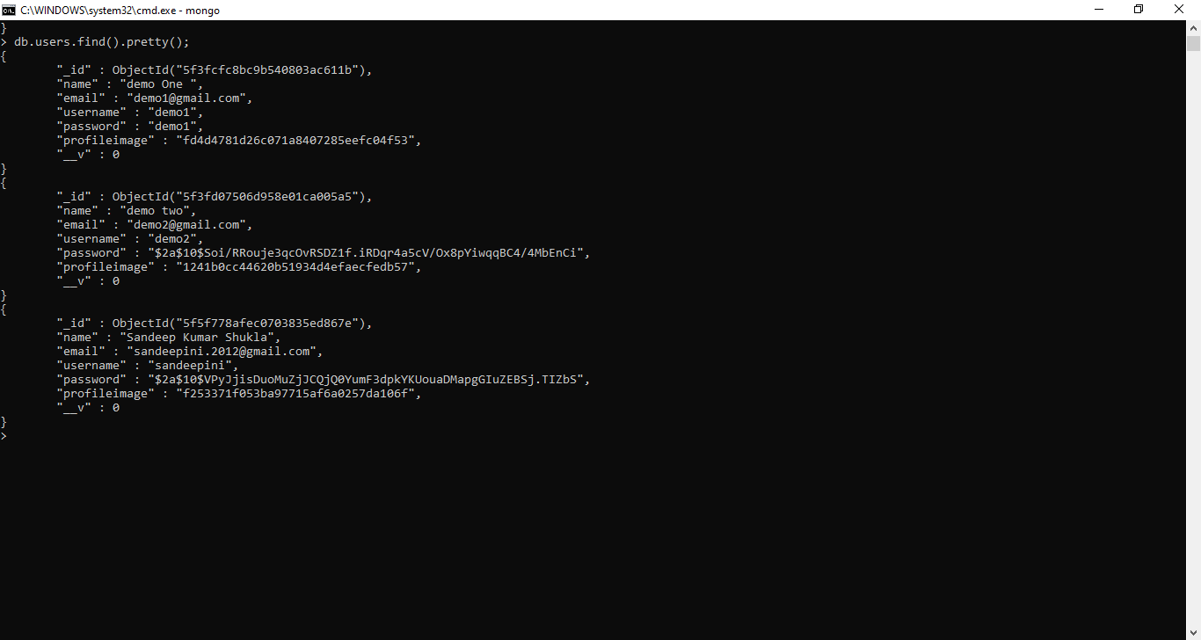

* + 1. **Results & Discussions**
* Learn how to authenticate using databases

**(11)**

**References**

[**https://www.udemy.com/course/the-complete-web-development-bootcamp/**](https://www.udemy.com/course/the-complete-web-development-bootcamp/)

[**https://www.w3schools.com/**](https://www.w3schools.com/)

[**https://developer.mozilla.org/en-US/**](https://developer.mozilla.org/en-US/)

[**https://getmdl.io/templates/index.html**](https://getmdl.io/templates/index.html)

[**https://codepen.io/**](https://codepen.io/)

[**https://uicookies.com/**](https://uicookies.com/)

[**https://www.materialpalette.com/**](https://www.materialpalette.com/)

[**https://loremipsum.io/**](https://loremipsum.io/)

[**https://dribbble.com/**](https://dribbble.com/)

[**https://www.worldweatheronline.com/developer/api/default.aspx**](https://www.worldweatheronline.com/developer/api/default.aspx)

[**https://icons8.com/**](https://icons8.com/)

[**https://fontawesome.com/**](https://fontawesome.com/)

[**https://emojipedia.org/**](https://emojipedia.org/)

[**https://pixabay.com/**](https://pixabay.com/)

[**https://www.wikipedia.org/**](https://www.wikipedia.org/)

**Other Certificates**

* **Introduction to Big Data**

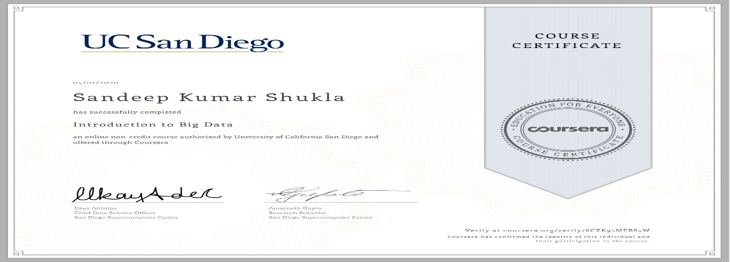

* **Flutter Development**



**(i)**

* **Machine Learning**

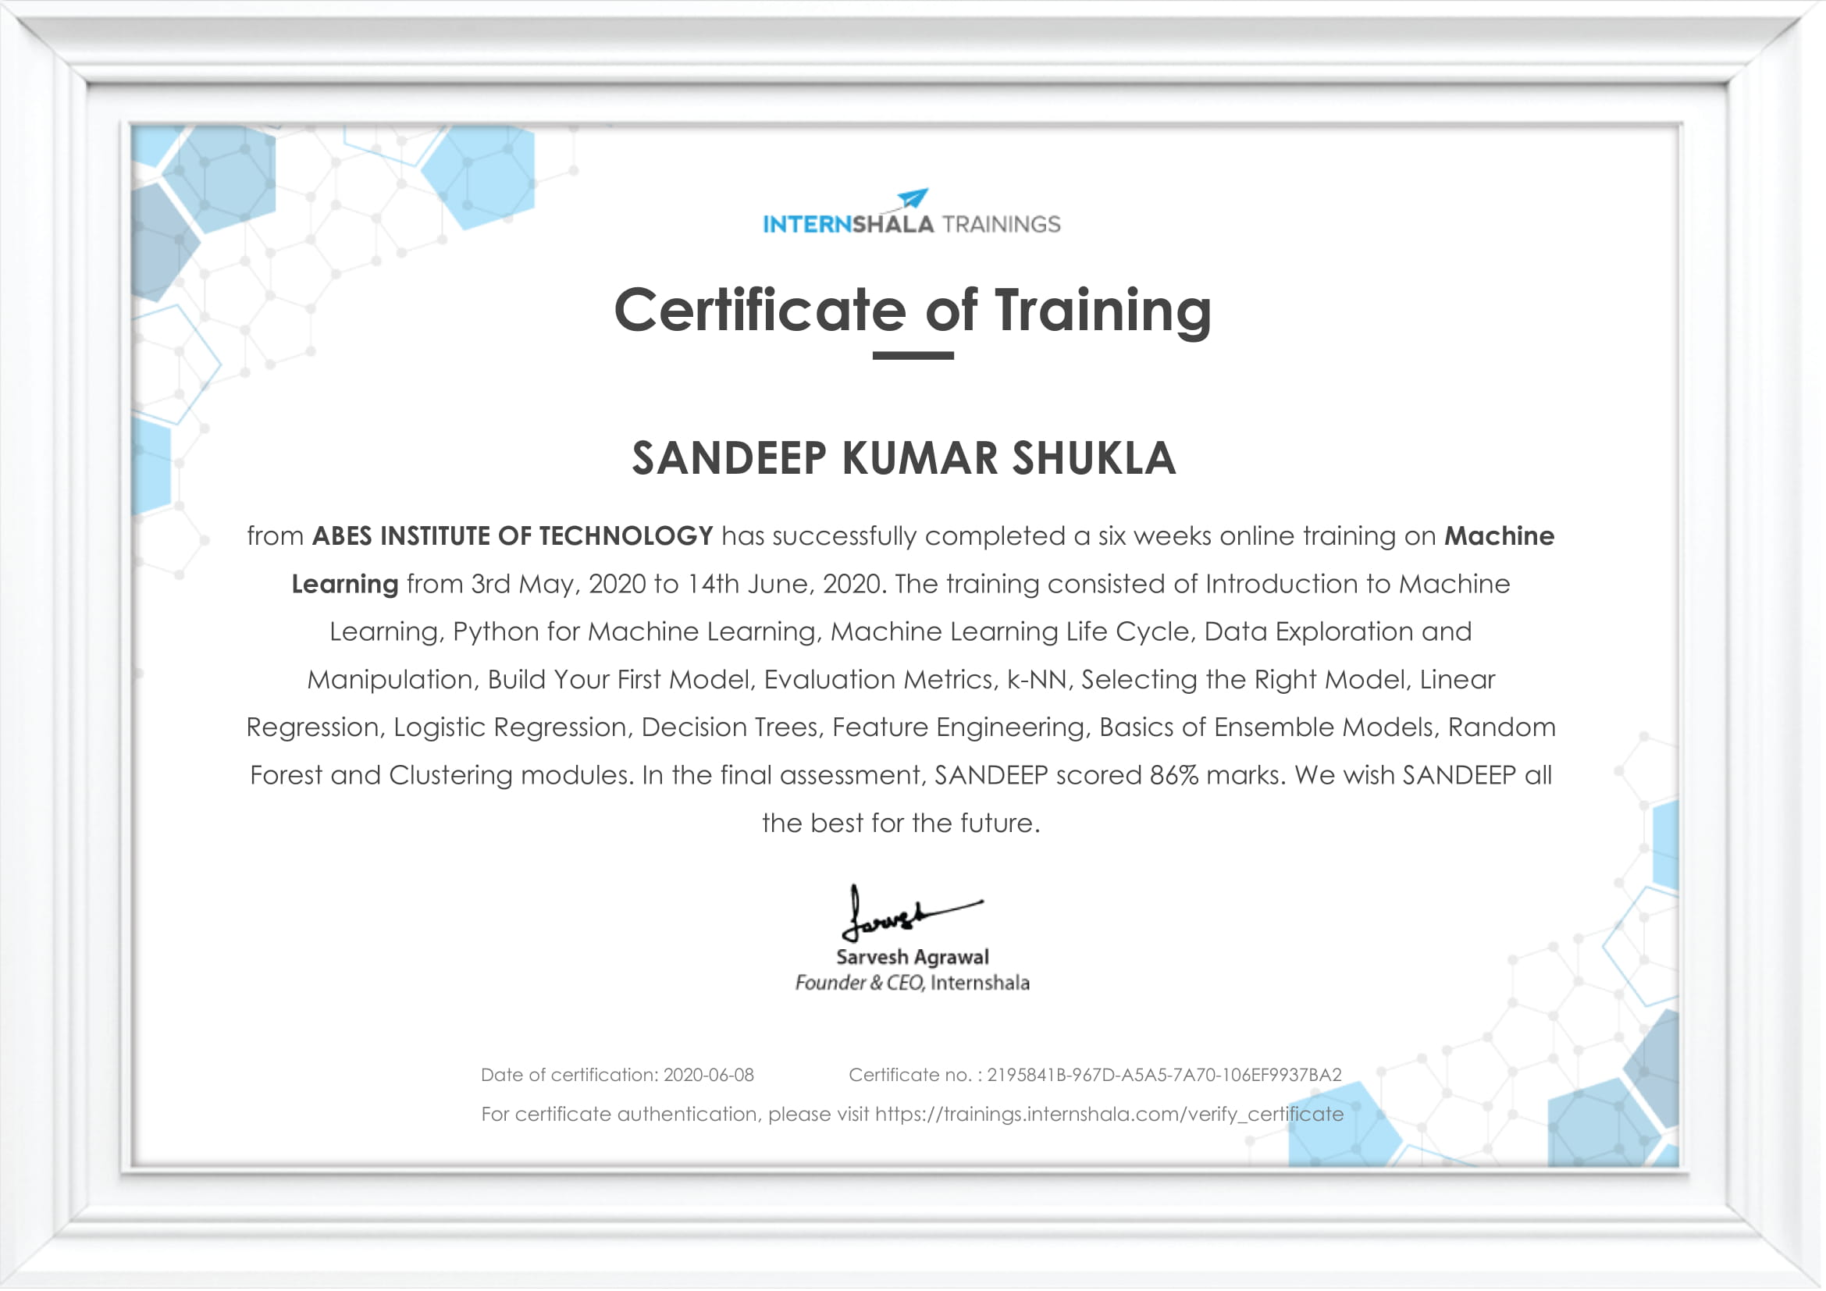

(ii)