

**ABESIT**

**COLLEGE CODE – 290**

# Lab File

|  |  |
| --- | --- |
| **NAME** | SANDEEP KUMAR SHUKLA |
| **BRANCH** | CSE |
| **UNIVERSITY ROLL NO.** | 1729010140 |
| **SESSION** | 2019-20 |
| **NAME OF LAB** | Web Technology Lab (RCS 554) |

**Aim :-** *Write a program to use basic tags, links, list, tables, images, videos and also implement frameset.*

**Code :-**

**HTML CODE**

<html>

<head>

<title>Basic HTML Tags</title>

</head>

<body>

<h1 style="text-align:center;">Basic HTML Tags</h1> <hr>

List of Subjects:-

<ol>

<li>English</li>

<li>Hindi</li>

<li>Maths</li>

</ol> <hr>

<img src="book.jpg" height="50px" width="70px"> <hr>

<table border="1.0" >

<tr>

<th colspan="2">List of Subjects</th>

</tr>

<tr>

<td>1.</td>

<td>English</td>

</tr>

<tr>

<td>2.</td>

<td>Hindi</td>

</tr>

</table><hr>

<h5>Simple Video</h5>

<video autoplay width="150px" height="80px" controls>

<source src="video1.mp4" type="video/mp4">

</video> <hr>

<a href="#">Click Here to move to next page</a> <hr>

</body>

</html>

**Output :-**

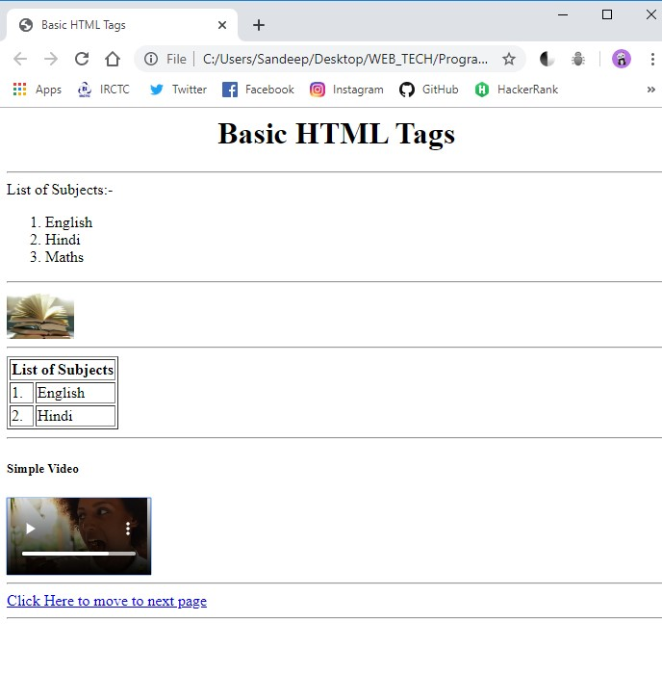

**Aim :-** *Apply CSS to change a certain portion, Bold, Italic, and Underline certain words in your HTML web pages.*

**Code :-**

**HTML CODE**

<!DOCTYPE html>

<html lang="en" dir="ltr">

<head>

<meta charset="utf-8">

<title>Apply CSS</title>

</head>

<body>

<div style="height:50px;width:98%;background-color:#dedef0;">

<h1 style="text-align:center; text-decoration:underline;font-family:cursive;">Applying CSS to change Certain Portion</h1>

</div> <br><br>

<hr width="40%">

<div style="height:300px;width:98%;background-color:#f8f8f8;">

<span style="font-weight:bold;">Name :</span> Sandeep Kumar Shukla <br>

<span style="font-weight:bold;">RollNo. :</span>1729010140 <br>

<span style="font-weight:bold;">College :</span> ABES Institute of Technology <br>

<div style="text-align:center;background-color:#eef5b2">

<h2>Welcome in the world of <span style="text-decoration:underline;font-family:cursive;">Web Tech</span></h2>

</div>

</div>

<hr width="40%">

</body>

</html>

**Output :-**

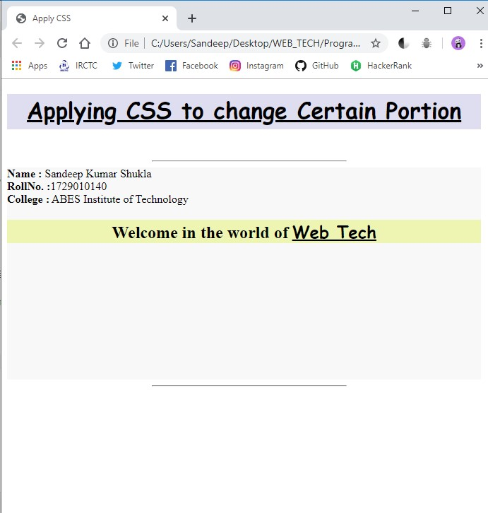

**Aim :-***Write a program using HTML and CSS to create a menu.*

**Code :-**

**HTML CODE**

<!DOCTYPE html>

<html lang="en" dir="ltr">

<head>

<meta charset="utf-8">

<title>Menu</title>

<style media="screen">

.navbar {

overflow: hidden;

background-color: #110133;

position: fixed;

top: 0;

width: 100%;

}

.navbar a {

float: left;

display: block;

color: #f2f2f2;

text-align: center;

padding: 14px 16px;

text-decoration: none;

}

</style>

</head>

<body>

<div class="navbar">

<a href="#home">Home</a>

<a href="#news">News</a>

<a href="#news">Features</a>

<a href="#news">Pages</a>

<a href="#news">Download</a>

<a href="#contact">Contact</a>

</div>

<div style="margin-top: 100px;margin-left:20%">

<h1>This is menu using HTML and CSS.</h1>

</div>

</body>

</html>

**Output :-**

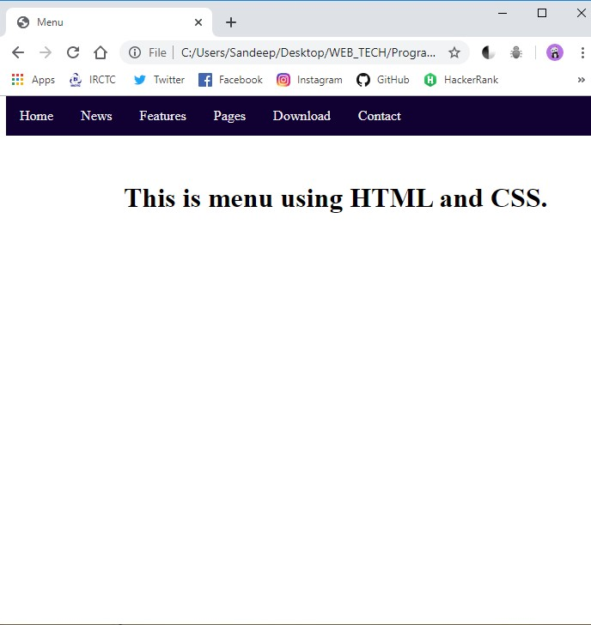

**Aim :-** *Wrirte a program to invoke External CSS in HTML.*

**Code :-**

**HTML CODE**

<!DOCTYPE html>

<html lang="en" dir="ltr">

<head>

<meta charset="utf-8">

<title>External CSS</title>

<link rel="stylesheet" href="Styles.css">

</head>

<body>

<div class="heading">

<h1>Khao Piyo Restaurants</h1>

</div>

<div class="div_style">

<h3>Address:</h3>

<p>Sandeep Kumar Shukla</p>

<p>ABES Chipiyana Road,Jaat Chowk,Mahaveer Market,Ghaziabad(U.P.)</p>

<p>9559123391</p>

</div>

</body>

</html>

**CSS CODE**

h1{

text-align: center;

font-size: 64px;

}

.heading{

border: 2px solid black;

border-radius: 5px;

background-color: #beebe9;

}

.div_style{

border: 2px solid black;

border-radius: 5px;

height: 300px;

width: auto;

}

**Output :-**

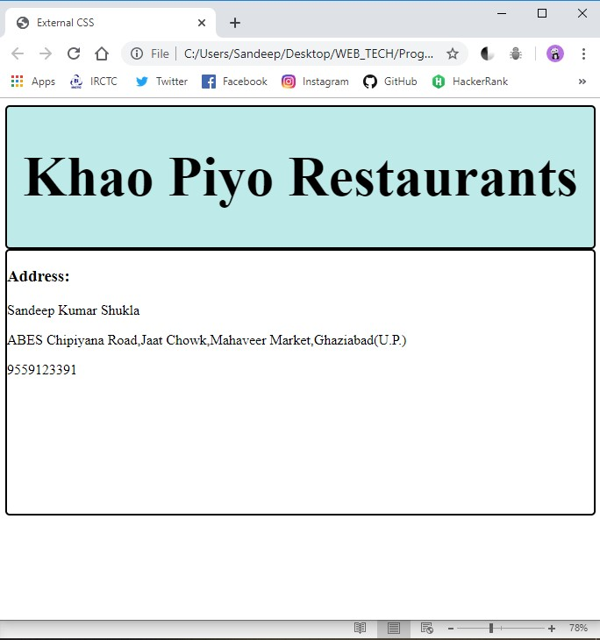

**Aim :-** *Wrirte a program to invoke Internal CSS in HTML.*

**Code :-**

**HTML CODE**

<!DOCTYPE html>

<html lang="en" dir="ltr">

<head>

<meta charset="utf-8">

<title>Internal CSS</title>

<link href="https://fonts.googleapis.com/css?family=Lobster&display=swap" rel="stylesheet">

<style media="screen">

h1 {

text-align: center;

font-size: 64px;

font-family: 'Lobster';

}

.heading {

border: 2px solid black;

border-radius: 5px;

background-color: #beebe9;

}

.div_style {

border: 2px solid black;

border-radius: 5px;

height: 200px;

width: auto;

}

p {

font-family: 'Lobster';

}

.p_style {

text-align: center;

font-size: 25px

}

</style>

</head>

<body>

<div class="heading">

<h1>CIS Residency</h1>

</div>

<div class="div_style">

<p class="p_style">Affordable Boys Hostel</p>

<p class="p_style">A home with differnce</p>

</div>

<div class="div_style">

<h3>Address:</h3>

<p>Sandeep Kumar Shukla</p>

<p>ABES Chipiyana Road,Jaat Chowk,Mahaveer Market,Ghaziabad(U.P.)</p>

<p>9559123391</p>

</div>

</body>

</html>

**Output :-**

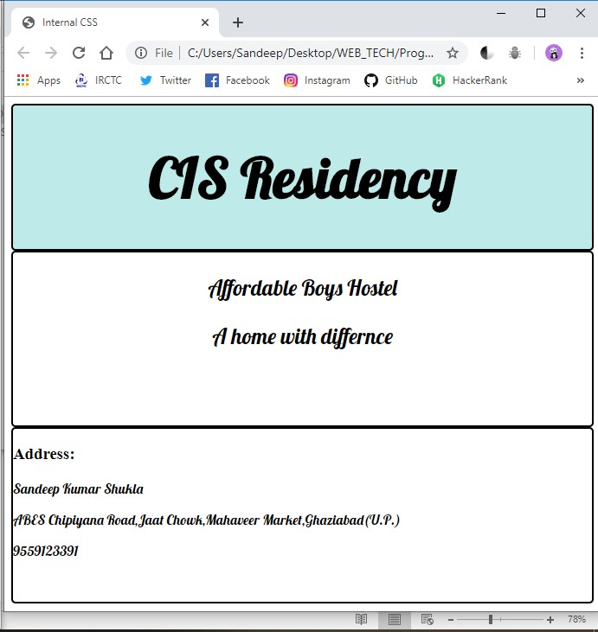

**Aim :-** *Create one HTML using CSS which repeat background image.*

**Code :-**

**HTML CODE**

<!DOCTYPE html>

<html lang="en" dir="ltr">

<head>

<meta charset="utf-8">

<title></title>

<style media="screen">

h1 {

text-decoration: underline;

text-align: center;

color: black;

}

h2,

h3 {

color: color;

}

.heading_style {

height: 90px;

width: 98%;

background-color: white;

}

img {

height: 100px;

width: 100px;

padding: 20px;

}

body {

background-image: url("https://images.pexels.com/photos/1227520/pexels-photo-1227520.jpeg?auto=compress&cs=tinysrgb&dpr=1&w=500");

background-repeat: repeat;

background-size: 100px 150px;

}

div {

padding: 10px;

}

</style>

</head>

<body>

<div class="heading_style">

<h1>Web Tech LAB</h1>

</div><br><br>

<div class="heading_style">

<h2>Task:</h2>

<h3>Create a HTML page using CSS which uses repeated Background</h3>

</div>

</body>

</html>

**Output :-**

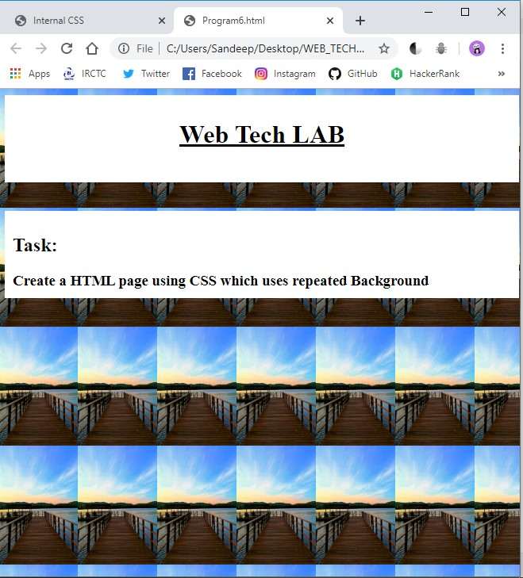

**Aim :-** *Write HTML to Display your CV.*

**Code :-**

**HTML CODE**

<!DOCTYPE html>

<html lang="en" dir="ltr">

<head>

<meta charset="utf-8">

<title>Sandeep's Personal Site</title>

</head>

<body>

<table cellspacing="20">

<tr>

<td><img src="./images/sandeep profile picture.png" alt="Sandeep Profile Picture" height="150" width="150"></td>

<td><h1>Sandeep Kumar Shukla</h1>

<p><em>I'm an extremely organized person who is focused on producing results.</em></p>

<p>I am an Android, iOS and Web Developer. I Love playing Volleyball.</p></td>

</tr>

</table> <hr>

<h3>Education</h3>

<ul>

<li><em><strong>ABES Institute of Technology </strong></em>(Bachelor of Technology: Computer Science And Engineering) - Ghaziabad(U.P)</li>

<li><em><strong>Sunbeam School Varuna </strong></em>(Class 12)- Varanasi(U.P.)</li>

<li><em><strong>Sunbeam School Varuna </strong></em>(Class 10)- Varanasi(U.P.)</li>

</ul>

<hr>

<h3>Skills</h3>

<table cellspacing="10">

<tr>

<td>C/C++ Programming</td>

<td>⭐⭐⭐⭐</td>

</tr>

<tr>

<td>Java Programming</td>

<td>⭐⭐⭐⭐</td>

</tr>

<tr>

<td>HTML,CSS,Javascript</td>

<td>⭐⭐⭐</td>

</tr>

</table>

<hr>

<a href="hobbies.html">My Hobbies</a>

<a href="contact-me.html">Contact</a>

</body>

</html>

**Output :-**

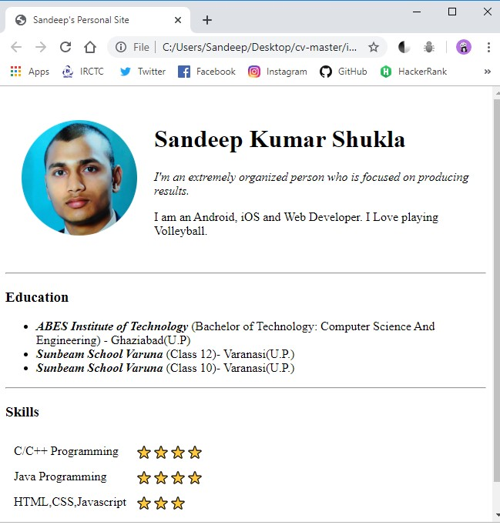

**Aim :-** *Write a program to print date using Javascript.*

**Code :-**

**HTML CODE**

<!DOCTYPE html>

<html lang="en" dir="ltr">

<head>

<meta charset="utf-8">

<title>Current Date</title>

</head>

<body>

<h1>The Current Date is:-</h1>

<script type="text/javascript">

var now = new Date();

document.write( now.getDate()+ "/" +(now.getMonth() + 1) + "/" + now.getFullYear());

</script>

</body>

</html>

**Output :-**

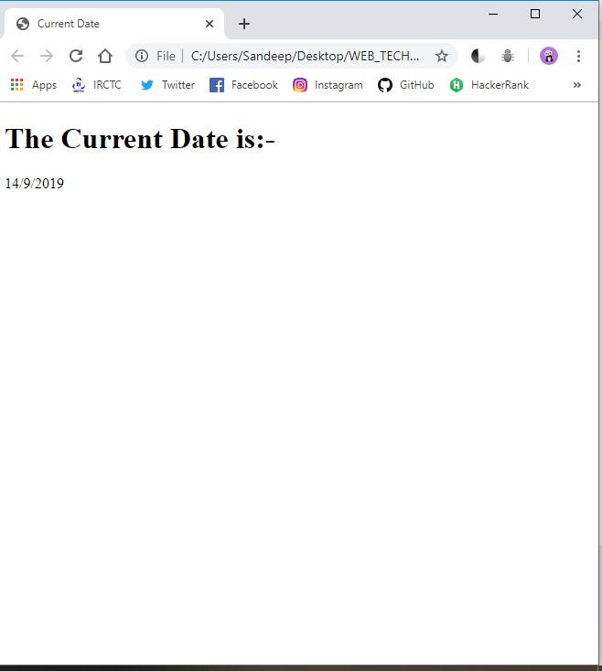

**Aim :-** *Write a program to sum and multiply two numbers using Javascript.*

**Code :-**

**HTML CODE**

<!DOCTYPE html>

<html lang="en" dir="ltr">

<head>

<meta charset="utf-8">

<title>Sum and Multiply</title>

</head>

<body>

<script>

function add() {

var num1 = document.form.text1.value;

var num2 = document.form.text2.value;

var sum = Number(num1) + Number(num2);

alert("Sum of two numbers is: " + sum);

}

function product() {

var num1 = document.form.text1.value;

var num2 = document.form.text2.value;

var sum = Number(num1) * Number(num2);

alert("Product is: " + sum);

}

</script>

<form name="form">

<table>

<tr>

<td>Enter First Number:</td>

<td><input type="text" name="text1"></td>

</tr>

<tr>

<td>Enter Second Number:</td>

<td><input type="text" name="text2"></td>

</tr>

<tr>

<td><input type="button" value="Add" onclick="add();"></td>

<td><input type="button" value="Product" onclick="product();"></td>

</tr>

</table>

</body>

</html>

**Output :-**

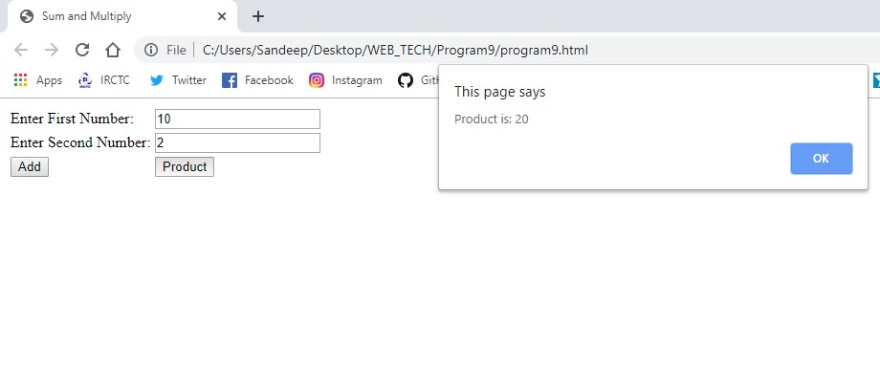

**Aim :-** *Write a program to show use of alert, confirm, prompt box.*

**Code :-**

**HTML CODE**

<!DOCTYPE html>

<html lang="en" dir="ltr">

<head>

<meta charset="utf-8">

<title></title>

</head>

<body>

<script type="text/javascript">

mess1 = 'Do you want to continue.';

x = confirm(mess1);

if (x == true) {

visiter_name = prompt("Input your name : ");

if (visiter_name != null && visiter_name != "")

alert("Your Name is : " + visiter_name);

else

alert("Blank name ...!");

} else {

alert("You have clicked on Cancel Button.");

}

</script>

</body>

</html>

**Output :-**

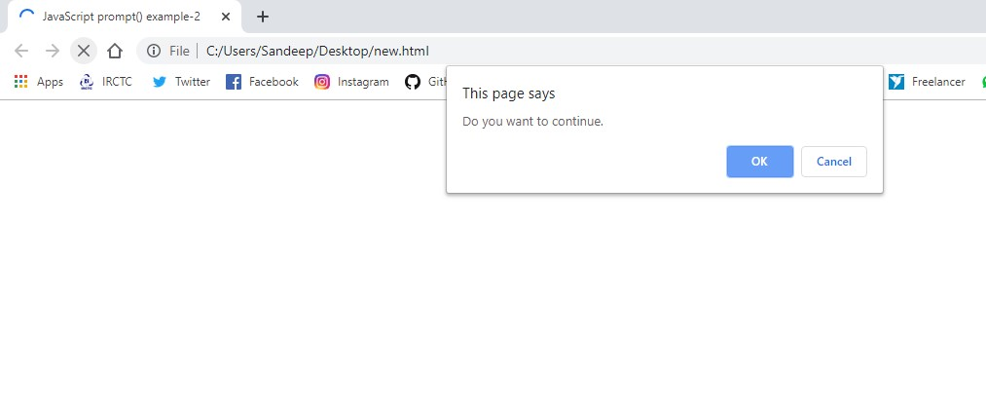

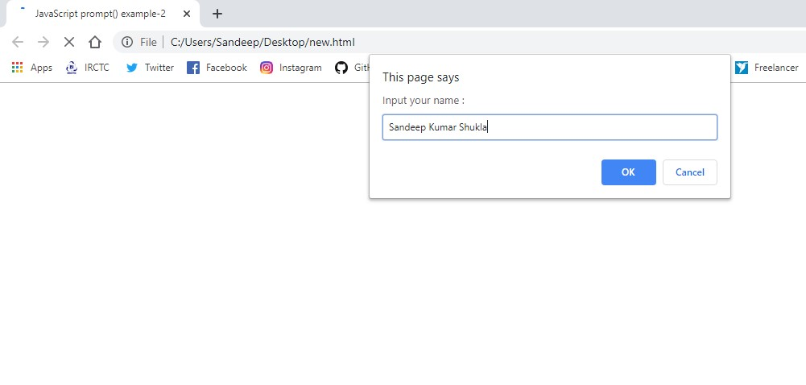

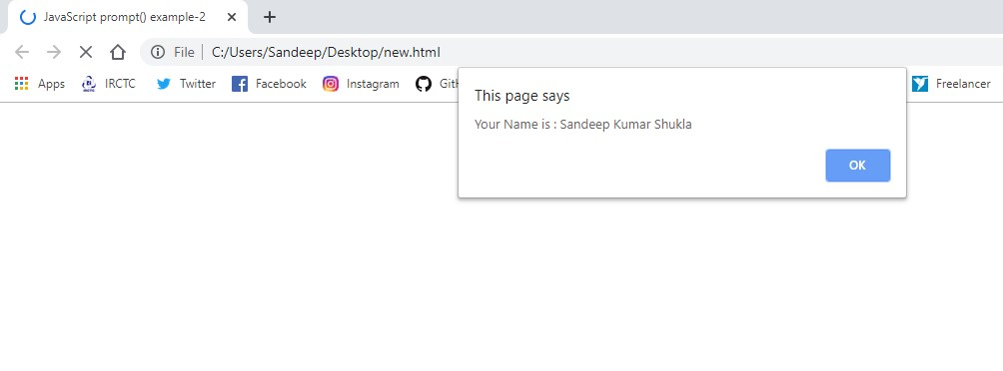

**Aim :-** *Write a program to add two numbers using “Prompt Box” in JavaScript.*

**Code :-**

**HTML CODE**

<!DOCTYPE html>

<html lang="en" dir="ltr">

<head>

<meta charset="utf-8">

<title>ADDITION</title>

</head>

<body>

<SCRIPT LANGUAGE="JavaScript">

var first_number = parseFloat(prompt("Enter the first number", ""));

var second_number = parseFloat(prompt("Enter the second number", ""));

var answer = first_number + second_number;

document.write("The answer is " + answer);

</SCRIPT>

</body>

</html>

**Output :-**

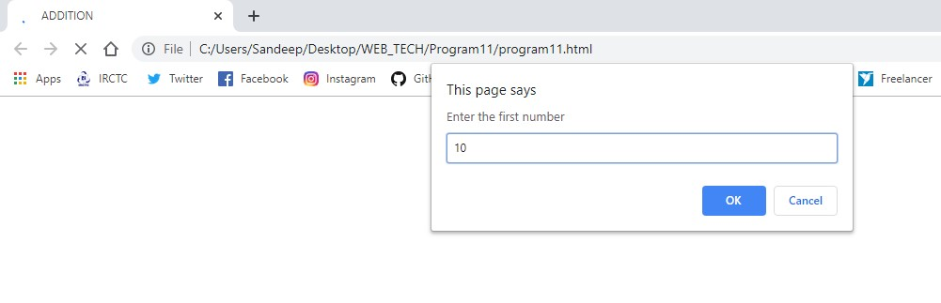

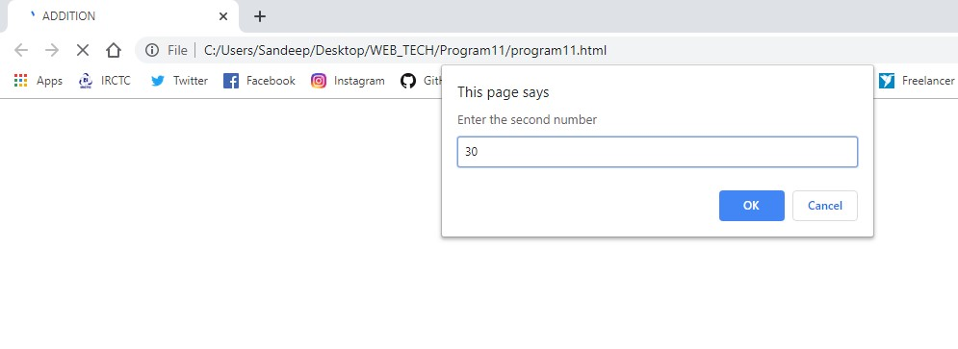

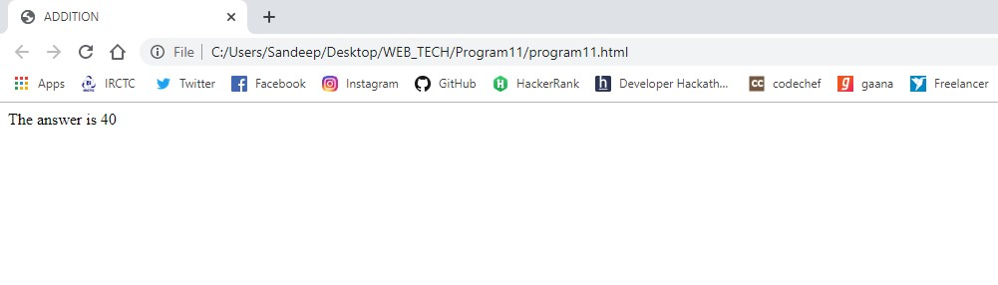

**Aim :-**  *Create a registration form and put validation check on values entered by the users using JavaScript. Also stop user submittimg blank form.*

**Code :-**

**HTML CODE**

<!DOCTYPE html>

<html lang="en" dir="ltr">

<head>

<meta charset="utf-8">

<title>Form Validation</title>

<link rel="stylesheet" href="Styles.css">

<script src="sample.js"></script>

</head>

<body onload="document.registration.userid.focus();">

<h1>Registration Form</h1>

Use tab keys to move from one input field to the next.

<form name='registration' onSubmit="return formValidation();">

<ul>

<li><label for="userid">User id:</label></li>

<li><input type="text" name="userid" size="12" /></li>

<li><label for="passid">Password:</label></li>

<li><input type="password" name="passid" size="12" /></li>

<li><label for="username">Name:</label></li>

<li><input type="text" name="username" size="50" /></li>

<li><label for="address">Address:</label></li>

<li><input type="text" name="address" size="50" /></li>

<li><label for="country">Country:</label></li>

<li><select name="country">

<option selected="" value="Default">(Please select a country)</option>

<option value="AF">Australia</option>

<option value="AL">Canada</option>

<option value="DZ">India</option>

<option value="AS">Russia</option>

<option value="AD">USA</option>

</select></li>

<li><label for="zip">ZIP Code:</label></li>

<li><input type="text" name="zip" /></li>

<li><label for="email">Email:</label></li>

<li><input type="text" name="email" size="50" /></li>

<li><label id="gender">Sex:</label></li>

<li><input type="radio" name="msex" value="Male" /><span>Male</span></li>

<li><input type="radio" name="fsex" value="Female" /><span>Female</span></li>

<li><label>Language:</label></li>

<li><input type="checkbox" name="en" value="en" checked /><span>English</span></li>

<li><input type="checkbox" name="nonen" value="noen" /><span>Non English</span></li>

<li><label for="desc">About:</label></li>

<li><textarea name="desc" id="desc"></textarea></li>

<li><input type="submit" name="submit" value="Submit" /></li>

</ul>

</form>

</body>

</html>

**CSS Code(**styles.css**)**

h1 {

margin-left: 70px;

}

form li {

list-style: none;

margin-bottom: 5px;

}

form ul li label{

float: left;

clear: left;

width: 100px;

text-align: right;

margin-right: 10px;

font-family:Verdana, Arial, Helvetica, sans-serif;

font-size:14px;

}

form ul li input, select, span {

float: left;

margin-bottom: 10px;

}

form textarea {

float: left;

width: 350px;

height: 150px;

}

[type="submit"] {

clear: left;

margin: 20px 0 0 230px;

font-size:18px

}

p {

margin-left: 70px;

font-weight: bold;

}

**JavaScript Code (**sample.js**)**

function formValidation() {

var uid = document.registration.userid;

var passid = document.registration.passid;

var uname = document.registration.username;

var uadd = document.registration.address;

var ucountry = document.registration.country;

var uzip = document.registration.zip;

var uemail = document.registration.email;

var umsex = document.registration.msex;

var ufsex = document.registration.fsex;

if (userid_validation(uid, 5, 12)) {

if (passid_validation(passid, 7, 12)) {

if (allLetter(uname)) {

if (alphanumeric(uadd)) {

if (countryselect(ucountry)) {

if (allnumeric(uzip)) {

if (ValidateEmail(uemail)) {

if (validsex(umsex, ufsex)) {}

}

}

}

}

}

}

}

return false;

}

//For userid Validation

function userid_validation(uid, mx, my) {

var uid_len = uid.value.length;

if (uid_len == 0 || uid_len >= my || uid_len < mx) {

alert("User Id should not be empty / length be between " + mx + " to " + my);

uid.focus();

return false;

}

return true;

}

//Password Checking

function passid_validation(passid, mx, my) {

var passid_len = passid.value.length;

if (passid_len == 0 || passid_len >= my || passid_len < mx) {

alert("Password should not be empty / length be between " + mx + " to " + my);

passid.focus();

return false;

}

return true;

}

**Output :-**

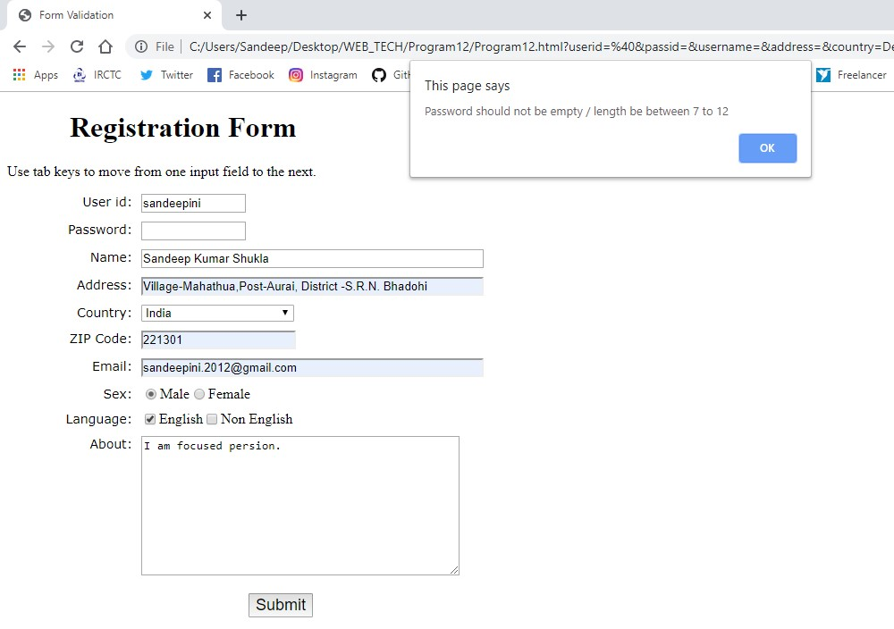

**Aim :-***Write a HTML program to design an entry form of student details and print the values filled in the form using JavaScript.*

**Code :-**

**HTML CODE**

<!DOCTYPE html>

<html lang="en" dir="ltr">

<head>

<meta charset="utf-8">

<title>Form Validation</title>

<script type="text/javascript">

function print_form() {

window.print();

}

</script>

</head>

<body onload="document.registration.userid.focus();">

<h1>Registration Form</h1>

Use tab keys to move from one input field to the next.

<form name='registration' onSubmit="return formValidation();">

<ul>

<li><label for="userid">User id:</label></li>

<li><input type="text" name="userid" size="12" /></li>

<li><label for="passid">Password:</label></li>

<li><input type="password" name="passid" size="12" /></li>

<li><label for="username">Name:</label></li>

<li><input type="text" name="username" size="50" /></li>

<li><label for="address">Address:</label></li>

<li><input type="text" name="address" size="50" /></li>

<li><label for="country">Country:</label></li>

<li><select name="country">

<option selected="" value="Default">(Please select a country)</option>

<option value="AF">Australia</option>

<option value="AL">Canada</option>

<option value="DZ">India</option>

<option value="AS">Russia</option>

<option value="AD">USA</option>

</select></li>

<li><label for="zip">ZIP Code:</label></li>

<li><input type="text" name="zip" /></li>

<li><label for="email">Email:</label></li>

<li><input type="text" name="email" size="50" /></li>

</ul>

<input type="submit" name="submit" value="Submit" />

<input type="button" name="button" value="Print" onclick="print_form()" />

</form>

</body>

</html>

**Output :-**

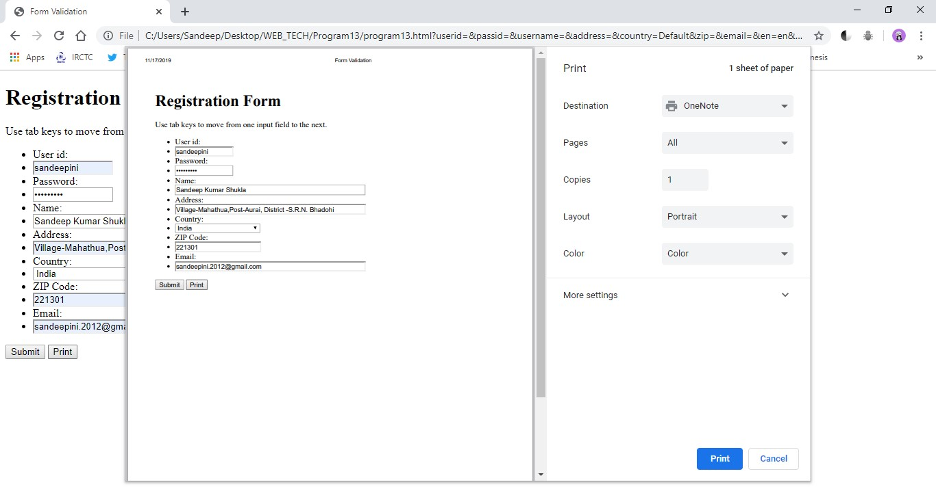

**Aim :-** *Write HTML to validate an E-mail Id.*

**Code :-**

**HTML CODE**

<!DOCTYPE html>

<html lang="en" dir="ltr">

<head>

<meta charset="utf-8">

<title>E-mail Validation</title>

</head>

<body>

<script type="text/javascript">

function checkEmail() {

var email = document.getElementById('txtEmail');

var filter = /^([a-zA-Z0-9_\.\-])+\@(([a-zA-Z0-9\-])+\.)+([a-zA-Z0-9]{2,4})+$/;

if (!filter.test(email.value)) {

alert('Please provide a valid email address');

email.focus;

return false;

}

}

</script>

<h3>Validate your E-mail Id :</h3>

<input type='text' id='txtEmail' />

<input type='submit' name='submit' value="Check " onclick='Javascript:checkEmail();' />

</body>

</html>

**Output :-**

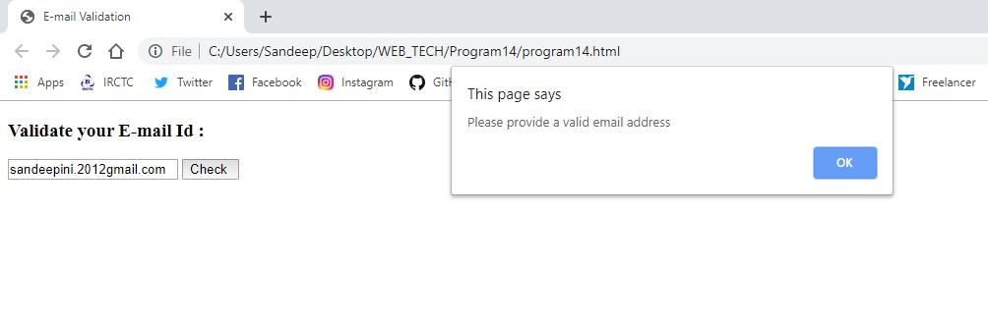

**Aim :-** *Write a program to print “Hello World” in java*

**Code :-**

import java.util.*;

class HelloWorld{

public static void main(String[] args){

System.out.println("Hello World!");

}

}

**Output :-**

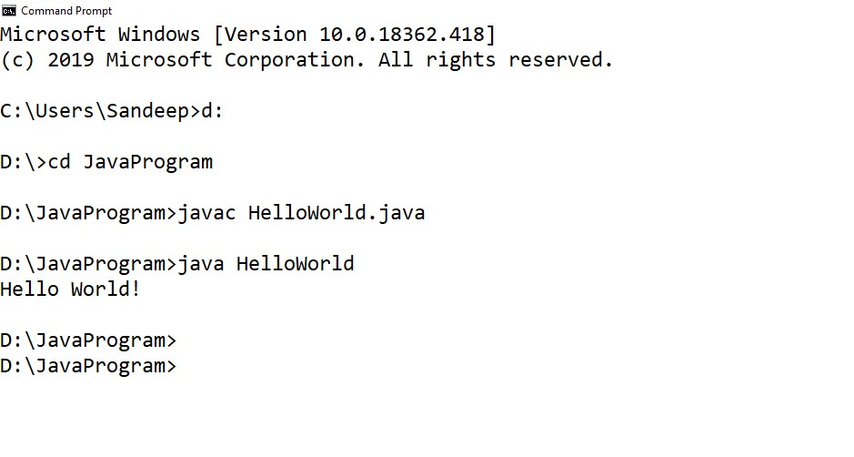

**Aim :-** *Write a program to implements basic datatypes and control structure.*

**Code :-**

import java.util.*;

class Factorial{

public static void main(String[] args){

int N,fact=1;

Scanner sc = new Scanner(System.in);

System.out.println("Enter a number :");

N = sc.nextInt();

for(int i=1;i<=N;i++){

fact = fact*i;

}

System.out.println("Factorial of a number :" + fact);

}

}

**Output :-**

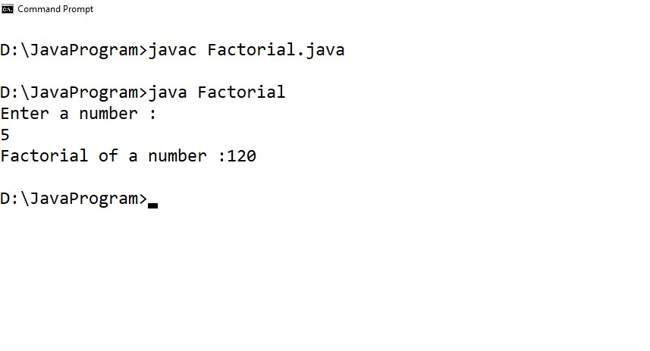

**Aim :-** *Write a program to print a pattern in java.*

**Code :-**

import java.util.*;

class Pattern{

public static void main(String[] args){

int N=5;

System.out.println("The Given Pattern are");

for(int i=1;i<=N;i++){

for(int j=1;j<=i;j++){

System.out.print(j + "\t");

}

System.out.println();

}

}

}

**Output :-**

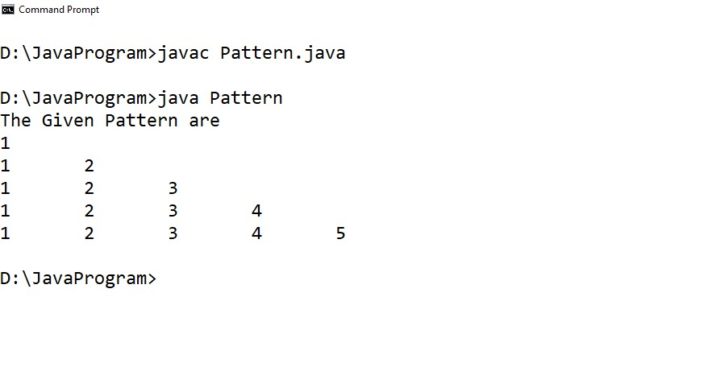

**Aim :-** *Write a program to print sum of series 1+x+x2+x3+…+xn in java.*

**Code :-**

// Print sum of series 1+x+x2+x3+......+xn

import java.io.*;

import java.lang.Math;

import java.util.*;

class sumSeries

{

public static void main(String ar[])

{

double i,x=0,n=0,sum=0;

DataInputStream obj= new DataInputStream(System.in);

try

{

System.out.println("Enter the value of x:");

x=Integer.parseInt(obj.readLine());

System.out.println("Enter the value of n:");

n=Integer.parseInt(obj.readLine());

}

catch(IOException e) { }

for(i=0;i<=n;i++)

sum=sum+Math.pow(x,i);

System.out.println("Sum is:"+sum);

}

}

**Output :-**

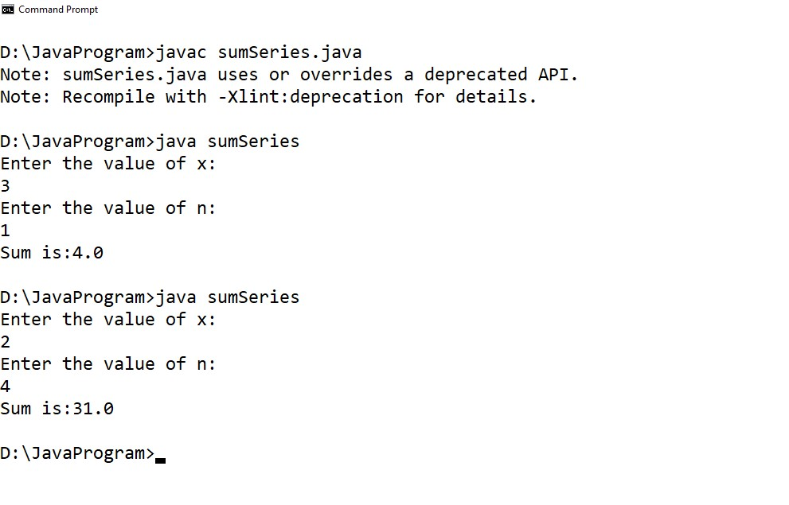

**Aim :-** *Write a program to search an Element in array in java.*

**Code :-**

import java.util.*;

public class searchElement {

public static int Index(int arr[], int t)

{

if (arr == null) {

return -1;

}

int len = arr.length;

int i = 0;

while (i < len) {

if (arr[i] == t) {

return i;

}

else {

i = i + 1;

}

}

return -1;

}

public static void main(String[] args)

{

int[] array = { 5, 4, 6, 1, 3, 2, 7, 8, 9 };

// find the index of 6

System.out.println("Index position of 5 is: " + Index(array, 6));

// find the index of 7

System.out.println("Index position of 7 is: " + Index(array, 7));

}

}

**Output :-**

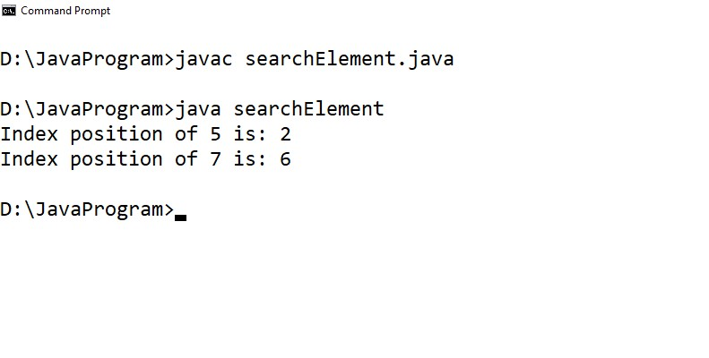

**Aim :-** *To construct a program using 2D array in java.*

**Code :-**

import java.util.*;

class Array{

public static void main(String[] args){

Scanner sc = new Scanner(System.in);

System.out.print("Enter the number of rows : ");

int r = sc.nextInt();

System.out.print("Enter the number of column : ");

int c = sc.nextInt();

int[][] a = new int[r][c];

for(int i=0;i<r;i++)

for(int j=0;j<c;j++){

int N = sc.nextInt();

a[i][j] = N;

}

System.out.println("You entered this Array : ");

for(int i=0;i<r;i++){

for(int j=0;j<c;j++){

System.out.print(a[i][j] + "\t");

}

System.out.println();

}

}

}

**Output :-**

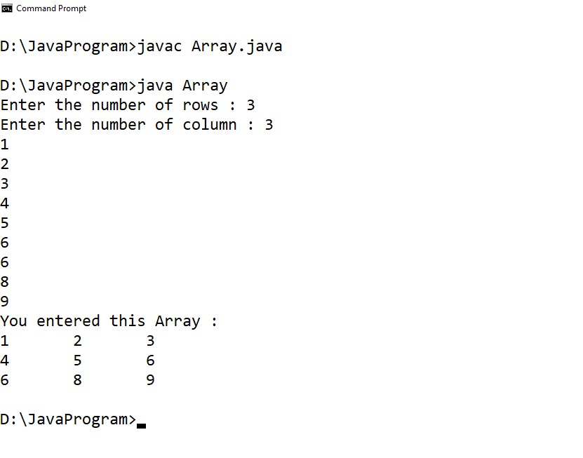

**Aim :-** *To construct a program having classes and methods with object calling in java***.**

**Code :-**

import java.util.*;

public class SimpleCalculation

{

public int sum(int num1,int num2){

return (num1+num2);

}

public double sum(double num1,double num2){

return (num1+num2);

}

public static void main(String[] args)

{

SimpleCalculation obj1 = new SimpleCalculation();

int s1 = obj1.sum(12,12);

double s2 = obj1.sum(10.0,12.5);

System.out.println(s1);

System.out.println(s2);

}

}

**Output :-**

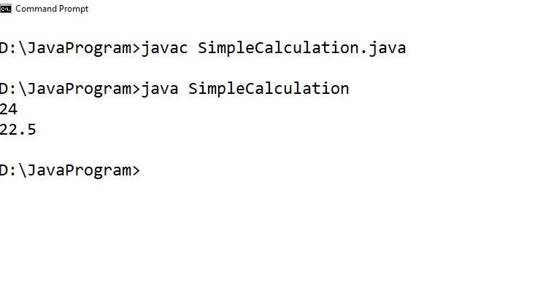

**Aim :-** *Write a program to implement polymorphism, using methods in java*

**Code :-**

class Bank{

float getRateOfInterest(){return 0;}

}

class SBI extends Bank{

float getRateOfInterest(){return 8.4f;}

}

class ICICI extends Bank{

float getRateOfInterest(){return 7.3f;}

}

class AXIS extends Bank{

float getRateOfInterest(){return 9.7f;}

}

class TestPolymorphism{

public static void main(String args[]){

Bank b;

b=new SBI();

System.out.println("SBI Rate of Interest: "+b.getRateOfInterest());

b=new ICICI();

System.out.println("ICICI Rate of Interest: "+b.getRateOfInterest());

b=new AXIS();

System.out.println("AXIS Rate of Interest: "+b.getRateOfInterest());

}

}

**Output :-**

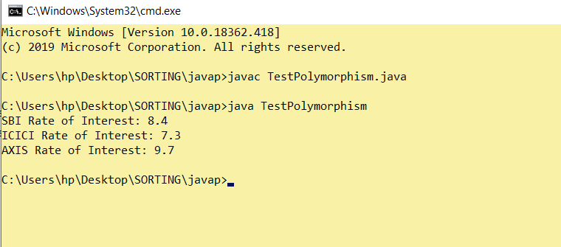

**Aim :-** *Write a program using Multilevel Inheritance in java.*

**Code :-**

class Shape {

public void display() {

System.out.println("Inside display");

}

}

class Rectangle extends Shape {

public void area() {

System.out.println("Inside area");

}

}

class Cube extends Rectangle {

public void volume() {

System.out.println("Inside volume");

}

}

public class Tester {

public static void main(String[] arguments) {

Cube cube = new Cube();

cube.display();

cube.area();

cube.volume();

}

}

**Output :-**

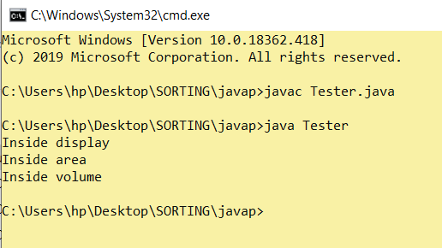

**Aim :-** *Write a program to implement packages in java.*

**Code :-**

import java.util.ArrayList;

class ArrayListUtilization {

public static void main(String[] args) {

ArrayList<Integer> myList = new ArrayList<>(3);

myList.add(3);

myList.add(2);

myList.add(1);

System.out.println(myList);

}

}

**Output :-**

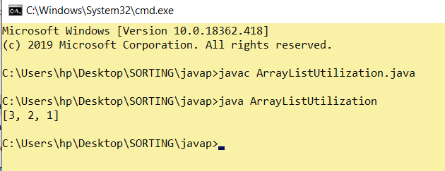

**Aim :-** *Write a program implementing interface.*

**Code :-**

import java.io.*;

interface in1

{

final int a = 10;

void display();

}

class Disp implements in1

{

public void display()

{

System.out.println("Geek");

}

public static void main (String[] args)

{

testClass t = new testClass();

t.display();

System.out.println(a);

}

}

**Output :-**

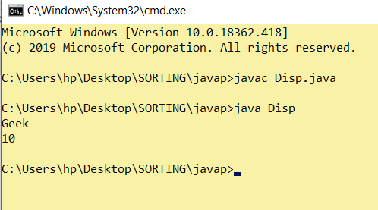

**Aim :-** *Write a program implementing Multithreading and concept of Exception Handling .*

**Code :-**

class Count implements Runnable

{

Thread mythread ;

Count()

{

mythread = new Thread(this, "my runnable thread");

System.out.println("my thread created" + mythread);

mythread.start();

}

public void run()

{

try

{

for (int i=0 ;i<10;i++)

{

System.out.println("Printing the count " + i);

Thread.sleep(1000);

}

}

catch(InterruptedException e)

{

System.out.println("my thread interrupted");

}

System.out.println("mythread run is over" );

}

}

class RunnableExample

{

public static void main(String args[])

{

Count cnt = new Count();

try

{

while(cnt.mythread.isAlive())

{

System.out.println("Main thread will be alive till the child thread is live");

Thread.sleep(1500);

}

}

catch(InterruptedException e)

{

System.out.println("Main thread interrupted");

}

System.out.println("Main thread run is over" );

}

}

**Output :-**

