PlacementHub — Functionality, Features & Flows
Version: June 2026 (sandbox / pre-launch)
Audience: Product, engineering, QA, college TPOs, and employer partners
Scope: What the platform does, how roles interact, and the main end-to-end journeys

1. What PlacementHub is
PlacementHub is a multi-tenant campus placement and engagement platform. It connects three primary audiences on one system:
Audience | Primary job on the platform
Students | Discover opportunities, apply, attend interviews, respond to offers
College admins (TPO / placement office) | Run the placement season, approve employers, enforce rules, coordinate selection
Employers | Partner with campuses, publish roles and drives, run hiring, record offers

A super admin layer operates the whole platform: onboarding colleges and employers, user support, global settings, and audit visibility.
Beyond core placement, the product supports internships, short projects, hackathons, alumni hiring, sponsorships, startup seed funding, guest faculty, and campus calendars — so industry engagement and final placements live in one place rather than scattered spreadsheets and email threads.

2. Multi-tenant model
Every college is a tenant. Data is scoped by tenant:
- Students belong to one college tenant.
- Employers are cross-tenant: one company account can request tie-ups with many colleges.
- Employer–campus partnerships (employer_approvals) gate what an employer can see or do for each institute (pending → approved → rejected).
- Academic years and placement season labels separate batches and reporting across years.
Employers work across all approved campuses (campus switcher is disabled; the top bar shows “All campuses”). Per-screen campus dropdowns still exist where a specific campus context is required (assessments, interviews, some exports).

3. Roles and access
Role | Signs up via | Home after login
Student | Not self-service — college provisions the master list; student receives login email | Student dashboard
Employer | /register (platform approval may apply) | Employer dashboard
College admin | /register or super-admin onboarding | College dashboard
Super admin | Provisioned by platform ops | Admin dashboard

Alumni students are flagged on the student account; they see alumni job browse/apply menus instead of campus placement drives.
Navigation is role-based (sidebar + full-screen hub). Alerts, data export, and feedback are shared across roles where enabled.

4. Opportunity types (programs)
PlacementHub treats each program type as a first-class pipeline with its own browse, apply, and application tabs.
Type | Typical use | Who publishes | College gate
Placement drives | On-campus / virtual hiring events linked to roles | Employer requests; college approves | Drive visibility + employer partnership
Jobs | Full-time, part-time, PPO | Employer publishes to selected campuses | College approves listing visibility per campus
Internships | Summer / semester internships | Employer | College approves visibility
Short projects | Portfolio / exposure work | Employer | College approves visibility
Hackathons | Competitions (optional PPO link) | Employer | College approves visibility
Alumni jobs | Lateral roles for graduated alumni | Employer | Published to alumni on campus

Students apply from Browse screens; status is tracked under My Applications (separate tabs per type). Employers manage listings under Student Opportunities; colleges monitor Applications and program boards.

5. Features by role

5.1 Student
Area | Capabilities
Profile & documents | Academic details, skills, resume and proofs; profile completion guidance
Discovery | Browse drives, jobs, internships, projects, hackathons; placement calendar
Applications | Apply before deadlines; track status (applied → shortlisted → in progress → selected, etc.)
Selection | My Interviews; view hiring outcomes where exposed
Offers | Review and accept/decline per college rules
Communication | Clarifications (official Q&A batches); alerts; feedback
Compliance | Eligibility checks (CGPA, backlogs, batch year, deadlines); withdrawal flows
Privacy | My data export (where supported)

5.2 Employer
Area | Capabilities
Organization | Company profile, sponsorships, startup seed funding, campus guest needs
Partnerships | Request campus tie-ups; track approved / pending / rejected
Publishing | Internships, placement drives, projects (and jobs via dedicated flows)
Recruitment & selection | Hiring Results Dashboard (read); Assessment uploads (CSV); Assessment Update Online (write); Assessment map (round labels, legacy)
Pipeline | Applications; FCFS “unavailable” list; offers (including CSV upload from Offers page)
Operations | Interview scheduling; events calendar
Communication | Clarifications, discussions, email templates, feedback

5.3 College admin (TPO)
Area | Capabilities
Partnerships | Approve/reject employer requests; employer directory
Programs | Placement drives board; internships; internship results
Students | Master list, verification, add student, enrollment key
Pipeline | Campus applications board; offers
Evaluation | Hiring Assessment (read-only mirror of employer results); interview scheduling
Rules | Placement rules (CGPA, offer limits, season dates, FCFS, etc.)
Engagement | Calendar, events, guest faculty & lectures, sponsorships, startup funding
Insights | Reports, audit reports
Communication | Clarifications (publish batches), discussions, templates, feedback

5.4 Super admin
Area | Capabilities
Directory | Colleges, employers, users, placement listings, archived students
Onboarding | Pending registrations (college + employer approval queue)
Operations | Feedback inbox, error logs, email logs, audit reports
Configuration | Platform settings (SMTP, branding URLs, feature-related globals)

6. End-to-end flows

6.1 One placement season (all roles)

Narrative: Platform enables a college and employer → TPO approves the partnership → employer publishes opportunities → college curates visibility → students apply → employer runs selection (CSV/online assessments, interviews) → offers are recorded → college placement rules (e.g. one FT offer, FCFS) apply → leadership closes the season with reports.
Deployments may skip steps (auto-approved employers) or add steps (extra assessments). Role-specific sections below are the day-to-day source of truth.

6.2 Student journey
- Provisioned by college (CSV / add student) — receives login email (no self-registration on /register).
- Sign in, complete My Profile and Documents.
- Browse drives, internships, jobs, projects, or hackathons; use Placement calendar for dates.
- Apply before each deadline; eligibility enforced (CGPA, backlogs, batch, deadline; branch matching is display-only until taxonomy ships).
- Track My Applications; respond to My Interviews and Alerts.
- Read Clarifications from the placement committee.
- Act on My Offers per institute policy.

6.3 Employer journey
- Register (or be onboarded by super admin); complete Company Profile.
- Campus Partnerships — request tie-ups; wait for college approved status.
- Publish internships, drives, projects; select campuses where posting constraints allow.
- College approves job/internship visibility per campus where required.
- Recruitment & selection:
- Enter results via Assessment uploads (CSV) or Assessment Update Online (hiring_result: Shortlist, Reject, Select, Decline, Withdraw).
- Review on Hiring Results Dashboard; Submit results when final.
- Schedule interviews; review Applications.
- Record Offers (UI or CSV from Offers page).
- Participate in Clarifications / Discussions when the college publishes threads.

6.4 College admin journey
- Configure Settings (season label, policies exposed in product).
- Approve employer partnerships before companies run on campus.
- Manage Students — verify profiles; rotate Enrollment key if needed (legacy flows; students are primarily provisioned directly).
- Curate Placement drives / Internships visibility.
- Monitor Applications and Offers; mirror employer Hiring Assessment (read-only).
- Coordinate Interview Scheduling with employers.
- Publish Clarifications; moderate Discussions.
- Enforce Placement Rules; export Reports / Audit reports.

6.5 Assessment CSV workflow (employer)
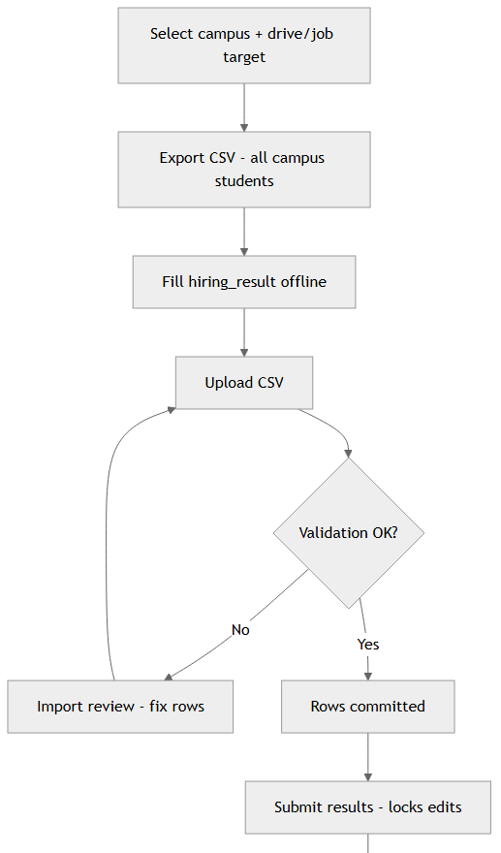

Alternative: Assessment Update Online — same data model, inline edits, no file.
Assessment updates are dashboard-visible; they do not email students by default.

7. Key subsystems

7.1 Employer–campus partnerships
- Employer requests access from Campus Partnerships.
- College approves via Employer Partnership Requests.
- Until approved, employer actions for that tenant are blocked or empty at the API layer (employer_approvals).
- Employers see a directory of all colleges (for requests), not only approved ones.

7.2 Job posting visibility
- Employer publishes a job/internship/project to selected campuses.
- Each campus has a college_status on visibility (pending / approved / rejected).
- Students only see approved, published listings for their tenant.

7.3 Placement drives
- Employer requests a drive with role details, dates, venue, eligibility.
- College approves the drive; students register/apply.
- Drive lifecycle includes scheduled, in progress, completed; venue warnings surface when date is near and venue unconfirmed.

7.4 FCFS (first-come-first-served)
When enabled in college settings, the first employer to confirm a student on a track (internship, placement, jobs) blocks other employers from selecting that student on the same track for that campus. Unavailable (FCFS) on the employer menu lists students already claimed.

7.5 Placement rules (college)
Configurable per tenant, including:
- Offer limits (e.g. max simultaneous offers)
- Minimum CGPA and backlog rules
- Placement season windows
- FCFS enablement
- Academic year scoping on drives and postings
Rules are enforced at apply time and offer time where implemented.

7.6 Communication
Channel | Purpose
Alerts | In-app notifications (applications, approvals, reminders)
Email | Transactional mail (welcome, selection, password reset, etc.); super-admin Email logs
Clarifications | Official batched Q&A — college publishes questions/answers for employers
Discussions | Moderated threads where enabled
Email / message templates | Reusable copy for college and employer outreach

7.7 Data export & audit
- My data export — role-scoped self-service downloads where supported.
- Audit reports — college and super-admin compliance views.
- CSV export on many tabular screens (applications, assessments, interviews, offers).

7.8 Help & feedback
- In-app Help widget — natural-language answers from indexed help docs (sync via npm run qa:sync-help-knowledge).
- Feedback — product feedback routed to admin inbox.
- Developer Notes (/developer) — QA runbooks, demo APIs, guided runner (password-gated).

8. Accounts and security (summary)
Topic | Behavior
Student onboarding | College adds to master list; student signs in with issued credentials — not via public student registration
Employer / college signup | /register with captcha; may require super-admin approval before first login
Sessions | Role-based dashboard access; middleware protects routes
Dev / QA surfaces | /developer, /data-entry password-gated; screen ID pills for guided testing (hide in production via env)
Multi-tenant isolation | Tenant ID on student data; employer campus scope checked on sensitive APIs

9. Engagement modules (beyond core placement)
Module | Employer | College
Sponsorships | Offer sponsorships | View / coordinate
Startup seed funding | Apply / track | Review campus startups
Campus guest needs | Respond to lecture needs | Guest faculty & lectures — list needs
Events & calendar | Employer calendar | College calendar + events

These share the same tenant and partnership model as hiring but do not replace the application/offer pipeline.

10. Alumni
- Employers post alumni jobs (lateral roles).
- Alumni-flagged students browse Alumni Jobs instead of campus placement drives.
- Separate application tabs and interview flows where configured.
- Alumni Job Assessment Online on employer menu for alumni hiring updates.

11. Platform matrix (quick reference)
Capability | Student | Employer | College | Super admin
Browse / apply to programs | ✓ | — | monitor | —
Publish drives & listings | — | ✓ | approve | listings admin
Assessment results entry | view | ✓ CSV/online | read-only | —
Interview scheduling | view | ✓ | ✓ | —
Offers | accept/decline | ✓ + CSV | monitor | —
Placement rules | subject to | — | configure | —
Partnership approval | — | request | approve | —
User / tenant admin | — | profile | students | ✓
Audit / email logs | export self | export self | audit | ✓

12. Related documentation
Document | Use when
docs/help/README.md (help/README.md) | Role-specific help markdown (synced from in-app help)
docs/help/use-case-flows/ (help/use-case-flows/) | Step-by-step flows per role
PRODUCT.md (../PRODUCT.md) | Product purpose, users, brand tone
DESIGN.md (../DESIGN.md) | UI / design principles
/developer (../src/content/developerNotes.js) | QA playbooks, demo APIs, pending backlog
docs/help/developer/database-schema.md (help/developer/database-schema.md) | Tables and relationships

13. Glossary
Term | Meaning
TPO | Training & Placement Officer; college admin role
Tie-up / partnership | Approved link between employer and college tenant
hiring_result | Employer assessment outcome: Shortlist, Reject, Select, Decline, Withdraw
FCFS | First-come-first-served locking of a student on a track per campus
Tenant | One college instance in the multi-tenant database
Visibility row | Per-campus approval state for a job posting
Guided Runner | QA automation that steps through screens using dev screen IDs

This document describes intended product behavior for the current sandbox build. Some help pages may still mention student self-registration with an enrollment key; production provisioning is college-driven. For the latest menu names, use the in-app sidebar or src/config/dashboardMenu.js.

PlacementHub — Functionality, Features & Flows · June 2026 (sandbox / pre-launch)

