**Prediction of Ground Vibration induced due to Rock Blast using Machine Learning**

**An Interim Report on UG Project**

Submitted in Partial Fulfilment of the Requirements for the Degree of

***Bachelor of Technology***

In Mining Engineering

By

**Janapati Sandeep**

Roll No: 21155046 {Pt. III, Sem No. 6}

Under the guidance of

Dr. Sanjay Kumar Palei



Department of Mining Engineering

Indian Institute of Technology (BHU)

Varanasi-221005, India

**May 2023**

DECLARATION BY THE CANDIDATE

I, **Janapati Sandeep**, certify that the work embodied in this UG Project Report is my bonafide work and carried out by me under the supervision of **Dr. Sanjay Kumar Palei** in the Department of Mining Engineering, Indian Institute of Technology (BHU), Varanasi. The matter embodied in this report has not been submitted for the award of any other degree.

I declare that I have faithfully acknowledged and given credits to the research workers wherever their works have been cited in my work in this report. I further declare that I have not willfully copied any other's work, paragraphs, text, data, results, etc., reported in journals, books, magazines, reports dissertations, theses, etc., or available on websites, and have not included them in this report as my work.

Date: [Signature of the student]

Place: Varanasi **Janapati Sandeep**

Roll No. 21155046  
 B. Tech. Part III, Even Sem

CERTIFICATE FROM THE SUPERVISOR

This is to certify that the above statement made by the student is correct to the best of my knowledge.

|  |  |
| --- | --- |
| [Signature of the Supervisor]  Dr. Sanjay Kumar Palei  Associate Professor  Department of Mining Engineering  IIT – BHU. Varanasi | [Signature of the HoD]  Dr. Suprakash Gupta  The Head  Department of Mining Engineering  IIT – BHU. Varanasi |

Table of Contents

List of Figures v

List of Tables vi

List of Abbreviations vii

Chapter 1. Introduction 1

1.1 Peak Particle Velocity (PPV) 2

1.2 Artificial Neural Network (ANN) 3

1.3 Objectives 3

Chapter 2. Literature Review 4

Chapter 3. Theoretical Study 13

3.1 Rock Blasting 13

3.2 Drilling 13

3.2.1 Drilling Patterns 13

3.3 Loading Explosives 14

3.4 Blast Initiation 14

3.4.1 Blast Initiation Patterns 15

3.5 Ground Vibration 16

3.5.1 Factors Affecting Ground Vibration 16

3.5.2 Control of Ground Vibration 17

Chapter 4. Model Preparation 18

4.1 Exploratory Data Analysis 18

4.1.1 Spacing (m) and PPV (mm/s) 18

4.1.2 Burden (m) and PPV (mm/s) 19

4.1.3 Powder Factor (kg/m3) and PPV (mm/s) 19

4.1.4 MCPD (kg) and PPV (mm/s) 20

4.1.5 Distance (m) and PPV (mm/s) 20

4.2 Linear Regression Model 21

4.3 Polynomial Regression Model 22

4.4 Artificial Neural Network Model 24

Chapter 5. Results and Discussions 26

Chapter 6. Conclusions and Future scope of study 27

References 28

List of Figures

Figure 3.1 Overview of Square Drilling Pattern 13

Figure 3.2 Overview of Rectangular Drilling Pattern 14

Figure 3.3 Overview of Staggered Drilling Pattern 14

Figure 3.4 Overview of Row to Row Blast Initiation Pattern 15

Figure 3.5Overview of V-Cut Blast Initiation Pattern 15

Figure 3.6 Overview of Extended V-Cut Blast Initiation Pattern 16

Figure 4.1 Scatter plot between Spacing and PPV 18

Figure 4.2 Scatter plot between Spacing and PPV 19

Figure 4.3 Scatter plot between Powder Factor and PPV 19

Figure 4.4 Scatter plot between MCPD and PPV 20

Figure 4.5 Scatter plot between MCPD and PPV 21

Figure 4.6 Plot between Degree of Polynomial and R2 score 23

Figure 4.7 Actual Value and Predicted Value 24

Figure 4.8 Scatter plot between Actual Value and Predicted Value 25

Figure 4.9 Neural Network Layer Architecture used to predict the PPV 25

List of Tables

Table 4‑1 Degree and R2 Score 23

Table 5‑1 Model comparision with R2 Score 26

List of Abbreviations

ANN Artificial Neural Network

BP Back Propagation

EXG Extreme Gradient

GMM Ground Motion prediction Models

MAE Mean Absolute Error

MSE Mean Squared Error

PGA Peak Ground Acceleration

PPV Peak Particle Velocity

RMSE Root Mean Squared Error

VAF Variance Accounted For

WEKA Waikato Environment for Knowledge analysis

# Introduction

There is an increasing trend towards surface excavation for exploitation of minerals and for infra-structural developmental projects in India. Drilling and blasting is one of the major economical operations to excavate a rock mass. Until now, explosives are a valuable source of energy required for breakage, excavation and displacement of rock mass. When an explosive detonates in a blast hole, a tremendous amount of energy, in terms of pressure (up to 50 GPa) and temperature (up to 5000 K) is released. Although, significant developments have taken place in explosive technology, the explosive energy utilization has not made much progress due to the complexity of the various rock parameters. Only a fraction of explosive energy (20–30%) is used in the actual breakage and displacement of the rock mass, and the rest of the energy is spent in undesirable effects like ground vibrations, fly rocks, noises, back breaks, over breaks, etc.

To meet the present day demand for coal and other economic minerals, large scale mechanized surface mines are being planned. In these mines, a huge quantity of explosive is consumed to break and displace the overburden of rock mass. These explosives used in a blasting round, create nuisances to the people residing in the close vicinity of the mining area. Sometimes, due to high ground vibration level, their dwellings may get damaged and there is always confrontation between mine management and the people residing in the surroundings of the mine area.

High ground vibrations, not only do they create problems to the nearby population, but also adversely affects the integrity of the surrounding structures in the mine area. Sometimes, it provokes the population and can put mines into closure. High intensity vibration also damages and chocks the existing ground water conduits and harms the ecology of the nearby area. It may be sometimes responsible for water logging and up-rooting of the plants/trees nearby the mining area. If ground vibration is not controlled or minimized, it may be one of the main causes for the deforestation in future. Ground vibration may damage the free face and generate a number of back breaks. These back breaks create problems while drilling the next round of blast and generate over-size boulders. This adversely affects the mine economics, hamper production and endanger the socio-economic development of the surrounding area.

The ground vibration is a wave motion, spreading outward from the blast like ripples spreading outwards due to impact of a stone dropped into a pond of water. As the vibration passes through the surface structures, it induces vibrations in those structures also. These vibrations induce a resonance in the structures if the frequency of ground vibration matches the natural frequency of the structure and due to this, amplitude of the vibration may further exceed the amplitude of the initial ground vibrations. Peak Particle Velocity is the most commonly used parameter for assessment of ground vibration and associated damage. Ground vibration is influenced by a number of parameters such as physico-mechanical properties of rock mass, explosive characteristics and blast design. It is essential to know the effect of these parameters on blasting for efficient utilization of explosive energy in a given rock mass vis-a-vis minimization of undesired blast-induced effects. The design parameters like maximum charge per delay, distance between blast face and monitoring point, burden, spacing, powder factor considerably alter dispersion of the seismic energy. Rock characteristics also often vary widely from place to place in a mine or even from one end to another of a single face.

## Peak Particle Velocity (PPV)

PPV is a key measure in rock blasting to understand ground vibration. It describes the maximum speed that a particle in the rock travels due to the blast wave. Higher PPV indicates stronger vibrations, which can damage nearby structures or infrastructure. By controlling PPV through blast design factors like explosive type and amount, engineers minimize vibration effects. Regulations often specify safe PPV limits based on distance from the blast site. A number of vibration predictors were proposed by different researchers for the prediction of PPV. All the predictors estimate the PPV mainly based on two parameters (maximum charge used per delay and distance between blast face and monitoring point). However, few predictors considered attenuation/damping factor too. For the same excavation site, different predictors give different values of safe PPV vis-a -vis charge per delay. There is no uniformity in the predicted result by different predictors. It is well known that the PPV is influenced by various geological, geotechnical, blast geometry and explosive parameters, which have not been incorporated in any of the available predictors. Because the number of influencing parameters is too high and the inter-relation among them is also very complicated, empirical methods may not be fully suitable for such problems. Currently, tools such as artificial neural network is frequently used.

## Artificial Neural Network (ANN)

AN is a branch of the artificial intelligence science and has developed rapidly since the 1980s. Nowadays, ANN is popularly used and considered one of the intelligent tools to solve complex problems. ANN has the ability to learn from patterns acquainted before. It is a highly interconnected network of a large number of processing elements called neurons in an architecture inspired by the brain. ANN can be massively parallel and hence said to exhibit parallel distributed processing. ANN shows characteristics such as mapping capabilities or pattern association, generalization, robustness or fault tolerance as well as parallel and high speed information processing. ANN learns by examples, thus, it can be trained with known examples of a problem to acquire knowledge about it. Once, appropriately trained, the network can be put to effective use of solving unknown or untrained instances of the problem. Due to its multidisciplinary nature, ANN is becoming popular among the researchers, planners, designers, etc., as an effective tool for the accomplishment of their work. Therefore, ANN is being successfully used in many industrial areas as well as in research areas.

## Objectives

The primary objectives of this report are –

i) To gain knowledge about different types of Rock Blasting mechanisms and identify different features that affect the ground vibration,

ii) To create a Machine Learning Algorithm to predict the Ground Vibration caused due to Rock Blasting.

# Literature Review

1) An attempt has been made to evaluate and predict the blast-induced ground vibration and frequency by incorporating rock properties, blast design and explosive parameters using the ANN technique. A three-layer, feed-forward back-propagation neural network having 15 hidden neurons, 10 input parameters and two output parameters were trained using 154 experimental and monitored blast records from one of the major producing surface coal mines in India. Twenty new blast data sets were used for the validation and comparison of the PPV and frequency by ANN and other predictors. To develop more confidence in the proposed method, same data sets have also been used for the prediction of PPV by commonly used vibration predictors as well as by multivariate regression analysis. Results were compared based on correlation and mean absolute error between monitored and predicted values of PPV and frequency. (Manoj Khandelwal and T.N. Singh)

2) The present study compares three different techniques (decision tree, artificial neural network and multivariate regression analysis) for predicting blast-induced ground vibrations in some Indian tunnelling projects. The performance of these models was also compared to site-specific conventional predictor equations. A database consisting of 137 vibration records was randomly divided into training and testing sets for model generation. Eight input parameters (total charge, tunnel cross-section, maximum charge per delay, number of holes, hole diameter, distance from blasting face, hole depth and charge per hole) were selected for model development using bivariate correlation analysis. Results indicated that the decision tree is best suited for predicting vibrations. The decision tree further suggested that the intensity of near-field ground vibrations is mainly affected by total charge fired in a round, whereas the intensity of far-field vibrations is governed by maximum charge per delay and charge per hole. Conventional ground vibration predictors and machine learning techniques such as neural networks do not depict the relationship between input and output parameters. However, the present study substantiates that the decision tree can be a good tool for precise prediction of ground vibrations. Further, the decision tree can classify and relate different blast design parameters for refining blast designs to control ground vibrations on sites.   
(Aditya Rana, N. K. Bhagat Et. al)

3) The blasting technique is mainly used for breaking the rock mass. It is also required to control blast-induced ground vibrations for the safety of nearby habitats. This study was conducted in two different mines and 56 blast vibration data collected from overburden benches. During trial blasts, it was confirmed that the study benches had similar geology. Analysis of blasts data was done using advanced data analysis software such as MATLAB-based ANN and Waikato Environment for Knowledge analysis (WEKA) and compared with the empirical equations. The ANN prediction model gave a significantly high R2 = 0.92 with a low root mean square error (RMSE, 0.67), while WEKA gave a comparatively low R2 = 0.86 with a high RMSE (1.11). (Jai Jain, Anurag Agrawal and Bhanwar Singh Choudhary)

4) Deep vibro-techniques impart vibrations into the ground to achieve targeted improvement. One of the common geotechnical challenges of these techniques is the question of how vibration attenuates over distance and its effect on nearby structures. In this paper, ground vibration data from several deep vibro-technique projects with different vibrators are analysed. Best-fit estimates of the field data are evaluated through analytical regression, and comparisons of the field data against requirements from some standard codes of practice for admissible vibrations are made. A preliminary estimate of ground vibration levels can be obtained from the empirical relations of vibrator energy and distance. Such an assessment, when coupled with the monitoring and collection of actual field data, should enable further predictions to be more refined. In addition to analysing ground vibration data, predictions of ground vibration and comparisons of theoretical predictions against regressions of the field data are demonstrated. Average estimates of soil profile and strengths are included in the evaluations as well. Suggestions for better predictability of ground vibrations are also given. Moreover, recommendations for safe working distances from existing structures or services are made for different types of vibrators and vibro-techniques. (Leong Kam Weng and Mikias M)

5) Ground vibration due to blasting is identified as a challenging issue in mining and civil activities. PPV is one of the blasting undesirable consequences, which is resulted during emission of vibration in blasted bench. This study focuses on the PPV prediction in the surface mines. In this regard, two ensemble systems, i.e., the ensemble of artificial neural networks and the ensemble of extreme gradient boosting (EXG Boosts) were developed for PPV prediction in one of the largest lead–zinc open-pit mines in the Middle East. For ensemble modelling, several ANN and EXG Boost base models were separately designed with different architectures. Then, the validation indices such as coefficient determination (R2), root mean square error (RMSE), mean absolute error (MAE), the variance accounted for (VAF), and Accuracy were used to evaluate the performance of the base models. The five top base models with high accuracy were selected to construct an ensemble model for each of the methods, i.e., ANNs and EXG Boosts. To combine the outputs of the top base models and achieve a single result stacked generalization technique, was employed. Findings showed ensemble models increase the accuracy of PPV predicting in comparison with the best individual models. The EXG Boosts was superior method for predicting of the PPV, which obtained values of R2, RMSE, MAE and Accuracy corresponding to the EXG Boosts were (0.990, 0.391, 0.257, 98.216), and (0.938, 0.295, 0.427, 92.059), for training and testing datasets, respectively. (Shahab Hosseini and Rashed Pourmirzaee)

6) Blasting plays a fundamental role in rock fragmentation, and it is the first preparatory stage in the mining extraction process. However, its undesirable effects, mostly ground vibration, can cause severe damages to the surroundings, such as cracks/collapses of buildings, instability of slopes, deformation of underground space, affect underground water, to name a few. Therefore, the primary purpose of this study was to predict the intensity of ground vibration induced by mine blasting operations with high accuracy, aiming to reduce the severe damages to the surroundings. A novel ANN-based cuckoo search optimization was proposed for this aim based on 118 blasting events that were collected at a quarry mine in Vietnam. Besides, stand-alone models, such as ANN, tree-based ensembles, and two empirical equations were considered and developed for comparative evaluation of the performance of the proposed ANN model. Afterwards, they were tested and validated based on three blasting events in practical engineering. The results revealed that the algorithm significantly improved the performance of the ANN model. In addition, the comparative results showed that the accuracy of the proposed hybrid ANN model was superior to the other models with MAE (mean absolute error) of 0.178, RMSE (root-mean-squared error) of 0.246, *R*2 (square of the correlation coefficient) of 0.990. The findings also indicated that explosive charge per borehole has a special relationship with ground vibration intensity. It should be considered and used instead of total explosive charge per blast in some cases, especially for the empirical models. (Xuan-Nam Bui, Hoang Nguyen)

7) One of the suitable methods for breaking hard ground (rock surface etc.) is by means of blasting, but with that comes several problems, one of the major ones associated is ground vibration. Ground vibration induced because of blasting is an important aspect to deal with while carrying out blasting for any purpose. To have a prior idea about PPV, which is one of the best representations of ground vibration induced due to blasting, is very much essential while designing blasting, so that the induced vibration can be controlled. In this study a feed forward ANN model of 2-30-25-1 topology was developed to predict PPV. A total number of 200 blasting data of shot to monitoring distance, charge per hole, and PPV were used for developing this model. The model has performed with an accuracy of almost 78%. This study can be used to forecast the intensity of ground vibration for any upcoming blasting event. (Satyajeet Parida, Abhishek Kumar Tripathi, Subha Ranjan Paul, Zeeshan Ahmed)

8) Blasting is still being considered to be one the most important applicable alternatives for conventional tunnelling. Ground vibration generated due to blasting is an undesirable phenomenon which is harmful for the nearby habitants and dwellings and should be prevented. In this paper, an attempt has been made to predict blast-induced ground vibration using ANN in the Siahbisheh project, Iran. To construct the model maximum charge per delay, distance from blasting face to the monitoring point, stemming and hole depth are taken as input parameters, whereas, PPV is considered as an output parameter. A database consisting of 182 datasets was collected at different strategic and vulnerable locations in and around the project. From the prepared database, 162 datasets were used for the training and testing of the network, whereas 20 randomly selected datasets were used for the validation of the ANN model. A four-layer feed-forward back-propagation neural network with topology 4-10-5-1 was found to be optimum. To compare performance of the ANN model with empirical predictors as well as regression analysis, the same database was applied. Superiority of the proposed ANN model over empirical predictors and statistical model was examined by calculating coefficient of determination for predicted and measured PPV. Sensitivity analysis was also performed to get the influence of each parameter on PPV. It was found that distance from blasting face is the most effective and stemming is the least effective parameter on the PPV. (Masoud Monjezi, M. Ghafurikalajahi A. Bahrami)

9) The purpose of this article is to evaluate and predict blast-induced ground vibration at Shur River Dam in Iran using different empirical vibration predictors and ANN model. Ground vibration is a seismic wave that spreads out from the blasthole when explosive charge is detonated in a confined manner. Ground vibrations were recorded and monitored in and around the Shur River Dam, Iran, at different vulnerable and strategic locations. A total of 20 blast vibration records were monitored, out of which 16 data sets were used for training of the ANN model as well as determining site constants of various vibration predictors. The rest of the 4 blast vibration data sets were used for the validation and comparison of the result of ANN and different empirical predictors. Performances of the different predictor models were assessed using standard statistical evaluation criteria. Finally, it was found that the ANN model is more accurate as compared to the various empirical models available. As such, a high conformity (*R* 2 = 0.927) was observed between the measured and predicted peak particle velocity by the developed ANN model. (Masoud Monjezi, Mahdi Hasanipanah and Manoj Khandelwal)

10) Blasting is a major component of the construction and mining industries in terms of rock fragmentation and concrete demolition. Blast designers are constantly concerned about fly rock and ground vibration induced by blasting as adverse and unintended effects of explosive usage on the surrounding areas. In recent years, several researches have been done to predict fly rock and ground vibration by means of conventional backpropagation ANN. However, the convergence rate of the ANN is relatively slow and solutions can be trapped at local minima. Finally, a model was selected, and the proposed model was trained and tested using 44 datasets obtained from three granite quarry sites in Malaysia. Each dataset involved ten inputs, including the most influential parameters on fly rock distance and PPV, and two outputs. The results indicate that the proposed method is able to predict fly rock distance and PPV induced by blasting with a high degree of accuracy. Sensitivity analysis was also conducted to determine the influence of each parameter on fly rock distance and PPV. The results show that the powder factor and charge per delay are the most effective parameters on fly rock distance, whereas sub-drilling and charge per delay are the most effective parameters on PPV. (D. Jahed Armaghani, M. Hajihassani, E. Tonnizam Mohamad, A. Marto & S. A. Noorani)

11) Prediction of PPV is very complicated due to the number of influencing parameters affecting seism wave propagation. In this paper, ANN is implemented to develop a model to predict PPV in a blasting operation. Based on the measured parameters of maximum explosive charge used per delay and distance between blast face to monitoring point, a three-layer ANN was found to be optimum with architecture 2-5-1. Through the analysis of coefficient of determination and mean absolute error (MAE) between monitored and predicted values of PPV, it indicates that the forecast data by the ANN model is close to the actual values. (Fu Qiang Gao, Xiao Qiang Wang)

12) This research focuses on blast-induced structural damage and human response to vibrations. Frequency is one of the important parameters that affect damage probability and human perception. The first and primary target of the study is to predict ground vibration and frequency simultaneously. A feed-forward back propagation neural network was created for modeling. Three operational parameters and vibration measurement distance were used as input parameters. The developed model was compared to the regression equations. Different error measures were considered to perform a vigorous model validation. Ten different blasting level charts were used to estimate structural damage probability. The regulations from North America, Europe, and Southern Hemisphere were examined and compared. Variation in the vibration regulations was also discussed. Some suggestions were put forward for the development of an international regulation. Two practical charts were created to predict human response to vibrations. A specific graph, which was proposed for pile driving induced vibrations, was considered for evaluation of blast vibrations. The developed soft computing framework can forecast probability of structural damage and human perception of vibrations effectively. (Turker Hudaverdi and Ozge Akyildiz)

13) The growth of density and circulation speed of railway transportation systems in urban areas increases the importance of the research issues of the produced environmental impacts. This study presents a field data analysis, obtained during monitoring campaigns of ground vibration, due to light railway traffic in urban areas, based on the ANN approach, using quantitative and qualitative predictors. Different ANN-based models, using those predictors, were evaluated/trained and validated. Using several criteria, including those that measures the possibility of ANN overfitting, the best ANN model was successfully obtained for Lisbon area. This model, with 16 input elements (quantitative and qualitative predictors), 2 neurons on the hidden layer with a hyperbolic tangent sigmoid transfer function, and 1 neuron on the output layer considering a linear transfer function, has 0.9720 for the coefficient of determination and 0.5293 for the sum squared error.  
(G. Paneiro, F. O. Durão, M. Costa e Silva & P. Falcão Neves)

14) Blast-induced ground vibration is one of the most important environmental impacts of blasting operations because it may cause severe damage to structures and plants in nearby environment. Estimation of ground vibration levels induced by blasting has vital importance for restricting the environmental effects of blasting operations. This study is aimed to compare the ground vibrations predicted from empirical formula and analytical program with the real data. Several predictor equations have been proposed by various researchers to predict ground vibration prior to blasting, but these are site specific and not generally applicable beyond the specific conditions. To evaluate and calculate the blast-induced ground vibration by incorporating blast design and rock strength, ANN was used. The advantage of the ANN compared to other empirical relations used for prediction of PPV is the fact that there was no limitation in the number of input parameters. The correlation coefficients for overall analysis for velocity and frequency are 0.997 and 0.989 respectively. The average relative error obtained from ANN estimation was 0.01 % for velocity and 3.96 % for frequency which are negligible when compared with the those predicted by empirical relationships. This study found that ANN method produced more accurate prediction than the empirical formula.   
(Edy Tonnizam, Seyed Ahmad Noorani, Danial Jahed Armaghani, Rosli Saad)

15) Blasting is a major component of the construction and mining industries in terms of rock fragmentation and concrete demolition. Blast designers are constantly concerned about flyrock and ground vibration induced by blasting as adverse and unintended effects of explosive usage on the surrounding areas. In recent years, several researches have been done to predict flyrock and ground vibration by means of conventional backpropagation (BP) ANN. However, the convergence rate of ANN is relatively slow and solutions can be trapped at local minima. Since particle swarm optimization is a robust global search algorithm, it can be used to improve ANNs' performance. Finally, a model was selected, and the proposed model was trained and tested using 44 datasets obtained from three granite quarry sites in Malaysia. Each dataset involved ten inputs, including the most influential parameters on flyrock distance and PPV, and two outputs. The results indicate that the proposed method is able to predict flyrock distance and PPV induced by blasting with a high degree of accuracy. Sensitivity analysis was also conducted to determine the influence of each parameter on flyrock distance and PPV. The results show that the powder factor and charge per delay are the most effective parameters on flyrock distance, whereas sub-drilling and charge per delay are the most effective parameters on PPV.   
(Danial Jahed Armaghani, Mohsen Hajihassani, Edy Tonnizam and Seyed Ahmad Noorani)

16) Due to its technical and economic advantages, the use of explosives in underground rock excavation is widely adopted. However, some safety and, especially, environmental issues arise when using this technique, mainly concerning ground vibrations induced by blasts. Thus, to minimize dynamic environmental impacts, prediction of blast-induced vibrations is imperative. In the last few years, artificial neural networks (ANNs) have been applied to model blast-induced ground vibrations. Nevertheless, ANN’s architecture, mainly the number of neurons in the hidden layer, has been selected manually concerning ANN’s performance parameters. To avoid over-fitting and reduce model’s complexity, this paper presents a bilevel optimization of ANN architecture, considering two transfer functions, based on the maximization of quality of the adjustment and model’s complexity, this last one as a penalty criterion. An ANN approach based on this bilevel optimization was successfully applied on a database of 1188 samples obtained from underground blast-induced ground vibration monitoring in a granitic rock mass. A residual analysis of the best-fitted model is performed to ensure the quality of the adjustment. It is demonstrated that the determined ANN model offers much higher generalization ability than the traditional prediction models usually used for blast-induced ground vibration amplitude predictions and other ANN architectures applied to ground vibration prediction.   
(Gustavo Paneiro, Fernando O. Durão, Matilde Costa e Silva and Pedro A. Bernardo)

17) The uncertainty in the empirical ground motion prediction models (GMMs) for any region depends on several parameters. In the present work, we apply an ANN to design a GMM of peak ground acceleration (PGA) for Kachchh, Gujarat, India, utilizing independent input parameters viz., moment magnitudes, hypocentral distances, focal depths and site proxy (in terms of average seismic shear-wave velocity from the surface to a depth of 30 m (Vs30)). The study has been performed using a PGA dataset consisting of eight engineering seismoscope records of the 2001 Mw7.7 Bhuj earthquake and 237 strong-motion records of 32 significant Bhuj aftershocks of Mw3.3–5.6 (during 2002–2008) with epicentral distances ranging from 1.0 to 288 km. We apply a feed-forward back propagation ANN method with 8 hidden nodes, which is found to be optimal for the selected PGA database and input–output mapping. The standard deviation of the error has been utilized to examine the performance of our model. We also test the ground motion predictability of our ANN model using real recordings of the 2001 Bhuj mainshock, two Mw5.6 Kachchh aftershocks and the 1999 Mw6.4 Chamoli mainshock. (Prantik Mandal)

# Theoretical Study

## Rock Blasting

Rock blasting is a fundamental technique in mining engineering which involves the controlled use of explosives to fragment and break apart rock formations for various purposes, such as excavation, construction of tunnels, roads, dams, and in extracting valuable minerals. The main objectives of Rock blasting is to create boundary of excavation to achieve smooth post-blast surface and to control wild flyrock and ground vibration within permissible limits. This objective is normally achieved by minimizing and making judicious use of explosives in the blast holes. Rock Blasting mainly involves 4 procedures they are Drilling, Loading Explosives, Blast initiation and Blast Execution

## Drilling

Drilling is the first step in the Rock Blasting it involves drilling holes into the rock. The diameter, depth, and spacing of these holes depend on factors like the type of rock, its strength, and the desired fragmentation. Modern drilling equipment, such as drill rigs, are used to create precise holes according to the blasting plan.

### Drilling Patterns

#### Square Pattern

A basic and widely used pattern where holes are arranged in a square grid. It's suitable for uniform, competent rock.

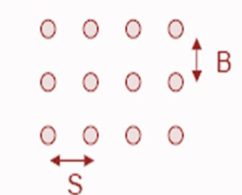

Figure 3.1 Overview of Square Drilling Pattern

#### Rectangular Pattern

Similar to square pattern, but with different spacing in rows and columns, useful for specific blasting geometries.

#### Staggered Pattern

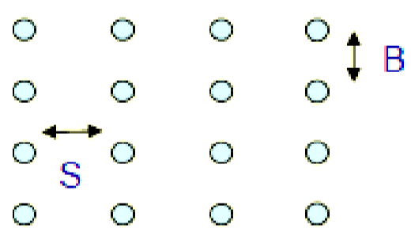

Figure 3.2 Overview of Rectangular Drilling Pattern

Holes are offset in alternating rows, providing better fragmentation and reducing vibration compared to a square pattern.

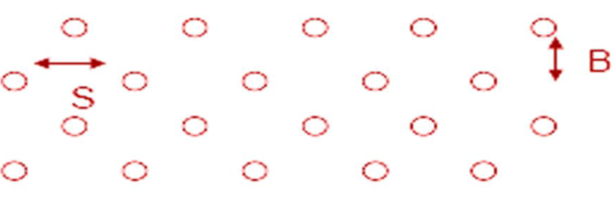

Figure 3.3 Overview of Staggered Drilling Pattern

## Loading Explosives

The next step is to insert explosives into the drilled holes. The type and amount of explosive used depend on the rock type, its density, and the desired result of the blast. The explosives are often in the form of cartridges or bulk explosives, designed to efficiently fracture the rock.  
Main type of explosive used are ANFO (Ammonium Nitrate Fuel Oil), Emulsion Explosives, Slurry Explosives, Gun Powder etc.,

## Blast Initiation

The next step is Blast Initiation it involves connecting the explosives in each hole to a blasting cap or detonator using a fuse or an electronic initiation system. Blasting caps are then connected to a blasting machine or firing device that sends an electrical current to initiate the explosion.

### Blast Initiation Patterns

#### Row to Row Pattern

This is a simple and commonly used pattern where detonators are initiated sequentially, row by row, starting from the bottom row to the upwards. It is suitable for stable rock formations and shallow blasts. It is simple and straightforward to implement. Minimizes the amount of detonator cord needed.

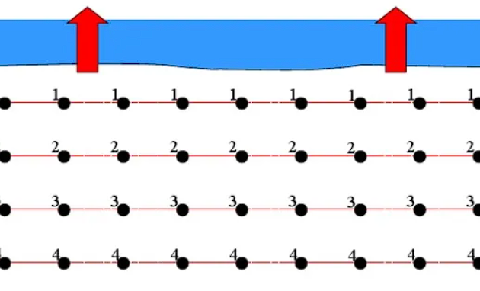

Figure 3.4 Overview of Row to Row Blast Initiation Pattern

#### V-Cut Pattern

This pattern involves drilling a V-shaped notch at the toe (bottom) of the blast face. Detonators are initiated from the apex of the V outwards, towards the free faces (sides and top) of the blast. It is suitable for harder rock formations where good fragmentation is required. Useful for creating a controlled line of breakage for the entire blast. Improves fragmentation, especially in the upper rows. Reduces ground vibration compared to a row-to-row pattern.

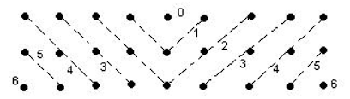

Figure 3.5Overview of V-Cut Blast Initiation Pattern

#### Extended V-Cut Pattern

This is a variation of the V-cut pattern where multiple V-cuts are created in a series, forming a chevron shape. Detonation follows a similar sequence, starting from the apex of each V and progressing outwards. It is used for very large blasts or those requiring exceptional fragmentation control. Offers a more controlled breakage path compared to a single V-cut. It also enhances fragmentation, especially in deeper blasts. Minimizes backbreak (unintended blasting beyond the target area).

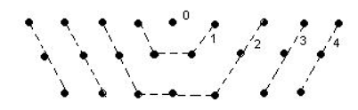

Figure 3.6 Overview of Extended V-Cut Blast Initiation Pattern

## Ground Vibration

When an explosive charge is detonated inside a blast hole, it is instantly converted into hot gases, and the expanding gases exert pressure on the blast hole walls. A high-intensity shock wave travels through the rock mass, which attenuates sharply with distance. A major portion of the explosive energy passes beyond the fractured zone in the form of elastic ground vibrations. As seismic waves travel through the rock mass, they generate particle motions, which are termed as ground vibrations. Vibrations from blasting are transient, but the disturbance may result in permanent damage to property/structure. Thus it is crucial to control the adverse effects of blasting.

### Factors Affecting Ground Vibration

1) Burden: Burden is the minimum distance from the axis of the Blast hole to the Free Face

2) Spacing: Spacing is the distance between two adjacent holes in square row

3) MCPD: Maximum Charge per Delay is the maximum quantity of explosive charge detonated on one interval (delay) within a blast.

4) Powder Factor: Powder Factor is defined as the amount of explosives over the cubic yards of material desired to be blasted.

5) Distance: It is the distance between the blasting site to the point of measurement of the ground vibration

### Control of Ground Vibration

The most common method of controlling ground vibration is by minimizing the charge weight per delay. Delay blasting permits to divide total charge into smaller charges, which are detonated in a predetermined sequence at specified intervals. Blasting without delay or sufficient delay numbers increases ground vibrations due to an increase in maximum charge per delay. The vibration can be significantly reduced by optimizing blast design parameters. It is suggested to establish optimum burden, hole spacing, powder factor, and hookup to control vibration.

# Model Preparation

## Exploratory Data Analysis

Exploratory Data Analysis (EDA) is an approach to analyzing datasets to summarize their main characteristics, often employing visualization methods. The goal is to gain insights into the data, understand its structure, detect patterns, identify outliers, and formulate hypotheses that can be further investigated. The data is collected from the various projects available in the internet, it consists of ensembled data of 993 Rock Blasts. I identified missing values, outliers, and inconsistencies in the data and removed them to ensure its quality and reliability. I also identified the trends of different input parameters w.r.t PPV using scatter plot of Matplotlib library, They are as follows :-

### Spacing (m) and PPV (mm/s)

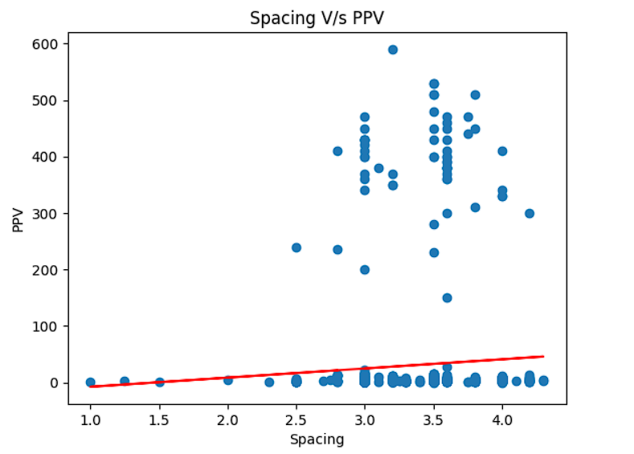

Figure 4.1 Scatter plot between Spacing and PPV

From the above plot we can see that PPV generally increases with increase in spacing but some of them have no trend and independent to each other. This type of plot clearly indicates that it cannot be solved using a regular Linear Regression model.  
Trend Line : y = 16.23x -24.03  
where, y = PPV in mm/sec, x = Spacing in m

### Burden (m) and PPV (mm/s)

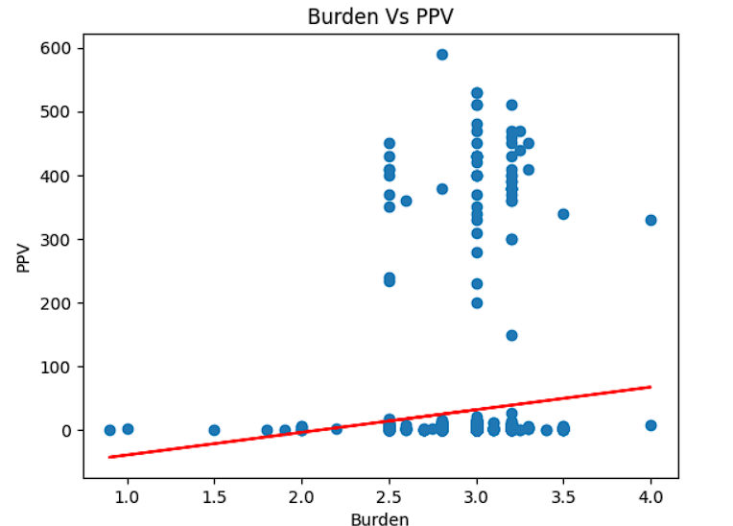

Figure 4.2 Scatter plot between Spacing and PPV

Same as the previous one the above plot we can see that PPV generally increases with increase in Burden but some of them have no trend and independent to each other.  
Trend line: y = 35.48x + -74.22  
where, y = PPV in mm/sec, x = Burden in m

### Powder Factor (kg/m3) and PPV (mm/s)

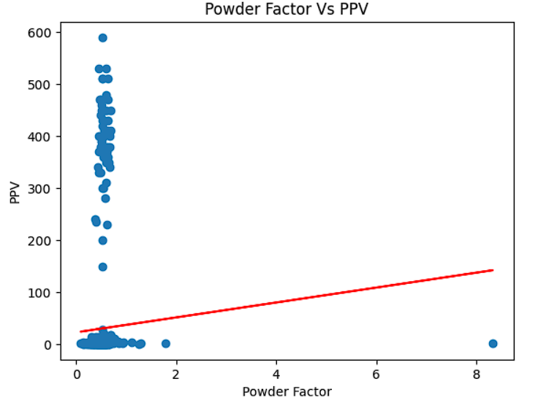

Figure 4.3 Scatter plot between Powder Factor and PPV

Almost all of the data has Powder Factor value in between 0 – 2 kg/m3, and once again the data follows a no trend.  
Trend line: y = 14.35x + 22.60  
where, y = PPV in mm/sec, x = Powder Factor in kg/m3

### MCPD (kg) and PPV (mm/s)

MCPD also doesn’t has any linear or polynomial trend as we can see in the above plot that the points are all spread over and doesn’t follow a trend.  
Trend line: y = 0.32x + -0.33  
where, y = PPV in mm/sec, x = MCPD in kg

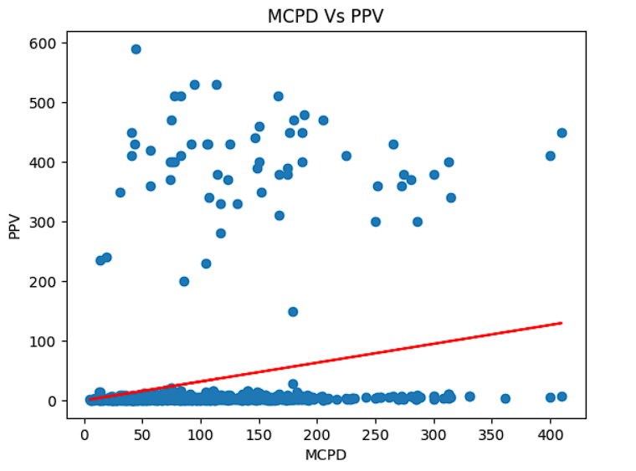

Figure 4.4 Scatter plot between MCPD and PPV

### Distance (m) and PPV (mm/s)

As we can in plot below as the distance increases the PPV decreases. It says that Distance has a negative trend with the PPV. It is because as distance between Point of measurement and face increases the impact of the blasting decreases and there will be less PPV in faraway places as compared to the nearby places.  
Trend line: y = -0.63x + 249.65  
where, y = PPV in mm/sec, x = Distance in m

Upon examination of the scatter plots, it became evident that there were no clear linear trends or polynomial relationships between the input and output parameters. Despite exploring various transformations and feature engineering techniques, we did not observe significant correlations or patterns that could be effectively modeled using traditional linear regression or polynomial regression approaches. Given the lack of linear relationships in my data, I have decided to explore more complex modeling techniques to capture the underlying nonlinear interactions between the input and output variables. ANNs have emerged as a promising solution due to their ability to learn intricate patterns and nonlinear relationships within data. By leveraging ANNs, I aim to develop a predictive model that can effectively capture the complex relationships present in my dataset. ANNs offer the flexibility to automatically learn and adapt to the underlying structure of the data, making them well-suited for tasks where traditional linear models fall short. However I made Linear Regression, Polynomial Regression models to check their performance.

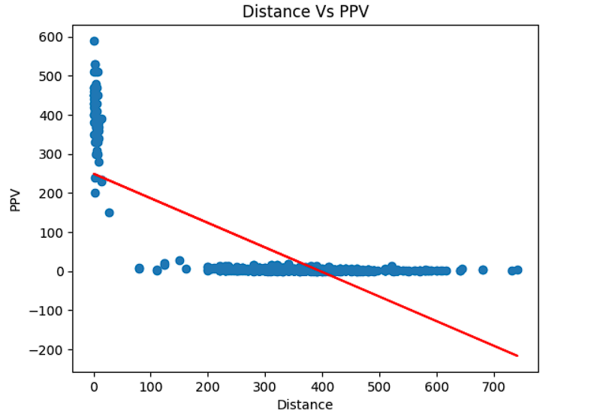

Figure 4.5 Scatter plot between MCPD and PPV

## Linear Regression Model

In this implementation, scikit-learn, a popular machine learning library in Python, is utilized to implement Linear Regression. Scikit-learn provides required set of tools for our Linear Regression model. First, the necessary modules from scikit-learn are imported, including LinearRegression for implementing linear regression, train_test_split for splitting the dataset into training and testing sets, and metrics for evaluating the model's performance. Then, an instance of the LinearRegression class is created, which represents the linear regression model. This model is then trained on the training data using the fit method, which learns the optimal parameters w and b from the training data. Once the model is trained, it is evaluated on the testing data to assess its performance. This is done by making predictions on the testing features using the predict method and comparing these predictions with the actual target values. R2 score is computed using functions from the metrics module.

Weights (w) = [ -4.69875775, 1.07257783, -1.24904128, 20.55022082, -72.5018824]  
Bias (b) = 28.69100958183187  
R2 score = 0.5947980522726319

## Polynomial Regression Model

In this implementation, scikit-learn is utilized to implement Polynomial Regression, an extension of linear regression where the relationship between the independent variable x and the dependent variable y is modeled as an n-degree polynomial. First, the necessary modules from scikit-learn are imported, including PolynomialFeatures for generating polynomial features, LinearRegression for implementing linear regression, Then, an instance of the PolynomialFeatures class is created, specifying the desired degree of the polynomial features. This class transforms the original features into polynomial features up to the specified degree. Subsequently, the transformed features are passed to an instance of the LinearRegression class, which represents the linear regression model. This model is then trained on the training data using the fit method, which learns the optimal parameters w and b from the training data. Once the model is trained, it is evaluated on the testing data to assess its performance. This is done by making predictions on the testing features using the predict method and comparing these predictions with the actual target values. Polynomial Regression is performed for degrees ranging from 1 to 5 and observed that R2 value is highest for degree = 3. The plot showing the R2 score for different degrees is shown below.

Weights (w) for degree 3 = [-4.49e-13, -0.26, -5.61, -8.54, 3.95, -4.62, -4.78, 21.90, 3.60, 1.49, -0.80, -3.38, 4.74, -9.18, 1.97, -92.95, -7.41, -1.66, 2.32, -3.42, 40.76, -2.79, 21.57, 20.81, -4.35, 18.57, 4.11, -6.35, 4.49, -54.54, 121.65, -8.56, 1.79, -2.05, 7.00, 0.42, -11.24, 12.45, 7.84, 39.06, -34.87, 5.24, 0.56, -1.59, 14.82, 13.01, 133.84, -254.89, 229.24, 4.47, 9.15, 12.41, 4.02, -18.51, -13.815, -61.55]

Bias (b) for degree 3 = 28.452354953764853  
R2 score = 0.9458507694937879

Table 4‑1 Degree and R2 Score

|  |  |
| --- | --- |
| **Degree** | **R2 Score** |
| 1 | 0.5947980522726319 |
| 2 | 0.8781305727907925 |
| 3 | **0.9458507694937879** |
| 4 | 0.9350485019172794 |
| 5 | 0.6416884233965652 |

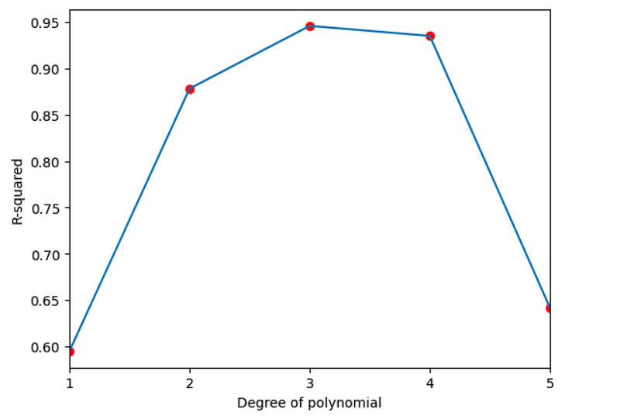

Figure 4.6 Plot between Degree of Polynomial and R2 score

## Artificial Neural Network Model

In this implementation, TensorFlow is utilized to implement an Artificial Neural Network, a versatile and powerful model capable of learning complex patterns in data. First, the necessary modules from TensorFlow are imported, including tensorflow.keras for building and training neural networks, and train_test_split from scikit-learn for splitting the dataset into training and testing sets. T hen, an instance of a Sequential model is created using tf.keras.Sequential(). This model serves as a container for the neural network layers. Subsequently, layers are added to the model. These layers are the type of dense (fully connected). The number of neurons and activation functions for each layer are specified (15-20-10-10-5-1) based on the dataset. After defining the architecture of the neural network, the model is compiled using the compile() method. During compilation, the optimizer, loss function, and evaluation metrics are specified. Common choices for optimizer is Adam optimizer. The loss function used is Mean Square Error Loss Function. Once the model is compiled, it is trained on the training data using the fit() method. Training involves feeding the input data through the network, computing the loss, and updating the network parameters (weights) using backpropagation. The number of epochs used is 35 and batch size is 110 and are typically specified during training. After training, the model's performance is evaluated on the testing data using the predict() method. After training and evaluating the Artificial Neural Network, the results are analyzed to understand its performance and the final R2 Score is obtained to be **0.9776852750791505**

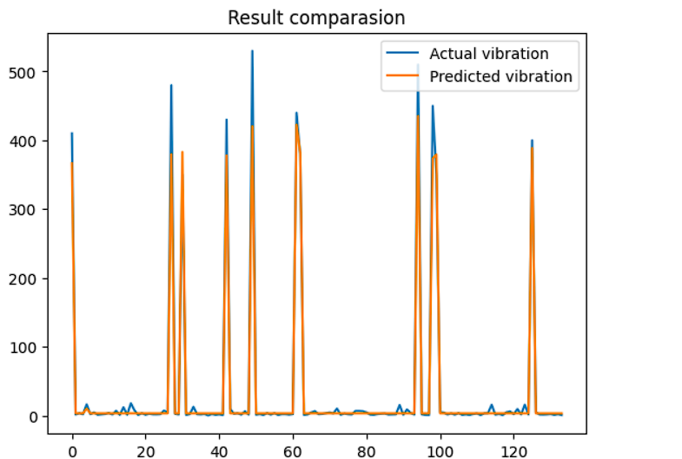

Figure 4.7 Actual Value and Predicted Value

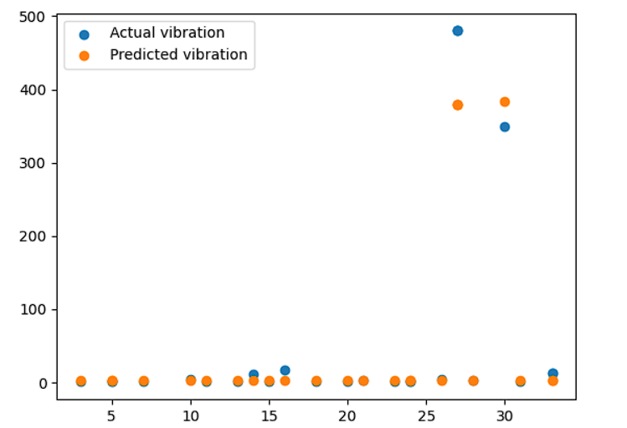

Figure 4.8 Scatter plot between Actual Value and Predicted Value

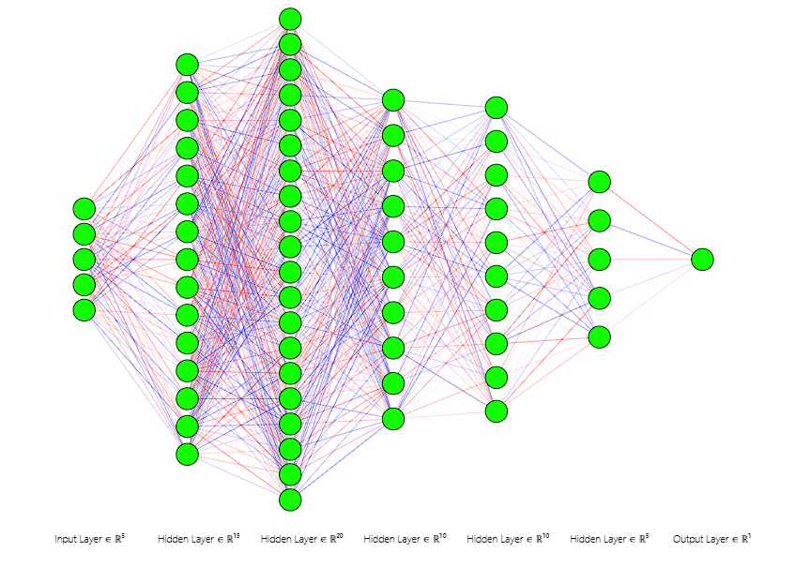

Figure 4.9 Neural Network Layer Architecture used to predict the PPV

# Results and Discussions

After implementing Linear Regression, Polynomial Regression, and ANN models for predicting blast-induced ground vibration, I obtained various R2 values, which serve as indicators of the model’s predictive performance. Upon evaluation, I found that the ANN model yielded the highest R2 value compared to the other two models.

The R2 value, also known as the coefficient of determination, measures the proportion of the variance in the dependent variable that is predictable from the independent variables. A higher R2 value indicates that the model explains a larger proportion of the variance in the target variable, suggesting better predictive capability.

In this case, the high R2 value achieved by the ANN model implies that it effectively captures the complex relationships between the input features and the blast-induced ground vibration. Therefore, based on the obtained results that the ANN model is the most suitable for predicting blast-induced ground vibration. Its high R2 value signifies its effectiveness in capturing the underlying dynamics of the problem, making it a valuable tool for predictive modeling in this domain.

Table 5‑1 Model comparision with R2 Score

|  |  |
| --- | --- |
| Model | R2 Score |
| Linear Regression | 0.5947980522726319 |
| Polynomial Regression (degree = 3) | 0.9458507694937879 |
| Artificial Neural Networks | **0.9776852750791505** |

# Conclusions and Future scope of study

ANN results indicate very close agreement for the PPV with the given data set as compared to Linear and Polynomial Regression. There are Conventional predictors that are based on only maximum charge per delay, distance between blast face and monitoring point and attenuation factor. These predictors do not take into account other influencing parameters. By adopting ANN technique, PPV can be predicted prior to the blast. The blast design can be modified accordingly so that blast nuisances can be minimize a greater utilization of explosive energy is achieved. Considering the complexity of the relationship among the inputs and outputs, the results obtained by ANN is highly encouraging and satisfactory. ANN can learn new patterns that are not previously available in the training dataset. ANN can also update knowledge over time as long as more training data sets are presented, and can process information in parallel way. Therefore, ANN results in a greater degree of accuracy than any other analysis techniques. Also, for the further future scope of study Decision Trees is also an emerging Machine Learning technique. Most of the researchers used Decision Trees for various projects related to mining have got a good result. Ground Vibration PPV can also be calculated using Decision Trees and may have a scope to obtain a better result with more R2 Score.

# References

Adhikari GR, Singh MM, Gupta RN. Influence of rock properties on blastinduced vibration. Min Sci Technol 1989, 297–300.

Armaghani, D. J., Hasanipanah, M., Amnieh, H. B. & Mohamad, E. T. Feasibility of ICA in approximating ground vibration resulting from mine blasting. *Neural Comput. Appl.* **29**, 457–465. <https://doi.org/10.1007/s00521-016-2577-0> (2018).

Dindarloo, S. R. Peak particle velocity prediction using support vector machines: A surface blasting case study. *J. South. Afr. Inst. Min. Metall.* **115**(7), 637–643. <https://doi.org/10.17159/2411-9717/2015/V115N7A10> (2015).

Ghoraba, S., Monjezi, M., Talebi, N., Armaghani, D. J. & Moghaddam, M. R. Estimation of ground vibration produced by blasting operations through intelligent and empirical models. *Environ. Earth Sci.* **75**, 1–9. <https://doi.org/10.1007/s12665-016-5961-2> (2016).

Hajihassani, M., Armaghani, D. J., Marto, A. & Mohamad, E. T. Ground vibration prediction in quarry blasting through an artificial neural network optimized by imperialist competitive algorithm. *Bull. Eng. Geol. Environ.* **74**(3), 873–886. <https://doi.org/10.1007/s10064-014-0657-x> (2015).

Hasanipanah, M., Monjezi, M., Shahnazar, A., Armaghani, D. J. & Farazmand, A. Feasibility of indirect determination of blast induced ground vibration based on support vector machine. *Measurement* **75**, 289 297 <https://doi.org/10.1016/j.measurement.2015.07.019> (2015).

Huang, Y., Yan, L., Cheng, Y., Qi, X. & Li, Z. Coal thickness prediction method based on VMDand,LSTM. <https://doi.org/10.3390/electronics11020232> (2022).

ISRM. Suggested methods for determining tensile strength of rock materials. Int J Rock Mech Min Sci Geomech Abstr 1978, 115:124

Khandelwal, M. and Singh, T. N. Evaluation of blast-induced ground vibration predictors. Soil Dyn. Earthq. Eng. 116–125

Khandelwal, M., Lalit Kumar, D. & Yellishetty, M. Application of soft computing to predict blast-induced ground vibration. *Eng. Comput.* **27**, 117 125 <https://doi.org/10.1007/s00366-009-0157-y> (2011)

Lawal, A. I., Kwon, S., Hammed, O. S. & Idris, M. A. Blast-induced ground vibration prediction in granite quarries: An application of gene expression programming, ANFIS, and sine cosine algorithm optimized ANN. *Int. J. Min. Sci. Technol.* **31**(2), 265–277. <https://doi.org/10.1016/j.ijmst.2021.01.007> (2021).

Mohamadnejad, M., Gholami, R. & Ataei, M. Comparison of intelligence science techniques and empirical methods for prediction of blasting vibrations. *Tunn. Undergr. Space Technol.* **28**, 238–244. <https://doi.org/10.1016/j.tust.2011.12.001> (2012).

Rad, H. N., Hasanipanah, M., Rezaei, M. & Eghlim, A. L. Developing a least squares support vector machine for estimating the blast-induced flyrock. *Eng. Comput.* **34**, 709–717. <https://doi.org/10.1007/s00366-017-0568-0> (2018)

Ragam, P., Komalla, A. R. & Kanne, N. Estimation of blast-induced peak particle velocity using ensemble machine learning algorithms: A case study. *Noise Vib. Worldw.* **53**(7–8), 404–413. <https://doi.org/10.1177/09574565221114662> (2022).

Resende, R., Lamas, L., Lemos, J. and Calçada, R., Stress wave propagation test and numerical modelling of an underground complex. Int. J. Rock Mech. Min. Sci., 2014, 72, 26–36

Shahnazar, A. *et al.* A new developed approach for the prediction of ground vibration using a hybrid PSO-optimized ANFIS-based model. *Environ. Earth Sci.* **76**, 1–17. <https://doi.org/10.1007/s12665-017-6864-6> (2017).