

VMS Login, User Activation & Customer Creation User Manual

Login Screen
First-time users click New User Activation.
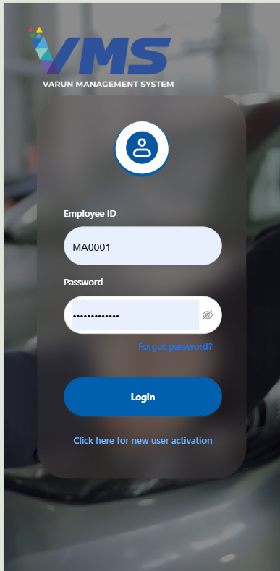

New User Registration
Enter Employee ID and submit.
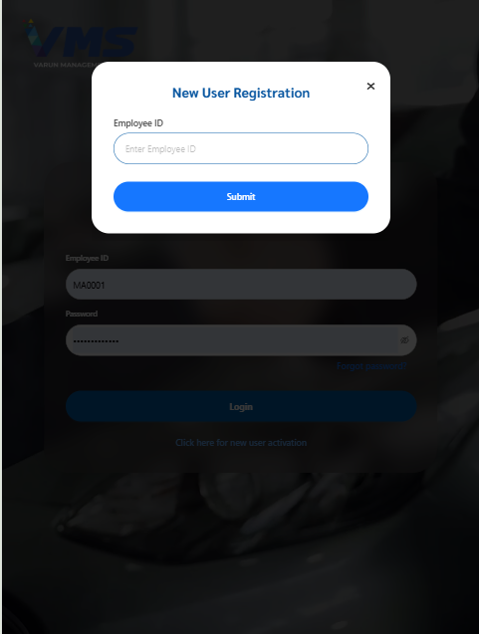

OTP Verification
Enter the 4-digit OTP received on registered mobile.
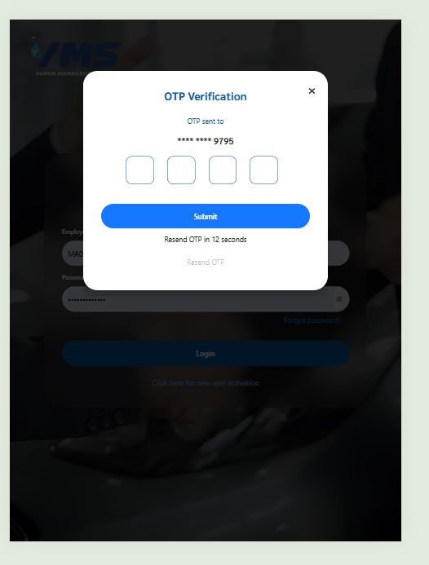

Create Password
Create password with one uppercase letter, one numeric digit and one special character.
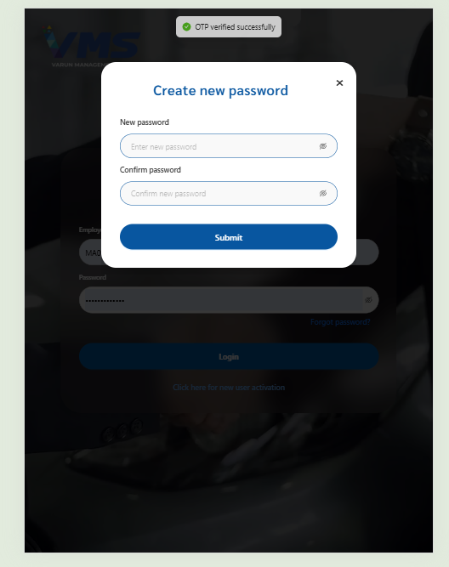

Password Created
Password created successfully.
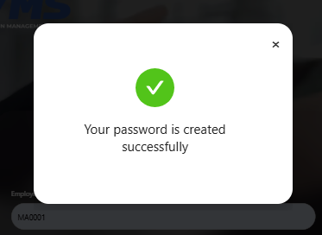

Home Dashboard
Login and access dashboard.
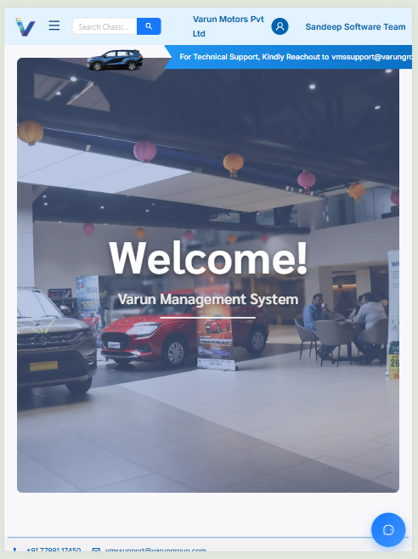

Sales Menu
Open Sales menu and navigate to Customers.
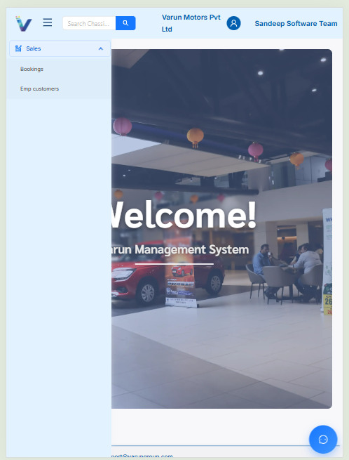

Customer Personal Information
Fill all mandatory customer details.
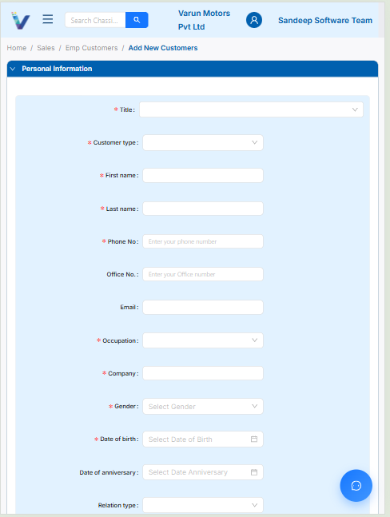

KYC Information
Provide at least one valid KYC document.
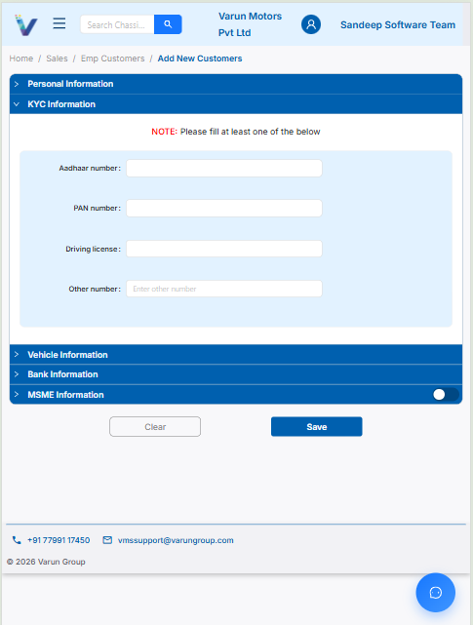

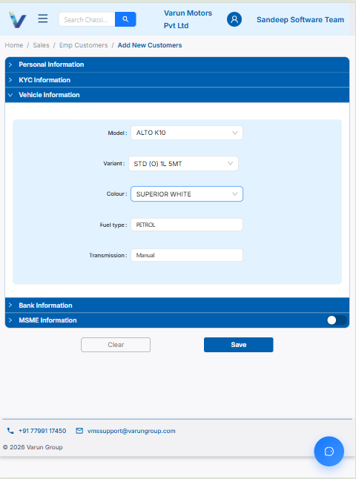
Vehicle Information

Select vehicle details from the list. These were already mapped in Inventory Masters.

MSME Information
Enter MSME details if applicable. And Click Save Button to create customer




