Deploy application using github actions ci/cd to EKS

Prerequisite

1. Terraform
2. Awscli
3. Kubectl

Configure AWS credentials using

aws configure

Clone the github repo  
  
git clone <https://github.com/sandeepkalathil/githubactions-eks.git>

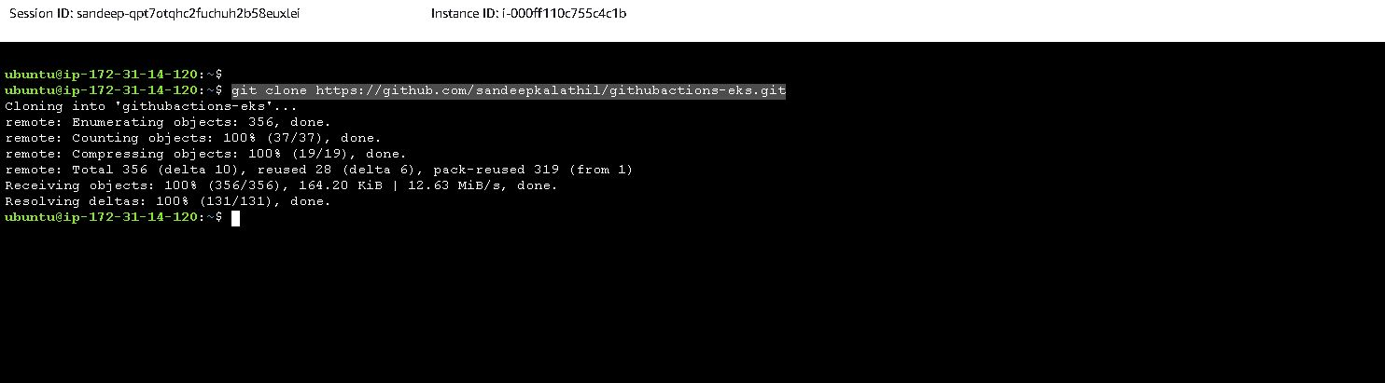

Go to the folder   
  
cd githubactions-eks/

cd terraform/

terraform init

terraform plan

terraform apply

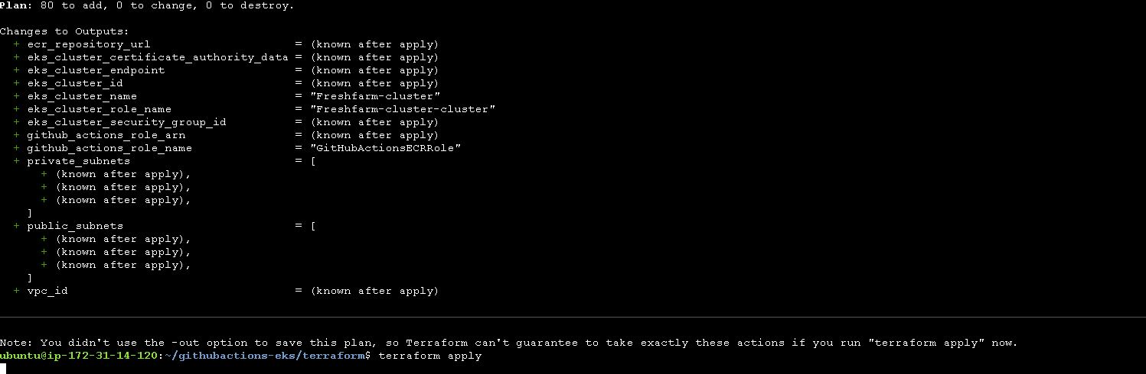

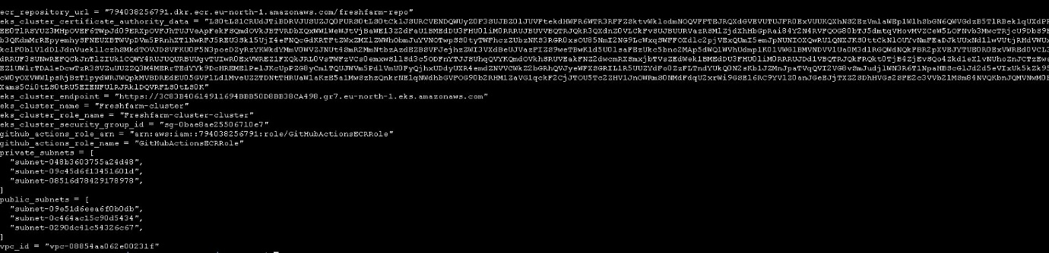

Go to the folder terraform-ingress and run the commands to install nginx-ingress  
  
terraform init

terraform plan

terraform apply

Once the resources are created, create your own Github repository to run the workflow  
  
