LOVELY PROFESSIONAL UNIVERSITY
Punjab, India
AQUA ALERT-AI
Urban Waterlogging Prediction Using Machine Learning
PROJECT REPORT
Submitted in partial fulfilment of the academic requirements for
Master of Technology (M.Tech)
Computer Science and Engineering – Data Science and Analytics
Semester 1
Submitted by
Sandeep Kaur
Registration Number: 12629813
Under the Guidance of
Mr. Pardeep Kumar
Submission Year: 2026

Table of Contents
- 1. Introduction
- 2. Problem Statement
- 3. Objectives
- 4. Dataset Description
- 5. Methodology and Workflow
- 6. Exploratory Data Analysis
- 7. Model Development
- 8. Model Evaluation and Results
- 9. Streamlit Dashboard
- 10. Conclusion
- 11. Limitations
- 12. References
- 13. Project Links and Evidence
Note: Page numbers can be added after final pagination in Microsoft Word.

1. Introduction
Urban waterlogging is an environmental and infrastructure challenge that can disrupt transportation, affect public safety, and create difficulties for residents and local authorities. Analysing recorded flood events can help describe patterns in flood depth, duration, timing, and severity.
AquaAlert-AI is an academic machine learning project developed to analyse urban street-flooding events using the FloodNet dataset from New York City. The project applies data preprocessing, exploratory data analysis, feature engineering, classification, and regression techniques. A Streamlit dashboard presents visualisations and allows users to demonstrate model predictions.
The current implementation analyses recorded flood events. It classifies the severity of a recorded event and estimates maximum flood depth from selected event and sensor attributes. It does not provide real-time flood forecasting or predict whether a location will experience a flood in the future.

2. Problem Statement
Raw urban flooding datasets may contain missing values, inconsistent data formats, and variables measured on different scales. A structured data science workflow is required to clean the data, explore relevant patterns, and evaluate machine learning models.
This project addresses the development of a machine learning workflow that processes historical street-flooding event data, classifies recorded events into project-defined severity categories, and estimates maximum flood depth. An interactive dashboard is developed to make the analysis and model demonstrations accessible.

3. Objectives
- Collect and load urban street-flooding event data.
- Inspect the dataset for missing values, duplicate records, and data-type issues.
- Clean and preprocess the dataset using Python libraries.
- Perform exploratory data analysis using statistical summaries and visualisations.
- Analyse outliers and relationships between numerical variables.
- Create time-based features and project-defined flood severity categories.
- Train and compare machine learning classification algorithms.
- Implement Linear Regression to estimate maximum flood depth.
- Evaluate model performance using appropriate classification and regression metrics.
- Develop an interactive Streamlit dashboard for data exploration and model demonstration.

4. Dataset Description

4.1 Dataset Source
The project uses the publicly available dataset “FloodNet: Street Flooding Events Measured by FloodNet Sensors”, published on NYC Open Data. The dataset provides event-level information about street-flooding events measured by FloodNet sensors in New York City.
Official dataset page: https://data.cityofnewyork.us/Environment/FloodNet-Street-Flooding-Events-Measured-by-FloodN/aq7i-eu5q

4.2 Dataset Overview
Attribute | Value
Records in local CSV snapshot | 3,581
Original columns | 13
Duplicate rows identified | 0
Missing values identified | 1
Raw file | data/raw/floodnet_street_flooding.csv

These values describe the local CSV snapshot used during project development. The live NYC Open Data dataset may be updated, so its current record count may differ.

4.3 Important Attributes
- Sensor Name and Sensor ID
- Flood Start Datetime and Flood End Datetime
- Maximum Flood Depth (inches)
- Time to Maximum Flood Depth (minutes)
- Time to Drain From Peak (minutes)
- Total Duration (minutes)
- Duration of Flooding Greater Than 4, 12, and 24 Inches

4.4 Dataset Scope
The dataset contains recorded flood events rather than a balanced collection of flood and non-flood observations. Therefore, this project classifies the severity of recorded events; it does not train a flood-versus-no-flood classifier. The data is specific to New York City and should not be generalised to other regions without additional local data and validation.

5. Methodology and Workflow
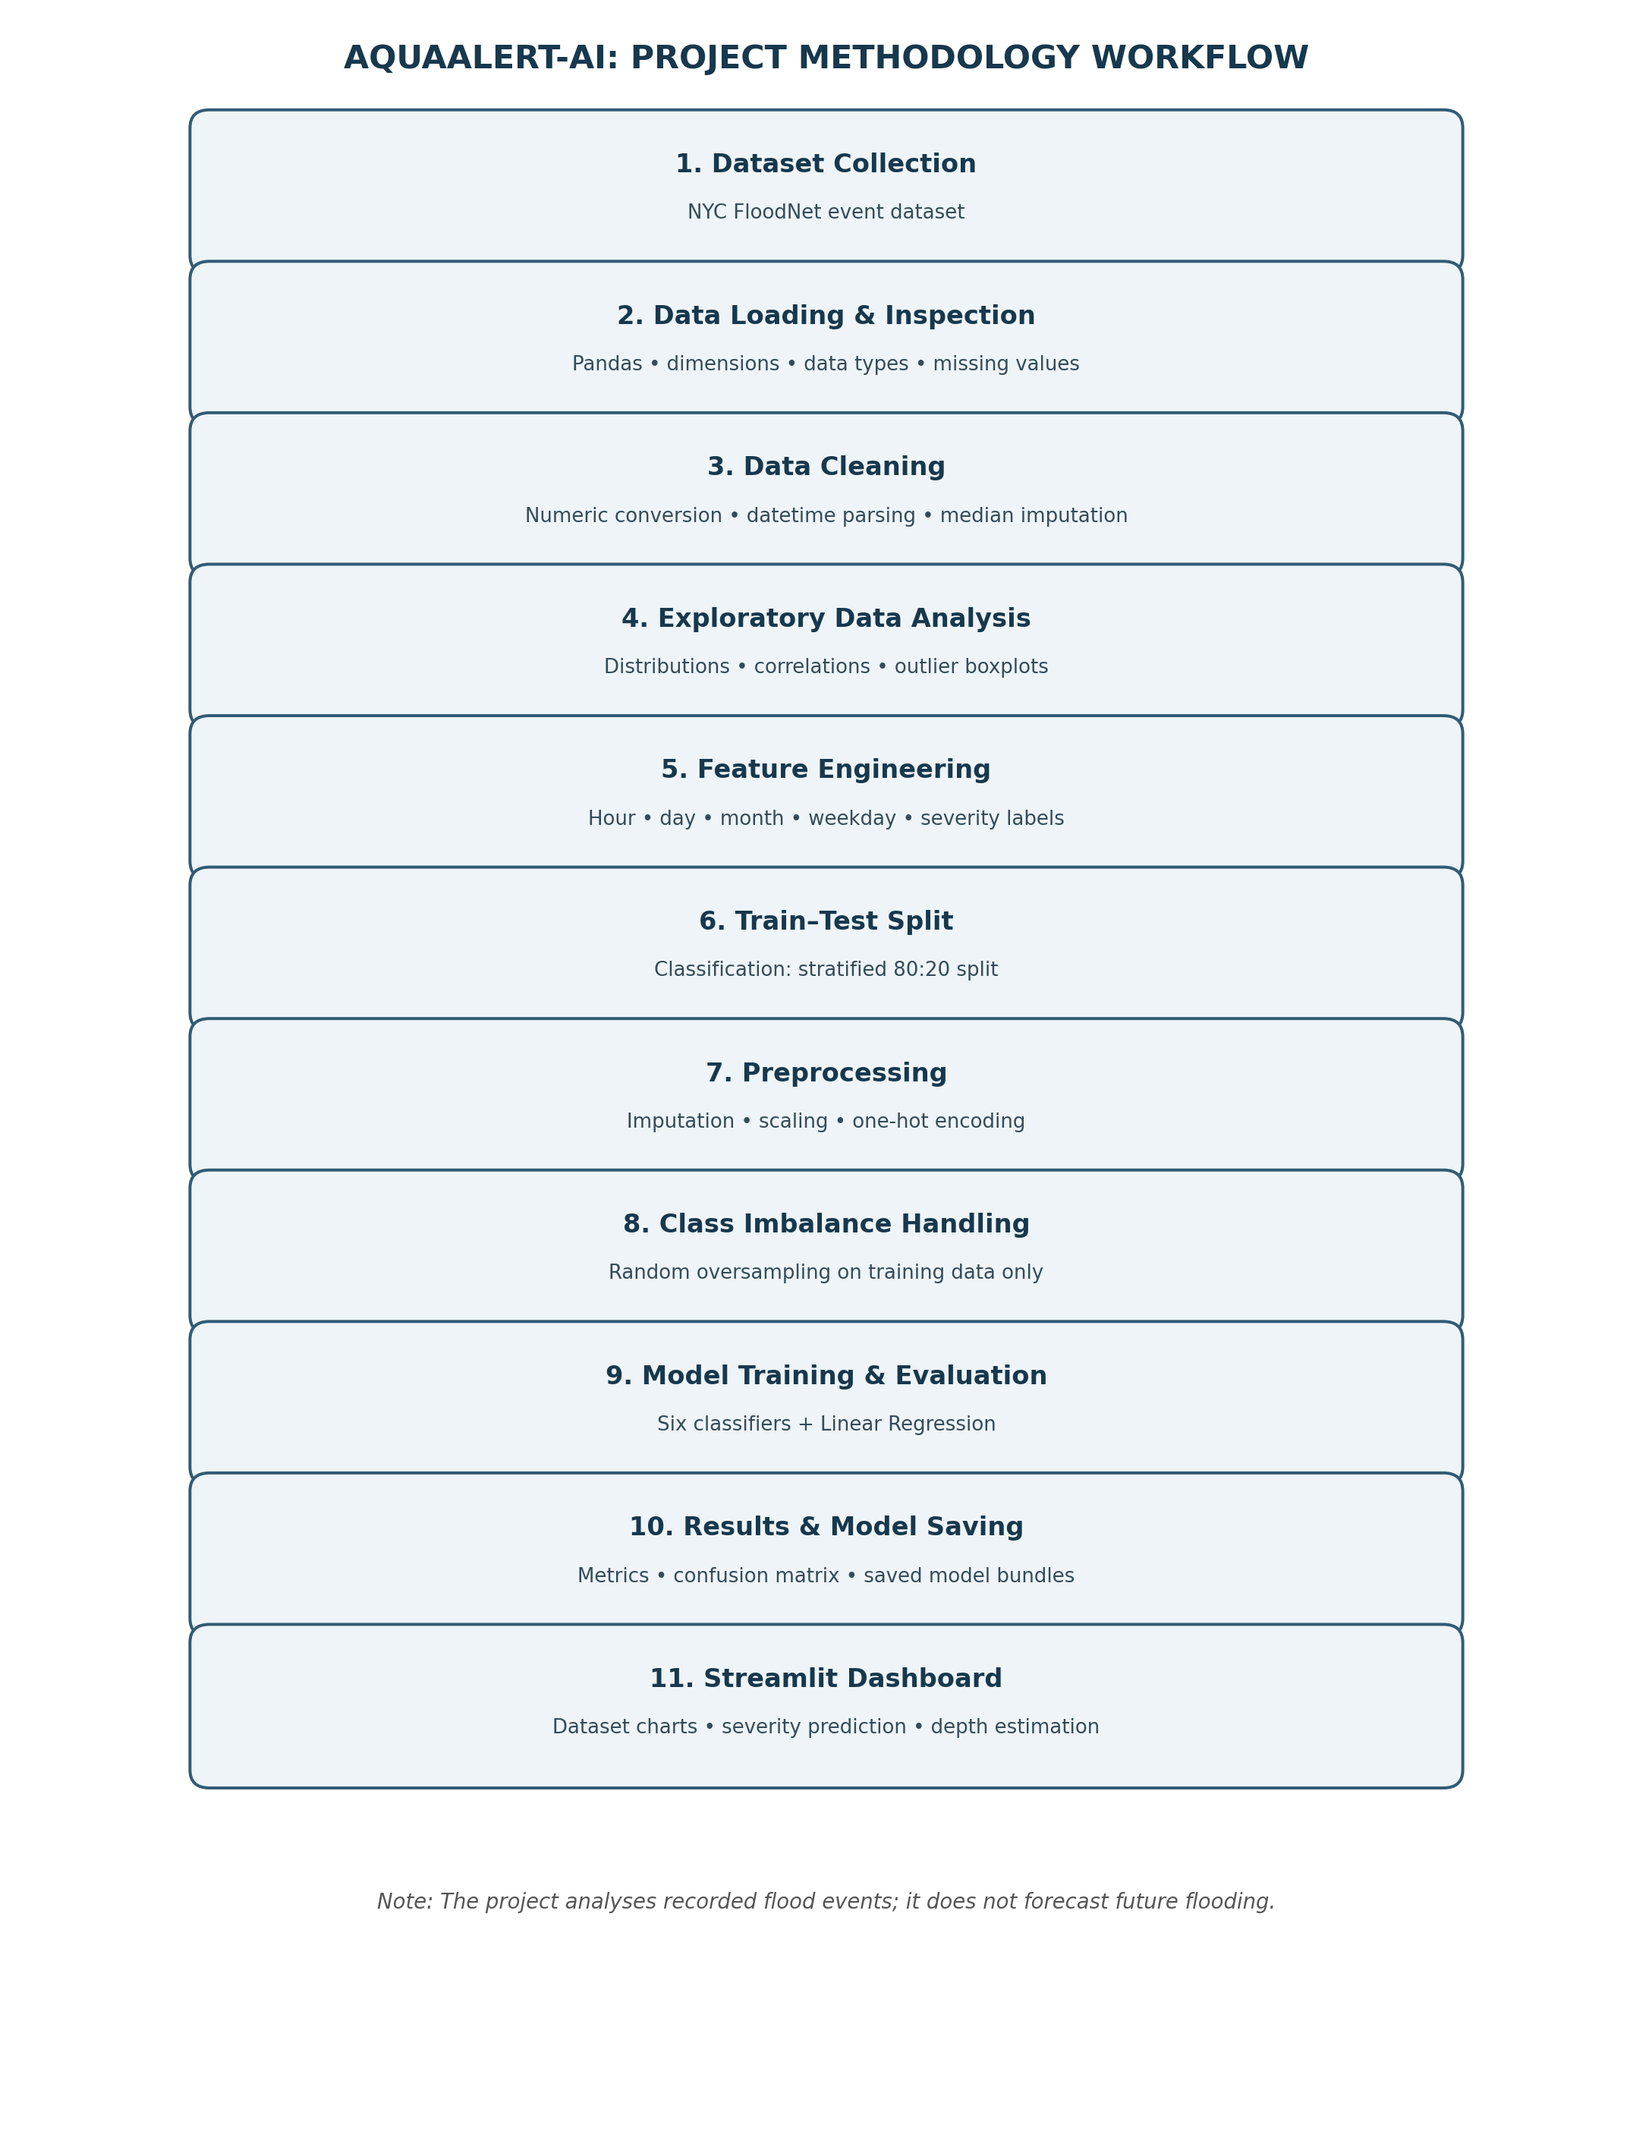
Figure 1. Methodology workflow of the AquaAlert-AI project.

5.1 Data Loading and Inspection
The dataset was loaded using Pandas. Initial inspection was performed to understand its dimensions, column names, data types, missing values, and duplicate records. NumPy and Pandas were used for numerical operations and data manipulation.

5.2 Data Cleaning
- Numeric-looking values containing commas were converted into numerical format.
- Numerical columns were converted using pd.to_numeric() with invalid values handled as missing values.
- Date and time values were parsed using Pandas datetime functionality.
- One missing value was identified in Time to Drain From Peak (minutes).
- The missing numerical value was filled using median imputation; the median used was 53.555.
- No duplicate rows were identified.
The cleaned dataset was saved as data/processed/floodnet_cleaned.csv.

5.3 Feature Engineering
Four time-based features were extracted from the flood start datetime: Flood Start Hour, Flood Start Day, Flood Start Month, and Flood Start Weekday.
Severity category | Maximum flood depth
Low | Less than 4 inches
Moderate | 4 to less than 12 inches
High | 12 to less than 24 inches
Severe | 24 inches or above

These are project-defined categories for academic analysis and are not official FloodNet warning categories. The featured dataset was saved as data/processed/floodnet_featured.csv.

5.4 Data Preprocessing
The classification data was split into training and testing sets using an 80:20 ratio, random_state=42, and stratification by the target class. Numerical features were processed using median imputation and StandardScaler. Categorical features were processed using most-frequent imputation and OneHotEncoder(handle_unknown='ignore'). A ColumnTransformer combined the transformations. The preprocessing pipeline was fitted on training data and then applied to test data.

5.5 Class Imbalance Handling
RandomOverSampler was applied only to the training data. After oversampling, each training class contained 1,593 observations. The test set was not oversampled and retained its original class distribution. This preserves the test set for evaluation on the held-out observations.

6. Exploratory Data Analysis

6.1 Flood Depth Distribution
The maximum flood depth distribution was right-skewed. Most recorded events had relatively lower maximum depths, while a smaller number of events reached higher depths.
[Insert project figure here: Figure 1 – Maximum Flood Depth Distribution (reports/figures/flood_depth_distribution.png)]
Figure 2. Distribution of maximum flood depth.

6.2 Correlation Analysis
Variable pair | Observed correlation
Maximum Flood Depth and Duration Greater Than 12 Inches | Approximately 0.64
Maximum Flood Depth and Duration Greater Than 4 Inches | Approximately 0.61
Time to Drain From Peak and Total Duration | Approximately 0.93
Duration Greater Than 12 Inches and Duration Greater Than 24 Inches | Approximately 0.62

The strong positive correlation between time to drain from peak and total duration indicates that these variables are closely related in the recorded events.
[Insert project figure here: Figure 2 – Correlation Heatmap (reports/figures/correlation_heatmap.png)]
Figure 3. Correlation heatmap of selected numerical variables.

6.3 Outlier Analysis
Boxplots were generated to inspect the distribution and possible outliers in maximum flood depth, total duration, time to drain from peak, and duration of flooding greater than 4 inches.
[Insert project figure here: Figure – Maximum Flood Depth (inches) – maximum_flood_depth_(inches)_boxplot.png]
[Insert project figure here: Figure – Total Duration (minutes) – total_duration_(minutes)_boxplot.png]
[Insert project figure here: Figure – Time to Drain From Peak (minutes) – time_to_drain_from_peak_(minutes)_boxplot.png]
[Insert project figure here: Figure – Duration Greater Than 4 Inches – duration_of_flooding_greater_than_4_inches_(minutes)_boxplot.png]
Figures 4–7. Boxplots used for outlier analysis.

7. Model Development

7.1 Classification Models
Six classification algorithms were trained to predict the project-defined Flood Severity target:
- Logistic Regression
- K-Nearest Neighbours (KNN)
- Decision Tree
- Random Forest
- Support Vector Machine (SVM)
- Gaussian Naive Bayes
The classifier used six input features: Flood Start Hour, Flood Start Day, Flood Start Month, Flood Start Weekday, Sensor Name, and Sensor ID. Maximum Flood Depth was excluded from the classifier inputs because it was used to derive the severity target.

7.2 Regression Model
Linear Regression was implemented to estimate Maximum Flood Depth (inches). It used the same six input features: Flood Start Hour, Flood Start Day, Flood Start Month, Flood Start Weekday, Sensor Name, and Sensor ID. Maximum Flood Depth was the numerical target.
A separate 80:20 train-test split was used for the regression experiment. A fresh preprocessing pipeline was fitted on the regression training data and applied to the test data. The trained model and preprocessing pipeline were saved in models/linear_regression_model.joblib.

7.3 Saved Model Artifacts
The Random Forest classifier and its preprocessing pipeline were saved together in models/random_forest_model.joblib. The Linear Regression model and its preprocessing pipeline were saved together in models/linear_regression_model.joblib.

8. Model Evaluation and Results

8.1 Classification Metrics
The classification models were evaluated using accuracy, macro precision, macro recall, and macro F1-score. Accuracy measures the proportion of correct predictions. Precision measures the correctness of predictions for a class, while recall measures the proportion of actual class observations correctly identified. The F1-score combines precision and recall. Macro averages give equal weight to each class.

8.2 Classification Model Comparison
Model | Accuracy | Macro Precision | Macro Recall | Macro F1
Logistic Regression | 45.47% | 36.21% | 42.08% | 33.17%
KNN | 49.37% | 36.10% | 41.98% | 35.72%
Decision Tree | 54.39% | 42.51% | 42.89% | 42.47%
Random Forest | 58.44% | 42.21% | 38.28% | 39.60%
SVM | 50.91% | 36.63% | 42.67% | 36.95%
Naive Bayes | 20.64% | 32.24% | 29.62% | 18.39%

Random Forest achieved the highest accuracy (58.44%). Decision Tree achieved the highest macro F1-score (42.47%). Thus, the preferred model depends on the evaluation metric.

8.3 Random Forest Class-wise Results
Severity | Precision | Recall | F1-score | Support
Low | 0.68 | 0.68 | 0.68 | 399
Moderate | 0.49 | 0.53 | 0.51 | 260
High | 0.26 | 0.20 | 0.23 | 50
Severe | 0.25 | 0.12 | 0.17 | 8

The model performed better for Low and Moderate classes than for High and Severe classes. The Severe category had only eight observations in the test set. Its low recall indicates difficulty identifying this minority class; therefore, the model should not be treated as reliable for high-stakes flood warning decisions.
[Insert project figure here: Figure 7 – Random Forest Confusion Matrix (reports/figures/random_forest_confusion_matrix.png)]
Figure 8. Confusion matrix for the Random Forest classifier.

8.4 Regression Results
Metric | Result
MAE | 3.0123 inches
MSE | 20.3840 inches squared
RMSE | 4.5149 inches
R-squared | 0.2134

The MAE indicates an average absolute prediction error of approximately 3.01 inches. The RMSE was approximately 4.51 inches. The R-squared score of 0.2134 indicates that the model explains approximately 21.34% of the variation in maximum flood depth on the evaluated test data. This indicates limited predictive performance.

9. Streamlit Dashboard
An interactive dashboard was developed using Streamlit. It loads the saved model bundles and the featured dataset. The application includes Home, Severity Prediction, Flood Depth Estimation, and About sections.

9.1 Home Page
The Home page displays the number of dataset records, average maximum flood depth, maximum recorded flood depth, and four visualisations: Flood Severity Distribution, Maximum Flood Depth Distribution, Flood Events by Hour, and Average Flood Depth by Severity.

9.2 Severity Prediction
The Severity Prediction page accepts Sensor Name, Sensor ID, Flood Start Hour, Flood Start Day, Flood Start Month, and Flood Start Weekday. It applies the saved preprocessing pipeline and Random Forest classifier to display a predicted severity category.

9.3 Flood Depth Estimation
The Flood Depth Estimation page accepts the same six input features and uses the saved Linear Regression model to display an estimated maximum flood depth in inches. The application displays a warning if the estimated value is negative.

9.4 Dashboard Screenshots
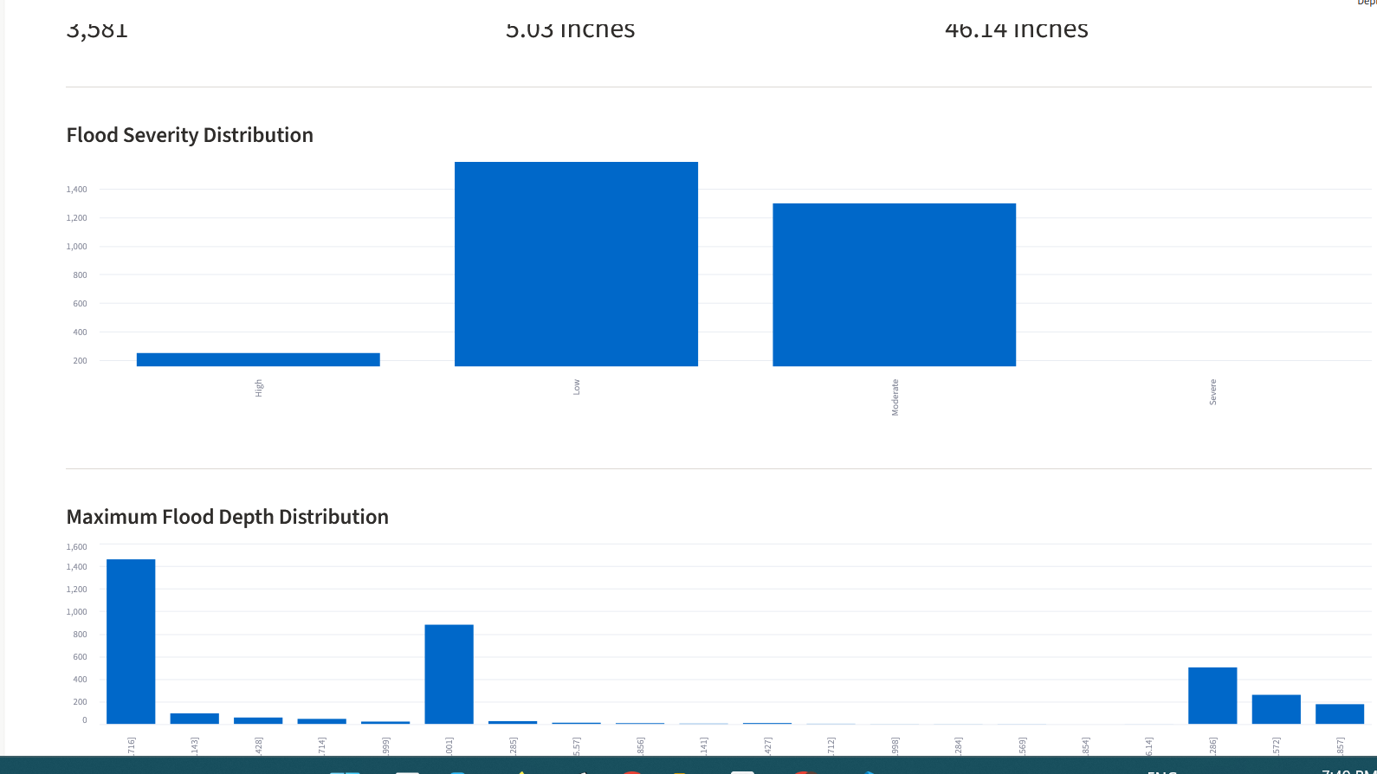
Figure 9. Dashboard overview showing severity and maximum flood depth distributions.
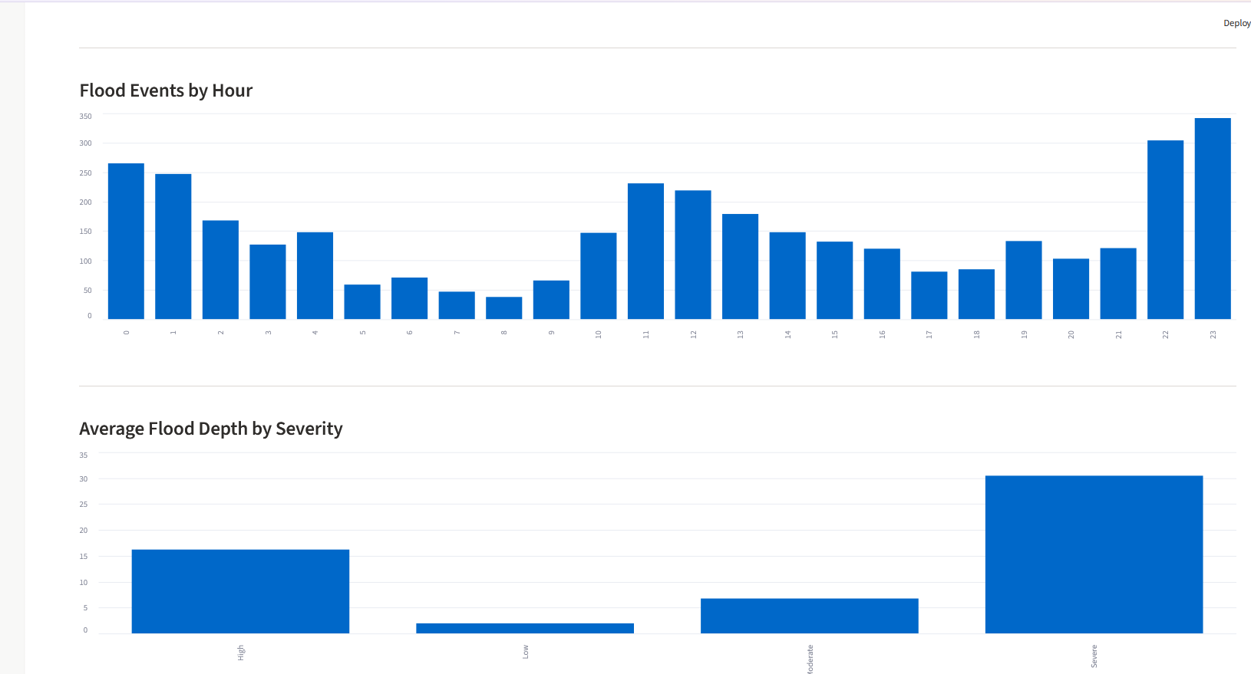
Figure 10. Dashboard charts showing flood events by hour and average depth by severity.
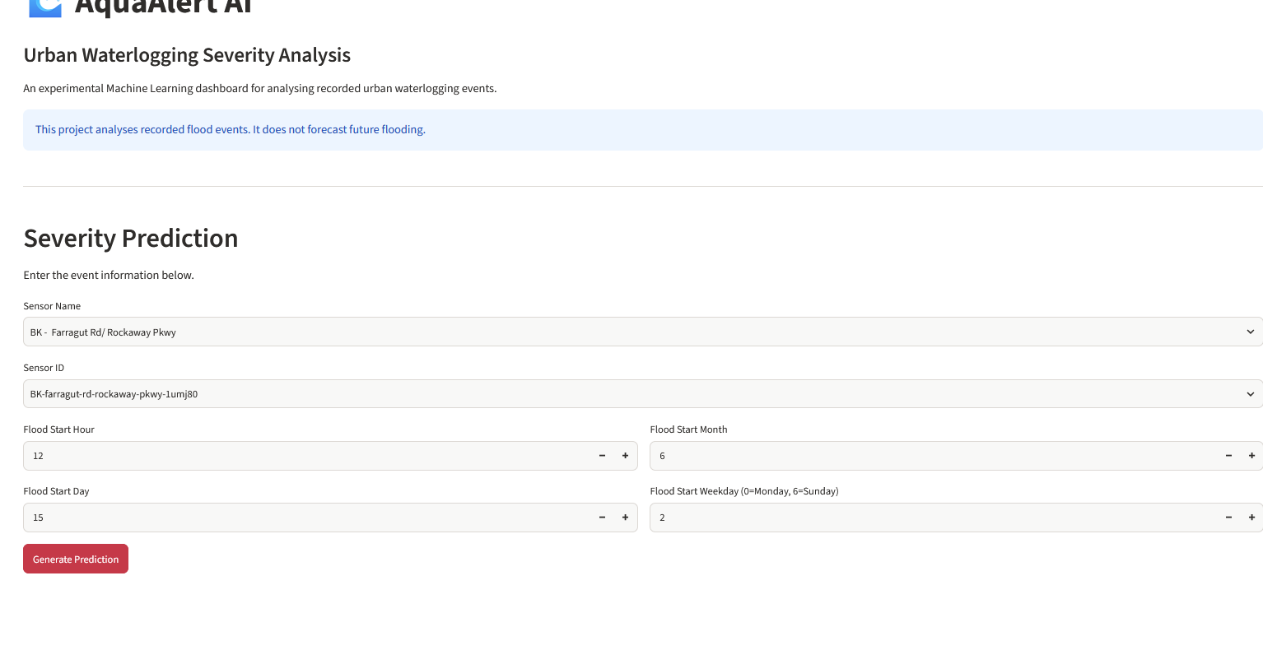
Figure 11. Severity Prediction interface.
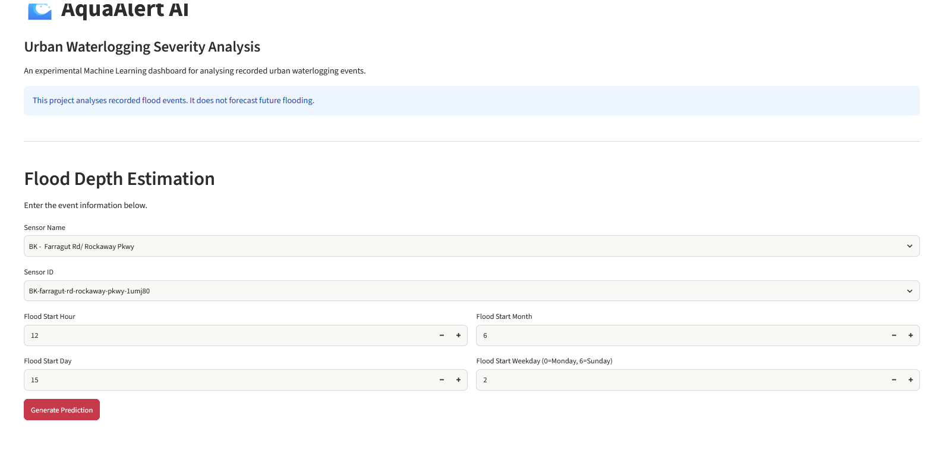
Figure 12. Flood Depth Estimation interface.
The dashboard includes a notice that the project analyses recorded flood events and does not forecast future flooding. It is an experimental academic application and should not be used for real-world emergency decisions.

10. Conclusion
AquaAlert-AI demonstrates the application of machine learning techniques to urban street-flooding event data. The project covered data loading, cleaning, exploratory data analysis, feature engineering, preprocessing, classification, regression, model evaluation, and dashboard development.
Six classification algorithms were compared. Random Forest achieved the highest accuracy of 58.44%, while Decision Tree achieved the highest macro F1-score of 42.47%. The Linear Regression model achieved an R-squared score of 0.2134, indicating limited explanatory performance.
The project provides practical experience in the machine learning workflow and demonstrates how historical event data can be analysed and presented through an interactive dashboard. Its results are exploratory and should not be interpreted as real-time flood forecasts.

11. Limitations
- Dataset scope: The dataset contains recorded flood events and does not provide non-flood observations for training a flood/no-flood classifier.
- Geographical limitation: The dataset is based on New York City and may not represent flooding conditions in other regions.
- Limited input features: Rainfall, weather forecasts, drainage network conditions, and live sensor readings are not included as model inputs.
- Class imbalance: The Severe category has very few test observations, affecting reliable evaluation of that class.
- Classification performance: Model performance is limited, particularly for minority severity categories.
- Regression performance: The Linear Regression R-squared score is 0.2134, so much of the variation in maximum flood depth remains unexplained.
- No real-time forecasting: The application does not use live sensor feeds or weather forecasts to predict future flooding.
- Project-defined severity: The severity thresholds are defined for this academic project and are not official FloodNet alert categories.

12. References
[1] NYC Open Data. “FloodNet: Street Flooding Events Measured by FloodNet Sensors.” https://data.cityofnewyork.us/Environment/FloodNet-Street-Flooding-Events-Measured-by-FloodN/aq7i-eu5q
[2] NumPy Developers. “NumPy Documentation.” https://numpy.org/doc/
[3] pandas Development Team. “pandas Documentation.” https://pandas.pydata.org/docs/
[4] Scikit-learn Developers. “Scikit-learn User Guide.” https://scikit-learn.org/stable/user_guide.html
[5] imbalanced-learn Developers. “imbalanced-learn Documentation.” https://imbalanced-learn.org/stable/
[6] Streamlit. “Streamlit Documentation.” https://docs.streamlit.io/

13. Project Links and Evidence
GitHub Repository: https://github.com/sandeepkaur075/AquaAlert-AI
Source Code: The src/ directory and root-level app.py file in the repository.
Project screenshots: The screenshots/ directory in the repository.
Dataset source: https://data.cityofnewyork.us/Environment/FloodNet-Street-Flooding-Events-Measured-by-FloodN/aq7i-eu5q
LinkedIn Evidence: Not published at the time of report preparation. Add a project post URL here if one is published later.

Final Editing Checklist
- Insert the four EDA/outlier figure files and the Random Forest confusion matrix at the indicated placeholders.
- Update the Table of Contents page numbers after the document is finalised.
- Confirm the official course/project report template and any required declaration or certificate pages with the university.
- Check the submission date and supervisor name spelling against university records.
- Review all results against the saved CSV result files before submission.

