**Creating the Azure VPN**

In this section, we’ll be creating a virtual network in the Azure portal.

**Step 1:** Create the virtual network:

After login to Azure portal, click New -> Networking -> Virtual Network, Create

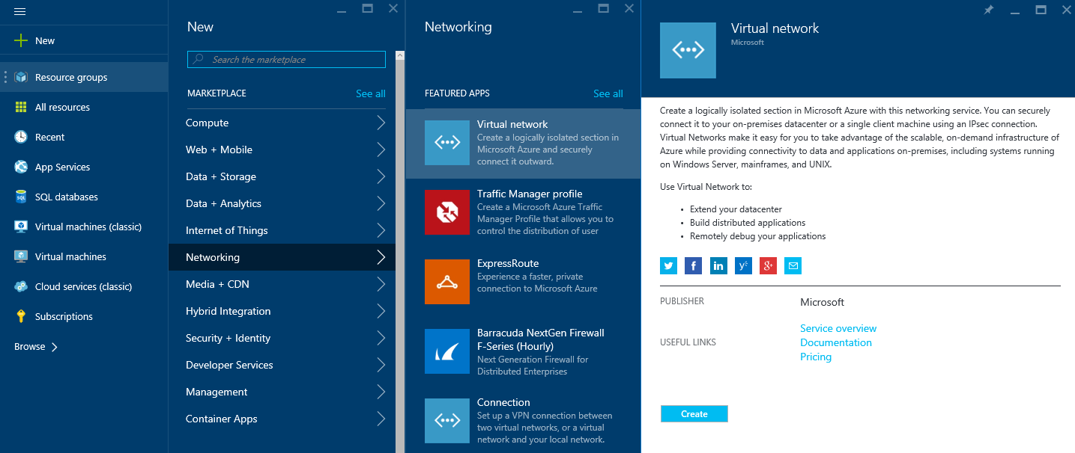

**Step 2:** Create new virtual network

Fill in the name of Virtual Network, the Address range you wish to use in Azure, and the location.

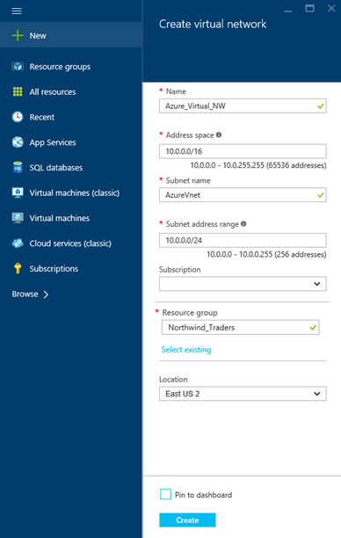

**Step 3:** After creation of a virtual network add a gateway subnet named GatewaySubnet

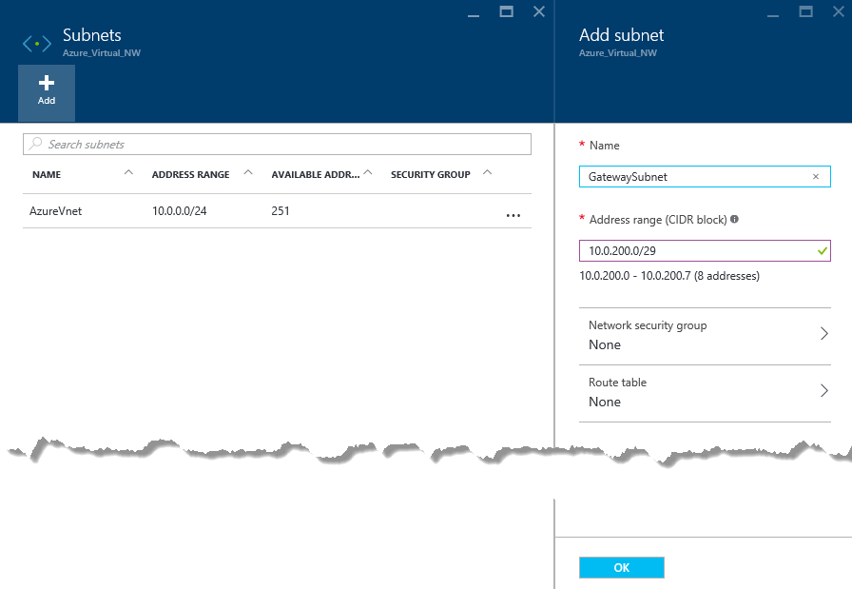

**Step 4:** Create a VPN Connection

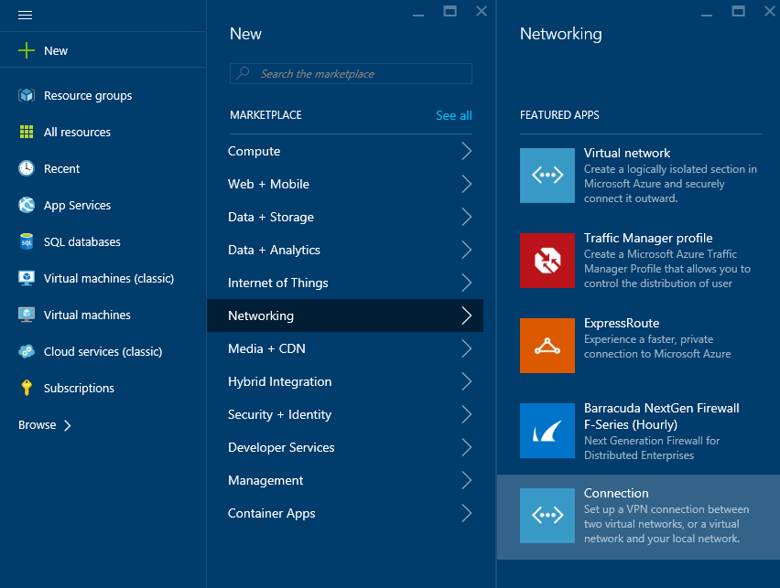

**Step 5**: Setup Azure Route-based gateway

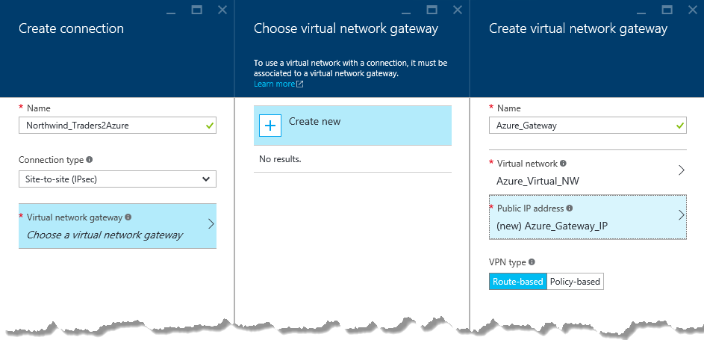

**Step 6:** Setup Local Gateway

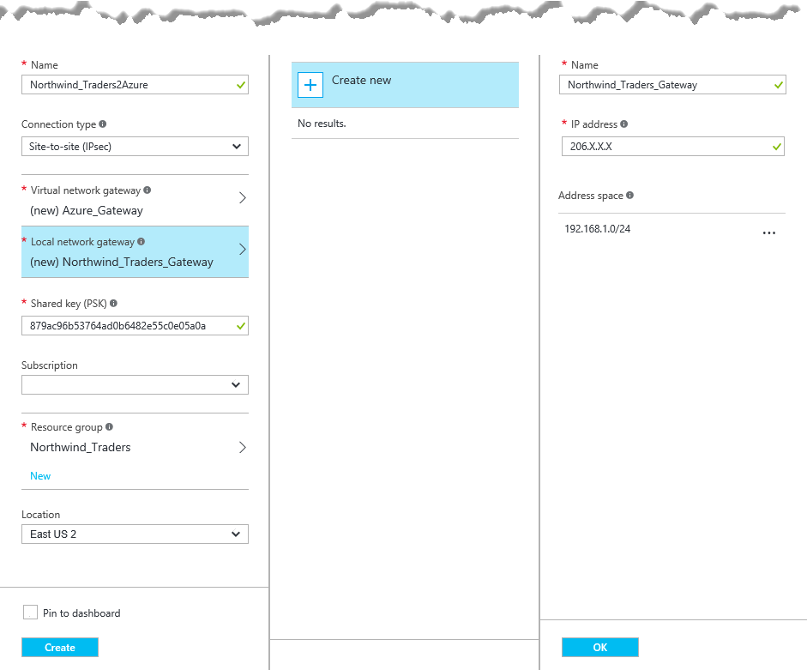

In our example:

**Local virtual network gateway:** 206.X.X.X *(SSG external interface IP (Public IP address)*

**Local Network Address:** 192.168.1.0/24 *(Your on-premises local network. Specify starting IP address of your network.)*

**Shared Key:** 879ac96b53764ad0b6482e55c0e05a0a

It takes couple of minutes to create Gateway Connection. Once created review the Virtual Network Gateway IP Address

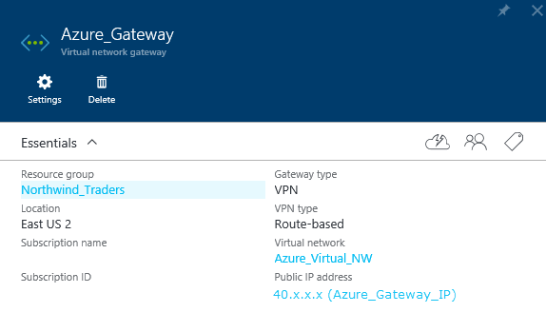

**Configuring the SSG**

Now we need to configure the SSG. Log into the ScreenOS. One we have logged into ScreenOS CLI we need to see what route can reach the Dynamic Azure Gateway

The ScreenOS command is **Get Interface**

Machine generated alternative text:
. c0c0 . becb 
. c0c0 . beca 
ssgS—seriaI—» get interface 
D 
Down, 
R 
Re ady 
Z one 
Null 
Unt rus t 
Trust 
Null 
Null 
Null 
Null 
001b 
001b 
001b 
001b 
001b 
001b 
001b 
. c0c0 
. c0c0 
. c0c0 
. c0c0 
. c0c0 
VIAN 
be co 
be c 5 
be c c 
be ce 
be Cf 
state VSD 
ve , 
Inte r fa ce s 
serial 0/0 
ethO O 
e thO/I 
b graupO 
ethO/ 2 
ethO/ 3 
ethO/ 4 
ethO/5 
ethO/ 6 
bg roup2 
v lanl 
nul I 
Inact i ve, U 
in vsys Root : 
IP Address 
o. 0/0 
0.0 
206. x. x. x 
o. 0/0 
0.0 
192.168.1 
0 0.0. 0/0 
0 0.0. 0/0 
0 0.0. 0/0 
0 0.0. 0/0 
o.o.o.o/o 
24 
1/24 

In this example **eth0/0** is the name of the outgoing-interface, **bgroup0** is the name of the bridge group interface

The follow script may need to be modified to suit your device

*###Script Begin###*

*set interface tunnel.1 zone untrust*

*set interface tunnel.1 ip unnumbered interface* ***bgroup0***

*set route* ***10.0.0.0/16*** *interface tunnel.1*

*set ike gateway ikev2 azure-gateway address* ***40.X.X.X*** *outgoing-interface* ***eth0/0*** *preshare* ***879ac96b53764ad0b6482e55c0e05a0a*** *sec-level compatible*

*set ike gateway azure-gateway dpd-liveness interval 10*

*set vpn azure-ipsec-vpn gateway azure-gateway tunnel idletime 0 sec-level compatible*

*set vpn azure-ipsec-vpn bind interface tunnel.1*

*set address trust onprem-networks-1* ***192.168.1.0/24***

*set address untrust azure-networks-1* ***10.0.0.0/16***

*set policy top from trust to untrust onprem-networks-1 azure-networks-1 any permit*

*set policy top from untrust to trust azure-networks-1 onprem-networks-1 any permit*

*set flow vpn-tcp-mss 1350*

*save*

*###Script End###*

###Script Key###

**bgroup0 is the name of the bridge group interface**

**eth0/0 is the name of the outgoing-interface**

**40.X.X.X is the IP address of the Dynamic Azure gateway**

***879ac96b53764ad0b6482e55c0e05a0a* is the Azure Gateway preshared key**

10.0.0.0/16 this is the IP address rage of the azure-networks

**192.168.1.0/24 this is IP address range of the onprem-networks**

We will need to use the text typed at the terminal as input to the configuration

How to check to see main mode is connected

The ScreenOS command is **Get SA**

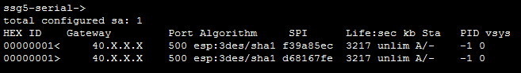

([Both A/- and A/U are positive states that your tunnel is up](http://kb.juniper.net/InfoCenter/index?page=content&id=KB6134&actp=search))

We can also check the Azure Gateway to view connection

