ToothGrowth

### Overview

For this excercise, we will look at the data for the ToothGrowth dataset, and determine which variables have an impact on the growth of teeth.

### Review of the Data

First, we need to look at the data to understand the variables and the overall summary.

head(ToothGrowth)

## len supp dose  
## 1 4.2 VC 0.5  
## 2 11.5 VC 0.5  
## 3 7.3 VC 0.5  
## 4 5.8 VC 0.5  
## 5 6.4 VC 0.5  
## 6 10.0 VC 0.5

summary(ToothGrowth)

## len supp dose   
## Min. : 4.20 OJ:30 Min. :0.500   
## 1st Qu.:13.07 VC:30 1st Qu.:0.500   
## Median :19.25 Median :1.000   
## Mean :18.81 Mean :1.167   
## 3rd Qu.:25.27 3rd Qu.:2.000   
## Max. :33.90 Max. :2.000

Next, it will be helpful to see some graphs of the main variables: length, supplement, and dose.

## Warning: package 'ggplot2' was built under R version 3.2.3

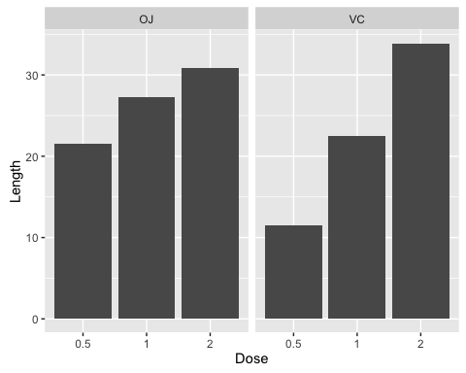

### T Test for Supp

Having reviewed our data, we should now begin looking at how t-tests compare across the variables.

t.test(len ~ supp, ToothGrowth, var.equal = FALSE)

##   
## Welch Two Sample t-test  
##   
## data: len by supp  
## t = 1.9153, df = 55.309, p-value = 0.06063  
## alternative hypothesis: true difference in means is not equal to 0  
## 95 percent confidence interval:  
## -0.1710156 7.5710156  
## sample estimates:  
## mean in group OJ mean in group VC   
## 20.66333 16.96333

Unfortunately, given that the p-value is above 0.05, the data is not statistically significant and we cannot reject the null hypothesis.

### T Test for Dose

Next, we will need to complete t-tests for the various dose levels.

t.test(ToothGrowth$len[ToothGrowth$dose == 2],ToothGrowth$len[ToothGrowth$dose == 1])

##   
## Welch Two Sample t-test  
##   
## data: ToothGrowth$len[ToothGrowth$dose == 2] and ToothGrowth$len[ToothGrowth$dose == 1]  
## t = 4.9005, df = 37.101, p-value = 1.906e-05  
## alternative hypothesis: true difference in means is not equal to 0  
## 95 percent confidence interval:  
## 3.733519 8.996481  
## sample estimates:  
## mean of x mean of y   
## 26.100 19.735

t.test(ToothGrowth$len[ToothGrowth$dose == 2],ToothGrowth$len[ToothGrowth$dose == 0.5])

##   
## Welch Two Sample t-test  
##   
## data: ToothGrowth$len[ToothGrowth$dose == 2] and ToothGrowth$len[ToothGrowth$dose == 0.5]  
## t = 11.799, df = 36.883, p-value = 4.398e-14  
## alternative hypothesis: true difference in means is not equal to 0  
## 95 percent confidence interval:  
## 12.83383 18.15617  
## sample estimates:  
## mean of x mean of y   
## 26.100 10.605

t.test(ToothGrowth$len[ToothGrowth$dose == 1],ToothGrowth$len[ToothGrowth$dose == 0.5])

##   
## Welch Two Sample t-test  
##   
## data: ToothGrowth$len[ToothGrowth$dose == 1] and ToothGrowth$len[ToothGrowth$dose == 0.5]  
## t = 6.4766, df = 37.986, p-value = 1.268e-07  
## alternative hypothesis: true difference in means is not equal to 0  
## 95 percent confidence interval:  
## 6.276219 11.983781  
## sample estimates:  
## mean of x mean of y   
## 19.735 10.605

Given that all three levels have a p-value of less than 0.05, we can reject the null hypothesis for all three cases.

### Conclusion

Based on our conclusion, different dosages can have an effect on the length of teeth. However, the supplement does not.