Problem 2
%script_simaircraft06.m
%
% Copyright (c) 2019 Mark L. Psiaki. All rights reserved.
%
% This Matlab script simulates the motion of an
% aircraft by using the design and control input
% data in maneuver02_data.mat
% and the point-mass translational aircraft
% dynamics model in ffunctaircraft03.m.
%
% This script uses N-point trapezoidal numerical
% integration in order to do the numerical
% integration.
%
% This script also makes plots of the flight time history.
%
% Clear the Matlab workspace.
%
clear
%
% Load the aircraft parameters, the thrust, angle-of-attack,
% and roll/bank-angle input time histories, and the initial
% state vector.
%
load maneuver02_data
%
% Define the aircraft dynamics function handle
% in a form that is suitable for input to ode45.m
% or to a trapezoidal numerical integration.
%
ffunctode45_03 = @(tdum,xdum) ...
ffunctaircraft03(tdum,xdum,m,S,CLalpha,CD0,oneoverpiARe,...
tinhist,Thist,alphahist,phihist);
%
% Define the time span of the simulation, computing outputs
% every half second.
%
t0 = tinhist(1,1);
tf = tinhist(end,1);
%
% Compute the ode45.m results using a very
% precise relative tolerance.
%
tspan = (t0:0.5:tf)';
optionsode45 = odeset('RelTol',1.e-12);
tic
[thist03,xhist03] = ode45(ffunctode45_03,tspan,x0,optionsode45);
timetoode45 = toc
%
% Set up 3 different N values and prepare to store 3 different
% time histories generated by trapezoidal integration.
%
Nvec = [500;2000;8000];
thist03_trapez_cell = cell(3,1);
xhist03_trapez_cell = cell(3,1);
timetotrapez_vec = zeros(3,1);
%
% Select N and perform N steps of trapezoidal numerical integration
% to go from time tmin to time tmax.
%
n = size(x0,1);
for jj = 1:3
N = Nvec(jj,1)
deltat = (tf-t0)/N;
Np1 = N + 1;
thist03_trapez = zeros(Np1,1);
xhist03_trapez = zeros(Np1,n);
thist03_trapez(1,1) = t0;
xhist03_trapez(1,:) = x0';
clear Np1
tic
tkp1 = t0;
xkp1 = x0;
for k = 0:(N-1);
tk = tkp1;
xk = xkp1;
tak = tk;
xak = xk;
fak = ffunctode45_03(tak,xak);
tbk = tk+deltat;
xbk = xk+deltat*fak;
fbk = ffunctode45_03(tbk,xbk);
tkp1 = tk+deltat;
xkp1 = xk+(deltat/2)*(fak+fbk);
kp2 = k + 2;
thist03_trapez(kp2,1) = tkp1;
xhist03_trapez(kp2,:) = xkp1';
end
clear k tk xk tak xak fak tbk xbk fbk tkp1 xkp1 kp2
timetotrapez = toc
timetotrapez_vec(jj,1) = timetotrapez;
thist03_trapez_cell{jj,1} = thist03_trapez;
xhist03_trapez_cell{jj,1} = xhist03_trapez;
end
clear jj N deltat thist03_trapez xhist03_trapez timetotrapez
%
% Plot the ground track.
%
figure(1)
hold off
plot(xhist03(:,2)*0.001,xhist03(:,1)*0.001,'b-','LineWidth',3)
hold on
plot(xhist03_trapez_cell{1,1}(:,2)*0.001,...
xhist03_trapez_cell{1,1}(:,1)*0.001,'k:','LineWidth',1.5)
plot(xhist03_trapez_cell{2,1}(:,2)*0.001,...
xhist03_trapez_cell{2,1}(:,1)*0.001,'g--','LineWidth',1.5)
plot(xhist03_trapez_cell{3,1}(:,2)*0.001,...
xhist03_trapez_cell{3,1}(:,1)*0.001,'r-.','LineWidth',1.5)
hold off
grid
axis('equal')
xlabel('Eastward Displacement (km)')
ylabel('Northward Displacment (km)')
title('Ground Tracks for simaircraft06.mat')
legend('ode45.m',...
['Trapezoidal integration w/',int2str(Nvec(1,1)),' steps'],...
['Trapezoidal integration w/',int2str(Nvec(2,1)),' steps'],...
['Trapezoidal integration w/',int2str(Nvec(3,1)),' steps'])
%
% Plot the altitude, airspeed, flight-path angle,
% and heading angle time histories.
%
figure(2)
subplot(411)
hold off
plot(thist03,-xhist03(:,3),'b-','LineWidth',3)
hold on
plot(thist03_trapez_cell{1,1},-xhist03_trapez_cell{1,1}(:,3),...
'k:','LineWidth',1.5)
plot(thist03_trapez_cell{2,1},-xhist03_trapez_cell{2,1}(:,3),...
'g--','LineWidth',1.5)
plot(thist03_trapez_cell{3,1},-xhist03_trapez_cell{3,1}(:,3),...
'r-.','LineWidth',1.5)
hold off
grid
ylabel('Altitude above Airport (m)')
title('State time histories for simaircraft06.mat')
legend('ode45.m',...
['Trapezoidal integration w/',int2str(Nvec(1,1)),' steps'],...
['Trapezoidal integration w/',int2str(Nvec(2,1)),' steps'],...
['Trapezoidal integration w/',int2str(Nvec(3,1)),' steps'])
subplot(412)
hold off
plot(thist03,xhist03(:,4),'b-','LineWidth',3)
hold on
plot(thist03_trapez_cell{1,1},xhist03_trapez_cell{1,1}(:,4),...
'k:','LineWidth',1.5)
plot(thist03_trapez_cell{2,1},xhist03_trapez_cell{2,1}(:,4),...
'g--','LineWidth',1.5)
plot(thist03_trapez_cell{3,1},xhist03_trapez_cell{3,1}(:,4),...
'r-.','LineWidth',1.5)
hold off
grid
ylabel('Airspeed (m/sec)')
subplot(413)
hold off
plot(thist03,xhist03(:,5)*(180/pi),'b-','LineWidth',3)
hold on
plot(thist03_trapez_cell{1,1},...
xhist03_trapez_cell{1,1}(:,5)*(180/pi),'k:','LineWidth',1.5)
plot(thist03_trapez_cell{2,1},...
xhist03_trapez_cell{2,1}(:,5)*(180/pi),'g--','LineWidth',1.5)
plot(thist03_trapez_cell{3,1},...
xhist03_trapez_cell{3,1}(:,5)*(180/pi),'r-.','LineWidth',1.5)
hold off
grid
ylabel('Flight Path Angle (deg)')
subplot(414)
hold off
plot(thist03,xhist03(:,6)*(180/pi),'b-','LineWidth',3)
hold on
plot(thist03_trapez_cell{1,1},...
xhist03_trapez_cell{1,1}(:,6)*(180/pi),'k:','LineWidth',1.5)
plot(thist03_trapez_cell{2,1},...
xhist03_trapez_cell{2,1}(:,6)*(180/pi),'g--','LineWidth',1.5)
plot(thist03_trapez_cell{3,1},...
xhist03_trapez_cell{3,1}(:,6)*(180/pi),'r-.','LineWidth',1.5)
hold off
grid
ylabel('Heading Angle (deg)')
xlabel('Time (seconds)')
%
% Plot the thrust, angle-of-attack, and roll/bank-angle
% time histories.
%
figure(3)
subplot(311)
hold off
plot(tinhist,Thist,'LineWidth',1.5)
grid
ylabel('Thrust (N)')
title('Control input time histories for simaircraft06.mat')
subplot(312)
hold off
plot(tinhist,alphahist*(180/pi),'LineWidth',1.5)
grid
ylabel('Angle-of-Attack (deg)')
subplot(313)
hold off
plot(tinhist,phihist*(180/pi),'LineWidth',1.5)
grid
ylabel('Roll/Bank-Angle (deg)')
xlabel('Time (seconds)')
%
% Display final state error.
%
format long
errorxfinal_500 = xhist03_trapez_cell{1,1}(end,:)' - xhist03(end,:)'
errorxfinal_2000 = xhist03_trapez_cell{2,1}(end,:)' - xhist03(end,:)'
errorxfinal_8000 = xhist03_trapez_cell{3,1}(end,:)' - xhist03(end,:)'
%
% Save the results.
%
textcommands = ['These data have been generated by the',...
' commands in script_simaircraft06.m'];
save simaircraft06
disp('errorxfinal_2000./errorxfinal_8000')
disp(errorxfinal_2000./errorxfinal_8000)
Output
timetoode45 = 1.379359100000000
N = 500
timetotrapez = 0.237054400000000
N = 2000
timetotrapez = 0.917606000000000
N = 8000
timetotrapez = 3.608178800000000
errorxfinal_500 =
1.0e+02 *
2.470874862165565
0.312780779269015
-0.020084760958699
-0.001686353740498
0.000002202438762
0.000076213603099
errorxfinal_2000 =
4.784498364122555
0.478795131981315
-0.085716895745350
-0.007187758640072
0.000037796464585
0.000149039574289
errorxfinal_8000 =
0.302894297890816
0.029262601630762
-0.004806028911162
-0.000405483572820
0.000002360428262
0.000009412494139
errorxfinal_2000./errorxfinal_8000
15.795934084725539
16.362015176326043
17.835285082508793
17.726386768487977
16.012545345590301
15.834227580369248
Q) How do errorxfinal_2000 and errorxfinal_8000 for this run compare errorxfinal_10000 and errorxfinal_100000 for the Euler integration run?
Ans) The are off by 2 orders of magnitude. About 100 to 40 times lower in Trapezoidal integration.

Q) How does trapezoidal integration compare to ode45.m in terms of execution speed?
Ans) The speeds are comparable.

Q) The theory of Euler’s method predicts that these ratios should be about 10. Is that true?
Ans) Yes. It is close to 16.
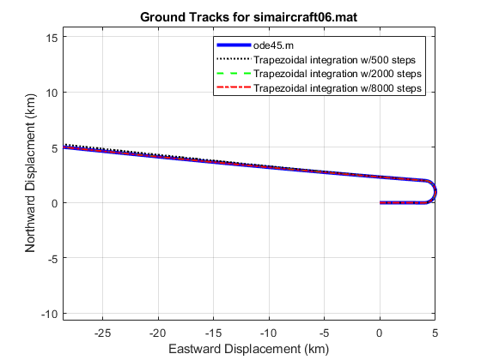
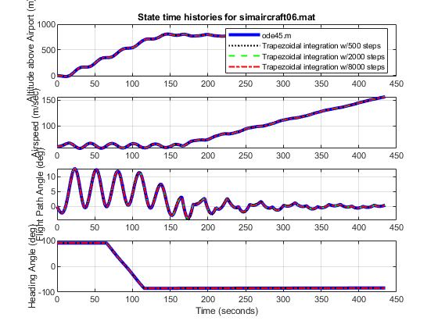
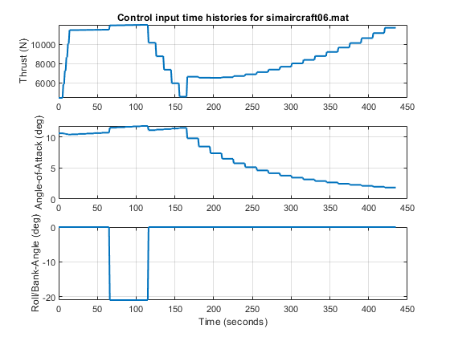
Published with MATLAB® R2019a

