Problem 2
%script_analandsimaircraft01.m
Controllabilitymat = ctrb(A,B); % C = [B, A*B, A^2 * B, ... , A^5 * B ]
K = place(A,B,closedloopeigenvalues);
ulinearfeedbackfunct = @(targdum,xargdum) ...
ueq - K*(xargdum - xeq - [XdotSM;YdotSM;zeros(4,1)]*targdum); % U = Ueq+deltaU = Ueq-K*DeltaX
Acl = A-B*K;

Output

A =
1.0e+02 *
Columns 1 through 3
0 0 0
0 0 0
0 0 0
0 0 -0.000001048938339
0 0 0.000000079431148
0 0 0
Columns 4 through 6
0.000000000000000 0 -1.200000000000000
0.010000000000000 0 0.000000000000000
0 -1.200000000000000 0
-0.000178843986844 -0.097972100000000 0
0.000013543010718 0 0
0 0 0
B =
0 0 0
0 0 0
0 0 0
0.000190227105528 -4.521936465223459 0
0.000000068313232 1.895722868536017 0
0 0 0.081643416666667
lambdavec =
-0.008942199342177 + 0.118918387346877i
-0.008942199342177 - 0.118918387346877i
-0.000000000000000 + 0.000000000000000i
0.000000000000000 + 0.000000000000000i
0.000000000000000 + 0.000000000000000i
0.000000000000000 + 0.000000000000000i
maxreallambda =
0
This system may be neutrally stable because the maximum
eigenvalue real part maximized over all of its eigenvalues
appears to be zero to within machine precision.
Warning: For eigenvalue lambda = -1.8629e-18, the rank of (lambda*eye(n) - A) is
4 but it should be smaller, it should be 2 in order for neutral
stability to hold true, because this eigenvalue is repeated 4 times.
Therefore, this system is unstable.
svsControllabilitymat =
1.0e+02 *
2.283055293661830
0.185122207963509
0.097972100000000
0.048885111439677
0.000816434166667
0.000001396474218
The system is controllable.
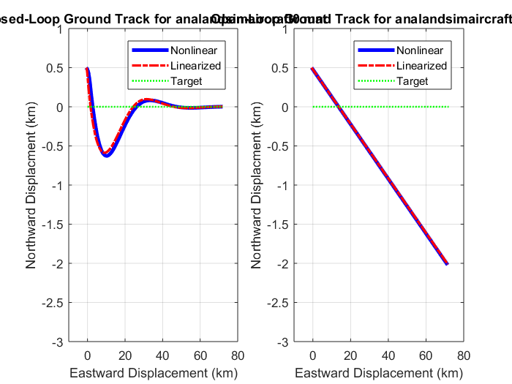
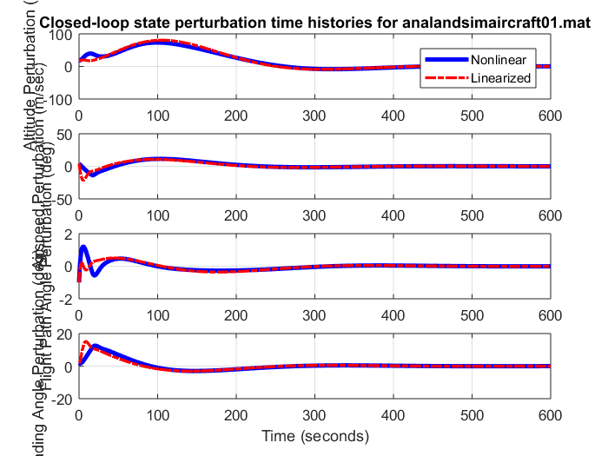
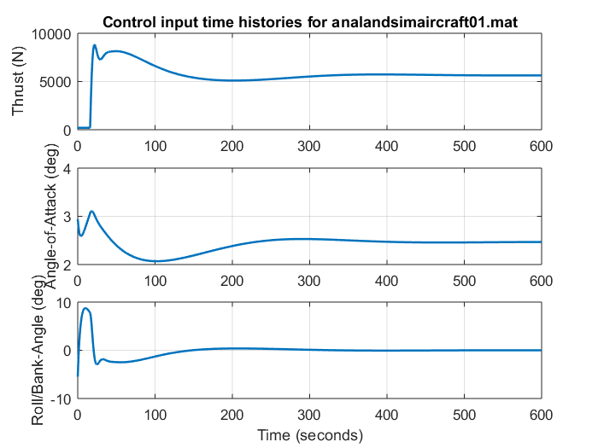
Q) How well does the closed-loop system track the target steady-motion trajectory after initial transients have died out?
A) The error in trajectory is within 2mts and 4 mts for X and Y respectively at the final simulation time. The oscillation are not completely settled at this time.

Case with 1/20 Factor of initial petrubation:
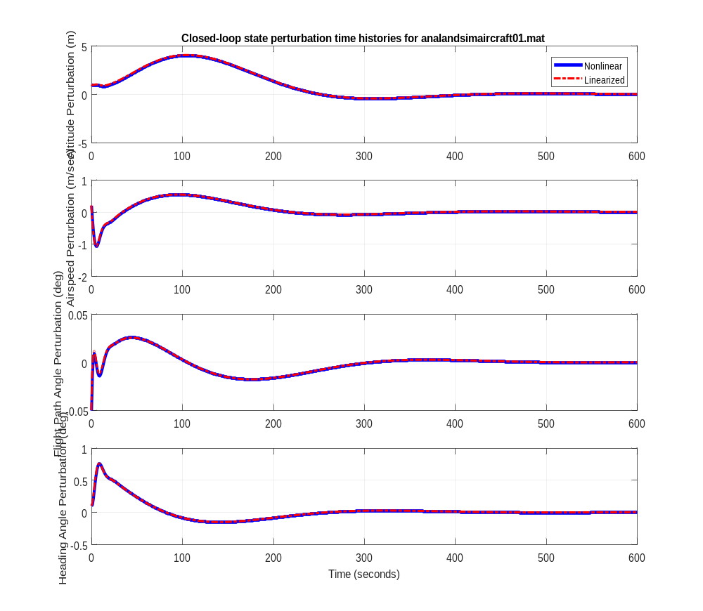

Q) In which case does the nonlinear response more closely match the linear response? Is this what you would expect?
A) The smaller X0 matches the nonlinear response better. This behavior is expected because; the new X0 is closer to the equilibrium and this improvement is to be anticipated. The A,B are linearized around the Xeq, and closer the X0 is to the Xeq, the A,B matrices represent the original nonlinear system better. This would mean that the controller works better, at is derived with A,B at equilibrium.

