A =
1.0e+02 *
Columns 1 through 3
0 0 0
0 0 0
0 0 0
0 0 -0.000001048938339
0 0 0.000000079431148
0 0 0
Columns 4 through 6
0.000000000000000 0 -1.200000000000000
0.010000000000000 0 0.000000000000000
0 -1.200000000000000 0
-0.000178843986844 -0.097972100000000 0
0.000013543010718 0 0
0 0 0
B =
0 0 0
0 0 0
0 0 0
0.000190227105528 -4.521936465223459 0
0.000000068313232 1.895722868536017 0
0 0 0.081643416666667
lambdavec =
-0.008942199342177 + 0.118918387346877i
-0.008942199342177 - 0.118918387346877i
-0.000000000000000 + 0.000000000000000i
0.000000000000000 + 0.000000000000000i
0.000000000000000 + 0.000000000000000i
0.000000000000000 + 0.000000000000000i
maxreallambda =
0
This system may be neutrally stable because the maximum
eigenvalue real part maximized over all of its eigenvalues
appears to be zero to within machine precision.
Warning: For eigenvalue lambda = -1.8629e-18, the rank of (lambda*eye(n) - A) is
4 but it should be smaller, it should be 2 in order for neutral
stability to hold true, because this eigenvalue is repeated 4 times.
Therefore, this system is unstable.
svsControllabilitymat =
1.0e+02 *
2.283055293661830
0.185122207963509
0.097972100000000
0.048885111439677
0.000816434166667
0.000001396474218
The system is controllable.
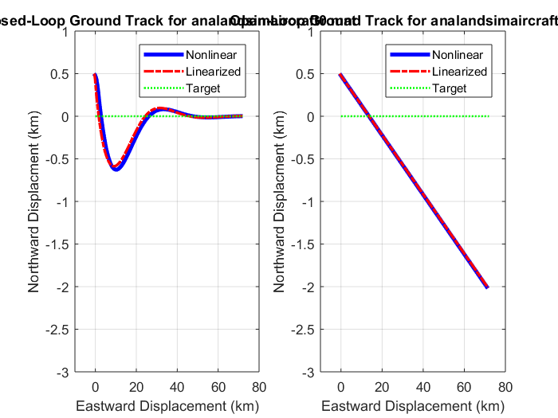
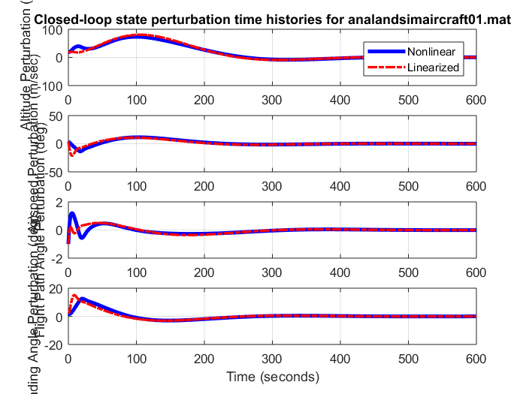
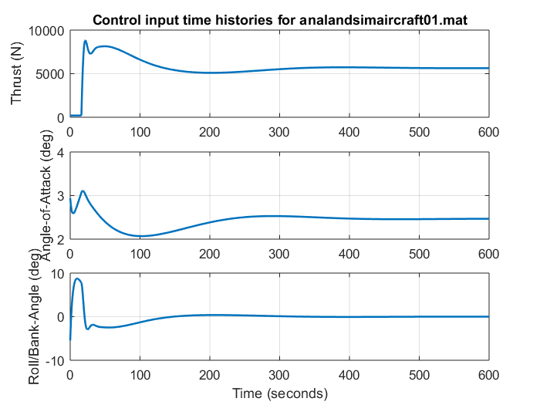
Published with MATLAB® R2017a

