Problem 4
%script_analandsimgravgradsc01.m
%
Observabilitymat = obsv(A,C); % O = [C; C*A; C * A^2; ... ; C * A^5]
%
L = place(A',C',observereigenvalues)';
%
Aclobs = A-L*C;

Output
A =
Columns 1 through 3
0 0 0.001047197551197
0 0 0
-0.001047197551197 0 0
-0.000005805649648 0 0
0 -0.000003947841760 0
0 0 0
Columns 4 through 6
0.500000000000000 0 0
0 0.500000000000000 0
0 0 0.500000000000000
0 0 -0.000923997839291
0 0 0
0.000628318530718 0 0
B =
0 0 0
0 0 0
0 0 0
0.011764705882353 0 0
0 0.010000000000000 0
0 0 0.040000000000000
lambdavec =
-0.000000000000000 + 0.000804738358774i
-0.000000000000000 - 0.000804738358774i
0.000000000000000 + 0.001404962946208i
0.000000000000000 - 0.001404962946208i
0.000000000000000 + 0.001983030174700i
0.000000000000000 - 0.001983030174700i
maxreallambda =
2.710505431213761e-19
This system may be neutrally stable because the maximum
eigenvalue real part maximized over all of its eigenvalues
appears to be zero to within machine precision.
svsObservabilitymat =
2.000000000015996
2.000000000003896
1.000002390641478
1.000000007589253
1.000000000001948
0.000001315944118
The system is observable.
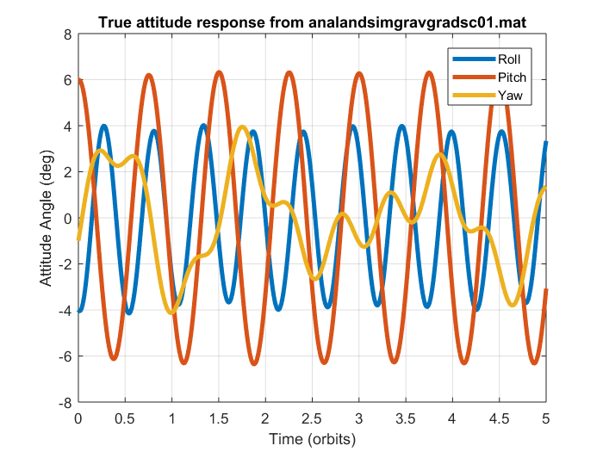
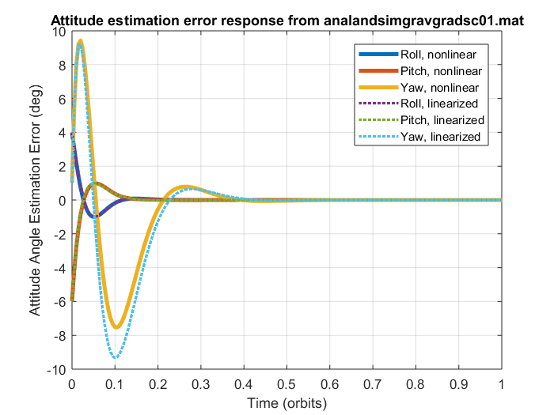

Q) How well do the observer errors converge to zero?
A) The final error is of the order of 1e-6. The convergence is good and practically zero.

Case with 1/10 Factor of initial petrubation:
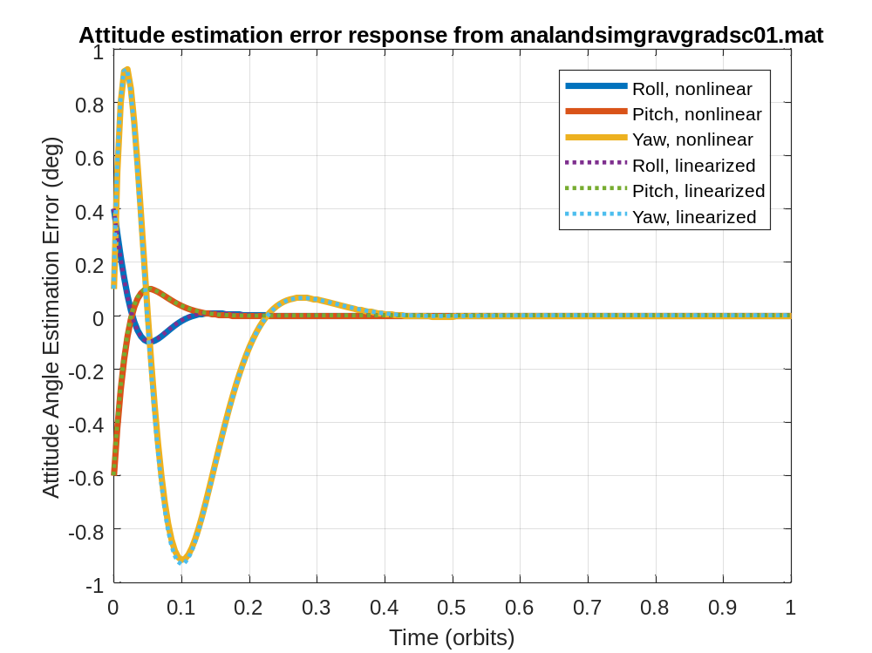
Q) In which case does the nonlinear observer error response more closely match the linear response? Is this what you would expect?
A) The smaller X0 matches the nonlinear response better. This behavior is expected because; the new X0 is closer to the equilibrium and this improvement is to be anticipated. The A is linearized around the Xeq, and closer the X0 is to the Xeq, the A matrix represents the original nonlinear system better. This would mean that the state estimator works better, as it is derived with A at equilibrium.

