# HW3 Prob – 7

clc; clear; close all;  
  
P = [1 0.5;0.5 2];  
alpha = 0.01;

## Threshold

mu_beta_z = @(theta_1) sum(sum(inv(P)))*theta_1;  
Var_beta_z = sum(sum(inv(P)));  
  
beta_0 = -norminv(alpha/2,mu_beta_z(0),sqrt(Var_beta_z));  
  
disp('Threshold \beta_0:')  
disp(beta_0)

Threshold \beta_0:  
 2.7537

## Power of test

theta_1_vec = -10:0.01:10;  
  
mu_beta_z_vec = mu_beta_z(theta_1_vec);  
  
power_vec = zeros(1,length(theta_1_vec));  
  
for nn = 1:length(theta_1_vec)  
 power_vec(nn) = normcdf(-beta_0,mu_beta_z_vec(nn),sqrt(Var_beta_z));  
 power_vec(nn) = power_vec(nn) + 1-normcdf(beta_0,mu_beta_z_vec(nn),sqrt(Var_beta_z));  
end  
  
figure;  
plot(theta_1_vec,power_vec,'Color','k','Linewidth',1.5)  
xlabel('Hypothesis 1, \theta_1');  
ylabel('Power(\theta_1)');  
title('Power of the Test')  
 grid on  
 ax = gca;  
 ax.LineWidth = 1;  
 ax.GridColor = [0 0 0];  
 ax.MinorGridColor = 'k';

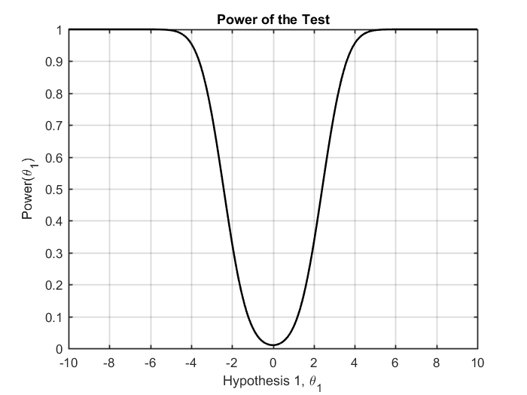

## beta|H0 and beta|H1 PDFs

six_sigma = 6*sqrt(Var_beta_z);  
  
del_beta_z_vec = linspace(-six_sigma,six_sigma,2000);  
  
theta_1 = 4;  
x_H0_vec = del_beta_z_vec;  
x_H1_vec = del_beta_z_vec+theta_1;  
  
pdf_beta_z_H0 = normpdf(x_H0_vec,mu_beta_z(0),sqrt(Var_beta_z));  
pdf_beta_z_H1 = normpdf(x_H1_vec,mu_beta_z(theta_1),sqrt(Var_beta_z));  
pdf_beta_0 = normpdf([-beta_0 beta_0],mu_beta_z(0),sqrt(Var_beta_z));  
  
figure;  
plot(x_H0_vec,pdf_beta_z_H0,'Color','k','Linewidth',1.5);hold on;  
plot(x_H1_vec,pdf_beta_z_H1,'--','Color','k','Linewidth',1.5);  
plot([-beta_0 beta_0],pdf_beta_0,'s','MarkerSize',7,...  
 'MarkerEdgeColor','k',...  
 'MarkerFaceColor',[0.4,0.4,0.4])  
xlabel('\beta(z)');  
ylabel('PDF, P(\beta(z)|H0) and P(\beta(z)|H1)');  
title('PDFs of the Test Statistic Under H0 and H1')  
legend('Under H0','Under H1','Threshold, \beta_0')  
 grid on  
 ax = gca;  
 ax.LineWidth = 1;  
 ax.GridColor = [0 0 0];  
 ax.MinorGridColor = 'k';  
% axis tight

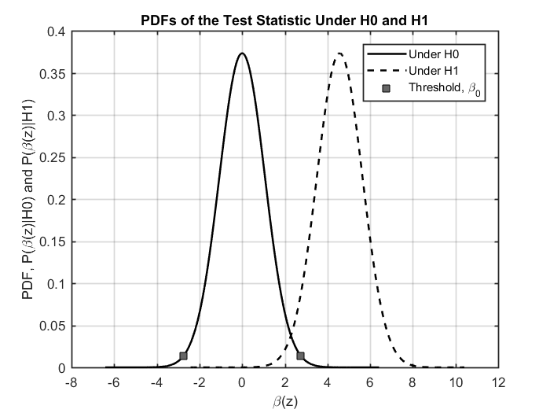

[*Published with MATLAB® R2017a*](http://www.mathworks.com/products/matlab)