Assignment 8 Problem 4
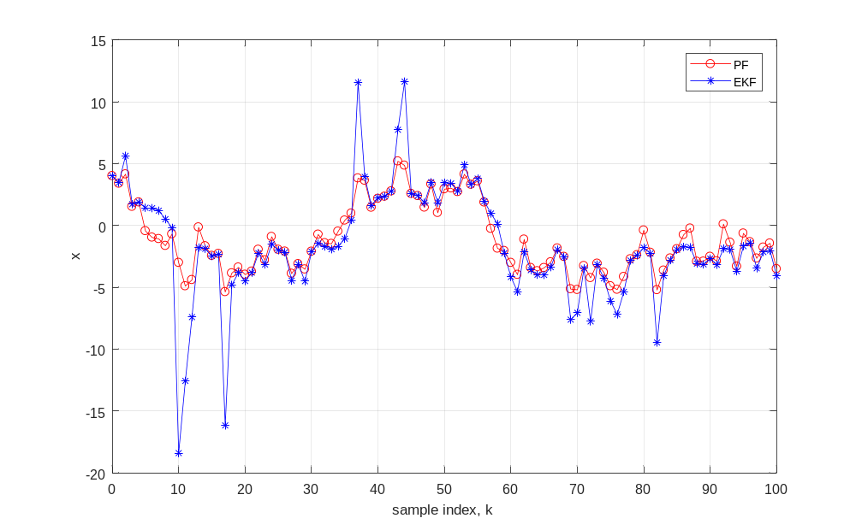

Code, Prob 3

clc; clear; close all;

Initialization
load('measdata_pfexample');
x_hat_0 = xhat0; P_0 = P0;
nx = 1;
nz = 1;
N = 101;
Ns = 1e7;
x_hat = zeros(nx,N);
P = zeros(nx,N);
x_hat(1) = x_hat_0;
P(1) = P_0;
x_math_0 = x_hat_0 + randn(Ns,1)*sqrt(P_0);
x_math_k = x_math_0;
W_k = ones(Ns,1)/Ns;

Particle Filter
for kk = 1:N-1
x_math_kp1 = 2*atan(x_math_k) + 0.5*cos(pi*kk/3) + randn(Ns,1)*sqrt(Q);
z_hat_kp1 = x_math_kp1 + x_math_kp1.^2 + x_math_kp1.^3;
expo_temp = (zkhist(kk,1)*ones(Ns,1) - z_hat_kp1).^2/R/2;
log_wk_m_expo = log(W_k) - expo_temp;
[~,imax] = max(log_wk_m_expo);
W_til_kp1 = exp(log_wk_m_expo - log_wk_m_expo(imax));
W_kp1 = W_til_kp1./sum(W_til_kp1);
x_hat(kk+1) = x_math_kp1'*W_kp1;
del_x_kp1 = x_math_kp1-x_hat(kk+1);
P(kk+1) = (del_x_kp1.^2)'*W_kp1;
c = zeros(1,Ns+1);
% Resamp, a version first approach
[eta,indv] = sort(rand(1,Ns));
nn = 1;
x_temp = zeros(1,Ns);
for ii = 1:Ns
flag = 1;
while flag && nn<=Ns
if eta(nn) >= c(ii) && eta(nn) < c(ii+1)
x_temp(indv(nn))=x_math_kp1(ii);
nn = nn +1;
flag = 1;
else
flag = 0;
end
end
end
Bool1 = eta>=c(1:end-1);
Bool2 = eta<c(2:end);
Bool = (Bool1.*Bool2);
% reset
x_math_k = x_temp';
W_k = ones(Ns,1)/Ns;
kk
end
figure(1);
plot([0:100],x_hat,'--r');grid on;hold on;
ylabel('x')
xlabel('sample index, k')
% ylim([-5 5])
Published with MATLAB® R2017a

Code, Prob 4

clc; clear; %close all;

Initialization
load('measdata_pfexample');
x_hat_0 = xhat0; P_0 = P0;
nx = 1;
nz = 1;
N = 101;
x_hat = zeros(nx,N);
P = zeros(nx,N);
x_hat(1) = x_hat_0;
P(1) = P_0;
Gamma = 1

EKF
for kk = 1:N-1
x_bar_kp1 = 2*atan(x_hat(kk)) + 0.5*cos(pi*kk/3);
F_k = 2 /(1 + x_hat(kk)^2 );
P_bar_kp1 = F_k^2*P(kk) + Q;
z_bar_kp1 = x_bar_kp1 + x_bar_kp1^2 + x_bar_kp1^3;
H_kp1 = 1 + 2*x_bar_kp1 + 3*x_bar_kp1^2;
nu_kp1 = zkhist(kk) - z_bar_kp1;
s_kp1 = H_kp1^2*P_bar_kp1+R;
w_kp1 = P_bar_kp1*H_kp1/s_kp1;
x_hat(kk+1) = x_bar_kp1 + w_kp1*nu_kp1;
P(kk+1) = P_bar_kp1 - w_kp1^2*s_kp1;
end
figure(1);
plot([0:100],x_hat,'-b');grid on;hold on;
ylabel('x')
xlabel('sample index, k')
% ylim([-5 5])
Published with MATLAB® R2017a

