Assignment 8 Problem 7 1
Initialization 1
Particle Filter 1
Smoothing 12
Results 12

Assignment 8 Problem 7
clc; clear; close all;

Initialization
load('measdata_pfexample02');
x_hat_0 = xhat0;
P_0 = P0;
nx = 1;
nz = 1;
N = 101;
Ns = 1e5;
x_hat = zeros(nx,N);
P = zeros(nx,N);
x_hat(1) = x_hat_0;
P(1) = P_0;
x_math = zeros(Ns,N+1);
x_math_0 = x_hat_0 + randn(Ns,1)*sqrt(P_0);
x_math_k = x_math_0;
z_hat_kp1 = zeros(Ns,N-1);
W_k = ones(Ns,1)/Ns;

Particle Filter
for kk = 1:N-1
x_math_kp1 = 2*atan(x_math_k) + 0.5*cos(pi*kk/3) + randn(Ns,1)*sqrt(Q);
z_hat_kp1(:,kk) = x_math_kp1 + x_math_kp1.^2 + x_math_kp1.^3;
expo_temp = (zkhist(kk,1)*ones(Ns,1) - z_hat_kp1(:,kk)).^2/R/2;
log_wk_m_expo = log(W_k) - expo_temp;
[~,imax] = max(log_wk_m_expo);
W_til_kp1 = exp(log_wk_m_expo - log_wk_m_expo(imax));
W_kp1 = W_til_kp1./sum(W_til_kp1);
x_hat(kk+1) = x_math_kp1'*W_kp1;
del_x_kp1 = x_math_kp1-x_hat(kk+1);
P(kk+1) = (del_x_kp1.^2)'*W_kp1;
c = zeros(1,Ns+1);
for ii = 2:Ns+1
c(ii) = c(ii-1) + W_kp1(ii-1);
end
% Resamp, a version first approach
[eta,indv] = sort(rand(1,Ns));
nn = 1;
x_temp = zeros(1,Ns);
for ii = 1:Ns
flag = 1;
while flag && nn<=Ns
if eta(nn) >= c(ii) && eta(nn) < c(ii+1)
x_temp(indv(nn))=x_math_kp1(ii);
nn = nn +1;
flag = 1;
else
flag = 0;
end
end
end
x_math(:,kk) = (x_math_k);
% reset
x_math_k = x_temp';
W_k = ones(Ns,1)/Ns;
kk
end
x_math(:,N) = (x_math_k);
kk =
1
kk =
2
kk =
3
kk =
4
kk =
5
kk =
6
kk =
7
kk =
8
kk =
9
kk =
10
kk =
11
kk =
12
kk =
13
kk =
14
kk =
15
kk =
16
kk =
17
kk =
18
kk =
19
kk =
20
kk =
21
kk =
22
kk =
23
kk =
24
kk =
25
kk =
26
kk =
27
kk =
28
kk =
29
kk =
30
kk =
31
kk =
32
kk =
33
kk =
34
kk =
35
kk =
36
kk =
37
kk =
38
kk =
39
kk =
40
kk =
41
kk =
42
kk =
43
kk =
44
kk =
45
kk =
46
kk =
47
kk =
48
kk =
49
kk =
50
kk =
51
kk =
52
kk =
53
kk =
54
kk =
55
kk =
56
kk =
57
kk =
58
kk =
59
kk =
60
kk =
61
kk =
62
kk =
63
kk =
64
kk =
65
kk =
66
kk =
67
kk =
68
kk =
69
kk =
70
kk =
71
kk =
72
kk =
73
kk =
74
kk =
75
kk =
76
kk =
77
kk =
78
kk =
79
kk =
80
kk =
81
kk =
82
kk =
83
kk =
84
kk =
85
kk =
86
kk =
87
kk =
88
kk =
89
kk =
90
kk =
91
kk =
92
kk =
93
kk =
94
kk =
95
kk =
96
kk =
97
kk =
98
kk =
99
kk =
100

Smoothing
nu_sum = zeros(Ns,1);
for ii = 1:Ns
nu_sum(ii,1) = sum(zkhist'-z_hat_kp1(ii,:));
end
expo_sum = -0.5 * nu_sum.^2/R;
[~,imax] = max(expo_sum);
W_smooth = exp(expo_sum - expo_sum(imax));
W_smooth = W_smooth./sum(W_smooth);
x_star = zeros(nx,N);
P_star = zeros(nx,N);
for kk = 1:N
x_star(kk) = x_math(:,kk)'*W_smooth;
del_x_kp1 = x_math(:,kk)-x_hat(kk);
P_star(kk+1) = (del_x_kp1.^2)'*W_smooth;
end

Results
figure(1);
plot([0:100],x_hat,'--r');grid on;hold on;
plot([0:100],x_star,'--b');grid on;hold on;
ylabel('x')
xlabel('sample index, k')
legend('PF','Fixed-Int PS')
disp('Final State Estimate')
disp(x_hat(end))
disp('Final State Covariance')
disp(P(end))
disp('Final smoothed-state Estimate')
disp(x_hat(end))
disp('Final smoothed-State Covariance')
disp(P(end))
Final State Estimate
3.01294167796554
Final State Covariance
0.000786197775671574
Final smoothed-state Estimate
3.01294167796554
Final smoothed-State Covariance
0.000786197775671574
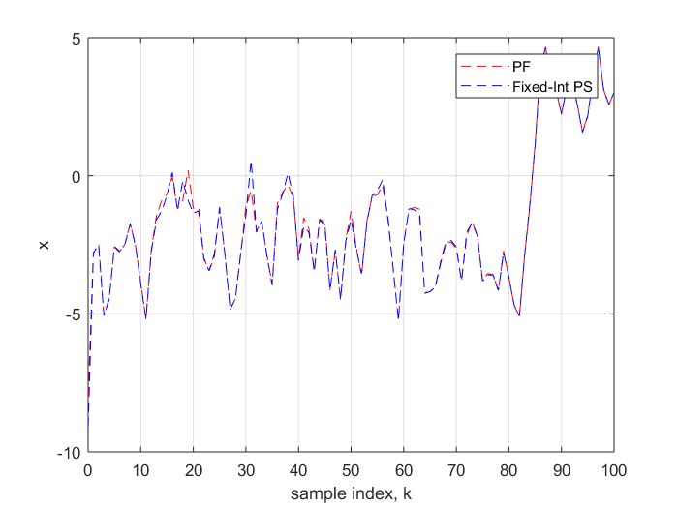
Published with MATLAB® R2017a

