Problem HW5 #6

Output from Code 50 Samples
Sample Mean of state estimation error at k=10, for a number of samples:50
-0.004944836496954
-0.060261925878203

Sample Mean of state estimation error at k=35, for a number of samples:50
-0.001424699736231
0.015156675408962

KF-Predicted state estimation error Covariance at k=10, for a number of samples:50
0.001695278460358 0.000656510993734
0.000656510993734 0.085931377272971

Sample (From Monte-Carlo) state estimation error Covariance at k=10, for a number of samples:50
0.001602211142559 0.002229212429678
0.002229212429678 0.074906131440162

KF-Predicted state estimation error Covariance at k=35, for a number of samples:50
0.001622216605823 0.000662324083523
0.000662324083523 0.084545630749705

Sample (From Monte-Carlo) state estimation error Covariance at k=35, for a number of samples:50
0.001887266629408 0.001979991707505
0.001979991707505 0.097544690359155

Output from Code 1000 Samples

Sample Mean of state estimation error at k=10, for a number of samples:1000
0.001522294648261
0.018971235966177
Sample Mean of state estimation error at k=35, for a number of samples:1000
-0.001225449661606
-0.002938652413939
KF-Predicted state estimation error Covariance at k=10, for a number of samples:1000
0.001695278460358 0.000656510993734
0.000656510993734 0.085931377272971
Sample (From Monte-Carlo) state estimation error Covariance at k=10, for a number of samples:1000
0.001718892918588 0.000379619316877
0.000379619316877 0.085785907714452
KF-Predicted state estimation error Covariance at k=35, for a number of samples:1000
0.001622216605823 0.000662324083523
0.000662324083523 0.084545630749705
Sample (From Monte-Carlo) state estimation error Covariance at k=35, for a number of samples:1000
0.001763060681687 0.001248785192115
0.001248785192115 0.081378788402975

Output from Code 1e6 Samples

Sample Mean of state estimation error at k=10, for a number of samples:1000000
1.0e-03 *

-0.036876147800749
-0.620021985201780

Sample Mean of state estimation error at k=35, for a number of samples:1000000
1.0e-04 *

-0.334144046944898
-0.049010364821637

KF-Predicted state estimation error Covariance at k=10, for a number of samples:1000000
0.001695278460358 0.000656510993734
0.000656510993734 0.085931377272971

Sample (From Monte-Carlo) state estimation error Covariance at k=10, for a number of samples:1000000
0.001697579597154 0.000659097234304
0.000659097234304 0.086002034577220

KF-Predicted state estimation error Covariance at k=35, for a number of samples:1000000
0.001622216605823 0.000662324083523
0.000662324083523 0.084545630749705

Sample (From Monte-Carlo) state estimation error Covariance at k=35, for a number of samples:1000000
0.001622742366084 0.000648206929062
0.000648206929062 0.084580477928315

Code and Plots

Output from Code 1
Data Loading 2
Initialization 2
Propogation of Cov and KF Gain Computation 2
Truth-model Monte-Carlo and State estimation 3
output 3
Plots 4
Sample covariances 8
Truth-model Code 10
clear;clc;close all;
format long

Data Loading
kf_example02a
% Modifications for the exam
Qk = 6.00000000000000; % for all k
Rk = 0.05000000000000; % for all k

Initialization
Nsamp = 1000;
kmax = size(thist,1);
[nx,nv] = size(Gammak);
nz = size(Hk,1);
x_hat_vec = zeros(nx,(kmax+1));
x_hat_vec(:,1) = xhat0;
P_xx_vec = zeros(nx,nx,(kmax+1));
P_xx_vec(:,:,1) = P0;
x1_hat_vec = zeros(Nsamp,(kmax+1));
x2_hat_vec = zeros(Nsamp,(kmax+1));
x1_vec = zeros(Nsamp,(kmax+1));
x2_vec = zeros(Nsamp,(kmax+1));
W_vec = zeros(nx,nz,kmax);
P11_KF = zeros(1,(kmax+1));
P22_KF = zeros(1,(kmax+1));
P12_KF = zeros(1,(kmax+1));
P11_KF(1) = P_xx_vec(1,1,1);
P22_KF(1) = P_xx_vec(2,2,1);
P12_KF(1) = P_xx_vec(1,2,1);

Propogation of Cov and KF Gain Computation
for k = 1:kmax
% Propagation state-error cov
P_bar_xx_kp1 = Fk*P_xx_vec(:,:,k)*Fk'+Gammak*Qk*Gammak';
% Gain Computation state-error cov
S_kp1 = Hk*P_bar_xx_kp1*Hk'+Rk;
W_vec(:,:,k) = P_bar_xx_kp1*Hk'/S_kp1;
temp_joseph = eye(nx) - W_vec(:,:,k)*Hk;
% Update state-error cov
P_xx_vec(:,:,k+1) = temp_joseph*P_bar_xx_kp1*temp_joseph'...
+ W_vec(:,:,k)*Rk*W_vec(:,:,k)';
P11_KF(k+1) = P_xx_vec(1,1,k+1);
P22_KF(k+1) = P_xx_vec(2,2,k+1);
P12_KF(k+1) = P_xx_vec(1,2,k+1);
end

Truth-model Monte-Carlo and State estimation
for n = 1:Nsamp
[xtruehist,zhist] = kf_truthmodel(Fk,Gammak,Hk,Qk,Rk,xhat0,...
P0,kmax);
for k = 1:kmax
% Propagation of state and state-error cov
x_bar_kp1 = Fk*x_hat_vec(:,k);
% Measurement update of state and state-error cov
z_kp1 = zhist(k);
W_kp1 = W_vec(:,:,k);
Innov_kp1 = z_kp1 - Hk*x_bar_kp1;
x_hat_vec(:,k+1) = x_bar_kp1 + W_kp1*Innov_kp1;
end
x1_hat_vec(n,:) = x_hat_vec(1,:);
x2_hat_vec(n,:) = x_hat_vec(2,:);
x1_vec(n,:) = xtruehist(:,1)';
x2_vec(n,:) = xtruehist(:,2)';
end
x1_tilde_vec = x1_vec-x1_hat_vec;
x2_tilde_vec = x2_vec-x2_hat_vec;
P11_samp = mean(x1_tilde_vec.^2);
P22_samp = mean(x2_tilde_vec.^2);
P12_samp = mean(x1_tilde_vec.*x2_tilde_vec);

output
disp(['Sample Mean of state estimation error at k=10, for a number of samples:' num2str(Nsamp)]);
disp([mean(x1_tilde_vec(:,11));mean(x2_tilde_vec(:,11))]);
disp(['Sample Mean of state estimation error at k=35, for a number of samples:' num2str(Nsamp)]);
disp([mean(x1_tilde_vec(:,36));mean(x2_tilde_vec(:,36))]);
Psamp_10 = [P11_samp(11) P12_samp(11);...
P12_samp(11) P22_samp(11)];
Psamp_35 = [P11_samp(36) P12_samp(36);...
P12_samp(36) P22_samp(36)];
disp(['KF-Predicted state estimation error Covariance at k=10, for a number of samples:' num2str(Nsamp)]);
disp(P_xx_vec(:,:,11));
disp(['Sample state estimation error Covariance at k=10, for a number of samples:' num2str(Nsamp)]);
disp(Psamp_10);
disp(['KF-Predicted state estimation error Covariance at k=35, for a number of samples:' num2str(Nsamp)]);
disp(P_xx_vec(:,:,36));
disp(['Sample state estimation error Covariance at k=35, for a number of samples:' num2str(Nsamp)]);
disp(Psamp_35);

Plots
t_vec = [0,thist'];
figure;
subplot(2,1,1)
ps = plot(t_vec,x1_vec);hold on;grid on;
ax = gca;
ax.LineWidth = 1;
ax.GridColor = [0 0 0];
ax.MinorGridColor = 'k';
ylabel('x_1')
legend([ps(1)],'Monte-Carlo')
subplot(2,1,2)
plot(t_vec,x2_vec);hold on;grid on;
ax = gca;
ax.LineWidth = 1;
ax.GridColor = [0 0 0];
ax.MinorGridColor = 'k';
xlabel('time, t (s)')
ylabel('x_2')
figure;
subplot(2,1,1)
ps = plot(t_vec,x1_hat_vec);hold on;grid on;
ax = gca;
ax.LineWidth = 1;
ax.GridColor = [0 0 0];
ax.MinorGridColor = 'k';
ylabel('x_1 hat ')
legend([ps(1)],'Monte-Carlo')
subplot(2,1,2)
plot(t_vec,x2_hat_vec);hold on;grid on;
ax = gca;
ax.LineWidth = 1;
ax.GridColor = [0 0 0];
ax.MinorGridColor = 'k';
xlabel('time, t (s)')
ylabel('x_2 hat')
figure;
subplot(2,1,1)
ps = plot(t_vec,x1_tilde_vec);hold on;grid on;
pm = plot(t_vec,mean(x1_tilde_vec),'k','LineWidth',1.5);
ax = gca;
ax.LineWidth = 1;
ax.GridColor = [0 0 0];
ax.MinorGridColor = 'k';
ylabel('x_1 tilde')
legend([ps(1) pm],'Monte-Carlo','sample Mean')
subplot(2,1,2)
plot(t_vec,x2_tilde_vec);hold on;grid on;
pm = plot(t_vec,mean(x2_tilde_vec),'k','LineWidth',1.5);
ax = gca;
ax.LineWidth = 1;
ax.GridColor = [0 0 0];
ax.MinorGridColor = 'k';
xlabel('time, t (s)')
ylabel('x_2 tilde')
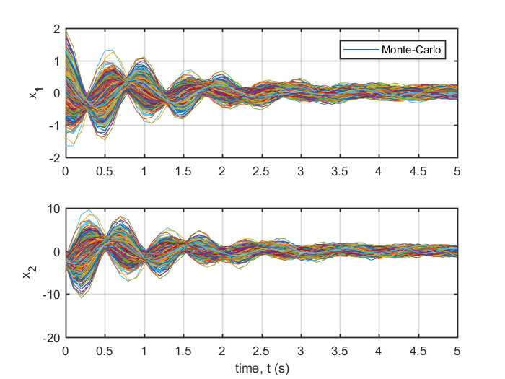
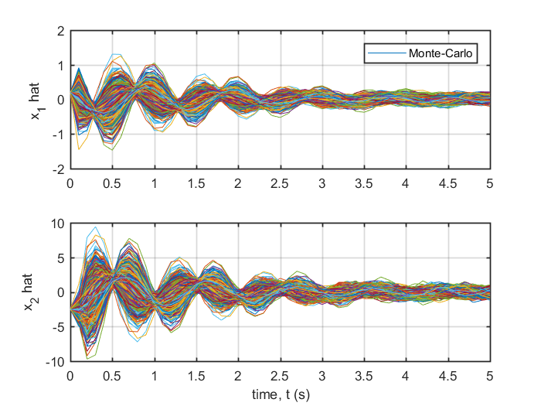
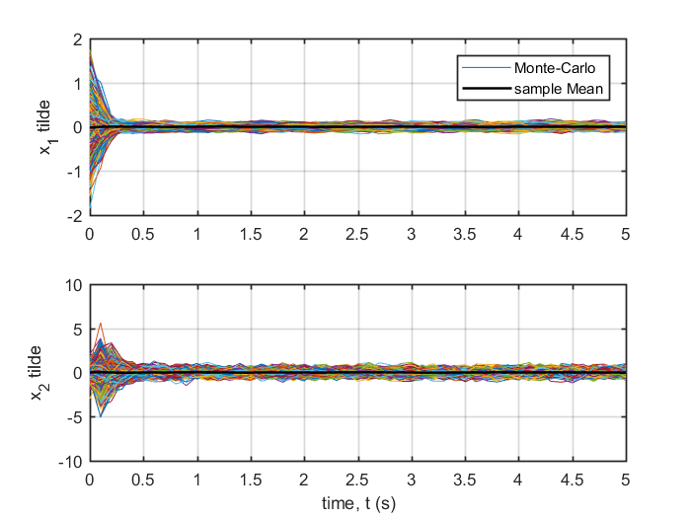

Sample covariances
figure;
subplot(3,1,1)
ps = plot(t_vec,P11_samp);hold on;grid on;
pm = plot(t_vec,P11_KF,'k','LineWidth',1.5);
ax = gca;
ax.LineWidth = 1;
ax.GridColor = [0 0 0];
ax.MinorGridColor = 'k';
ylabel('P11')
legend([ps(1) pm],'sample Cov','KF Predicted')
subplot(3,1,2)
plot(t_vec,P22_samp);hold on;grid on;
pm = plot(t_vec,P22_KF,'k','LineWidth',1.5);
ax = gca;
ax.LineWidth = 1;
ax.GridColor = [0 0 0];
ax.MinorGridColor = 'k';
xlabel('time, t (s)')
ylabel('P22')
subplot(3,1,3)
plot(t_vec,P12_samp);hold on;grid on;
pm = plot(t_vec,P12_KF,'k','LineWidth',1.5);
ax = gca;
ax.LineWidth = 1;
ax.GridColor = [0 0 0];
ax.MinorGridColor = 'k';
xlabel('time, t (s)')
ylabel('P12')
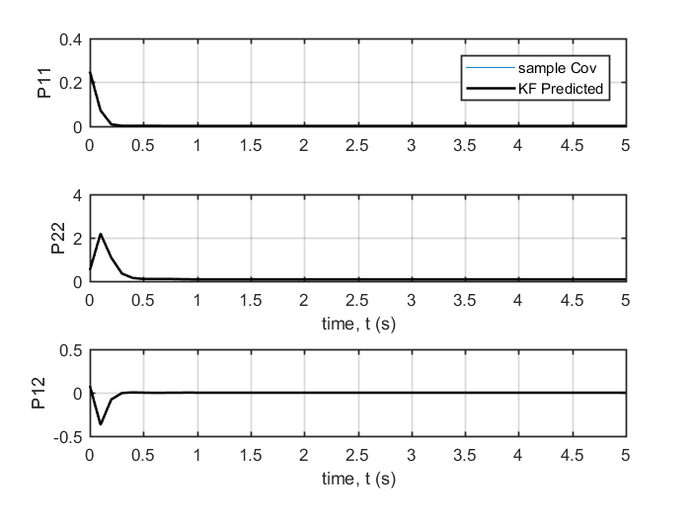

Truth-model Code
function [xtruehist,zhist] = kf_truthmodel(F,Gamma,H,Q,R,xhat0,...
P0,kmax)
%
% Copyright (c) 2002 Mark L. Psiaki. All rights reserved.
%
% This function performs a truth-model Monte-Carlo simulation for
% the discrete-time stochastic system model:
%
% x(k+1) = F*x(k) + Gamma*v(k)
% z(k) = H*x(k) + w(k)
%
% Where v(k) and w(k) are uncorrelated, zero-mean, white-noise
% Gaussian random processes with covariances E[v(k)*v(k)'] = Q and
% E[w(k)*w(k)'] = R. The simulation starts from a true x(0)
% that is drawn from the Gaussian distribution with mean xhat0
% and covariance P0. The simulation starts at time k = 0 and
% lasts until time k = kmax.
%
%
% Inputs:
%
% F The (nx)x(nx) state transition matrix for the time-
% invariant linear system.
%
% Gamma The (nx)x(nv) process noise gain matrix for the time-
% invariant linear system.
%
% H The (nz)x(nx) output gain matrix for the time-
% invariant linear system.
%
% Q The (nv)x(nv) symmetric positive definite process noise
% covariance matrix.
%
% R The (nz)x(nz) symmetric positive definite measurement
% noise covariance matrix.
%
% xhat0 The (nx)x1 initial state estimate.
%
% P0 The (nx)x(nx) symmetric positive definite initial state
% estimation error covariance matrix.
%
% kmax The maximum discrete-time index of the simulation.
%
% Outputs:
%
% xtruehist = [x(0)';x(1)';x(2)';...;x(kmax)'], the (kmax+1)x(nx)
% array that stores the truth time history for the state
% vector. Note that Matlab does not allow zero indices
% in its arrays. Thus, x(0) = xtruehist(1,:)',
% x(1) = xtruehist(2,:)', etc.
%
% zhist = [z(1)';z(2)';z(3)';...;z(kmax)'], the (kmax)x(nz)
% array that stores the measurement time history.
% z(1) = zhist(1,:)', z(2) = zhist(2,:)', etc. Note
% that the state vector xtruehist(j+1,:)' and
% the measurement vector zhist(j,:)' correspond
% to the same time.
%
%
% Get problem dimensions and set up the output arrays.
%
[nx,nv] = size(Gamma);
nz = size(H,1);
xtruehist = zeros((kmax+1),nx);
zhist = zeros(kmax,nz);
%
% Calculate the appropriate matrix square root of P0 for use in
% randomly generating an initial state.
%
P0_root = chol(P0)';
%
% Generate the initial truth state with the aid of a random number
% generator and store it.
%
x0 = xhat0+P0_root*randn(nx,1);
xtruehist(1,:) = x0';
%
% Calculate the appropriate matrix square roots of Q and R for use in
% randomly generating the process and measurement noise vectors.
%
Q_root = chol(Q)';
R_root = chol(R)';
%
% Iterate through the kmax samples, propagating the state with
% randomly generated process noise of the correct covariance and
% corrupting the measurements with randomly generated measurement
% noise of the correct covariance.
%
xk = x0;
for k = 1:kmax
xkm1 = xk;
vkm1 = Q_root*randn(nv,1);
xk = F*xkm1 + Gamma*vkm1;
wk = R_root*randn(nz,1);
zk = H*xk + wk;
kp1 = k + 1;
xtruehist(kp1,:) = xk';
zhist(k,:) = zk';
end
Published with MATLAB® R2017a

