**API Testing Introduction:**

An API (Application Programming Interface) is a software-to-software interface that enables two applications to exchange data among each other.

Types of API

1)SOAP

2)REST

Diff b/w API and Web Services

http VS https

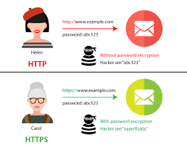

Terminologies

URI : Uniform Resource Identifier

URL - Uniform Resource Locatore

URN – Uniform Resource Nme

Feature & Resource

‘Feature’ is the term used in manual testing to test some functionality and similarly ‘Resource’ is the term used in API automation testing referring some functionalities.

Payload

Payload means body in the HTTP request and response message

Request payload

Response Payload

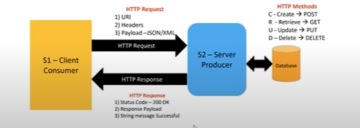

**API’s come underneath four different types:**

1. SOAP – Simple Object Access Protocol. These exchange data in the form of an XML file.

2) JavaScript – A specialist kind of APIs, these are focused around Javascript and are accessed using this language. These are only really used by Javascript and Web developers.

3) XML-RCP – To use these kinds of APIs, you call it using XML and it returns XML. This standard was further developed and became SOAP.

4) In RESTful APIs, communication between applications is done using the underlying HTTP protocol (HyperText Transfer Protocol). HTTP is widely used on the internet

There are four major HTTP request methods:

GET – to fetch data

PUT – to edit existing data

POST – to add the new data

DELETE – to delete data

**HTTP Status Codes:**

|  |  |
| --- | --- |
| **CATEGORY** | **DESCRIPTION** |
| **1xx: Informational** | Communicates transfer protocol-level information. |
| **2xx: Success** | Indicates that the client’s request was accepted successfully. |
| **3xx: Redirection** | Indicates that the client must take some additional action in order to complete their request. |
| **4xx: Client Error** | This category of error status codes points the finger at clients |
| **5xx: Server Error** | The server takes responsibility for these error status codes. |

**HTTP Status 200:** (**OK**) status code indicates that the ‘**request has been processed successfully’** on server. The response payload depends on HTTP method which was selected for request.

**HTTP Status 201:** (**CREATED**) indicates that as a result of HTTP POST request, **one or more new resources have been successfully created** on server.

**HTTP Status 202:**(**ACCEPTED**) indicates that request has been accepted for processing, but the processing has not been completed.

**HTTP Status 204:** (**No Content**) indicates that the server has successfully fulfilled the request and that there is **no content to send in the response**

**301 (Moved Permanently):**

The 301 status code indicates that the REST API’s resource model has been significantly redesigned and a new permanent URI has been assigned to the client’s requested resource.

**302 (Found):**

The HTTP response status code 302 Found is a common way of performing URL redirection.

**303 (See Other)**

A 303 response indicates that a controller resource has finished its work, but instead of sending a potentially unwanted response body, it sends the client the URI of a response resource.

**304 (Not Modified)**

This status code is similar to 204 (“No Content”) in that the response body must be empty.

**307 (Temporary Redirect)**

A 307 response indicates that the REST API is not going to process the client’s request.

**400 (Bad Request)**

400 is the generic client-side error status, used when no other 4xx error code is appropriate.

**401 (Unauthorized)**

A 401 error response indicates that the client tried to operate on a protected resource without providing the proper authorization.

**403 (Forbidden)**

A 403 error response indicates that the client’s request is formed correctly, but the REST API refuses to honor it i.e. the user does not have the necessary permissions for the resource.

**404 (Not Found)**

The 404 error status code indicates that the REST API can’t map the client’s URI to a resource but may be available in the future.

**406 (Not Acceptable)**

The 406 error response indicates that the API is not able to generate any of the client’s preferred media types, as indicated by the Accept request header.

**500 (Internal Server Error)**

500 is the generic REST API error response. Most web frameworks automatically respond with this response status code whenever they execute some request handler code that raises an exception.

**501 (Not Implemented)**

The server either does not recognize the request method, or it lacks the ability to fulfill the request. Usually this implies future availability (e.g., a new feature of a web-service API).