**Prerequisites SOAPUI in Eclipse:**

* Install the **Eclipse-Soap UI** add in.

**Creating New SOAP Project:**

* Select project and Right Click and click on ‘New SoapUI Project’.

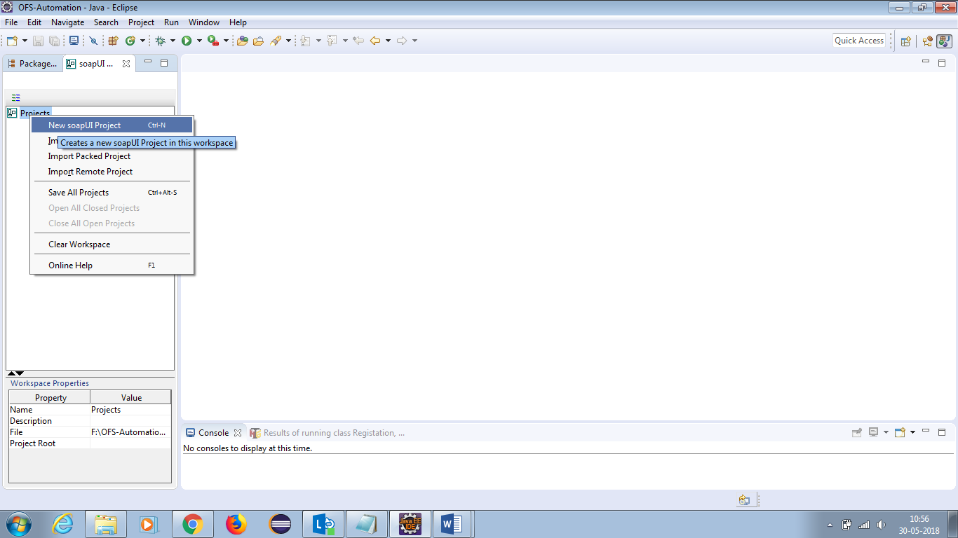

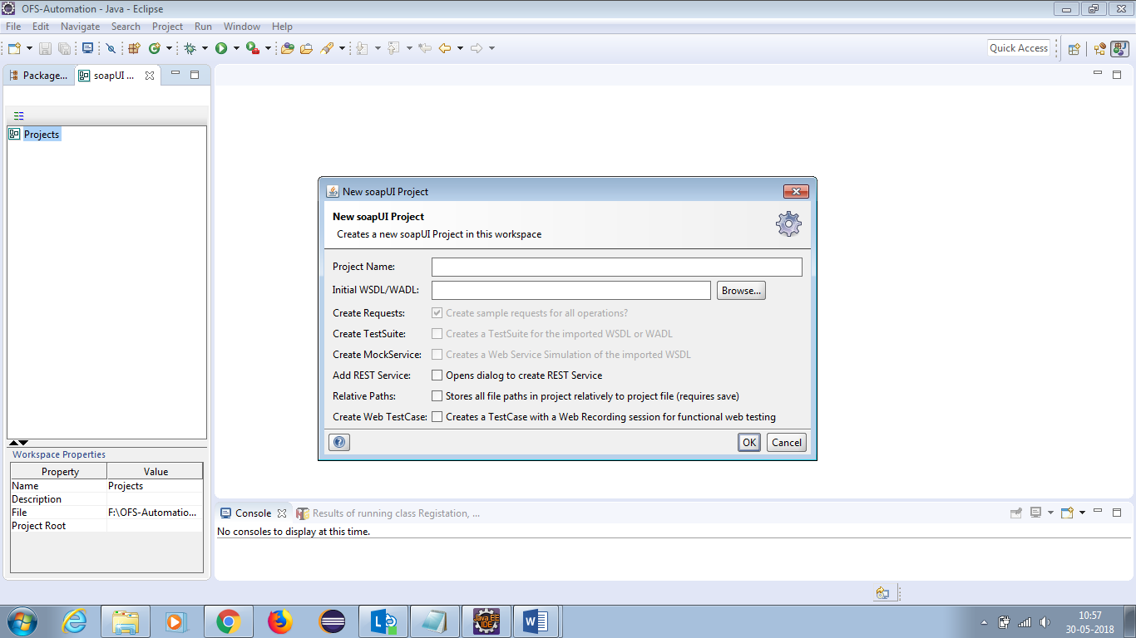

* Enter project name and WSDL/WADL URL then click ok.

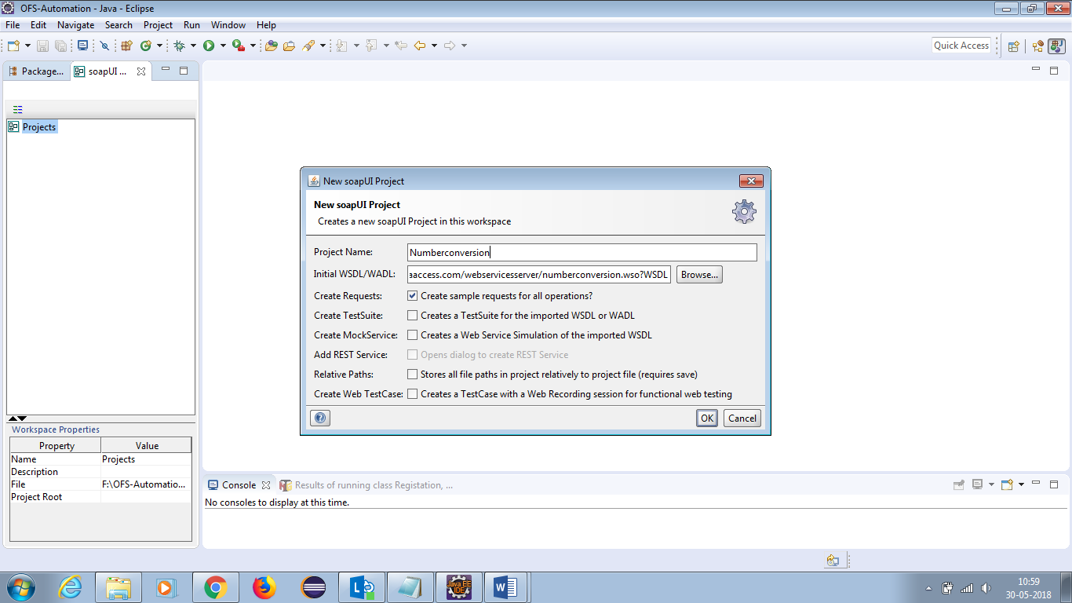

* Once SoapUI project created it will show the Requests as below screen.

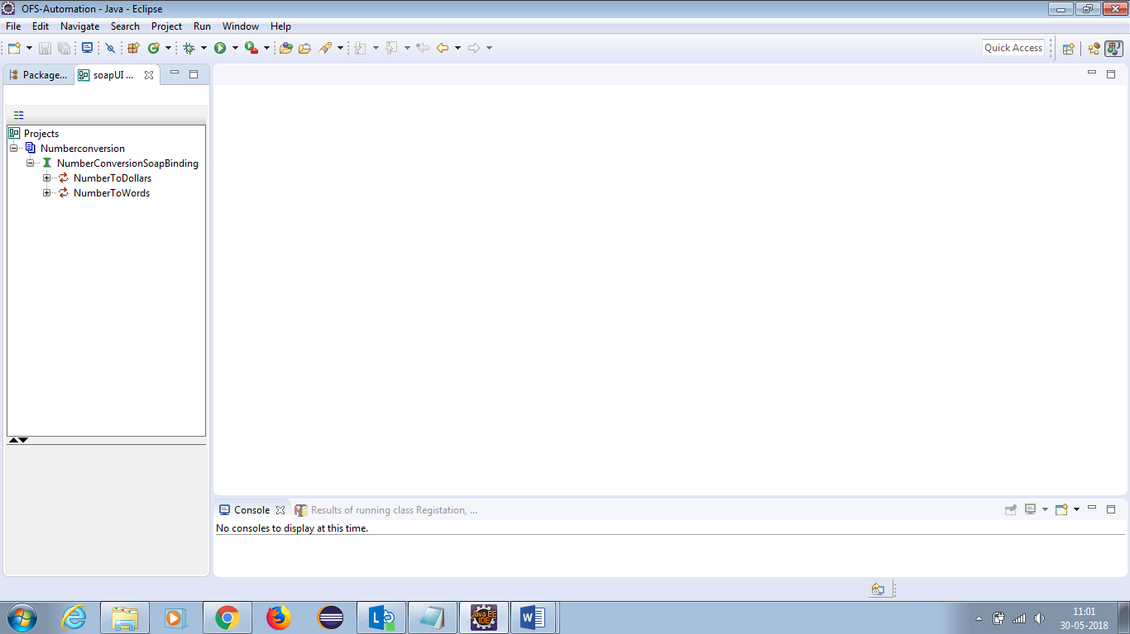

**To Verify the Response**:

* Double Click on Request.
* Enter the values in the place of ‘?’.
* Click on Run and verify the Response.

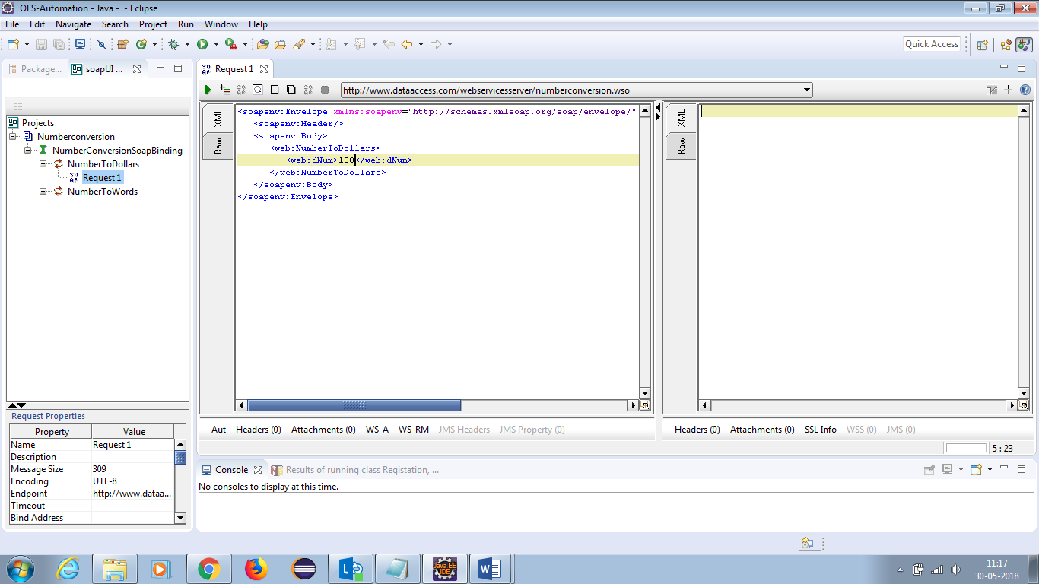

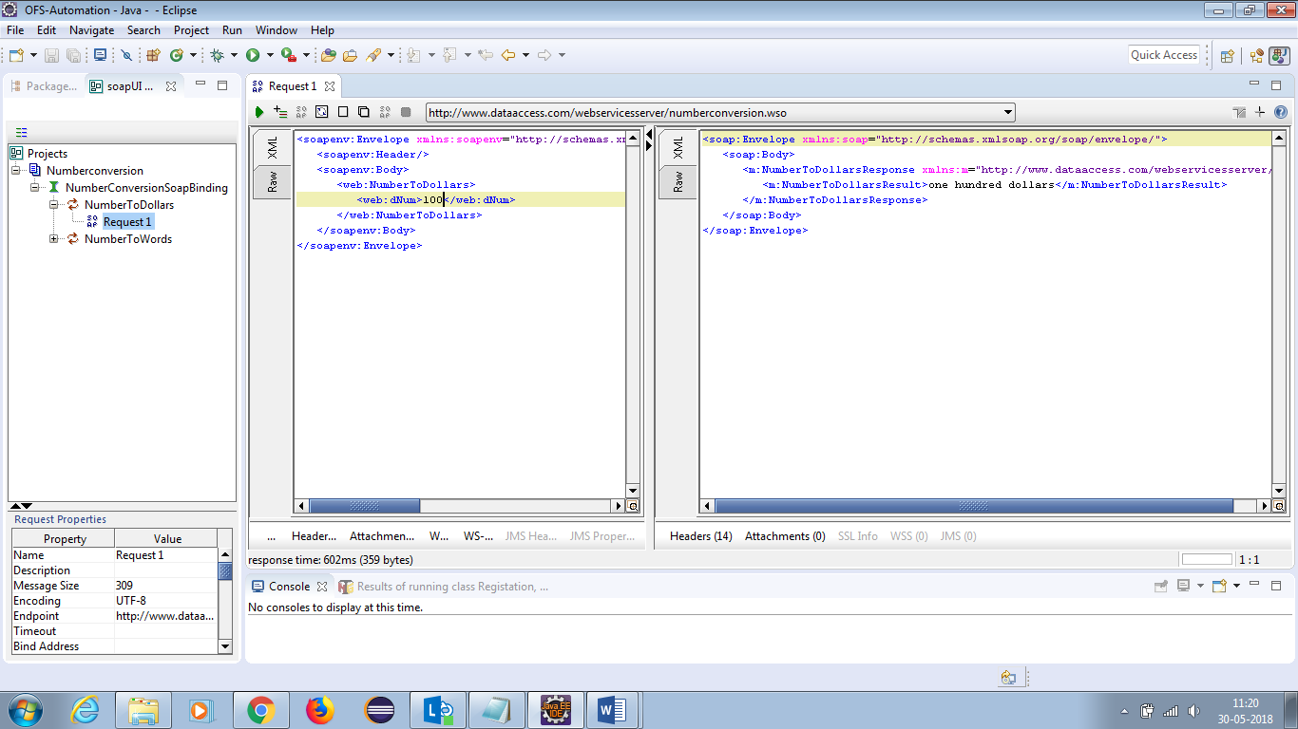

**Create this Request as a Test Case:**

* Click on + Icon mark in the header.
* Write the Test Suit Name.
* Click on OK Button.

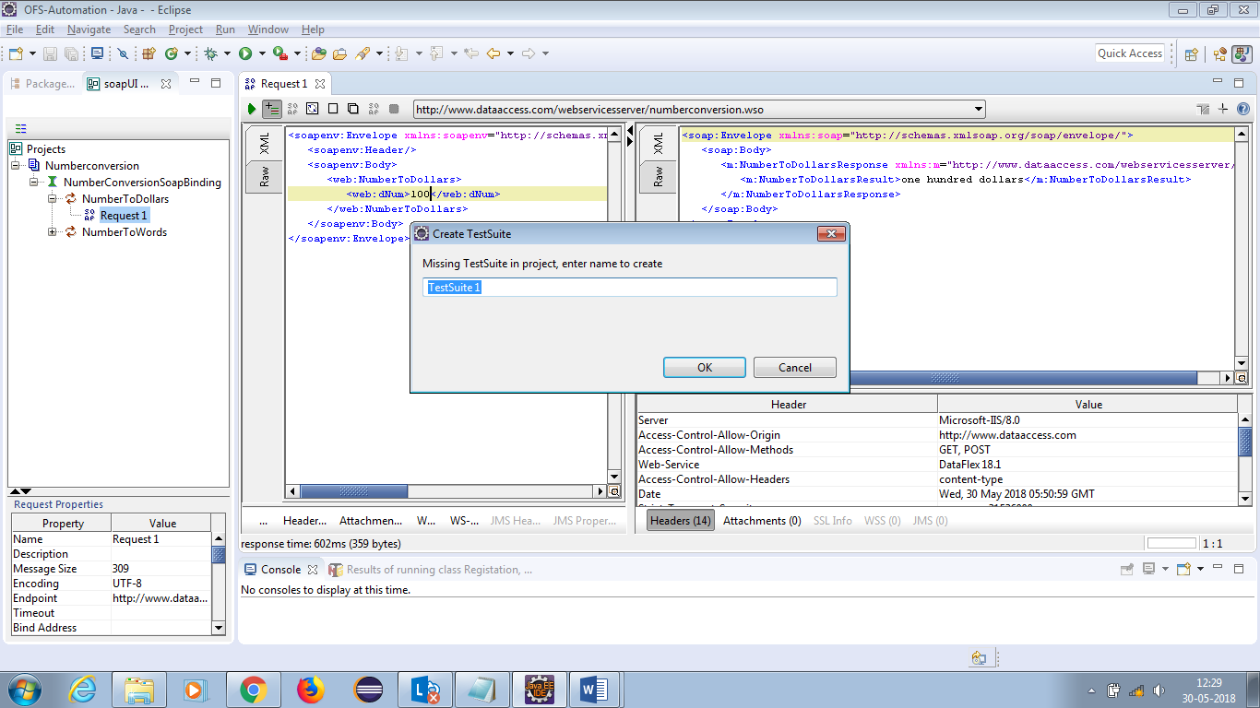

* Write the Testcase Name.
* Click on OK Button.

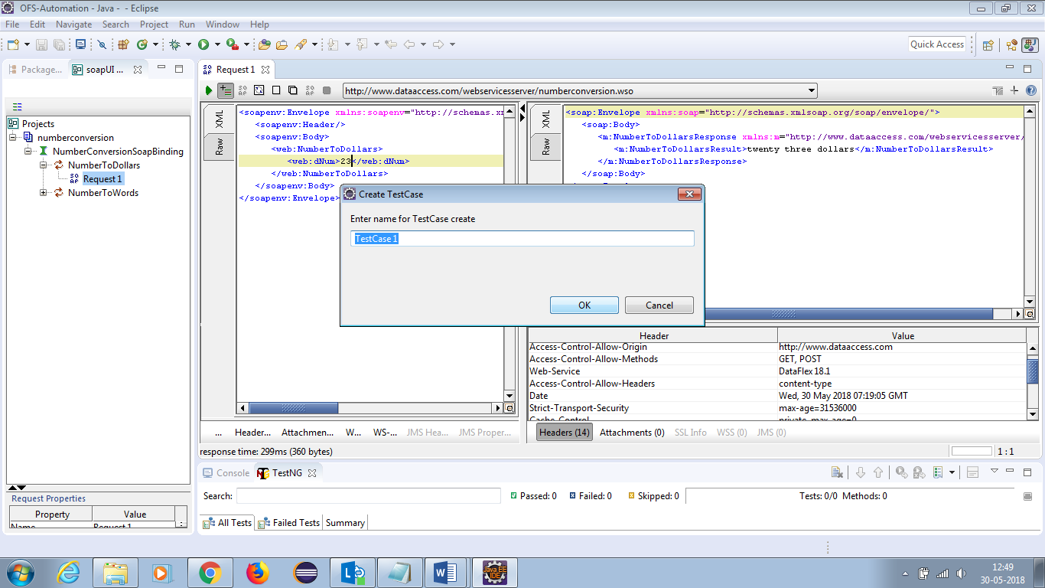

* Write the Request name and Click on Ok button.

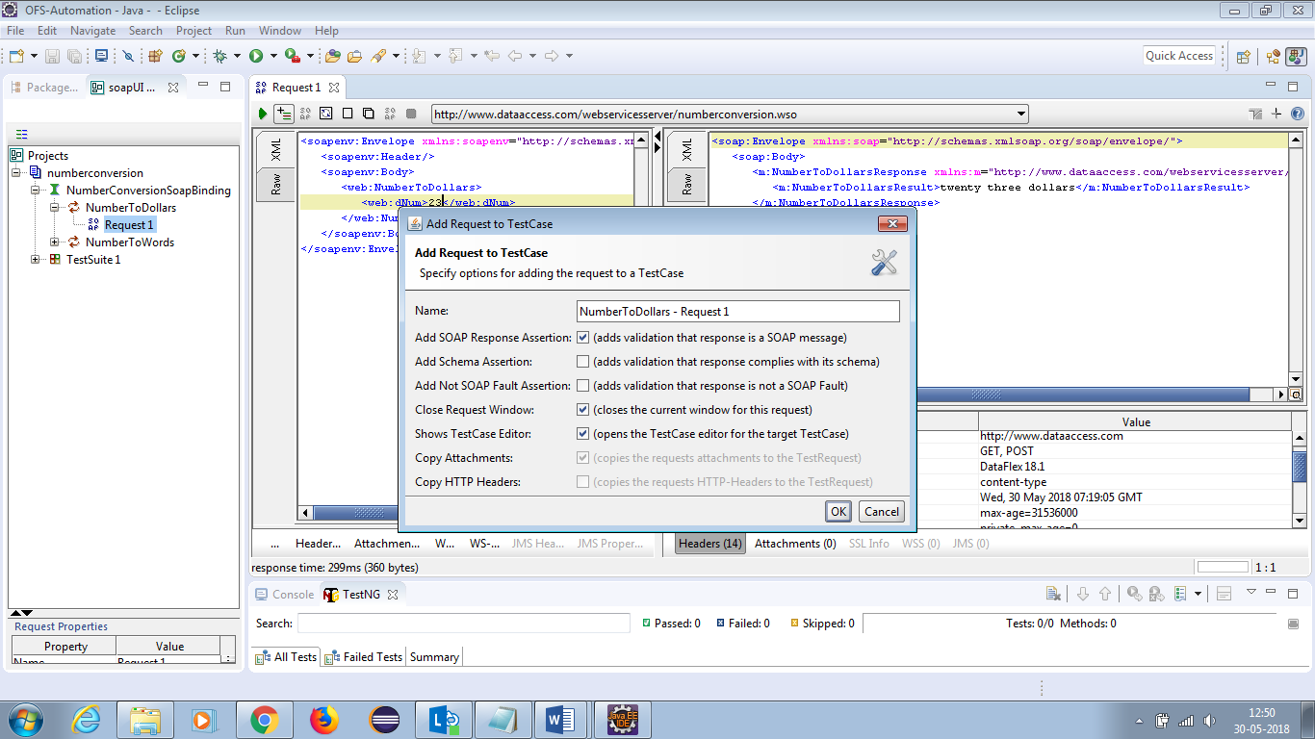

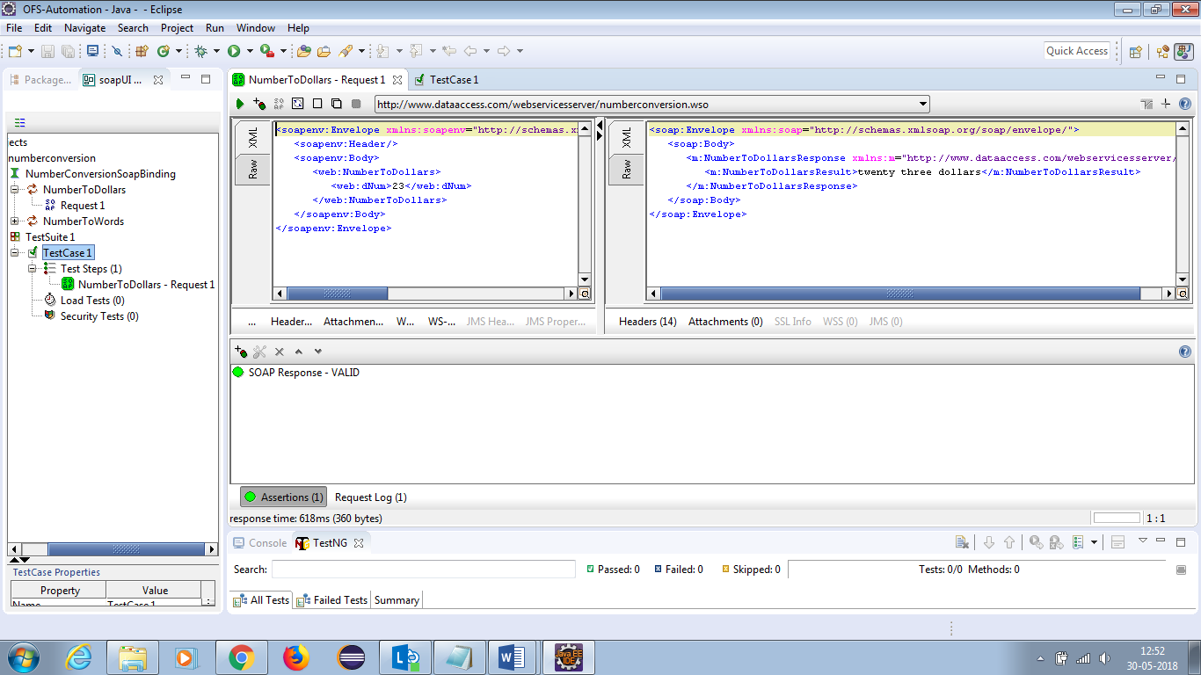

**Adding the Assertions in the Current Step:**

* Double Click on test case Request.
* Click on Assertions.
* Click on ‘**+’** icon and add the assertions what you required.



**Adding Assertions:**

* Contains
* Not Contains

**Contains:**

* Click on ‘**+’** icon.
* Select the ‘Contains’.
* Click on OK Button.

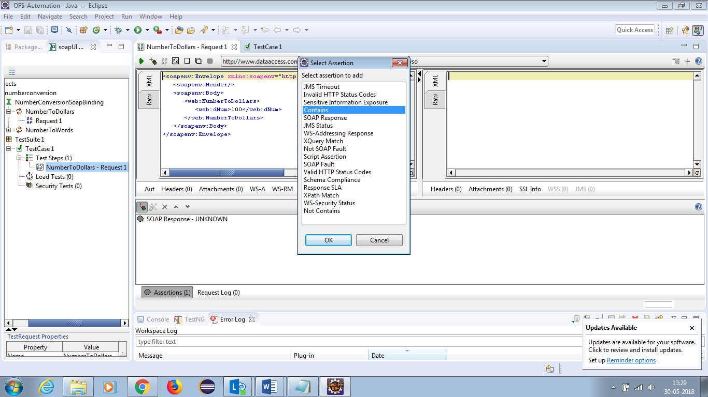

* Write the content in the text box.
* Click on Ok Button.

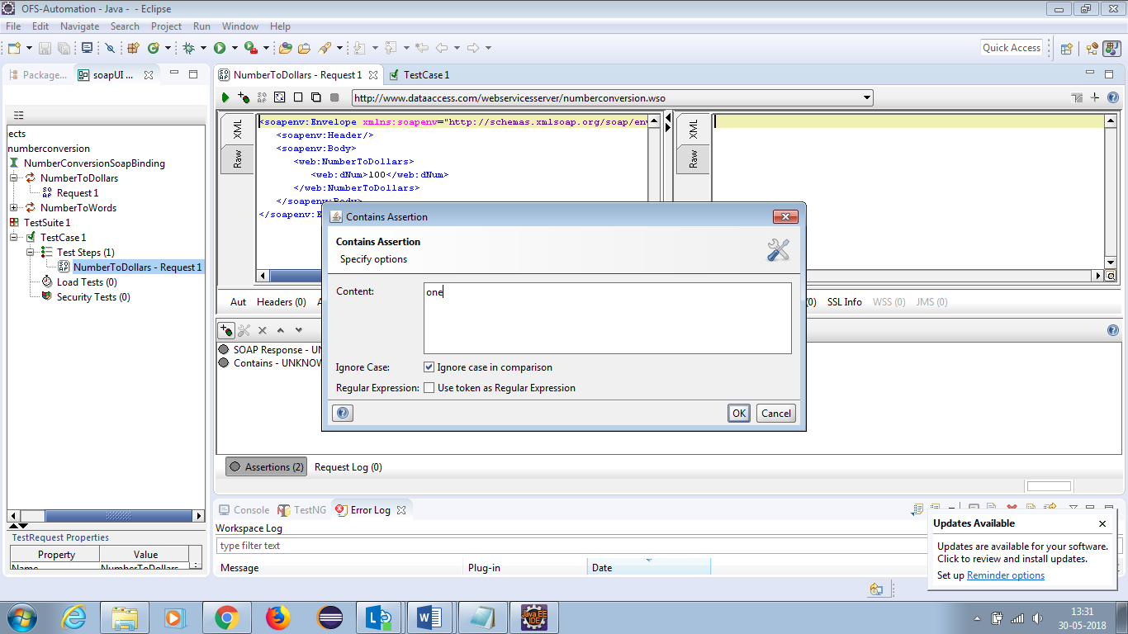

**Not Contains:**

* Click on ‘**+’** icon.
* Select the ‘Not Contains’.
* Click on OK Button.

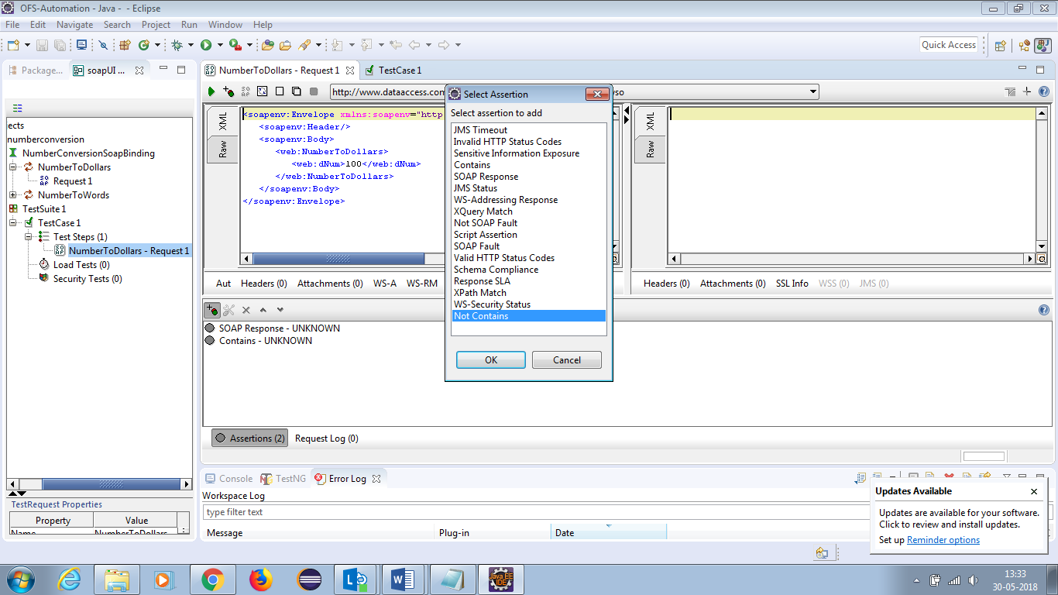

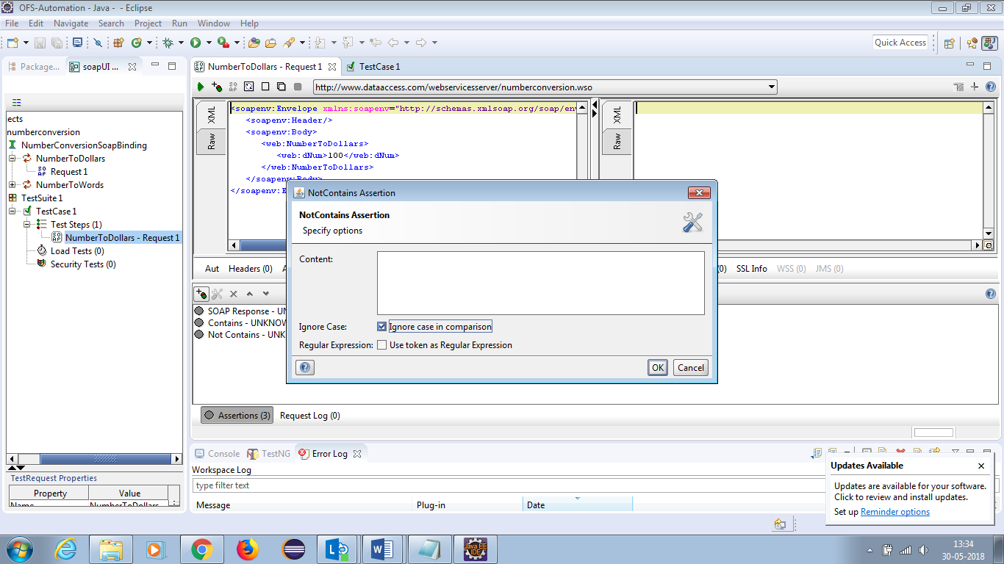

* Write the content in the text box (write any non-existing content).
* Click on Ok Button.

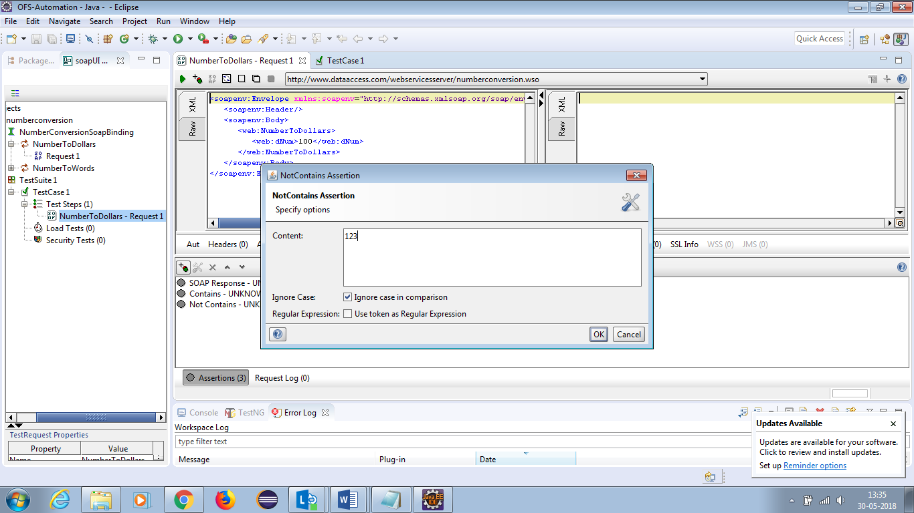

* Click On run verify the Response.

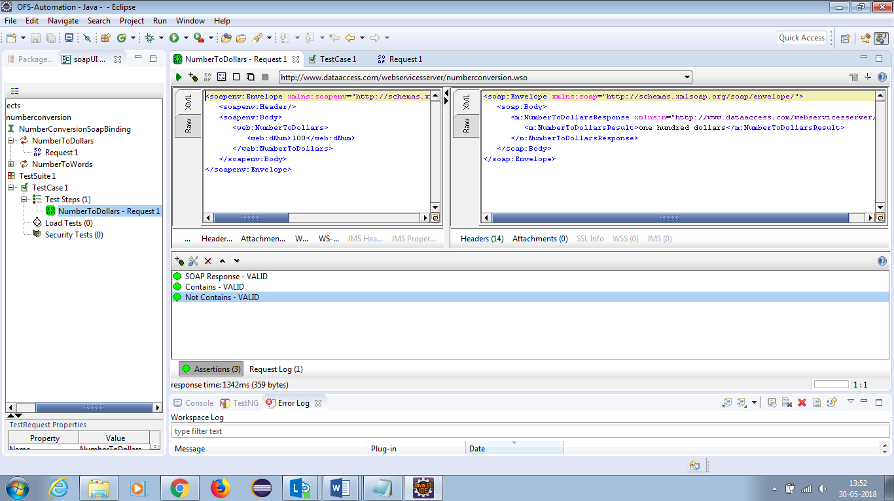

**GET DATA:**

We can get the data in 4 ways in SoapUI,

* Project
* Test Suite
* Testcase
* Test Step

**Project:**

Syntax: ${#Project#PropertyName}

* Select the ‘Project’ and go to Custom Properties in the bottom.
* Add the Property Values.