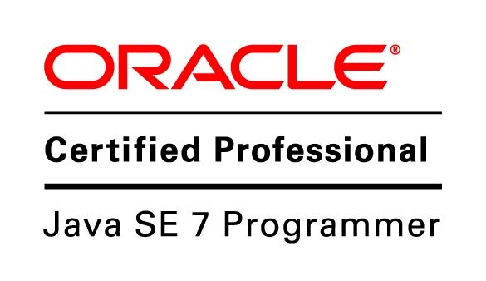
Sandeep Konda
Phone : +919986778898
Email : sandeepkonda@outlook.com

Core competencies

- Oracle Certified Java Programmer
- In-depth knowledge of software design and software development life cycles
- Working in Oracle as a full stack application developer having 7+ years of experience in Java EE Application development and 1+ years of experience in front-end technologies.
- Working knowledge in Relational Database Systems like MS SQL Server and fair exposure to T-SQL programming.
- Proficiency in Object Oriented Programming concepts.
- Possess excellent planning, designing and implementation skills.
- Ability to learn and adapt new technologies in short time.

Skill set

Back-end technologies | Java 1.8, J2EE, Struts 1.2, Hibernate 3.0, EJB 3.0
Front-end technologies | HTML, CSS, JavaScript, jQuery, AngularJS, KnockoutJS, Oracle JET, Servlets, JSP.
Application Servers | JBoss 4.2.3, Weblogic Server 11g, Grizzly
Databases | Oracle 11g, Microsoft SQL Server 2008, MYSQL
DB Management tools | Oracle SQL Developer, Microsoft server Management Studio
IDE | Eclipse, IDEA Intellij, Atom, NetBeans
Version Control | Git, SVN, Starteam, ADE
Build tools | ANT, Gradle, maven, gulp
Testing Frameworks | Junit, Spock, Jasmine
Other Skills | REST, SCIM, Microservices architecture, Docker, T-SQL, Agile software development
Other Tools | BrowserSync, Coverity, Checkstyle, PMD, Findbugs, iReports 3.7.4, Jira, Confluence.

Work Experience

Senior Member Of Technical Staff at Oracle India Pvt. Ltd (June 2014 – Present)

Oracle Identity Cloud Service (IDCS)

Oracle Identity Cloud Service Management provides an innovative, fully integrated service that delivers all the core identity and access management capabilities through a multi-tenant Cloud platform. The design of the next generation Identity cloud Service (IDCS) is based on the microservice architecture, which is naturally aligned with Cloud principles of Scalability, Elasticity, Resilience, Ease of Deployment, Functional Agility, Technical Adoption and Organization Alignment.

Roles & Responsibilities
- Own Password Management and Account Recovery modules in IDCS.
- Implemented Account Recovery module's server side functionality in IDCS from scratch.
- Developed UI for Account Recovery using OJET, which is based on KnockoutJS, requirejs, jquery and other open source JavaScript libraries.
- Fixing defects in Password Management and Account Recovery modules.
- Working on the ER’s submitted by customers or Sales teams.
- Performance improvements.
- POC's for new features in the product.
- Doing peer code review.

Oracle Identity Manager (OIM)

Oracle Identity Manager automates access rights management, security, and provisioning of IT resources. Identity Connectors are used to integrate Oracle Identity Manager with external, identity-aware applications.

Roles & Responsibilities
- Responsible for writing new connectors to provide integration between OIM and targets as proposed by product management team.
- Maintaining and enhancing Generic REST, Generic SCIM, BMC, Siebel connectors.
- Integrated OIM with various cloud application such as Box, ServiceNow, SuccessFactor etc., using Generic REST connector.
- Providing DHQA for new connectors written or enhancements done to the existing connectors.
- Writing Junit test cases and performing unit testing.

Software Analyst at Bally Technologies (July 2012 – June 2014)

Slot Data Systems (SDS)

Slot Data Systems is an integrated information system that monitors slot machines, other gaming devices, and customer activities. SDS responds to information collected by a Game Monitoring Unit (GMU) within each slot machine. The primary function of SDS is slot accounting and player tracking data collection. Slot accounting maintains the integrity of the floor and safeguards assets and revenues. It also provides an accurate and timely database of slot machine statistics for management review regarding machine performance and gaming trends. SDS enables to upgrade and enhance current slot accounting information by providing real time data, accurate automated meter, and jackpot/fill functions, and methods for hard/soft count reconciliation.

Roles & Responsibilities
- Writing new functionalities/enhancements to the existing product.
- Fixing defects in the product rose by testing team or found by development team.
- Working on production issues.
- Coordinating any new functionality implemented with testing and tech support teams.
- Helping tech support team in solving issues or retrofitting their version.
- Writing new stored procedures/queries and upgrade script when any new functionality is implemented which involves database changes.
- Working on patches and release for older version of product.
- Working on defects found by static analysis tool Coverity.
- Developing new Jasper reports using iReports 3.7.4 tool.

Assistant system engineer at Tata Consultancy Services (Sep 2010 – July 2012)

Corporate Liable Custom Solution (CLCS)

Corporate Liable Custom Solution is an web based enterprise solution provided by Sprint to its corporate customers. The web application is an online platform for selling phones and accessories. This application mainly targets for Customized online store for corporate Customers. Customization could be done in terms of Phone, Plans, Services & Accessory. The Stores are highly customizable. In order to set up or configure the new store a tool is provided as part of CLCS application

Roles & Responsibilities
- Involved in the implementation of business logic and Unit Testing
- Involved in the implementation phase for developing the Servlets classes and jsp’s
- Implementing changes/enhancements requested by client
- Fixing defects raised by testing team

Academic Credentials

- B.E. in Computer Science from Siddaganga Institute of Technology, Tumkur in the period
2006 - 2010 with an aggregate of 72.08% (University – Visvesvaraya Technological University)
- 12th from Shet RP Sukhani PU College, Raichur in 2006 with an aggregate of 81.83%
- 10th from Smt. Ratanabai Rikab Chand Sukhani H.S, Raichur in 2004 with an aggregate of 72.80%

