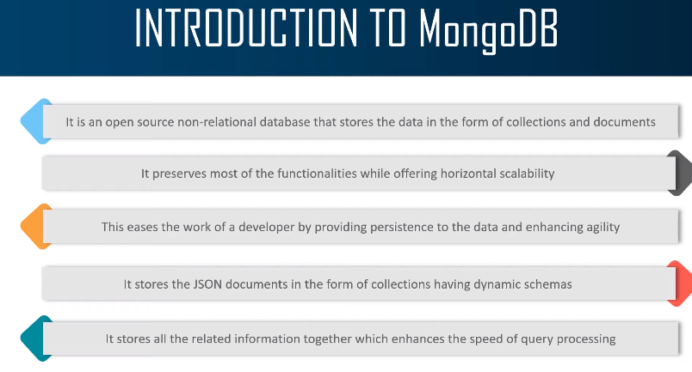
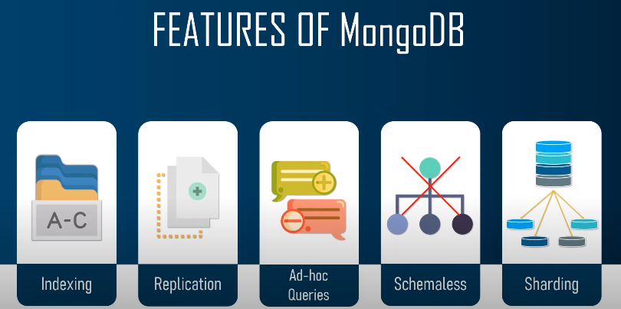
Installation :-

Mongo DB From Below URL (32 Bit)

https://www.mongodb.org/dl/win32/i386

Download File :- (mongodb-win32-i386-v3.2-latest-signed.msi) and install.

Now create a Project Like (D:\MERN\NodeExpressMongo_Project)

open CMD
> npm init
replace index.js to app.js

you will get your package.json file. Now install some dependencies.

> npm install express
>npm install mongodb
>npm install mongoose
>npm install -g nodemon –save-dev

Package.json -

{
"name": "nodeexpressmongo_project",
"version": "1.0.0",
"description": "",
"main": "app.js",
"scripts": {
"start": "nodemon app.js" // replace test with start.
},
"author": "MEN",
"license": "ISC",
"dependencies": {
"express": "^4.17.1",
"mongodb": "^4.0.0",
"mongoose": "^5.13.3"
},
"devDependencies": {
"nodemon": "^2.0.12"
}
}

Configuring -

environment Variable
C:\Program Files\MongoDB\Server\3.2\bin

Create a folder as below (To save data in local Mongo DB): -

C:\data\db

Go to your Project path and open cmd and run below command to start server (only for 32 bit PC.)
D:\MERN\NodeExpressMongo_Project>mongod --storageEngine=mmapv1 --dbpath "C:\data\db"

for 64 bit PC
D:\MERN\NodeExpressMongo_Project>mongod

IF your Server started successfully you will see below screen.

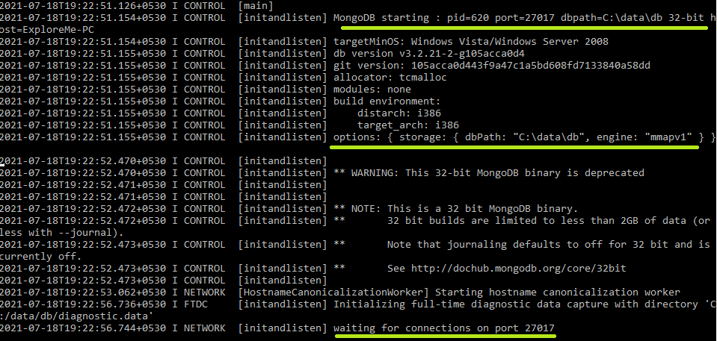

You need to open two terminal

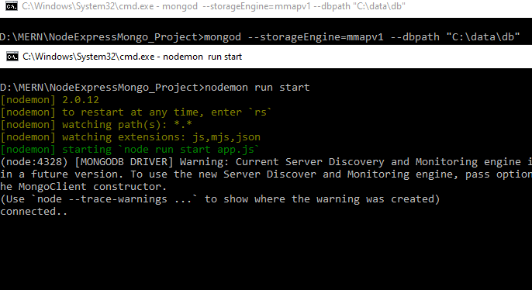

1. D:\MERN\NodeExpressMongo_Project>mongod --storageEngine=mmapv1 --dbpath "C:\data\db"
to keep server running

2. D:\MERN\NodeExpressMongo_Project>nodemon run start

to run your application.

Adding Code to get response using PostMan

Now create a app.js file and add below code.

const express = require('express');
const mongoose = require('mongoose');
const url = 'mongodb://localhost/MENApp';
const app = express();

mongoose.connect(url, {useNewUrlParser: true});
const con = mongoose.connection;
con.on('open', () => {
console.log('connected..')
});

const customRoute = require('./Router/menappRoute');
app.use('/details', customRoute); // this is a middleware.
app.listen(9000, () => {
console.log('Server Started.')
});

IF your server work correctly you will get connected… message in CMD.

Now we need to create Router to use (GET/POST/PATCH/DELETE Operations)

so create a folder let say Router → menAppRoute.js and add below code

const express = require('express');
const router = express.Router();
router.get('/', (req, res) => {
res.send('GEt Request');
});

module.exports = router;

Now press send button of your Postman. (URL : https://localhost:9000/details)

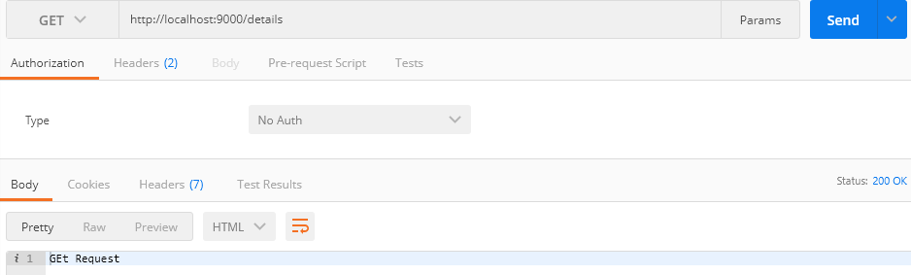

MONGO DB COMMANDS :-

