MONGO DB

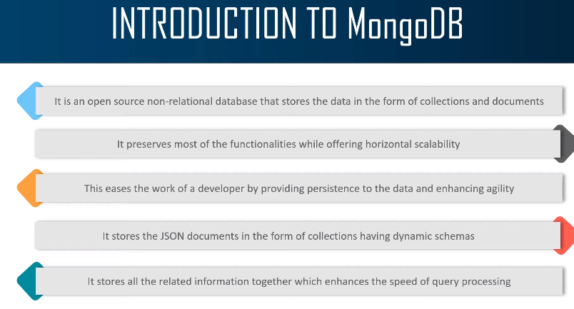

FEATURES :-

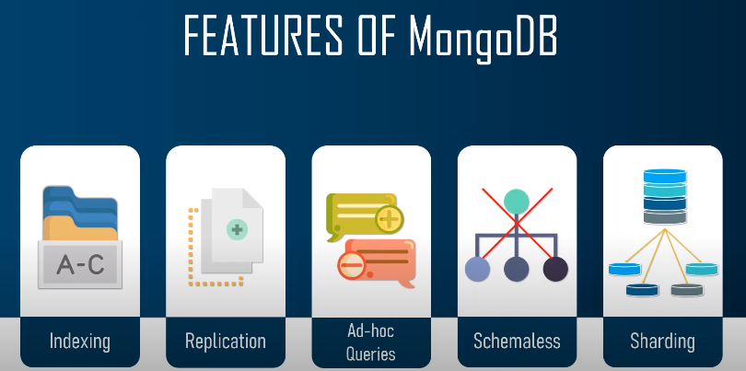

Installing :-

Downloading
https://www.mongodb.com/try/download/enterprise

32 Bit
Downloads for win32 (mongodb.org)

mongodb-win32-i386-v3.2-latest-signed.msi

MONGO DB COMMANDS :-

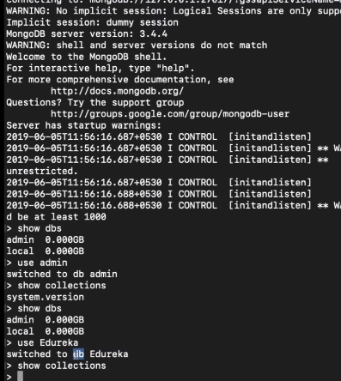

1. Log Into MongoDB
The following command can be used to log into the MongoDB database. Make sure that the user with credentials such as username and password exist in the database mentioned in place of dbname.
1
mongo -u <username> -p <password> --authenticationDatabase <dbname>

2. Show All Databases
Once logged in as a user with the appropriate role as userAdmin or userAdminAnyDatabase, the user can see all the databases using a command such as:
1
show dbs

3. Select Database to Work With
To start working with a particular database, the following command can be executed:
1
use databaseName

4. Authenticate and Log Out From Database
When switching to a different database using the use dbName command, the user is required to authenticate using a valid database user for that database. The following command can be used for authentication:
1
//
2
// Authenticate
3
//
4
db.auth("username", "password");
5
//
6
// Logout
7
//
8
db.logout()

5. List Down Collections, Users, Roles, etc.
The following commands can be used to check existing collections, users, etc.
1
//
2
// List down collections of the current database
3
//
4
show collections;
5
db.getCollectionNames();
6
//
7
// List down all the users of current database
8
//
9
show users;
10
db.getUsers();
11
//
12
// List down all the roles
13
//
14
show roles

CRUD Operations : -

https://www.geeksforgeeks.org/mongodb-crud-operations/

As we know that we can use MongoDB for various things like building an application (including web and mobile), or analysis of data, or an administrator of a MongoDB database, in all these cases we need to interact with the MongoDB server to perform certain operations like entering new data into the application, updating data into the application, deleting data from the application, and reading the data of the application.
MongoDB provides a set of some basic but most essential operations that will help you to easily interact with the MongoDB server and these operations are known as CRUD operations.

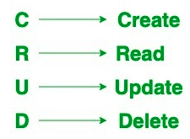

Create Operations –
The create or insert operations are used to insert or add new documents in the collection. If a collection does not exist, then it will create a new collection in the database. You can perform, create operations using the following methods provided by the MongoDB:

Method | Description
db.collection.insertOne() | It is used to insert a single document in the collection.
db.collection.insertMany() | It is used to insert multiple documents in the collection.

Example 1:
In this example, we are inserting details of a single student in the form of document in the student collection using db.collection.insertOne() method.

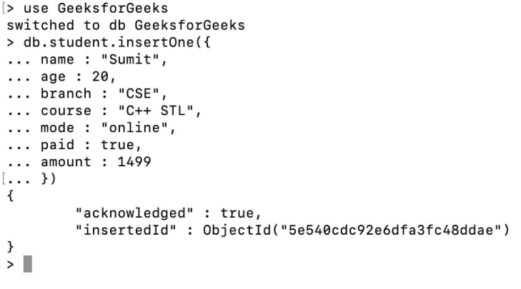

InsertMany()

Example 2:
In this example, we are inserting details of the multiple students in the form of documents in the student collection using db.collection.insertMany() method.

Read Operations –
The Read operations are used to retrieve documents from the collection, or in other words, read operations are used to query a collection for a document. You can perform read operation using the following method provided by the MongoDB:

Method | Description
db.collection.find() | It is used to retrieve documents from the collection.

Example :
In this example, we are retrieving the details of students from the student collection using db.collection.find() method.

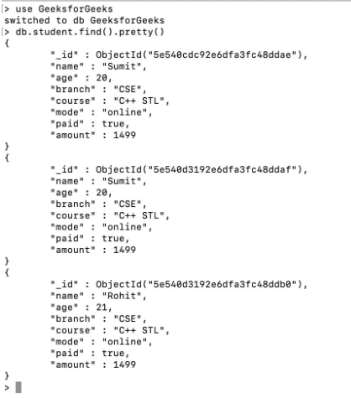

Update Operations –
The update operations are used to update or modify the existing document in the collection. You can perform update operations using the following methods provided by the MongoDB:

Method | Description
db.collection.updateOne() | It is used to update a single document in the collection that satisfy the given criteria.
db.collection.updateMany() | It is used to update multiple documents in the collection that satisfy the given criteria.
db.collection.replaceOne() | It is used to replace single document in the collection that satisfy the given criteria.
Example 1:
In this example, we are updating the age of Sumit in the student collection using db.collection.updateOne() method.

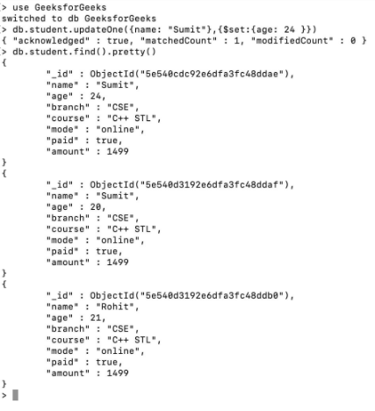

UpdateMany() –

Example 2:
In this example, we are updating the year of course in all the documents in the student collection using db.collection.updateMany() method.

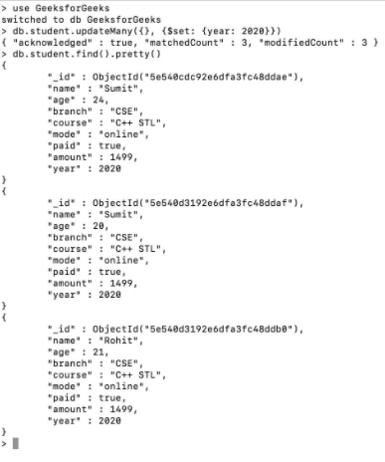

Delete Operations –
The delete operation are used to delete or remove the documents from a collection. You can perform delete operations using the following methods provided by the MongoDB:

Method | Description
db.collection.deleteOne() | It is used to delete a single document from the collection that satisfy the given criteria.
db.collection.deleteMany() | It is used to delete multiple documents from the collection that satisfy the given criteria.

Example 1:
In this example, we are deleting a document from the student collection using db.collection.deleteOne() method.

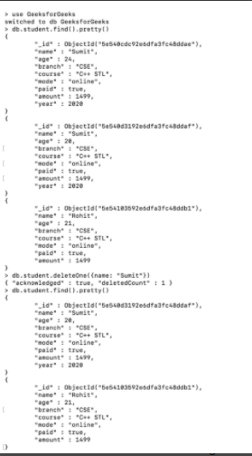

DeleteMany() –

Example 2:
In this example, we are deleting all the documents from the student collection using db.collection.deleteMany() method.

