MONGO DB

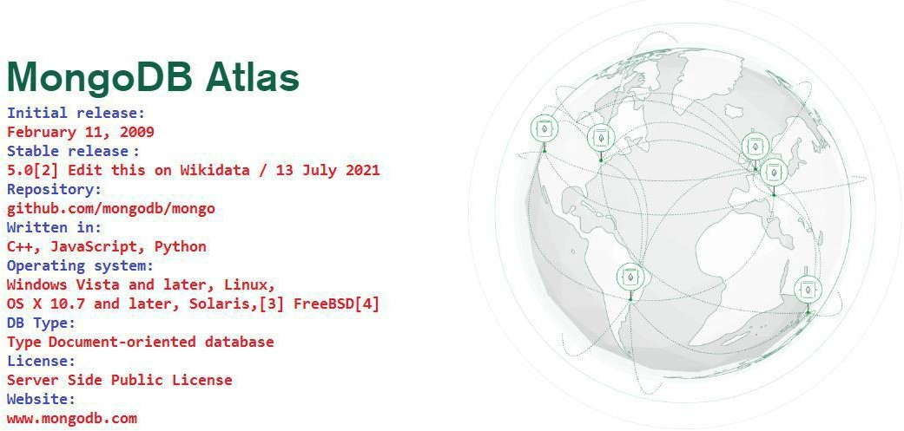
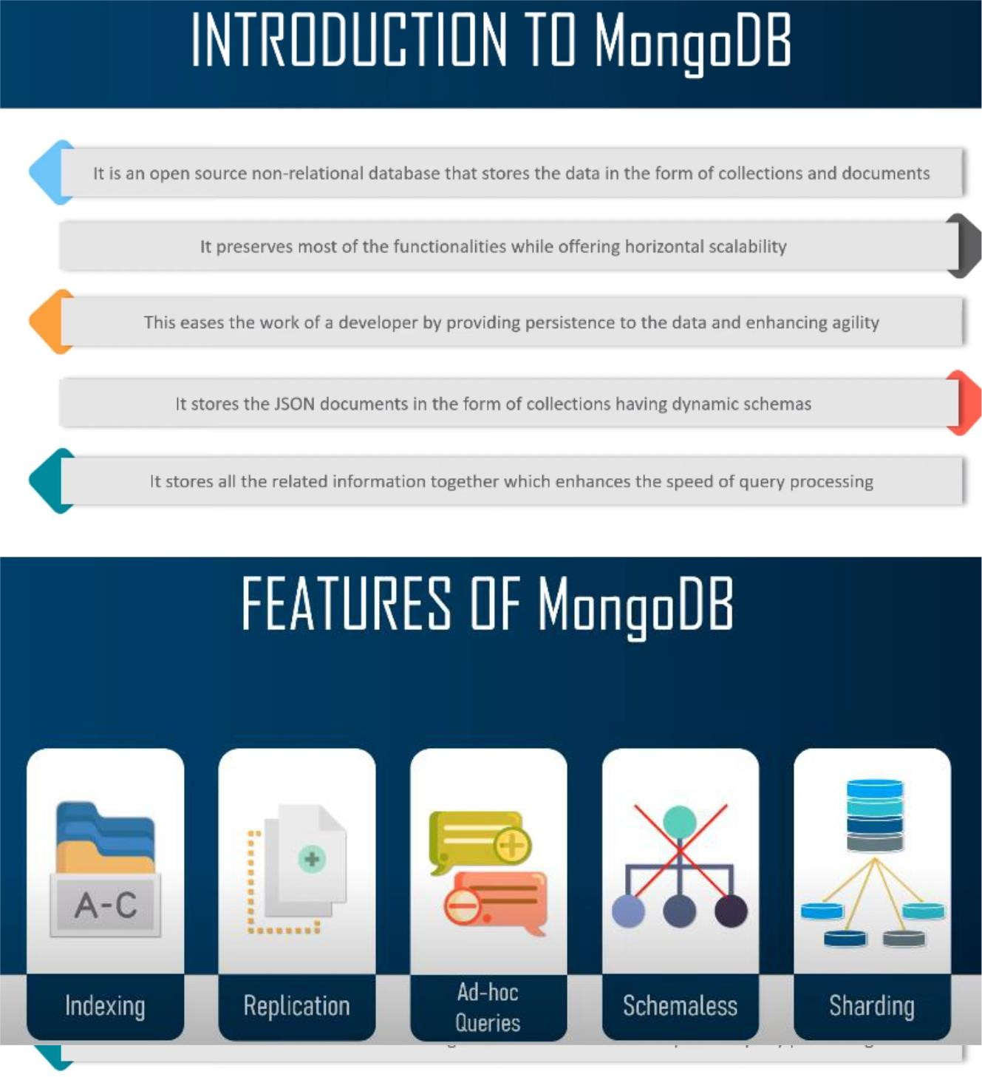

Official Site Doc Link: https://docs.mongodb.com/manual/crud/ https://docs.mongodb.com/manual/tutorial/query-documents/

MongoDB

It is a cross-platform, document oriented database that provides, high performance,
high availability, and easy scalability. MongoDB works on concept of collection and document.

Database
Database is a physical container for collections. Each database gets its own set of files on the
file system. A single MongoDB server typically has multiple databases.

Collection
Collection is a group of MongoDB documents. It is the equivalent of an RDBMS table. A
collection exists within a single database. Collections do not enforce a schema. Documents
within a collection can have different fields. Typically, all documents in a collection are of
similar or related purpose.

Document
A document is a set of key-value pairs. Documents have dynamic schema.
Dynamic schema
means that documents in the same collection do not need to have the same set of fields or
structure, and common fields in a collection's documents may hold different types of data.
The following table shows the relationship of RDBMS terminology with MongoDB

Any relational database has a typical schema design that shows number of tables and the
relationship between these tables. While in MongoDB, there is no concept of relationship.

Advantages of MongoDB over RDBMS

Schema less: MongoDB is a document database in which one collection holds different
documents. Number of fields, content and size of the document can differ from one
document to another.
Structure of a single object is clear. No complex joins.
Deep query-ability. MongoDB supports dynamic queries on documents using a document-based query language that's nearly as powerful as SQL.
Tuning.

Ease of scale-out: MongoDB is easy to scale.
Conversion/mapping of application objects to database objects not needed.
Uses internal memory for storing the (windowed) working set, enabling faster access
of data.

Why Use MongoDB?
Flexibility :-
It is sets of documents that can contain sub documents which may have complex hierarchy is really expressive and flexible.
Flexible query Model:-
A user can select some part of a document based on attribute values, regular expression or ranges.
Native Aggregation:-
It allows a user to extract and transform data from Mongo DB and load them in a new format or export to other data source.
Schema less Model: -
Application get the power and responsibility to interpret different properties in different ways.
Document Oriented Storage: Data is stored in the form of JSON.
Index on any attribute
Replication and high availability. Auto-sharing
Rich queries
Fast in-place updates
Professional support by MongoDB

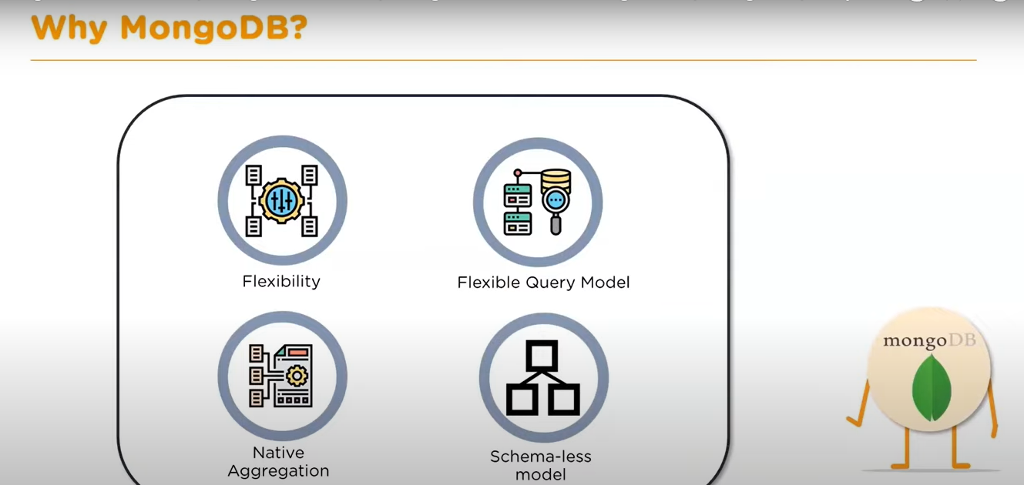

Characterstic of mongo db

- General purpose db –
Mongo db can serve hetrogenius loads at multiple purposes within an application.
- Flexible schema design :-
Document oriented database can be modified on a fly. It is key contrast of mongo db and any other relational db.

- Scalibility and load balancing :-
It is build to scale vertically but most importantly horizontally using sorting and architect can share load between different instants and achieve both read and write scalibility.
Load balancing happens automatically.
- Aggregation framework :-
Mongo db offers extract transform and load framework that eliminate the need for complex data bindings.
- Native replication:-
Data will get replicated across replica set without complicated setup.
- Security features :-
Both authentication and authorisation are linked to account in mongo db.
- Json :-
Json is widely used across web applications for front end and api communication.
- Map reduce :-
It is an excelent tool to build data pipe lines and mongo db uses map reduce readyE.

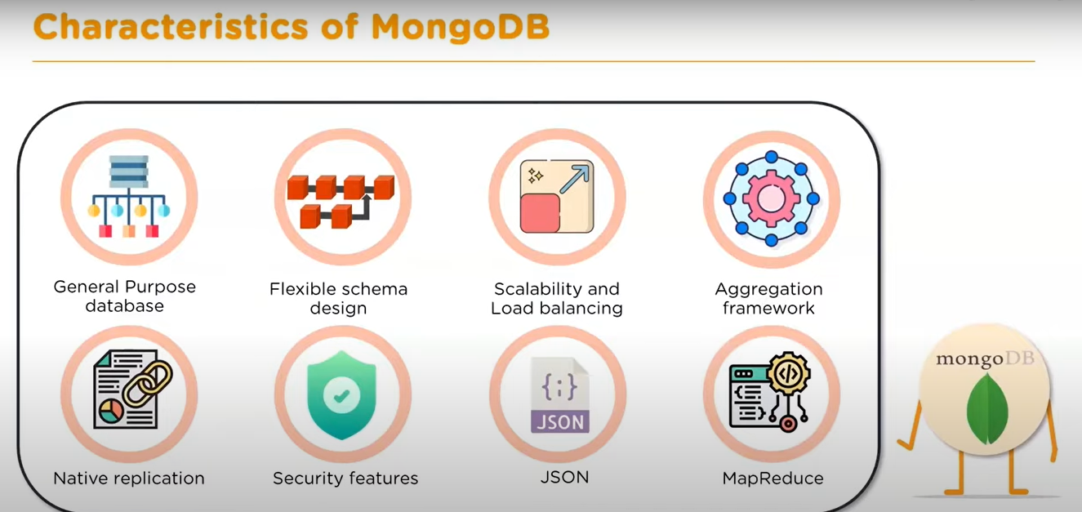

Where to Use MongoDB?
Big Data
Content Management and Delivery Mobile and Social Infrastructure User Data Management
Data Hub

What is No SQL
It is non relational database that is traditional database which is having tables with rows and columns.
Sql server , my sql etc.

Types of No SQL

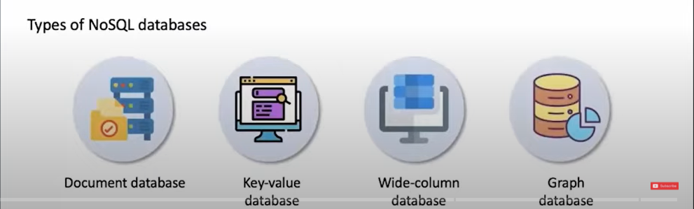

Applications of Mongo DB :-

- Internet of things
- Mobile applications
- Real time analysis
- Personalization
- Catalog management
- Content management

Installation:-

For 64 bit OS

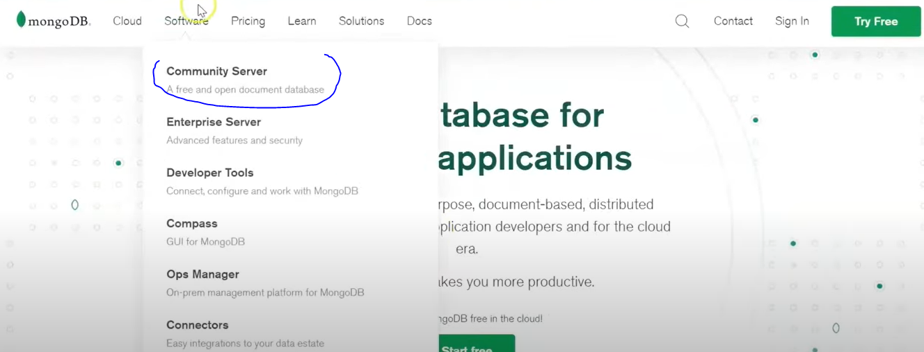

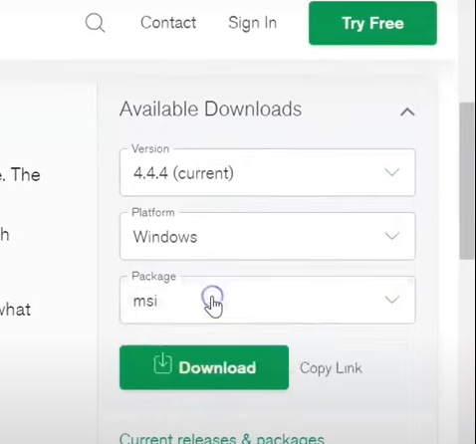

Then add it in environment variable under user variable option.

For 32 bit OS:-

Mongo DB From Below URL (32 Bit) https://www.mongodb.org/dl/win32/i386
Download File :- (mongodb-win32-i386-v3.2-latest-signed.msi) and install. Now create a Project Like (D:\MERN\NodeExpressMongo_Project)
open CMD
- npm init
replace index.js to app.js

you will get your package.json file. Now install some dependencies.
- npm install express
>npm install mongodb
>npm install mongoose
>npm install -g nodemon –save-dev

Package.json -

{
"name": "nodeexpressmongo_project", "version": "1.0.0",
"description": "",
"main": "app.js", "scripts": {
"start": "nodemon app.js"// replace test with start.

},
"author": "MEN",
"license": "ISC",
"dependencies": {
"mongoose": "^5.13.3"
"mongodb": "^4.0.0",
"express": "^4.17.1",
},
"devDependencies": {
"nodemon": "^2.0.12"
}
}

Configuration:-
C:\Program Files\MongoDB\Server\3.2\bin

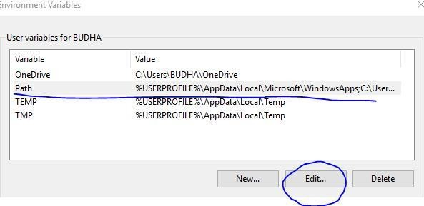
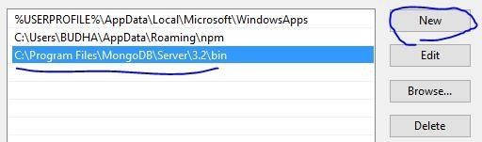

Create a folder as below (To save data in local Mongo DB): -

C:\data\db

Go to your Project path and open cmd and run below command to start server (only for 32 bit PC.)
D:\MERN\NodeExpressMongo_Project>mongod --storageEngine=mmapv1 -- dbpath "C:\data\db"

you will get below screen
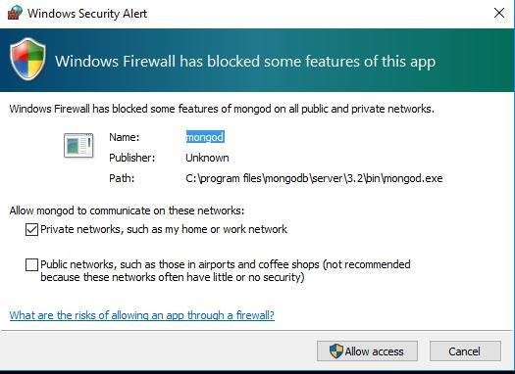

for 64 bit PC
D:\MERN\NodeExpressMongo_Project>mongod

IF your Server started successfully you will see below screen.
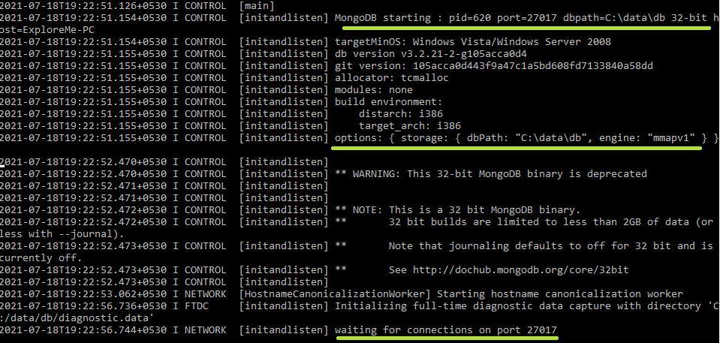

You need to open two terminal
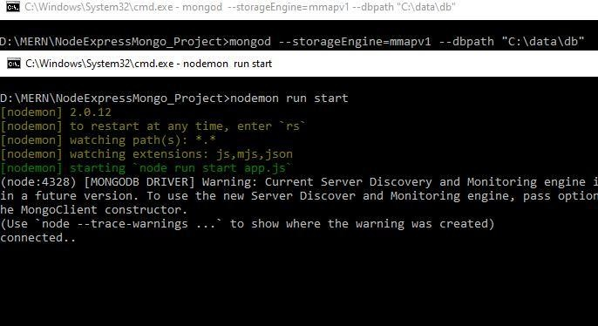
Open new command prompt and run below command

D:\MERN\NodeExpressMongo_Project>mongod -- storageEngine=mmapv1 --dbpath "C:\data\db"(to keep server running)
Again Open new command prompt and run below command

D:\MERN\NodeExpressMongo_Project>nodemon run start

to run your application.

Adding Code to get response using PostMan

Now create a app.js file and add below code.

const express = require('express'); const mongoose = require('mongoose'); const url = 'mongodb://localhost/MENApp'; const app = express();

mongoose.connect(url, {useNewUrlParser: true}); const con = mongoose.connection; con.on('open', () => {
console.log('connected..')
});

const customRoute = require('./Router/menappRoute'); app.use('/details', customRoute); // this is a middleware. app.listen(9000, () => {
console.log('Server Started.')

});

IF your server work correctly you will get connected… message in CMD. Now we need to create Router to use (GET/POST/PATCH/DELETE Operations) so create a folder let say Router → menAppRoute.js and add below code
const express = require('express'); const router = express.Router();
router.get('/', (req, res) => { res.send('GEt Request');
});
module.exports = router;

Now press send button of your Postman. (URL : http://localhost:9000/details)

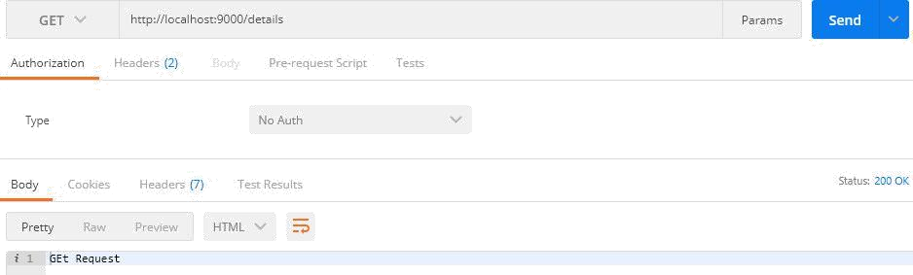

MONGO DB COMMANDS

To run mongo commands first you have to open a new command prompt and run below command (for 32 bit) to keep database active and in running state.

Open new command prompt and run below command
- mongod --storageEngine=mmapv1 --dbpath "C:\data\db"(mongod for 64 bit)

Again Open new command prompt and run below command

nodemon run start

Again Open new command prompt and run below command
- mongo

you will see a shell like below with a cursor blinking.

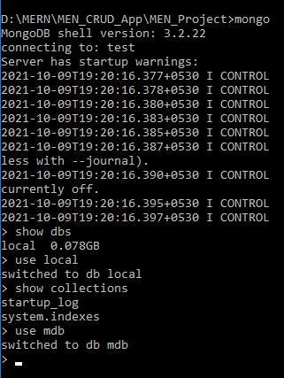

- To see all db
- show dbs

- To create new db > use db_name

To see your newely created db you need to insert atleast one record.

db.dbs.insert({"mdb_userName": "Sandee"});

- show dbs

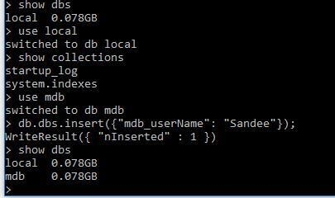

creating collections

- db.createCollection("cars")

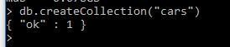

- show collections
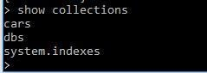
Insert document inside collection
- db.cars.insert({name: 'TATA', manufacture: 2010, model: "tata indica", price: 500000})
db.cars.insert({name: 'TATA', manufacture: 2010, model: "tata indica", price: 500000})

show docs created inside collection
- db.cars.find().pretty()
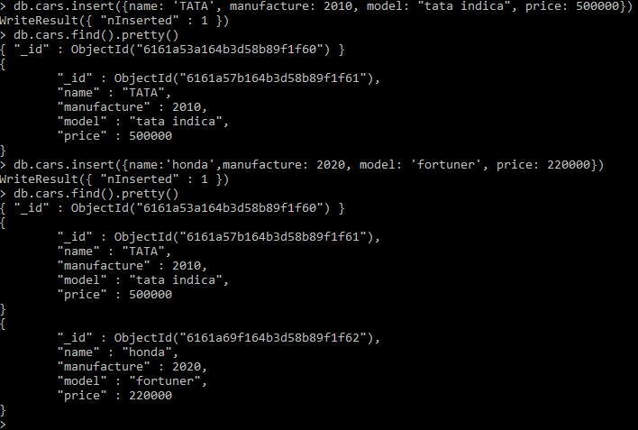

Updating specific field inside any record.

- db.cars.update({name: 'honda'}, {$set: {name: 'Ford'}})
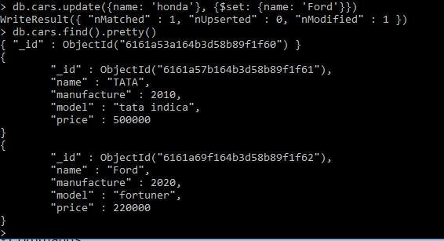

Adding new field to existing record.

- db.cars.update({name: 'Ford'}, {$set: {quantity: 400}}, {$upsert: true})

