MONGO DB

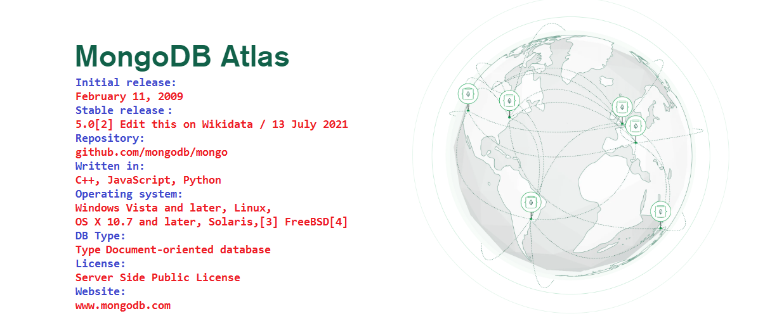
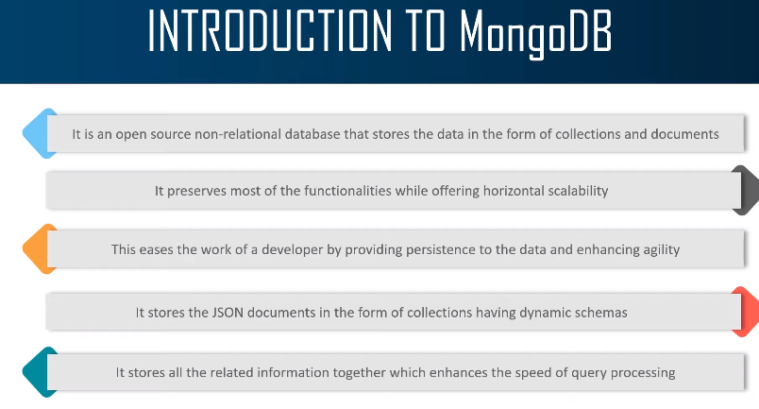
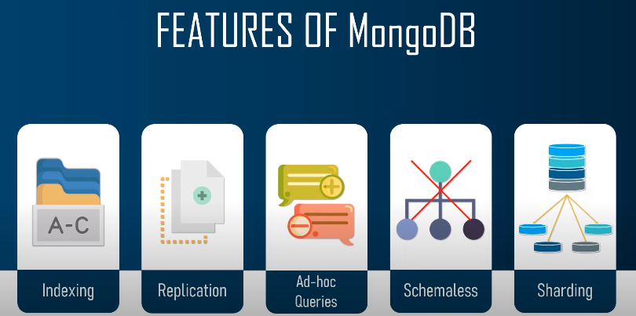

Official Site Doc Link:
https://docs.mongodb.com/manual/crud/
https://docs.mongodb.com/manual/tutorial/query-documents/

MongoDB
It is a cross-platform, document oriented database that provides, high performance,
high availability, and easy scalability. MongoDB works on concept of collection and document.

Database
Database is a physical container for collections. Each database gets its own set of files on the
file system. A single MongoDB server typically has multiple databases.

Collection
Collection is a group of MongoDB documents. It is the equivalent of an RDBMS table. A
collection exists within a single database. Collections do not enforce a schema. Documents
within a collection can have different fields. Typically, all documents in a collection are of
similar or related purpose.

Document
A document is a set of key-value pairs. Documents have dynamic schema. Dynamic schema
means that documents in the same collection do not need to have the same set of fields or
structure, and common fields in a collection's documents may hold different types of data.
The following table shows the relationship of RDBMS terminology with MongoDB

Any relational database has a typical schema design that shows number of tables and the
relationship between these tables. While in MongoDB, there is no concept of relationship.

Advantages of MongoDB over RDBMS

• Schema less: MongoDB is a document database in which one collection holds different
documents. Number of fields, content and size of the document can differ from one
document to another.
• Structure of a single object is clear.
• No complex joins.
• Deep query-ability. MongoDB supports dynamic queries on documents using a
document-based query language that's nearly as powerful as SQL.
• Tuning.
• Ease of scale-out: MongoDB is easy to scale.
• Conversion/mapping of application objects to database objects not needed.
• Uses internal memory for storing the (windowed) working set, enabling faster access
of data.

Why Use MongoDB?
• Document Oriented Storage: Data is stored in the form of JSON style documents.
• Index on any attribute
• Replication and high availability
• Auto-sharding
• Rich queries
• Fast in-place updates
• Professional support by MongoDB

Where to Use MongoDB?
• Big Data
• Content Management and Delivery
• Mobile and Social Infrastructure
• User Data Management
• Data Hub

Installation:-

Mongo DB From Below URL (32 Bit)

https://www.mongodb.org/dl/win32/i386

Download File :- (mongodb-win32-i386-v3.2-latest-signed.msi) and install.

Now create a Project Like (D:\MERN\NodeExpressMongo_Project)

open CMD
> npm init
replace index.js to app.js

you will get your package.json file. Now install some dependencies.

> npm install express
>npm install mongodb
>npm install mongoose
>npm install -g nodemon –save-dev

Package.json -

{
"name": "nodeexpressmongo_project",
"version": "1.0.0",
"description": "",
"main": "app.js",
"scripts": {
"start": "nodemon app.js" // replace test with start.
},
"author": "MEN",
"license": "ISC",
"dependencies": {
"express": "^4.17.1",
"mongodb": "^4.0.0",
"mongoose": "^5.13.3"
},
"devDependencies": {
"nodemon": "^2.0.12"
}
}

Mongoose is a way to make connection with mongodb database. It provide mongodb validation and query in a very simple manner and it makes development fast.

Mongoose provides a straight-forward, schema-based solution to model your application data. It includes built-in type casting, validation, query building, business logic hooks and more, out of the box.
Configuring:-

environment Variable
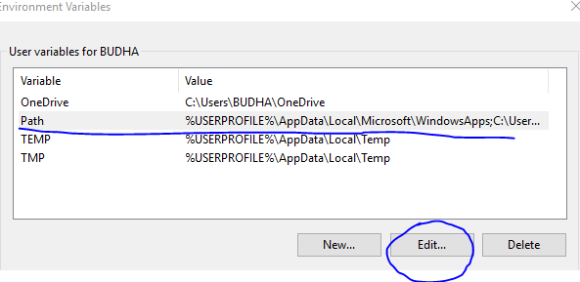
C:\

Program Files\MongoDB\Server\3.2\bin

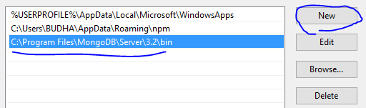

Create a folder as below (To save data in local Mongo DB): -

C:\data\db

Go to your Project path and open cmd and run below command to start server (only for 32 bit PC.)
D:\MERN\NodeExpressMongo_Project>mongod --storageEngine=mmapv1 --dbpath "C:\data\db"

you will get below screen

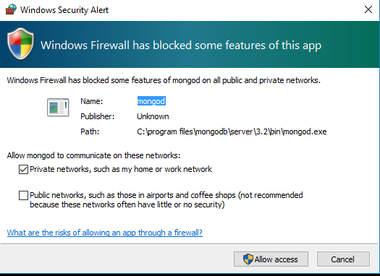

for 64 bit PC
D:\MERN\NodeExpressMongo_Project>mongod

IF your Server started successfully you will see below screen.

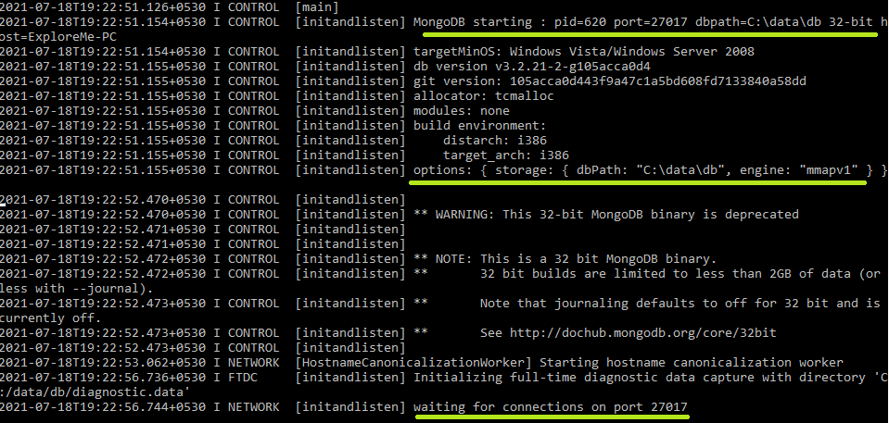

You need to open two terminal

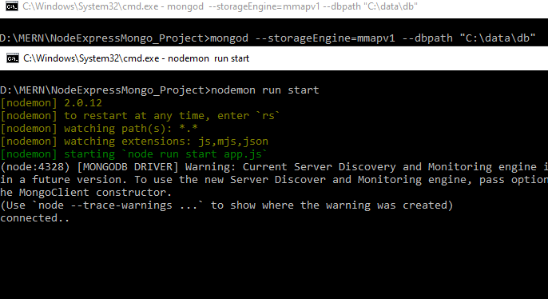

1. D:\MERN\NodeExpressMongo_Project>mongod --storageEngine=mmapv1 --dbpath "C:\data\db"
(to keep server running)

2. D:\MERN\NodeExpressMongo_Project>nodemon run start

to run your application.

Adding Code to get response using PostMan

Now create a app.js file and add below code.

const express = require('express');
const mongoose = require('mongoose');
const url = 'mongodb://localhost/MENApp';
const app = express();

mongoose.connect(url, {useNewUrlParser: true});
const con = mongoose.connection;
con.on('open', () => {
console.log('connected..')
});

const customRoute = require('./Router/menappRoute');
app.use('/details', customRoute); // this is a middleware.
app.listen(9000, () => {
console.log('Server Started.')
});

IF your server work correctly you will get connected… message in CMD.

Now we need to create Router to use (GET/POST/PATCH/DELETE Operations)

so create a folder let say Router → menAppRoute.js and add below code

const express = require('express');
const router = express.Router();
router.get('/', (req, res) => {
res.send('GEt Request');
});

module.exports = router;

Now press send button of your Postman. (URL : http://localhost:9000/details) or http://localhost:8000/details

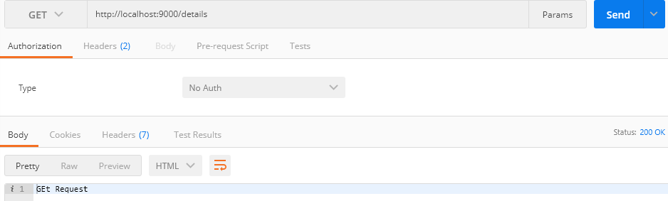

MONGO DB COMMANDS

To run mongo commands first you have to open a new command prompt and run below command (for 32 bit) to keep database active and in running state.

> mongod --storageEngine=mmapv1 --dbpath "C:\data\db"(mongod for 64 bit)

Then run below command in a new command prompt

> mongo
you will see a shell like below with a cursor blinking.
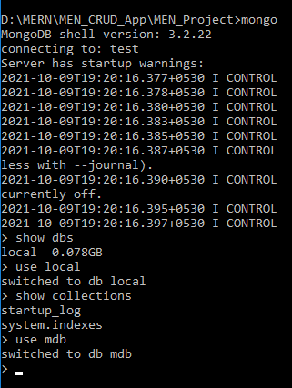

1. To see all db
> show dbs

2. To create new db
> use db_name

To see your newely created db you need to insert atleast one record.

3. db.dbs.insert({"mdb_userName": "Sandee"});

4. show dbs

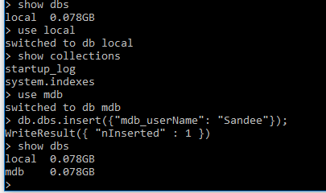

creating collections

> db.createCollection("cars")

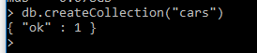

> show collections
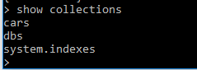

Insert document inside collection
> db.cars.insert({name: 'TATA', manufacture: 2010, model: "tata indica", price: 500000})
db.cars.insert({name: 'TATA', manufacture: 2010, model: "tata indica", price: 500000})

show docs created inside collection
> db.cars.find().pretty()

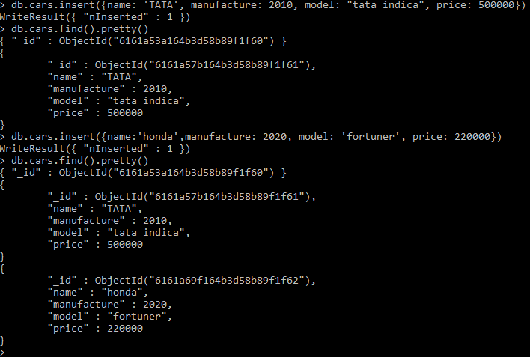
Updating specific field inside any record.

> db.cars.update({name: 'honda'}, {$set: {name: 'Ford'}})

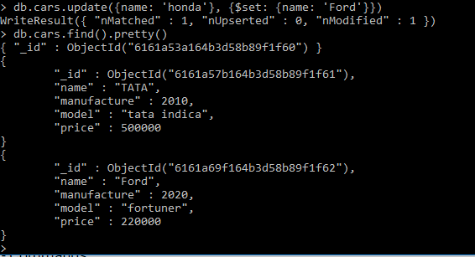

Adding new field to existing record.

> db.cars.update({name: 'Ford'}, {$set: {quantity: 400}}, {$upsert: true})

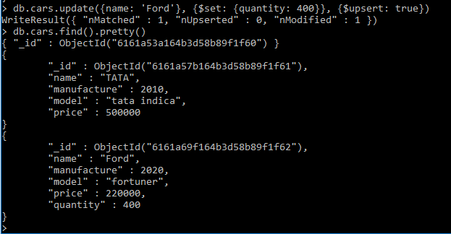

In

Mongoose

https://mongoosejs.com/

Mongoose provides a straight-forward, schema-based solution to model your application data. It includes built-in type casting, validation, query building, business logic hooks and more, out of the box.

Mongoose Schema
mongoose a schema represents the structure of a particular document, either completely or just a portion of the document. It's a way to express expected properties and values as well as constraints and indexes. A model defines a programming interface for interacting with the database (read, insert, update, etc).

Mongoose Models

Models are responsible for creating and reading documents from the underlying MongoDB database.

