**Automation Framework Development Steps:**

1. Manual Test
2. Core Java - Oracle
3. Selenium – Thought Works
4. Test NG – XYZ
5. POI – Apache
6. Log4J – Apache
7. Maven – Build Integration Tool

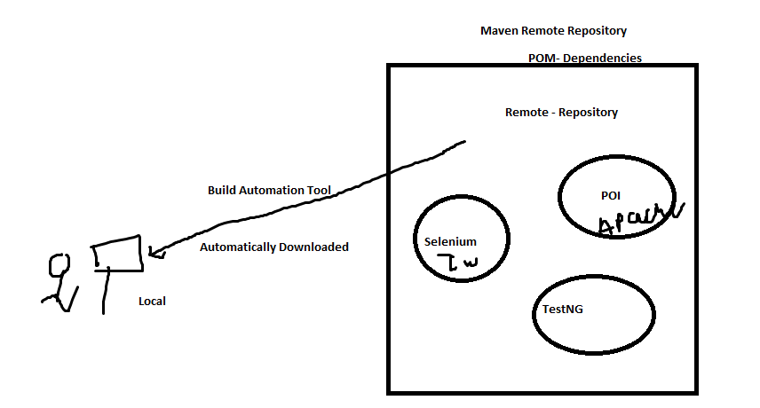

1. Created Maven Poject – File -> New -> Other 🡪 Maven Project
2. Kept only src/test/java folder
3. Visited to ppom.xml and added Dependencies – Selenium and TestNG
4. Created packages

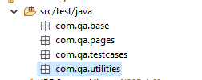

1. Created AppConf folder and .properties file under it

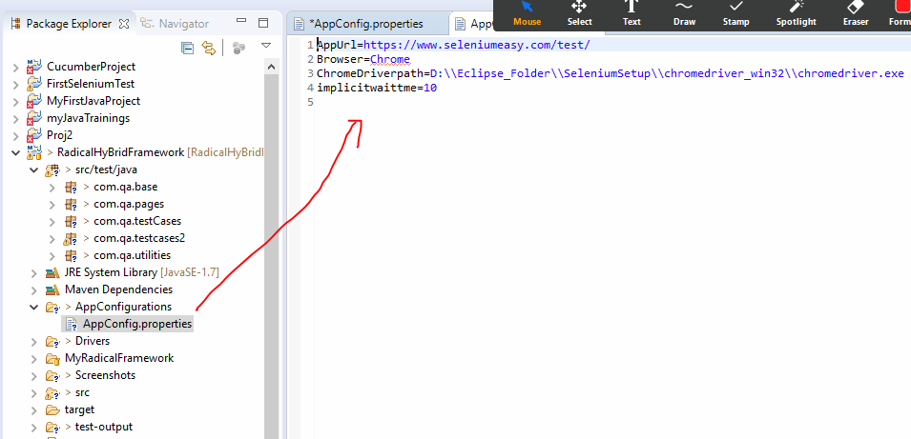

1. Created blank class under utilities package to read application properties from configuration file
2. Crated App Configurations class under utilities package and added methods to read app config properties

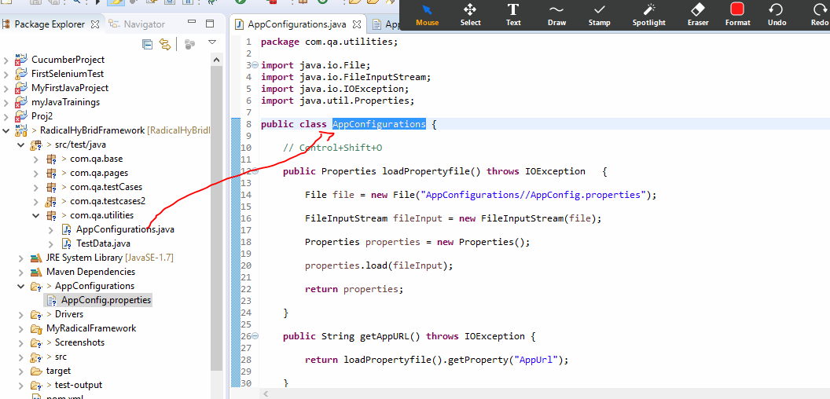

1. Created base class under base package and added code to start and stop browser

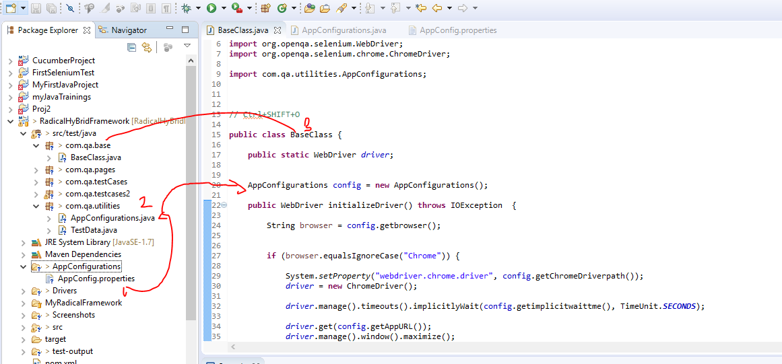

1. Page Object Model – Design Pattern

* Element locators – Object Repository - using @FindBy Annotation
* Page Constructer – Page Factory and initialized driver
* Page Operation Method
  + Page Operationn method-Reusing same code again and again by calling methods
  + Where we have to pass the data I have added parameter to the method
  + Where I have to get something and verify I have added methods with return type
  + Else add normal void methods without return type
* Under Test Case packages add Test Class to add test cases under it and extends it with base class

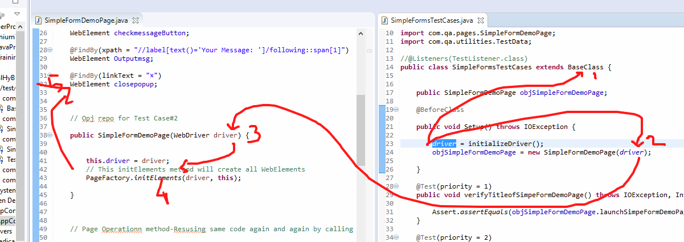

* Under before class annotation of Test NG add code to start browser
* Under After Class annotation of TestNG Class add code to close the browser
* And add test cases with @Test annotations and assertions