Project Overview
This SQL project shows how to analyze data from start to finish inside a database. It begins with creating and loading a table, checking data quality, and doing basic cleaning to make sure the dataset is accurate.
After preparing the data, the project recreates important KPIs that were first made in Excel, ensuring the results match across tools. It then goes deeper by analyzing default rates, customer segments, and trends. The project also uses advanced SQL concepts like window functions and CTEs to get richer insights.
Overall, this project demonstrates how SQL can be used to clean data, create KPIs, and perform meaningful analysis.

Objective
The objective of this SQL project is to showcase the ability to:
- Design relational tables and load structured data effectively
- Perform data validation, identify quality issues, and apply light cleaning techniques
- Reproduce key performance indicators (KPIs) using SQL queries
- Conduct deeper analysis, including loan default rates, behavioral segmentation, and time-based trends
- Apply intermediate and advanced SQL concepts such as aggregates, joins, window functions, and CTEs to derive insights
This objective ensures the project reflects real-world analytical workflows and demonstrates SQL proficiency suitable for data analyst and data science roles

Data Quality & Flags

1. Row count
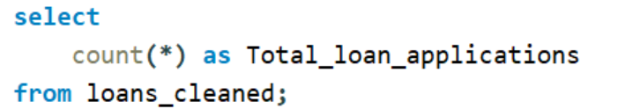
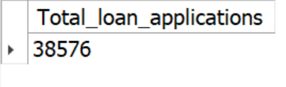
2. Missing values
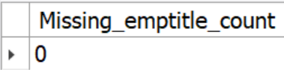

3.Basic distributions
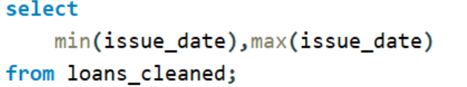
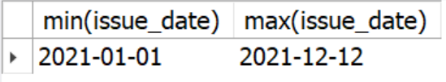

3.2 Interest Rate
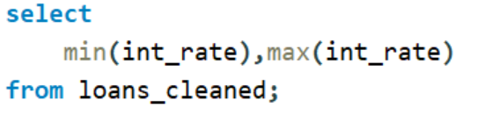
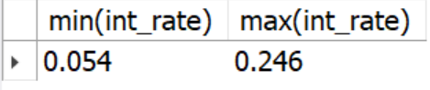

3.3 DTI
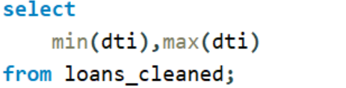
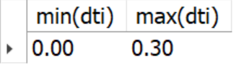

Portfolio KPIs
1.Overall KPs
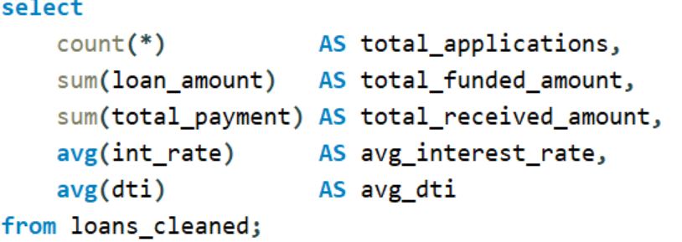

b) Good vs Bad breakdown
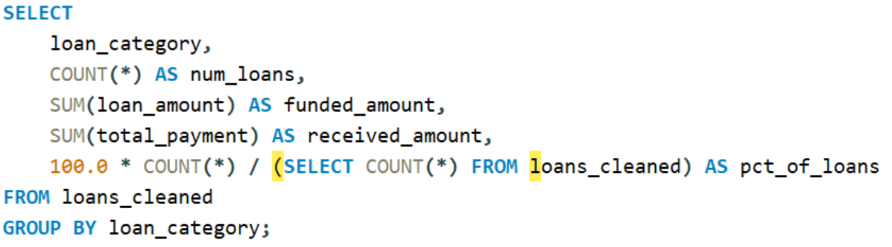
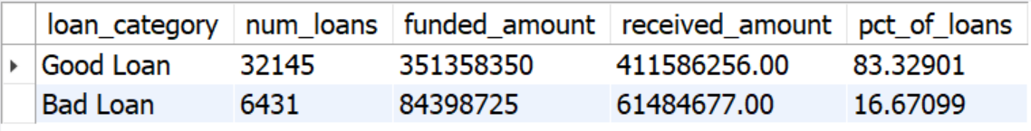

c) Loan status (Fully Paid / Charged Off / Current)
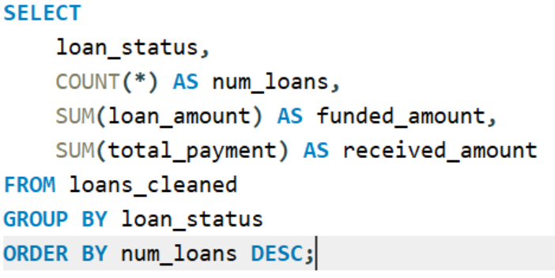
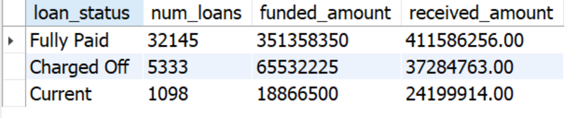

Segmentation & Default Analysis
a) Default rate by grade
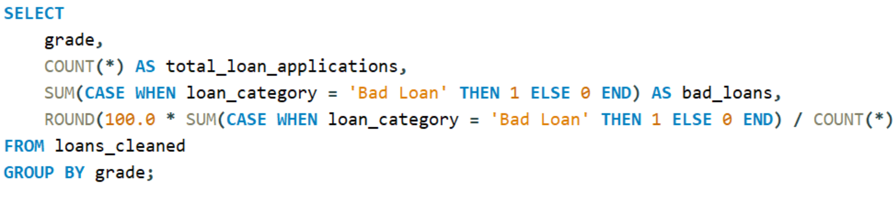
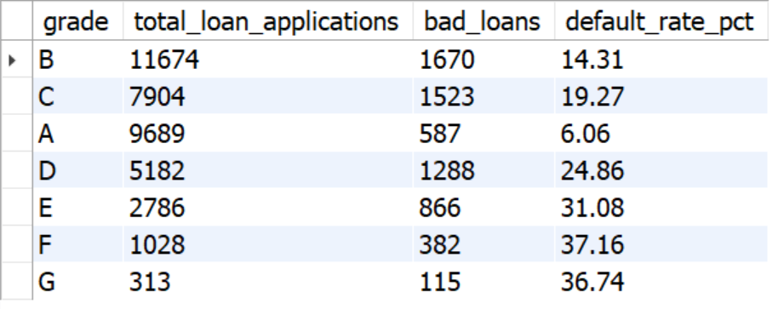

b) Default rate by purpose
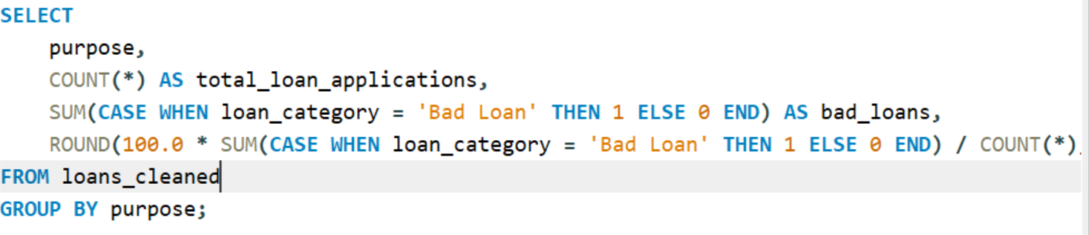
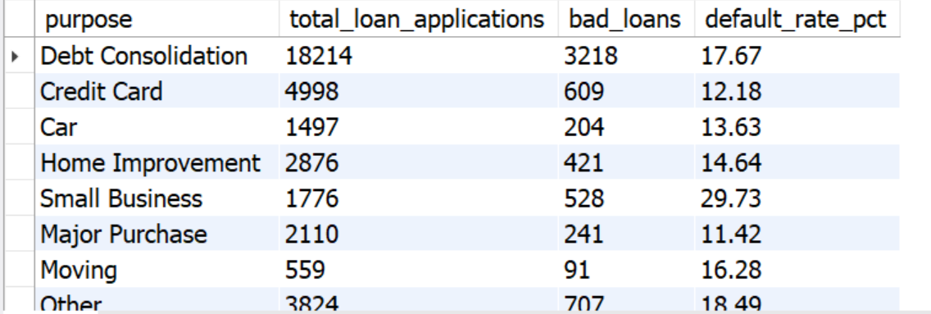

c) Default rate by state
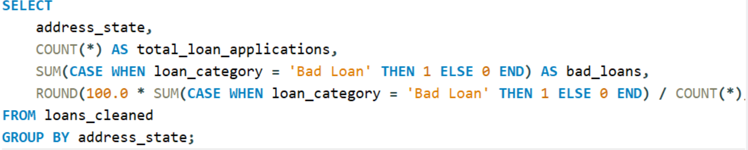

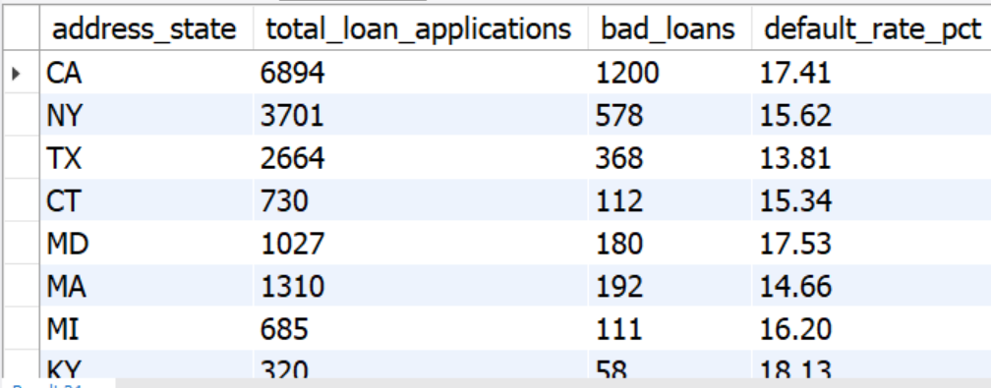

d) Term analysis (36 vs 60 months)
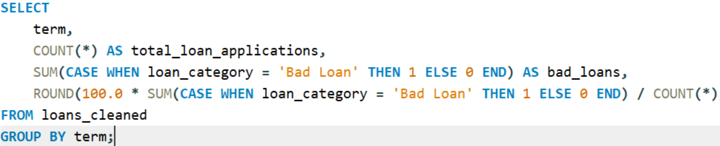
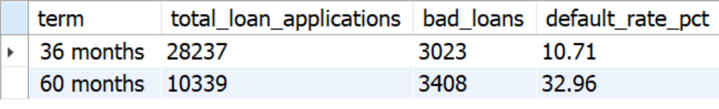

Time-based KPIs & Window Functions:

a) Monthly counts & default volumes
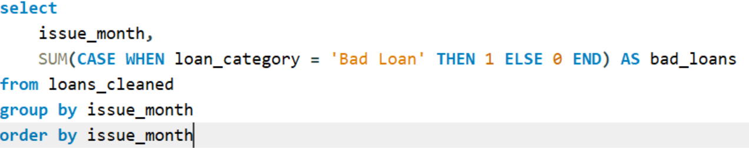
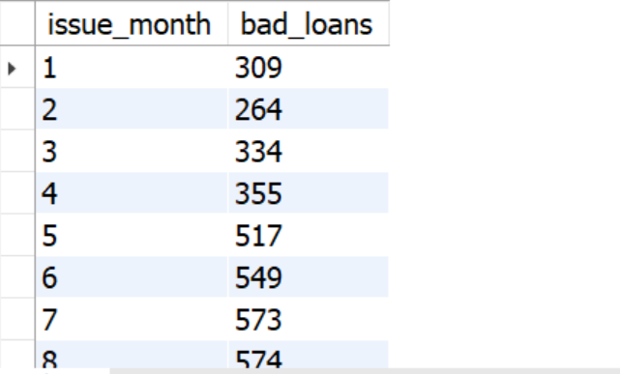

b) MoM growth in funded amount
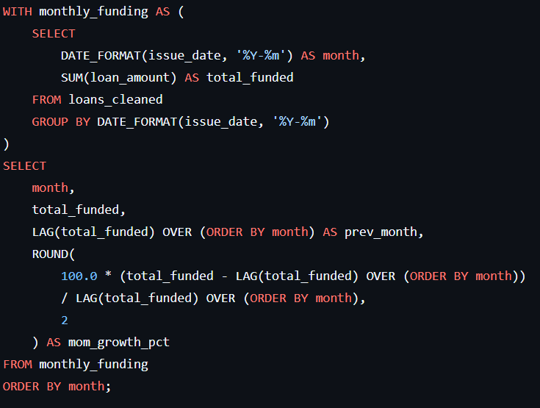
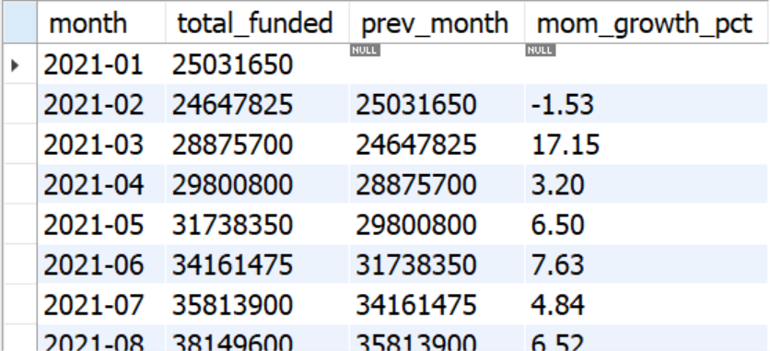
c. by issue year
