1) Install nginx and run nginx on port number 81.
2) Deploy a sample index.html file on nginx.
3) Install Apache and run Apache on port number 82
4) Deploy a sample index.html file on Apache.
5) Install Apache tomcat on port number 8082
6) Deploy a sample app on webapps
7) Create a tomcat.service file for tomcat.
8) Configure HA Proxy server

Step 1 — Launch an EC2 instance

- Open the AWS EC2 Console.
- Check the AWS Region in the top-right corner.
- Click Launch instance.

Step 2: Configure your instance

Give a name to instance

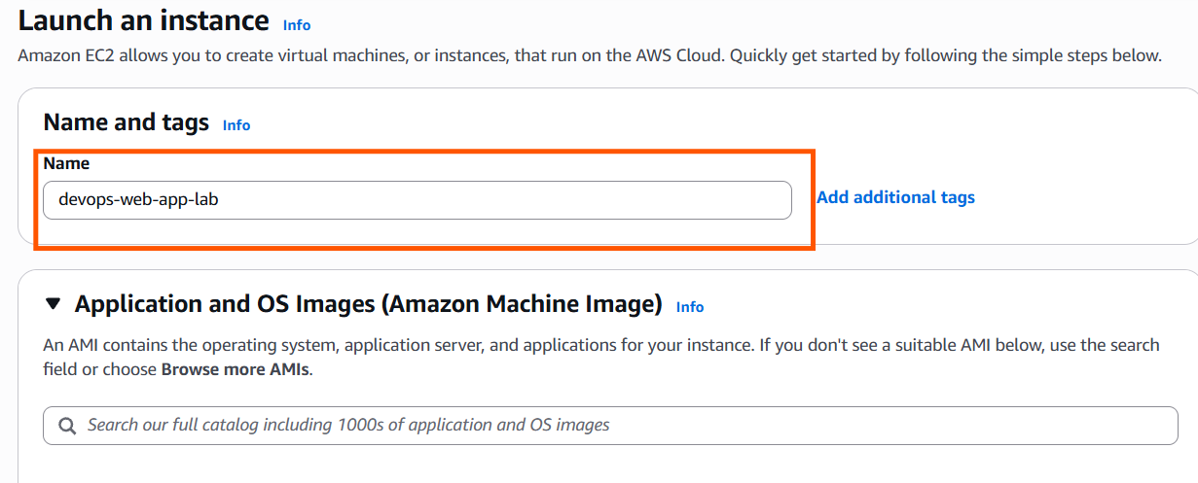
Choose Application and OS Images (AMI)

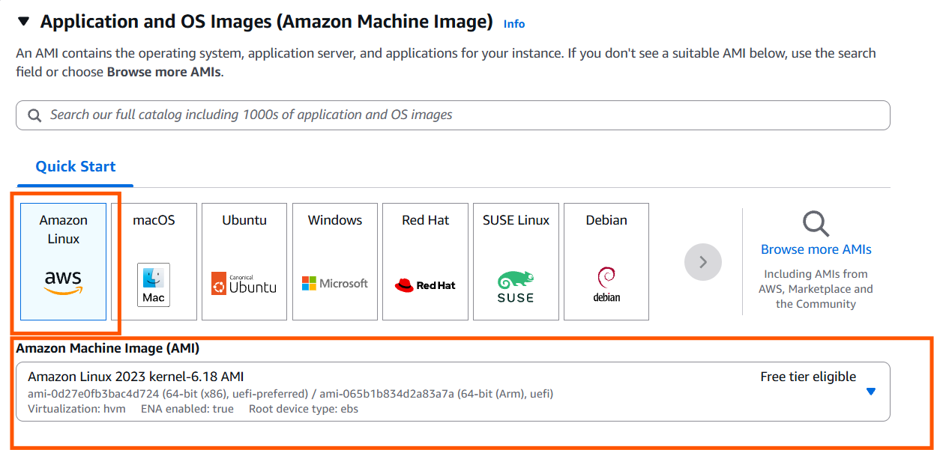

Choose instance type

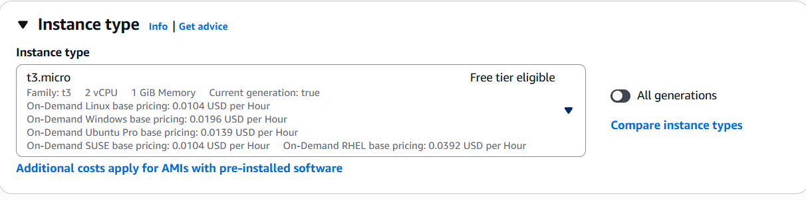

Create a key-pair login with .pem
Name: devops-lab-key
Type: RSA
Private key format: .pem

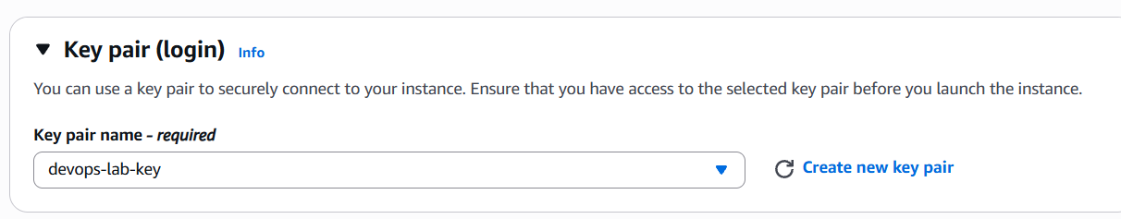
Firewall security group
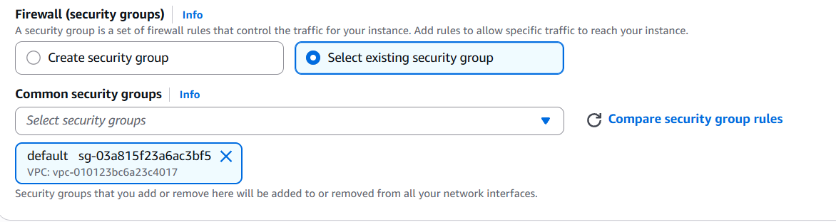

And launch instance..

—-----------------------

Now we have to connect to AWS EC2 Ubuntu server from using SSH, .the public IP address, and your .pem private key.

Step.1
Copy the public ip

- Go to EC2 → Instances.
- Select your devops-web-app-lab instance.
- Find Public IPv4 address under the instance details.
- Copy that IP address.

Step2. Locate .pem file and open powershell or bash

In my case its in downloads

Connect to aws ecr service with command
Ssh -i devops-lab-key.pem ec2-user@{publicIP}

Switch to root user
Command: sudo su -
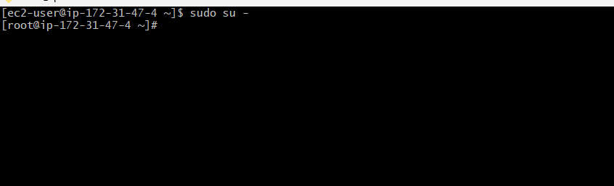

1) Install nginx and run nginx on port number 81.

Step 1 — Install Nginx

Command : yum install nginx -y

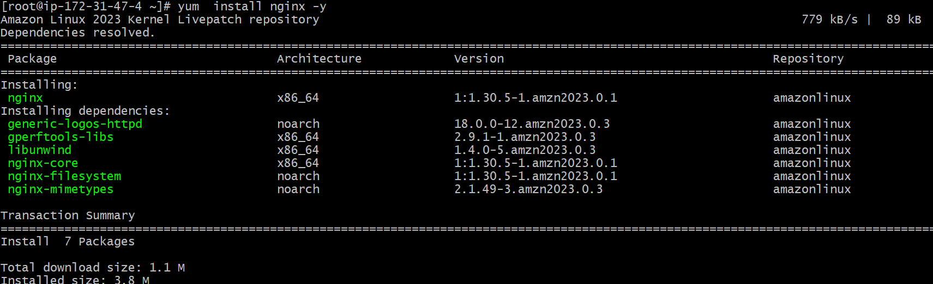

Step 2 — Start Nginx and check status

Command: systemctl start nginx
Systemctl status nginx or systemctl status nginx -l
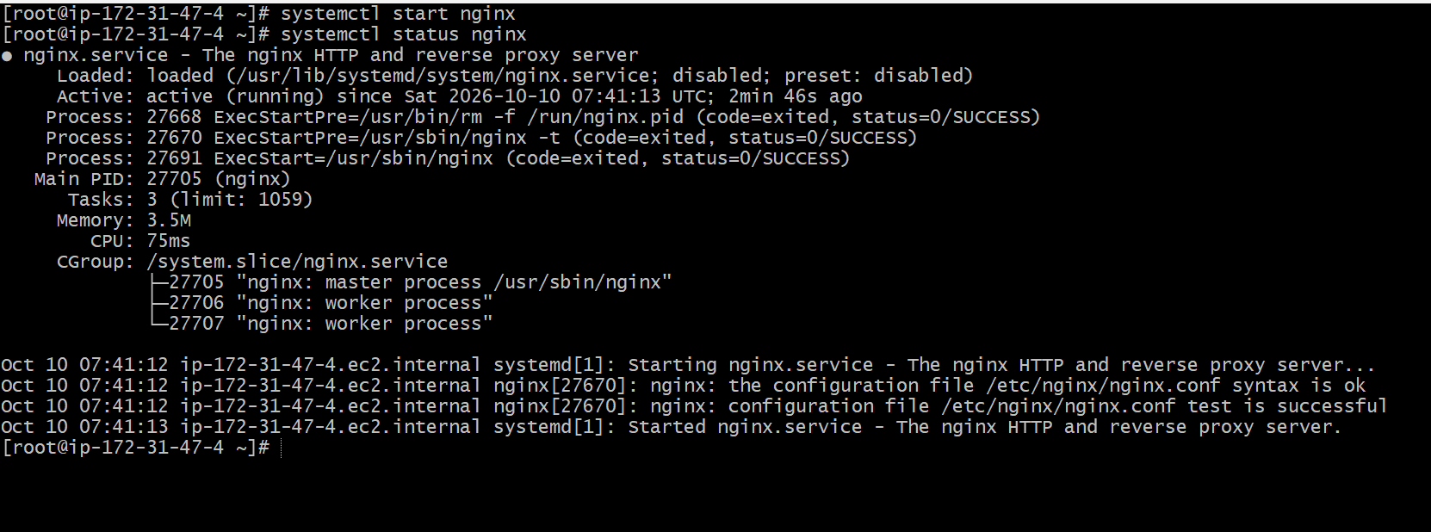

Step 3: Configure Nginx port
By default, Nginx listens on port 80. We need to change that to port 81.

Command: vi /etc/nginx/nginx.conf

Before
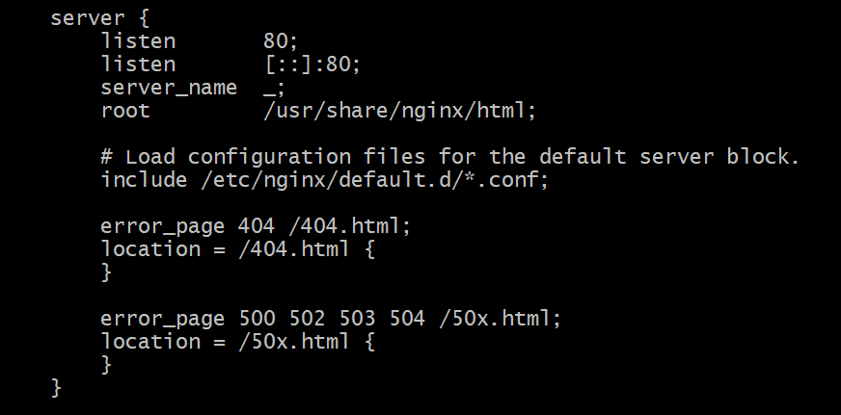

After


Step 4 — Test the Nginx configuration

Command nginx -t

Checks the Nginx configuration for syntax errors before we restart the service.



Restart nginx and check on which port is it running

systemctl restart nginx
ss -lntp | grep nginx

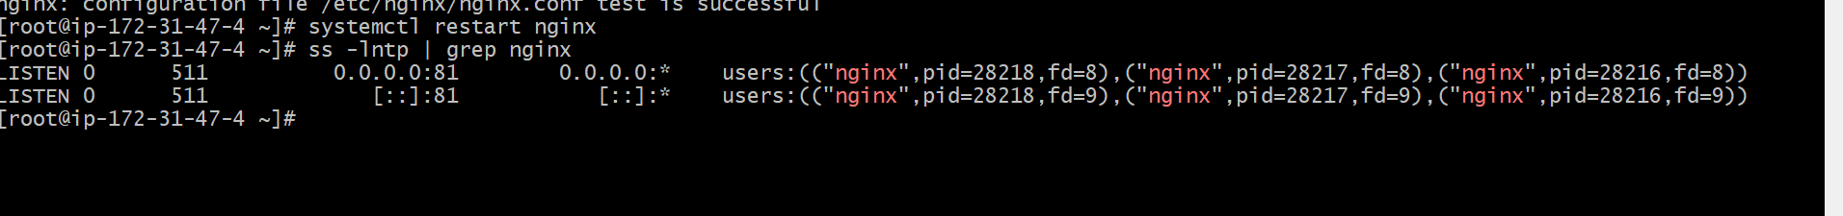

Open Nginx in your browser
In my case: http://54.152.124.28:81/
It shows nginx page ,
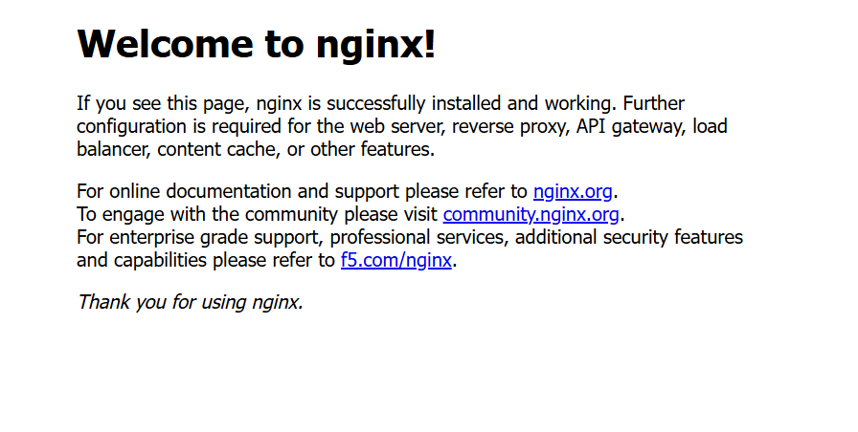

Edit /usr/share/nginx/html
This is the default page for nginx

And write html



—---------------------------------------------------------

2. Install Apache and run Apache on port number 82

Command: yum install httpd -y
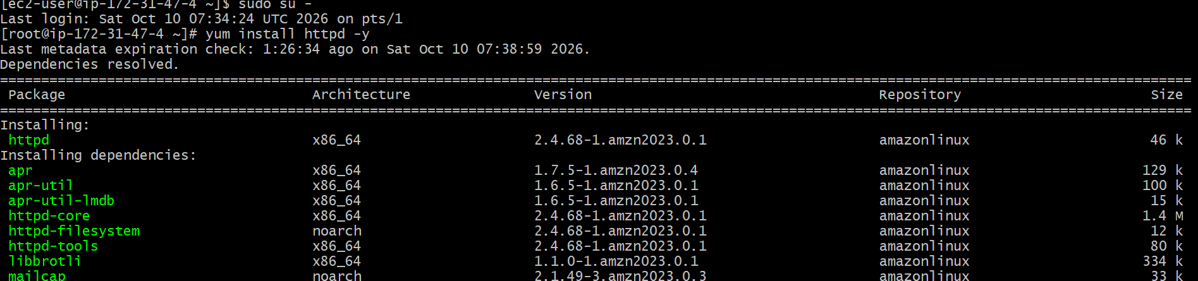

Once installation finishes, start Apache:
systemctl start httpd
Then check its status:
systemctl status httpd
Open Apache's configuration and change Change the listening port, and restart the httpd server

Command: nano /etc/httpd/conf/httpd.conf
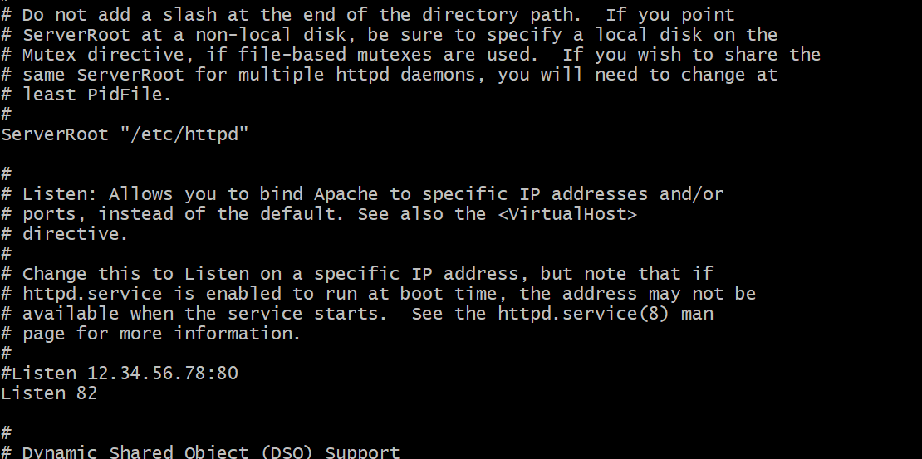

Restart Apache

Command: systemctl restart httpd

Then verify the configuration:
Command : httpd -t

check the listening port:

Command : ss -lntp | grep httpd

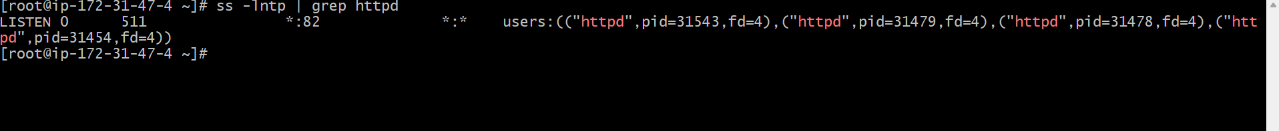

Find Apache's document root
Command : ls -l /var/www/html

Create the HTML file
Command: touch index.html

Add the content or html code in it and save



Open the public ip with port number 82
http://54.152.124.28:82/

Install Apache Tomcat and configure port 8082.

Step 1: Install Java
Command : install java-17-amazon-corretto-headless -y

Its a runtime environment to run tomcat app server, in tomcat we wil run our applications

Check whether Tomcat is available in the package repository

dnf search tomcat

check whether Tomcat is already installed?
rpm -q tomcat10

How to install tomcat10
dnf install tomcat10 -y

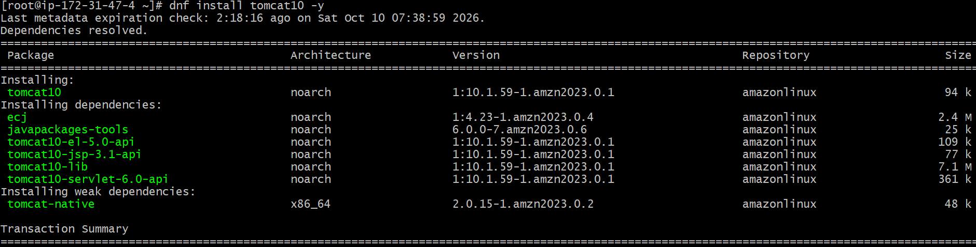

Start the Tomcat service
systemctl start tomcat10

Check the status
Systemctl status tomcat10

Configure Tomcat to use port 8082

First, let's locate the Tomcat configuration file.

Command: grep -n ”connector port” /etc/tomcat10/server.xml

Change the port
Command: nano /etc/tomcat10/server.xml

Restart the tomcat
Command: systemct restartl tomcat10

Verify the port
Command: ss -lntp | grep java

Find the Tomcat webapps directory
Command: rpm -ql tomcat10

find / -type d -name webapps 2>/dev/null



See whats inside webapps

Command ls -la /var/lib/tomcat10/webapps

Create a sample web application

- Create a directory myapp
- Create a index.html file in path /var/lib/tomcat10/webapps/myapp
- Add some basic html in index.html
- Access url http://54.152.124.28:8082/myapp/ in interent

7) Create a tomcat.service file for tomcat.

Step 1: Navigate to the systemd directory
Command: cd /etc/systemd/system
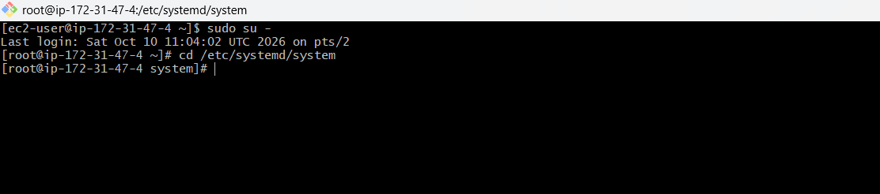

Step 2: Confirm your location
Command: pwd
pwd means print working directory
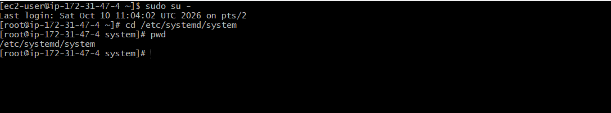
Step 3: Create tomcat.service
Command: sudo touch tomcat.service
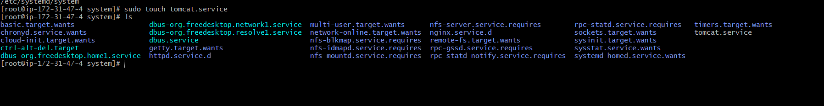

Step 4: Edit tomcat.service
Command: sudo nano tomcat.service

[Unit]
Description=Apache Tomcat Service
After=network.target

[Service]
Type=simple
User=tomcat
EnvironmentFile=/etc/tomcat10/tomcat10.conf
ExecStart=/usr/libexec/tomcat10/server start
SuccessExitStatus=143

[Install]
WantedBy=multi-user.target

[unit] - describes about the service and its startup dependencies
[services] - defines how the service runs
[Install] - defines how the service can be enabled at boot

Step 5: Check the service file syntax
Command: sudo systemd-analyze verify /etc/systemd/system/tomcat.service

Found spelling issues and fixed those

Step 6 — Reload systemd and verify

Command: sudo systemctl daemon-reload
Command: sudo systemctl status tomcat.service



8) Configure HA Proxy server
Step 1: Check whether it is installed
Command: rpm -q haproxy



Step 2 — Install HAProxy
Command: sudo dnf install haproxy -y

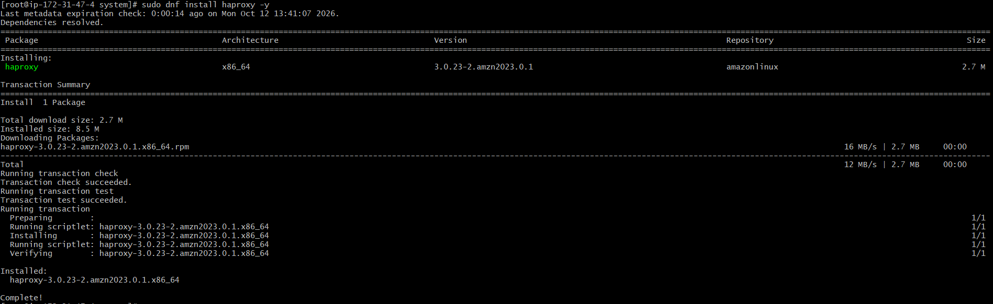

Step 3 — Verify HAProxy installation
Command: sudo rpm -q haproxy
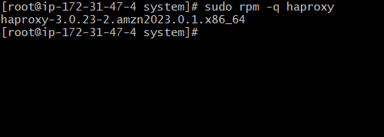

Step 4 — Check the HAProxy configuration file
Command: sudo rpm -ql | grep haproxy.cfg



Step 5 — Navigate to the configuration directory
Command: cd /etc/haproxy/

Step 6 — Inspect the HAProxy configuration
Command: sudo cat haproxy.cfg

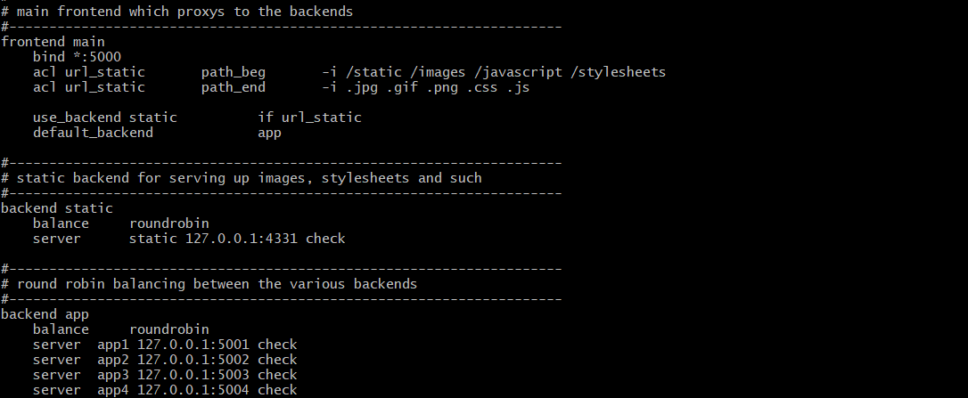

Currently listens on port 5000
And sends traffic to backend 5001–5004

Step 7 — Back up the configuration
Command: sudo cp haproxy.cfg haproxy.cfg.backup


Step 8 — Open the HAProxy configuration for editing
Command: sudo nano haproxy.cfg

Step 9 — Update the backend app section
Change bind to 80
Change servers to nginx 81 ,apache 82

Step 10 — Validate the HAProxy configuration

Command: sudo haproxy -c -V -f /etc/haproxy/haproxy.cfg

Step 11 — Start the HAProxy service and check status

Command: sudo systemctl start haproxy
Command : sudo systemctl status haproxy

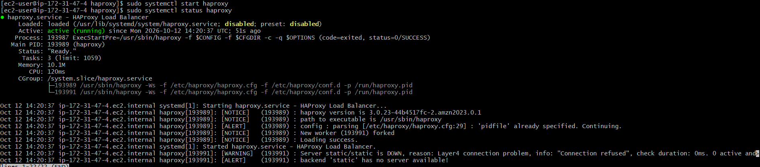

Step 12 — Check the listening port
Command: sudo ss -lntp | grep ‘:80
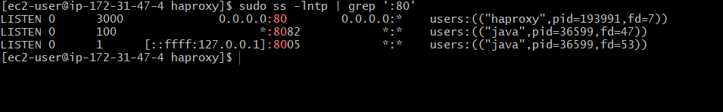

Step 13 — Test HAProxy locally
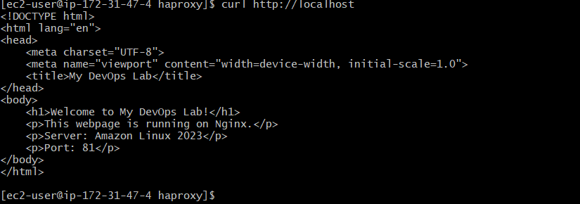’
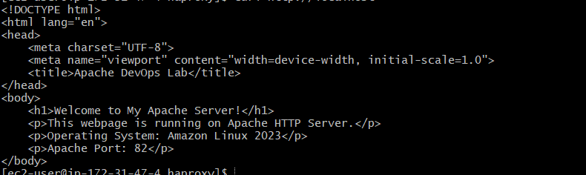

Step 14 — Enable HAProxy at boot
sudo systemctl enable haproxy

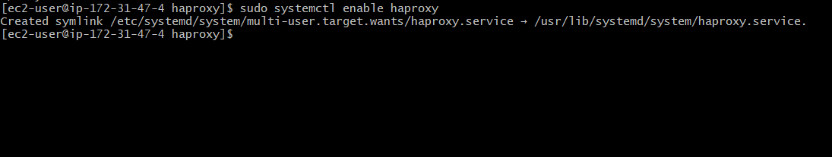

Step 15: Verify HAProxy is enabled

Command: sudo systemctl is-enabled haproxy

