1) Create user with name Techie and provide sudo access to user.

Step 1: To create username
Command : sudo useradd -m Techie
Step 2: to create password
Command : sudo passwd Techie
New password:
Retype new password:

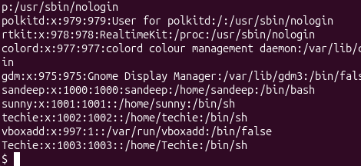

provide sudo access to user.

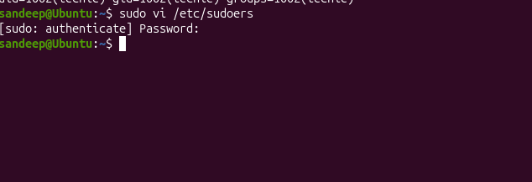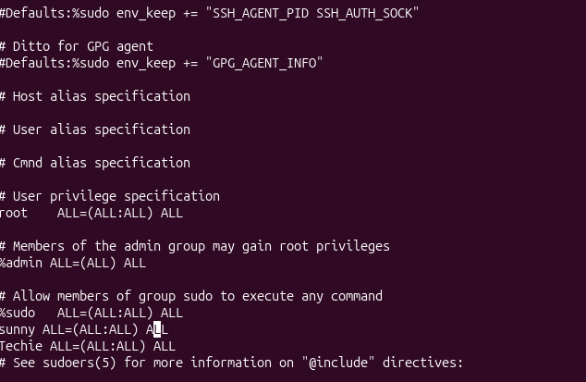

Gave access with sudoers file by editing using vi text editor

2) Navigate to the home directory.

Command : cd ~
Result : /home/Techie

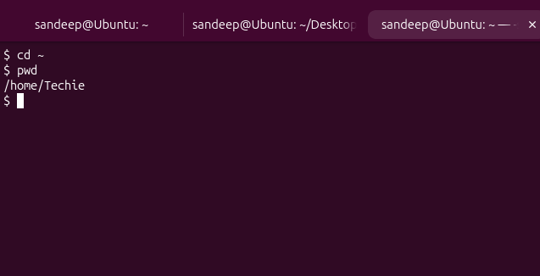

3) Create a new directory.
Command : mkdir <foldername>
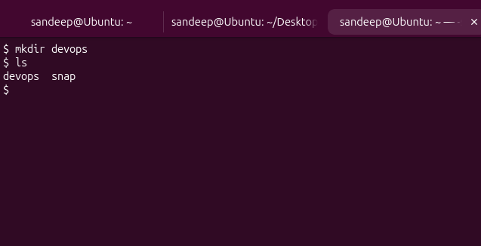

4) List the contents of a directory.
Command : ls

5) Change the current directory.
cd devops

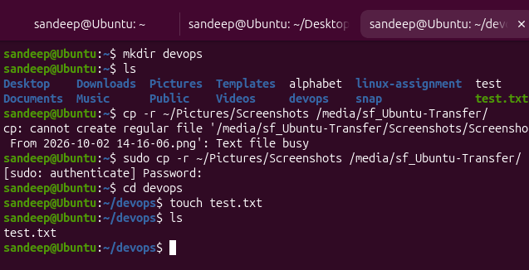

6) Create a new empty file.
touch test.txt

7) View the contents of a file.

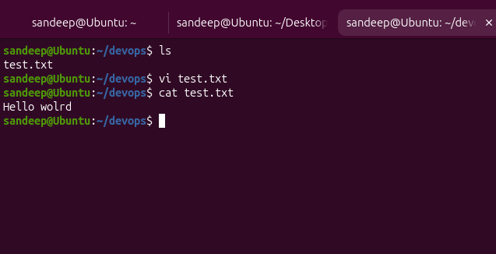

8) Copy a file to another location.
cp test.txt backup/
Syntax: cp {filename} {foldername}/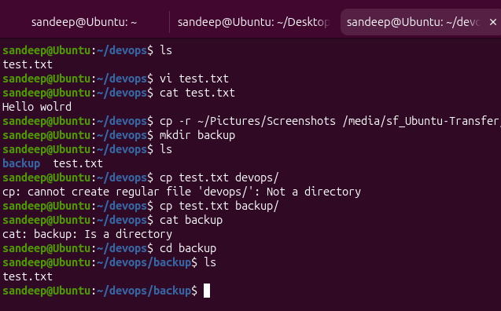

9) Move a file to another location.
mv {filename} {foldername}/
Mv test-2.txt backup
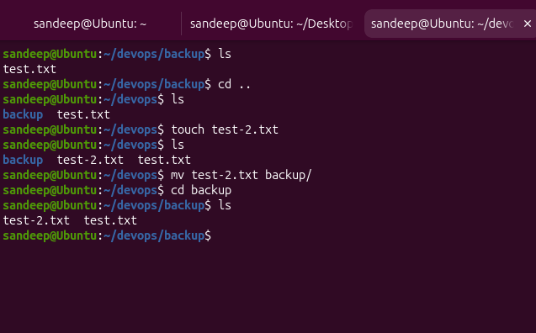

10) Rename a file.
Command : mv test.txt test-modified.txt
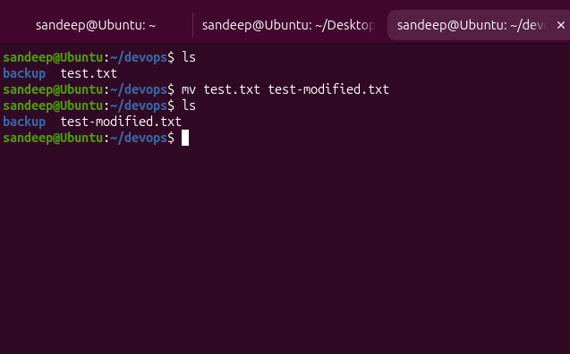

11) Delete a file.
Command : rm test-modified.txt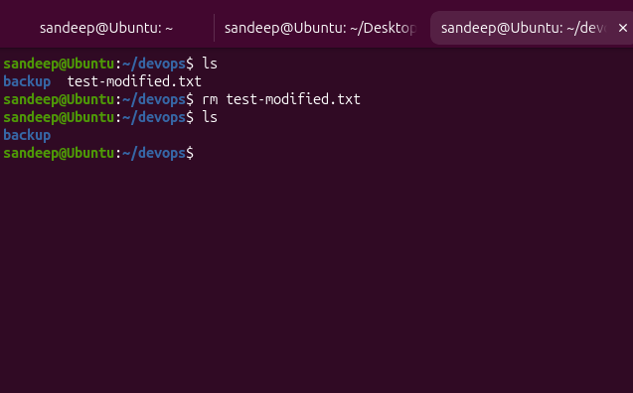

12) Grant or revoke permissions on a file or directory.
Before : permission for permission.txt - -rw-rw-r-- 1 sandeep sandeep 0 Oct 2 15:58 permission.txt

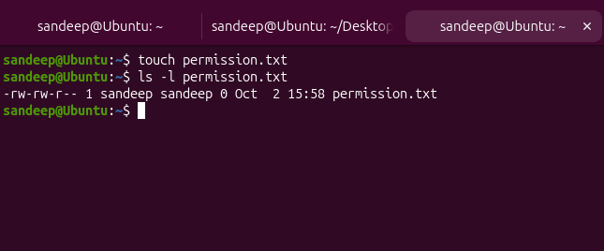

After
With command
chmod 755 permission.txt
Owner : read.write, execute; groups: read, write; others : read write;
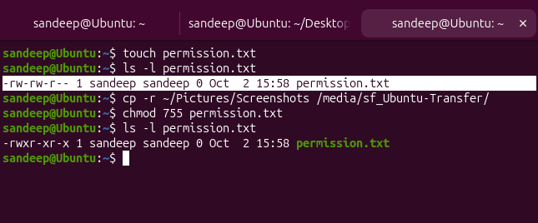

13) View the current date and time.
Command : date
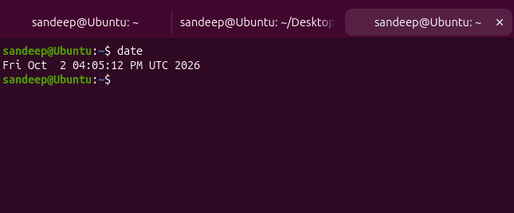

14) Check the system uptime.

Command : uptime
16:06:35 up 2:24, 1 user, load average: 0.00, 0.00, 0.04

16:06:35 → current time
up 2:24 → uptime = 2 hours 24 minutes
1 user → one user currently logged in
0.00, 0.00, 0.04 → load averages for 1, 5, and 15 minutes

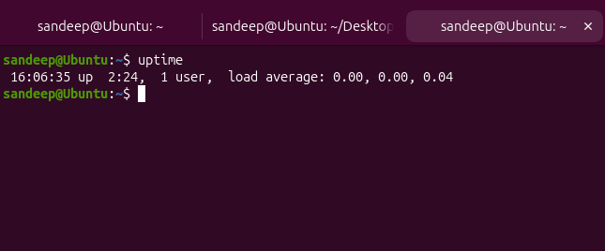

15) View the running processes.
Command : ps
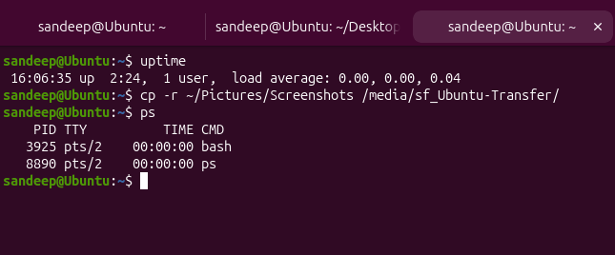

Output:
PID TTY TIME CMD
3925 pts/2 00:00:00 bash
8890 pts/2 00:00:00 ps

What these mean
- PID → Process ID, a unique number for each running process
- TTY → Terminal associated with the process
- TIME → CPU time used
- CMD → Command/process name
- bash → Your current shell
- ps → The command you just executed

16) Kill a running process.
Command : kill {processid(PID)}
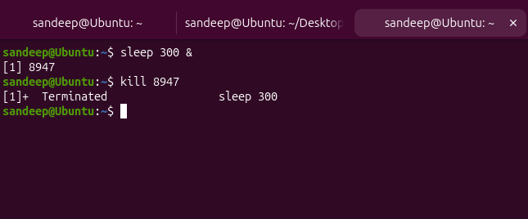

17) Install a package using the package manager (e.g., apt or yum).
Command : sudo apt install tree
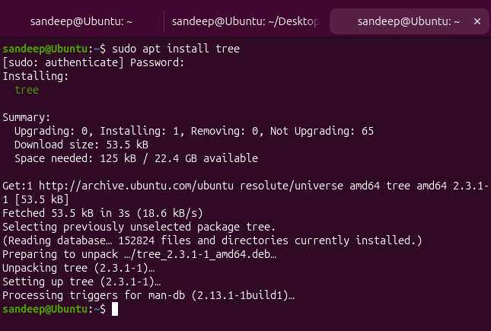

18) Update the system packages.
Command : sudo apt update
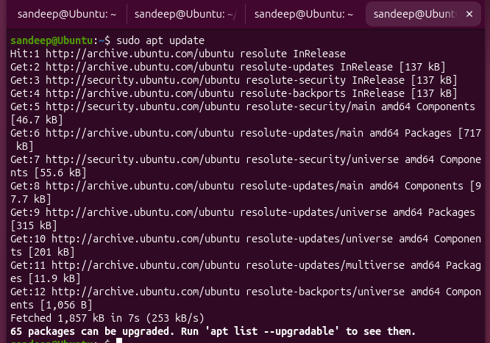

Command: sudo apt upgrade
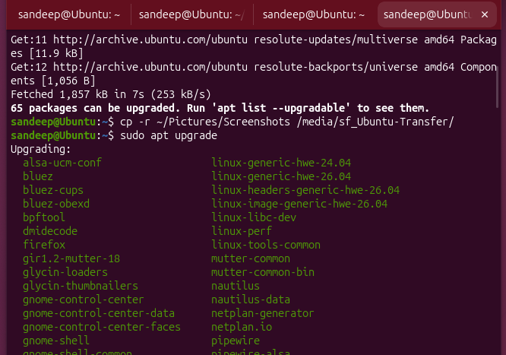

19) Create a symbolic link.
A symbolic link (symlink) is like a shortcut to another file or directory.

Created a sample file called original.txt
Nwo i will create a symbolik link to original.txt file
ln -s original.txt link.txt

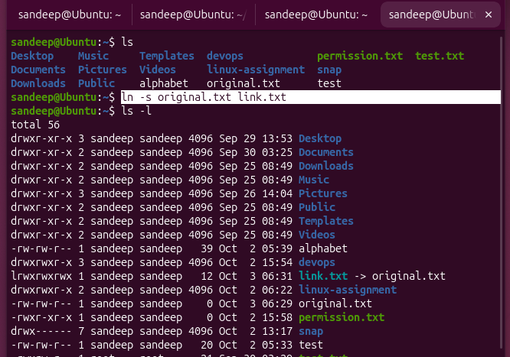
Breakdown of command - ln -s original.txt link.txt
ln - create a link
-s - symbolic link
Original.txt - the actual/original file
Link.txt - the shortcut/symlink

20) Search for files using the find command
find . -name "file.txt" - for searching the current directory
find / -name "file.txt" - searching from home directory - all files
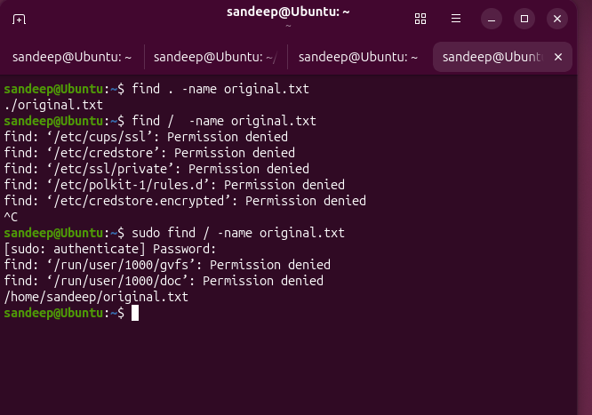

. → current location
/ → entire filesystem
~ → your home directory

21) Compress and decompress files using tar.
Command :Create + compress - tar -czvf backup.tar.gz original.txt link.txt

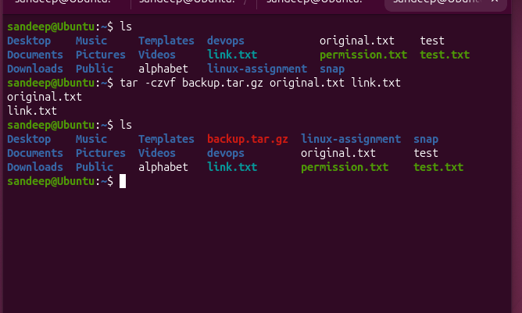
Extract + decompress - tar -xzvf backup.tar.gz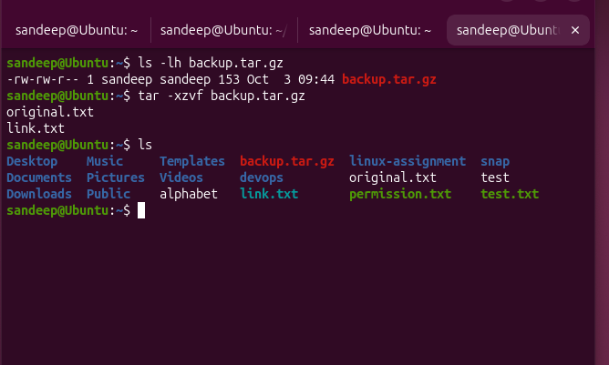

Compare the three commands we've learned
1. Create + compress
tar -czvf project-backup.tar.gz project/
c = create
2. View contents
tar -tzvf project-backup.tar.gz
t = list/view
3. Extract
tar -xzvf project-backup.tar.gz
x = extract

Easy memory trick
c → Create
t → Tell me what's inside
x → eXtract
The zvf part stays mostly the same.

22) Monitor system resources with top or htop.
Command : top
For quite : q

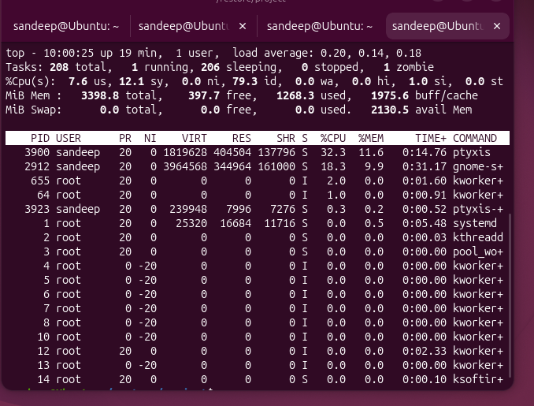

top ↓ CPU → %CPU RAM → %MEM / available memory Process → PID Application → COMMAND

23) Create and manage user groups.
1. Created the group
sudo groupadd developers
Meaning:
Create a new Linux group named developers.

2. Checked that it exists
getent group developers

getent = get entries

getent
getent = get entries
It retrieves information from Linux's system databases.

group
We're telling getent:
I want information from the group database.

developers
We're saying:
Specifically show me the developers group.
So the complete command means:
Show me the system information for the developers group.

You got:
developers:x:1004:
So the group exists.

3. Added sandeep to that group
sudo usermod -aG developers sandeep
Meaning:
Add the user sandeep to the developers group.
The important part is:
developers ← group
sandeep ← user
So now:
developers
│
└── sandeep

4. Verify
- groups sandeep

Why do we do this in DevOps?
Suppose you have 5 developers:
sandeep
rahul
amit
john
priya
Instead of giving permissions to each person individually, you can create:
developers
and put all 5 users in that group.
Then you can give the group permission to access a directory:
/project
Everyone in the developers group can then access it according to the permissions you've configured.
That's why Linux groups are important for permissions and access management.

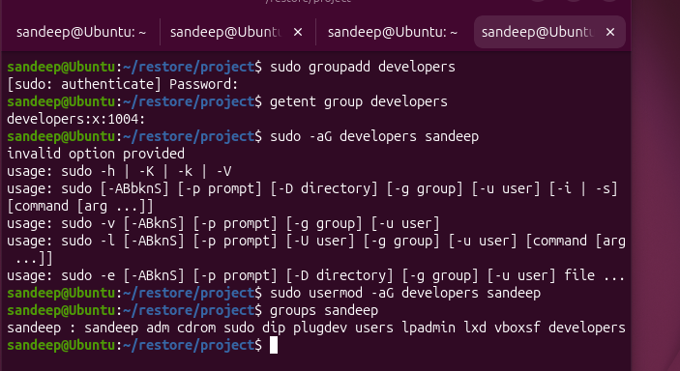

24) Set up SSH password less authentication.
ssh → Secure Shell, used to connect to another machine

Purpose:
Configure SSH key-based authentication so a user can connect to a Linux server without entering the account password every time. This is commonly used in DevOps automation with Jenkins, Ansible, deployment scripts, and Linux servers.
Step 1 – Check SSH client
ssh -V

Checks whether the SSH client is installed.
Step 2 – Install SSH server
sudo apt install openssh-server

Installs the SSH server (sshd) so the Linux machine can accept SSH connections.
Step 3 – Start SSH server
sudo systemctl start ssh

Starts the SSH server service.
Step 4 – Check SSH server status
sudo systemctl status ssh

Checks whether the SSH server is running.
Step 5 – Test SSH connection
ssh sandeep@localhost

localhost means the same Linux machine. This tests an SSH connection using the account password.
Step 6 – Generate SSH key pair
ssh-keygen -t ed25519

Creates two keys:
- ~/.ssh/id_ed25519 → Private key; keep it secret.
- ~/.ssh/id_ed25519.pub → Public key; can be copied to the server.
Step 7 – Copy public key to the server
ssh-copy-id sandeep@localhost

Copies the public key to:
~/.ssh/authorized_keys

The password may be requested once during this setup.
Step 8 – Test passwordless SSH
ssh sandeep@localhost

If configured correctly, SSH connects without asking for the account password.
Important Concepts:
- SSH Client: The machine that initiates the SSH connection.
- SSH Server: The machine that accepts SSH connections.
- sshd: The SSH server process.
- Port 22: Default SSH port.
- Private key: Stays on the client and must be protected.
- Public key: Stored on the server in authorized_keys.
- Passwordless SSH: Authentication happens using the SSH key pair instead of the account password.
DevOps Use Case:
Jenkins / Ansible / Admin Machine
|
| SSH using key
↓
Linux Server

This allows automated tools to securely connect to Linux servers without manually entering passwords.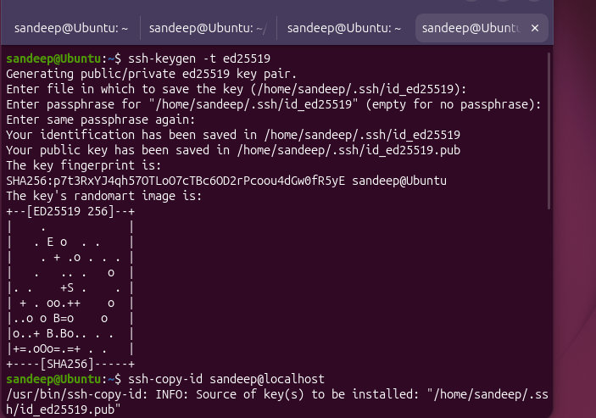
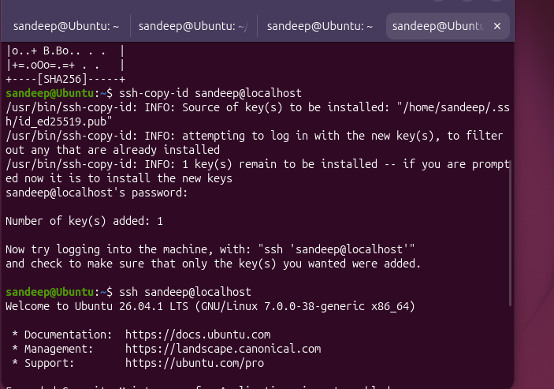

25) Monitor log files using tail or grep.
Goal: Learn how to look at application/system logs and search for specific messages. This is very common in DevOps when troubleshooting deployments, services, errors, and server issues.

We'll use two commands:
- tail → see the latest lines of a log
- grep → search for a specific word/pattern
Command : tail /var/log/syslog

Command - tail -f /var/log/syslog
- The -f means follow.
- It keeps the terminal open and shows new log entries as they arrive.
- That's very useful when you're restarting a service and watching what happens.

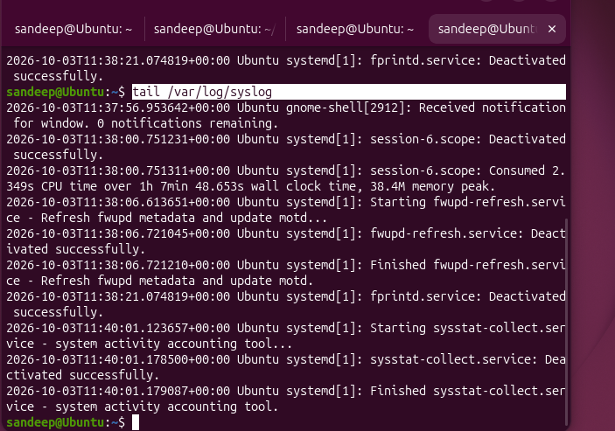

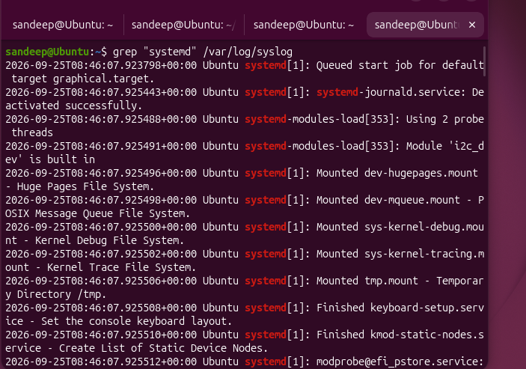
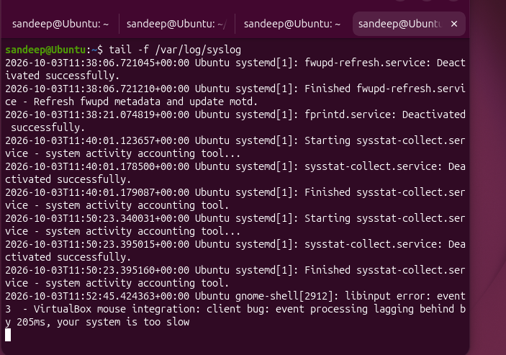

26) Set up a web server (e.g., Apache or Nginx).
Our goal is to understand this flow:
Browser
↓ HTTP request
Ubuntu Server
↓
Nginx
↓
Web page

Step 1 — Install Nginx
Command : sudo apt install nginx
What this does:
- sudo → administrator privileges
- apt → Ubuntu's package manager
- install → install software
- nginx → the web server

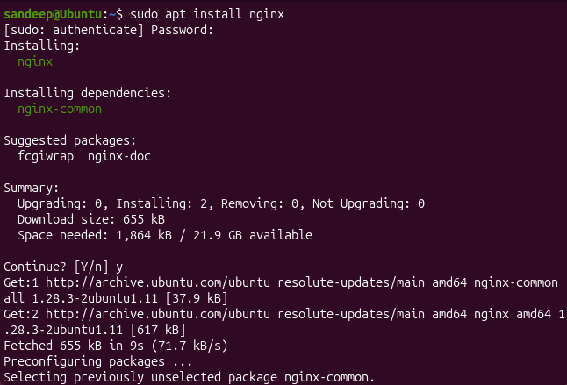

Step 2 — Check whether Nginx is running
Command: sudo systemctl status nginx
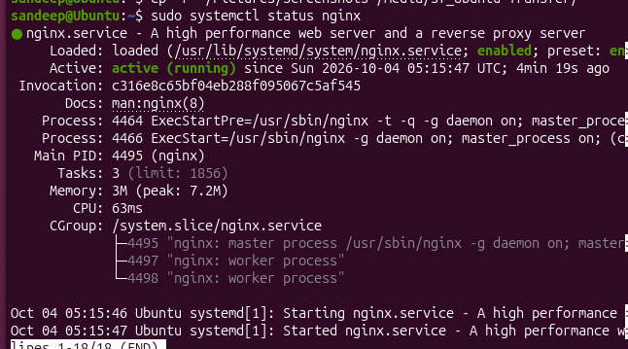

Step 3 — Check if Nginx is listening on port 80
A web server needs a port to receive network requests. HTTP normally uses port 80.
Run:
Sudo ss -tulpn | grep nginx
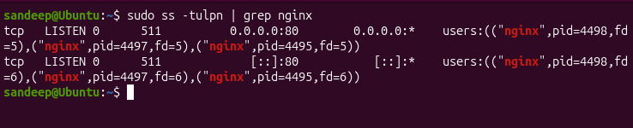

4. Install curl for Testing
Command : sudo apt install curl
curl is a command-line tool used to send requests to servers and test HTTP endpoints.

5. Test the Nginx Web Server
Command : curl http://localhost

Explanation:
- curl → Make an HTTP request.
- http:// → Use the HTTP protocol.
- localhost → The current Ubuntu machine.

6. Find the Nginx Web Root
Command : ls -l /var/www/html

7. View the Default HTML File
cat /var/www/html/index.nginx-debian.html
This displays the HTML source of the default Nginx webpage.

8. Create a Custom Webpage
sudo nano /var/www/html/index.html
Add:
<!DOCTYPE html>
<html>
<head>
<title>My DevOps Server</title>
</head>
<body>
<h1>Hello from Sandeep's Nginx Server!</h1>
<p>Nginx is working successfully.</p>
</body>
</html>
Save in Nano:
Ctrl + O
Enter
Ctrl + X

9. Test the Custom Webpage
curl http://localhost
The response should contain:
<h1>Hello from Sandeep's Nginx Server!</h1>
This confirms that Nginx is now serving our custom HTML page.

27) Configure and secure a MySQL Database.
1. Install MySQL Server
Command : sudo apt install mysql-server

What it does
- sudo → runs the command with administrator privileges.
- apt → Ubuntu's package management tool.
- install → tells APT to install a package.
- mysql-server → MySQL database server package.
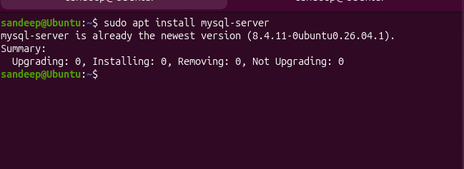

2. Check MySQL service
Command : sudo systemctl status mysql

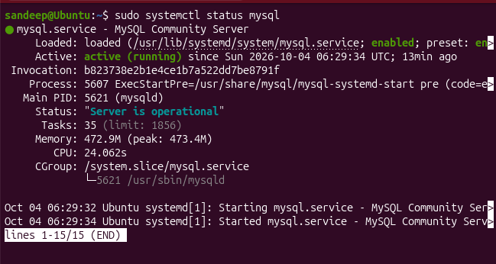
3. Make MySQL start automatically
Command : sudo systemctl enable mysql

4. Connect to mysql
Command : sudo mysql

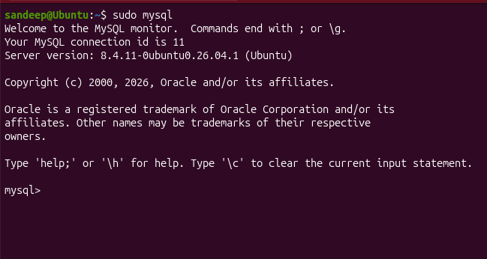

5. Check MySQL databases
Command : SHOW DATABASES;

6. Exit MySQL
Command : EXIT;

7. Run MySQL security configuration
Command: sudo mysql_secure_installation
And it will ask questions we have to choose ye sor no

28) Set up a Application Server (e.g.,Apache Tomcat)
Command : sudo apt install openjdk-17-jre-headless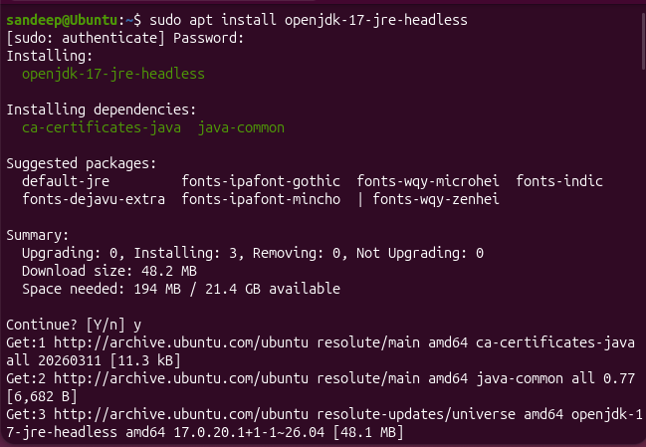

Checking java version after install;

Command : java -version
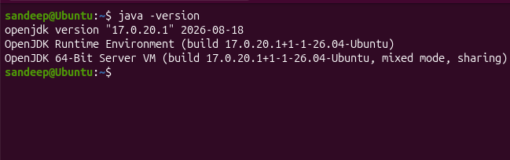

Install Tomcat
Command : sudo apt install tomcat10

What each part means
- sudo → administrator privileges
- apt → Ubuntu package manager
- install → install a package
- tomcat10 → Apache Tomcat 10 package
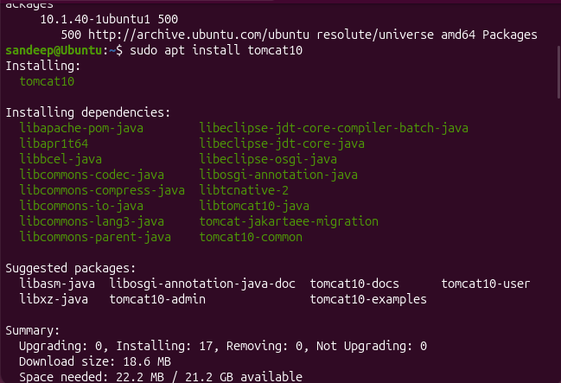

Check Tomcat service
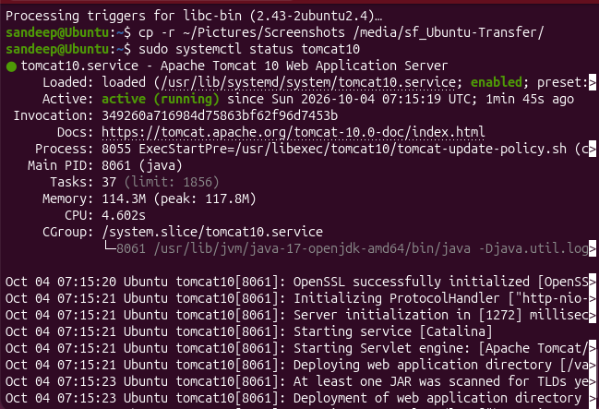

Check Tomcat's listening port
Command : sudo ss -tulpn | grep 8080

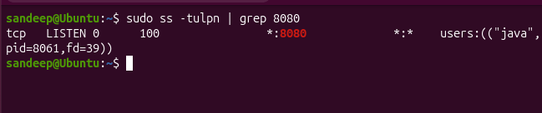

What it means
- tcp → Tomcat is using TCP.
- LISTEN → the server is waiting for incoming connections.
- *:8080 → Tomcat is listening on port 8080 on all network interfaces.
- java → Tomcat is running through Java.
- pid=8061 → this is the Tomcat/Java process ID.

Test Tomcat locally
Command : curl http://localhost:8080
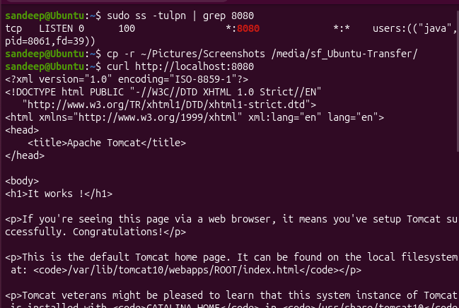

Check the Tomcat web application directory
This will help us understand where Tomcat serves applications from.

Command: ls -l /var/lib/tomcat10/webapps/
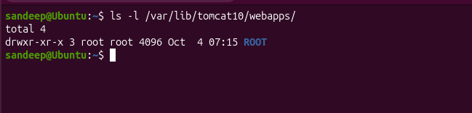

Create our own simple application

First, we'll create a separate application directory called devops.
Command: sudo mkdir /var/lib/tomcat10/webapps/devops

Create index.html
sudo nano /var/lib/tomcat10/webapps/devops/index.html

<!DOCTYPE html>
<html>
<head>
<title>DevOps Application</title>
</head>
<body>
<h1>Hello from Tomcat!</h1>
<p>Tomcat application server is working successfully.</p>
<p>Deployed by Sandeep.</p>
</body>
</html>

In Nano:
- Ctrl + O → save
- Press Enter → confirm filename
- Ctrl + X → exit

Test our deployed application
curl -i http://localhost:8080/devops/index.html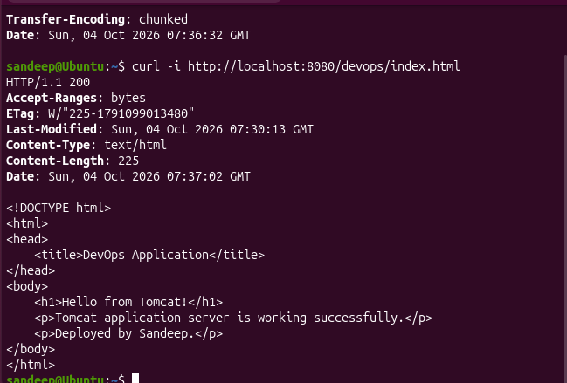

29) create a service file for Apache Tomcat.(Should execute by using systemtctl command)
sudo nano /etc/systemd/system/tomcat-custom.service

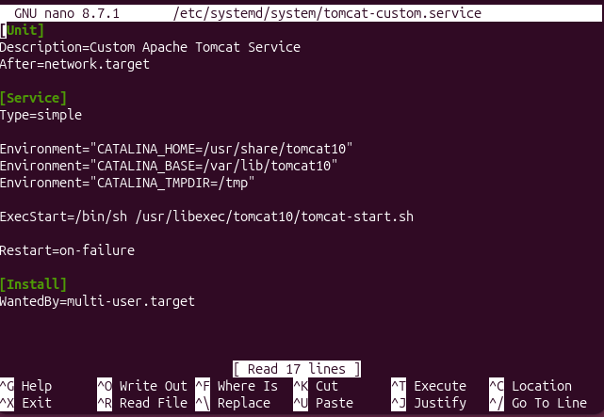

Tell systemd to reload service files
daemon-reload means:
"systemd, reread your service files because I may have added or changed one."

Check whether systemd recognizes our service
Run:
systemctl status tomcat-custom

30) Print specific columns from a delimited file.

Create a practice file
Command : cat > employees.csv
Data i entered
Name,age,Role,Salary
Sandeep,28,Frontend,50000
Ravi,30,Devops,80000
Sai,32,accountant,90000

And then to save , ctrl + D

And read the file content with command: cat employees.csv

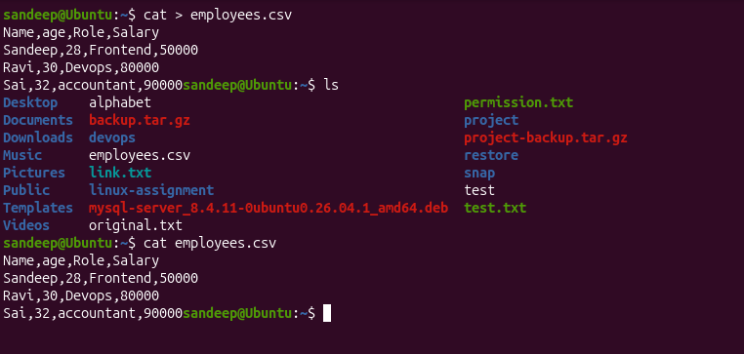

Print only Name and Role
Command : awk -F’,’ ‘{print $1, $3}’ employees.csv

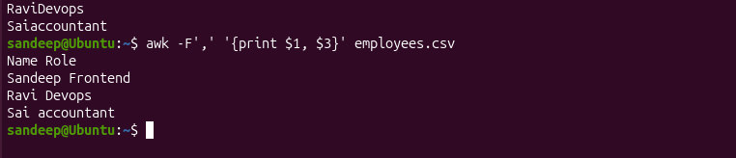

31) Filter and print lines based on a specific pattern or condition.
Example: Salary greater than 60,000
Command : awk -F’,’ ‘$4 > 60000 {print $1, $4}’ employees.csv


print only employees whose role is Devops:

Command : awk -F',' '$3 == "Devops" {print $1, $3}' employees.csv



32) Calculate and print the average, sum, or other statistics of a column.

For sum:
Command : awk -F’,’ ‘NR > 1 {sum += $4} END {print “Total Salary”, sum}’

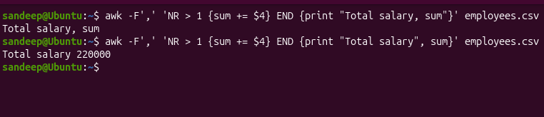

Average salary
Command: awk -F',' 'NR > 1 {sum += $4; count++} END {print "Average Salary:", sum/count}' employees.csv

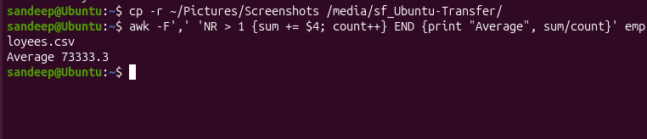

33) Perform string manipulation, such as extracting substrings or changing case.

Change to uppercase column 1
Command: awk -F’,’ ‘NR > 1 {print toupper($1)}’ employees.csv

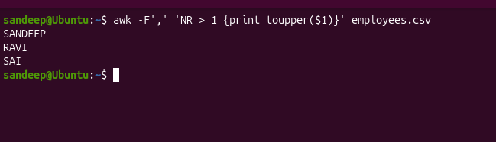

34) Count the occurrences of a specific pattern in a file.
let's count how many employees have the role Devops.
Command: awk -F',' '$3 == "Devops" {count++} END {print "Devops employees:", count}' employees.csv

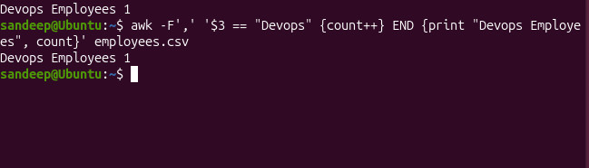

35) Sort lines based on a specific field or column.

sort by Salary, from lowest to highest.
Command : tail -n +2 employees.csv | sort -t',' -k4,4n
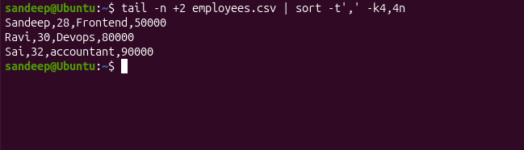

36) Merge multiple files based on a common field or column.
We'll create a second file containing department information:
cat > departments.csv
Data
Name,Department
Sandeep,IT
Ravi,Devops
Sai,Finance

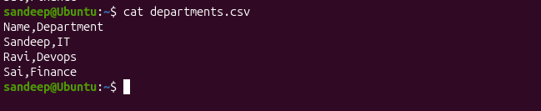

Merge two files
Command: awk -F',' 'NR==FNR {dept[$1]=$2; next} FNR>1 {print $1, $2, $3, $4,dept[$1]}' departments.csv employees.csv

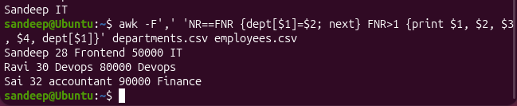

37) Substitute text in a file using search and replace.
Command: sed -i 's/Frontend/React/' employees.csv

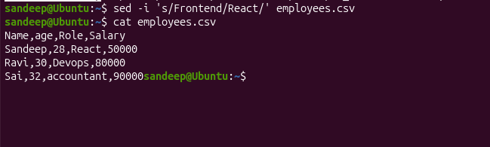

38) Delete specific lines based on a pattern or line number.

Command : sed -i '/accountant/d' employees.csv
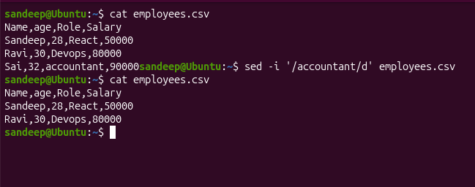

Delete with line number
sed -i '3d' employees.csv

39) Append or insert text before or after a specific pattern or line.

39A — Insert text before a matching pattern

sed '/pattern/i\text to insert' file
sed '/Ravi/i\Suresh,29,Backend,70000' employees.csv

39B — Append text after a matching pattern
sed '/Ravi/a\Suresh,29,Backend,70000' employees.csv

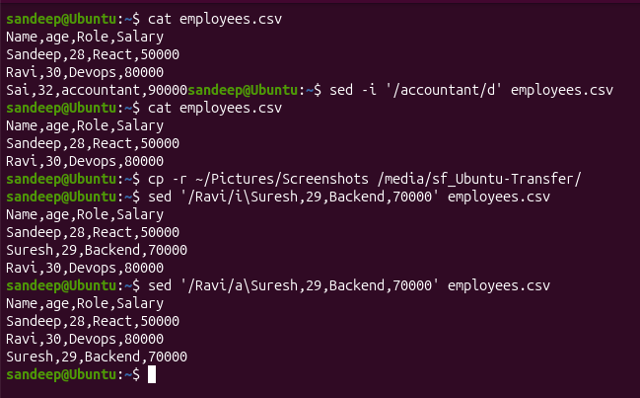

40) Print only specific lines from a file.

sed -n ‘2p’ employees.csv

What each part means
-n → don't print all lines
2 → line number 2
p → print that line

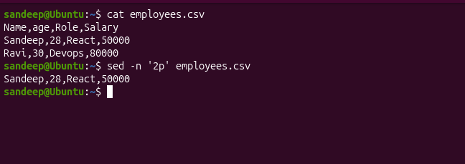

41) Copy file from linux to windows machine

Step 1 — Create a folder in Windows
Desktop → Ubuntu-Transfer

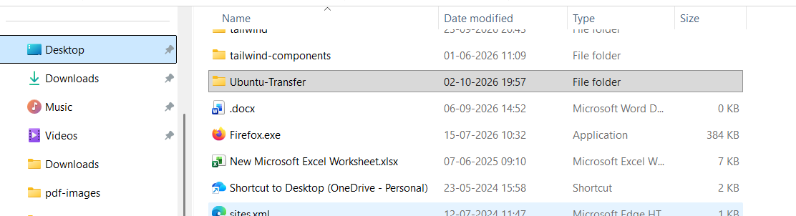

Step 2 — Configure it in VirtualBox
In VirtualBox:
Ubuntu VM → Settings → Shared Folders
Add the Windows folder:
Folder Path: C:\Users\<YourName>\Desktop\Ubuntu-Transfer
Folder Name: Ubuntu-Transfer
Enable:
- ✅ Auto-mount
- ✅ Make Permanent

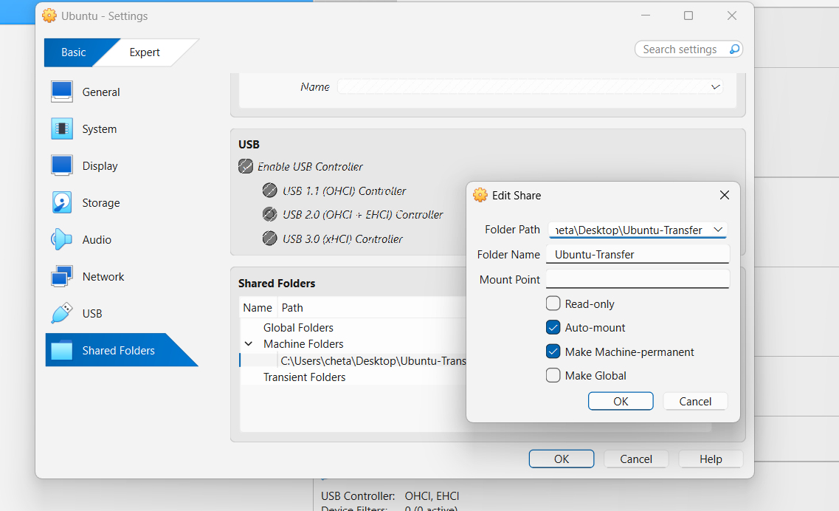

Step 3 — Start/restart Ubuntu
After Ubuntu starts, VirtualBox should mount the shared folder under:
/media/
Usually the mounted folder becomes:
/media/sf_Ubuntu-Transfer

Step 4 — Check the shared folder
ls /media/sf_Ubuntu-Transfer

Step 5 — If permission is denied
Add your Linux user to the VirtualBox shared-folder group:
sudo usermod -aG vboxsf sandeep

Step 6 — Copy the Linux file to Windows
cp employees.csv /media/sf_Ubuntu-Transfer/

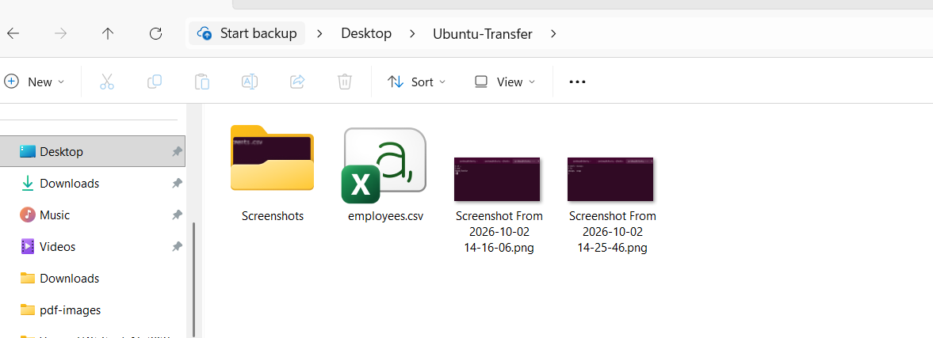

Step 7 — Verify
ls -l /media/sf_Ubuntu-Transfer/employees.csv
Then check your Windows Ubuntu-Transfer folder. employees.csv should be there.

42) 5 use cases for AWK and 5 use cases for sed

AWK — 5 use cases

We'll use employees.csv.

AWK Use Case 1 — Print specific columns
Purpose: Extract particular columns from a file.
awk -F',' '{print $1, $3}' employees.csv
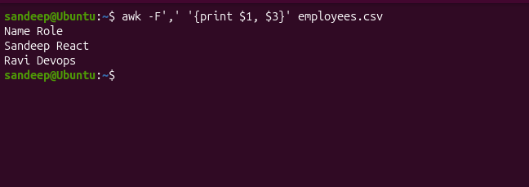

AWK Use Case 2 — Filter rows based on a condition

Purpose
Print employees whose salary is greater than ₹60,000.
awk -F',' '$4 > 60000 {print $1, $4}' employees.csv

What it means
- -F',' → comma is the column separator
- $4 → Salary column
- $4 > 60000 → condition
- print $1, $4 → print Name and Salary
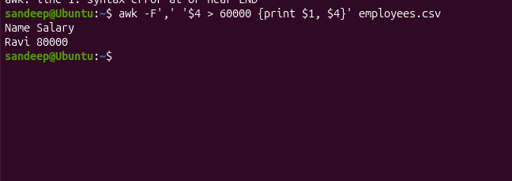

AWK Use Case 3 — Calculate the total
Purpose: Add all employee salaries.
awk -F',' 'NR > 1 {sum += $4} END {print "Total Salary:", sum}' employees.csv
Expected:
Total Salary: 130000

What's happening?
- NR > 1 → skip the header
- $4 → Salary column
- sum += $4 → keep adding salaries
- END → execute after reading the whole file
- print → display the result
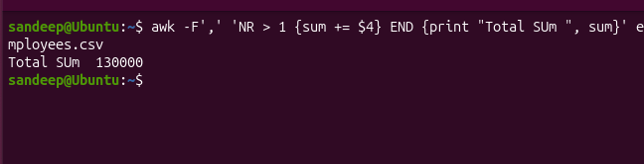

5 use cases

# | AWK Use Case | Example
1 | Print specific columns | awk -F',' '{print $1, $3}' employees.csv
2 | Filter rows based on condition | awk -F',' '$4 > 60000 {print $1, $4}' employees.csv
3 | Calculate sum/total | awk -F',' 'NR>1 {sum+=$4} END {print sum}' employees.csv
4 | Calculate average | awk -F',' 'NR>1 {sum+=$4; count++} END {print sum/count}' employees.csv
5 | Count matching records | awk -F',' '$3=="Devops" {count++} END {print count}' employees.csv

# | SED Use Case | Example
1 | Search and replace text | sed -i 's/React/Frontend/' employees.csv
2 | Delete lines matching a pattern | sed -i '/accountant/d' employees.csv
3 | Print a specific line | sed -n '2p' employees.csv
4 | Insert text before a pattern | sed '/Ravi/i\New Employee' employees.csv
5 | Append text after a pattern | sed '/Ravi/a\New Employee' employees.csv

AWK → mainly works with data/columns and calculations
Examples:
- Select columns
- Filter data
- Sum
- Average
- Count
SED → mainly works with modifying/filtering text
Examples:
- Replace
- Delete
- Print
- Insert
- Append

