**Skill Visualizations**

1. Stacked area chart to show aggregated skills

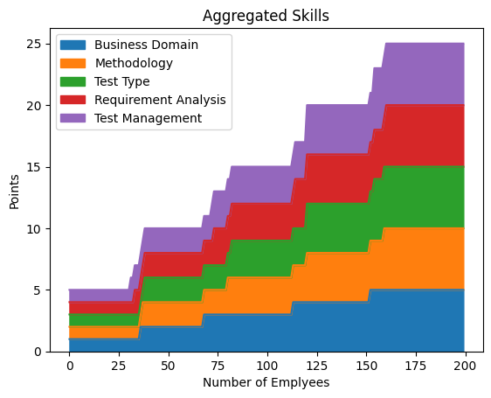

80% Percentile

70% Percentile

60% Percentile

1. Bubble chart to show individual skills for different categories

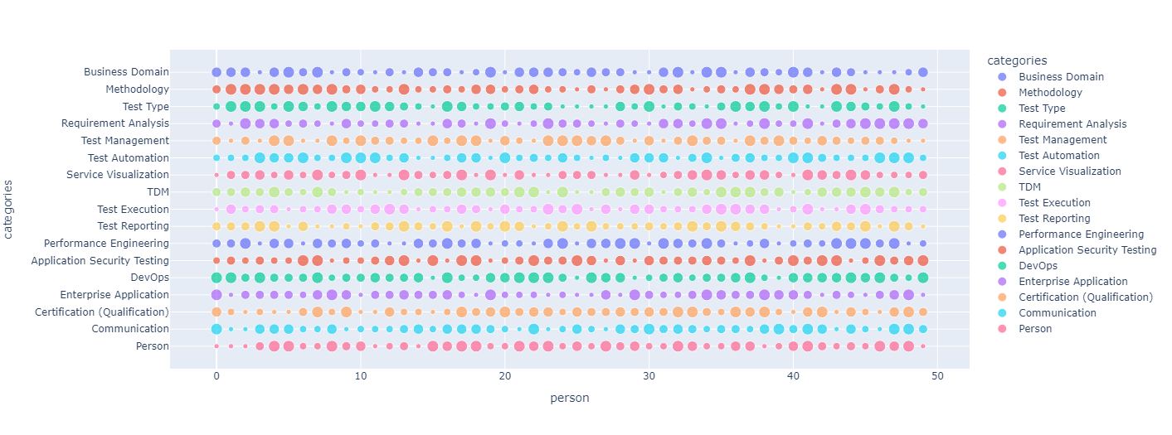

1. Bar graph to show the summation of points across each skill

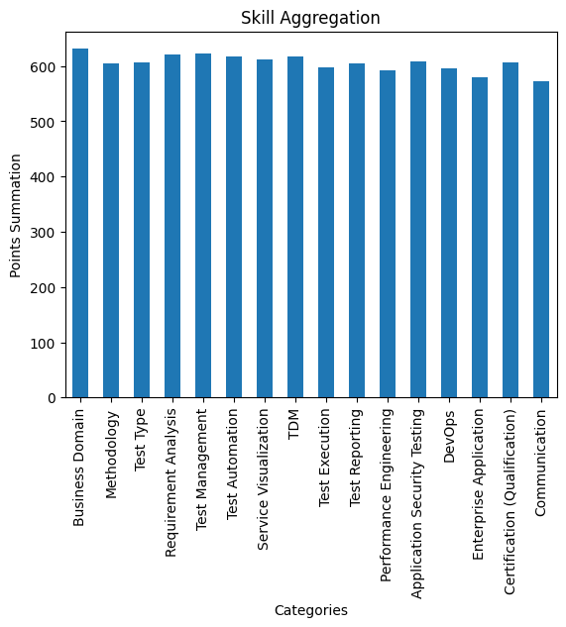

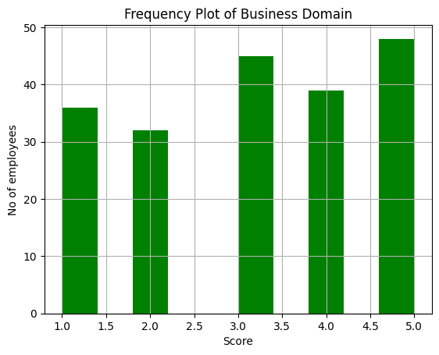

1. Histogram to show the frequency of points in the company for a skill