Sonarqube

sonar cube

--------------

sonar cube using

scan --> static source code analysis

sast ---> static application security testing

create a instance for soarqube select and subscribe ami image SonarQube t3.medium-->instance type

take publicip:9000 port number

Login:admin

Password:instanceID

After that change the password and login once again

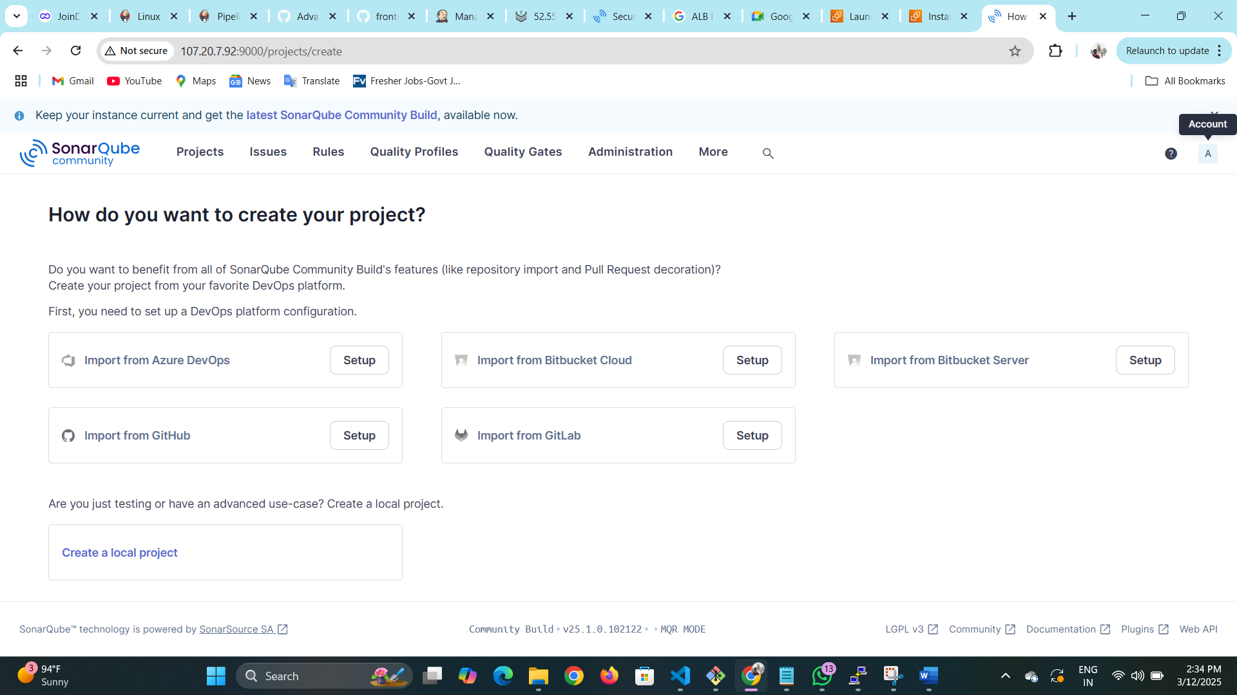

Go to account there u can find security

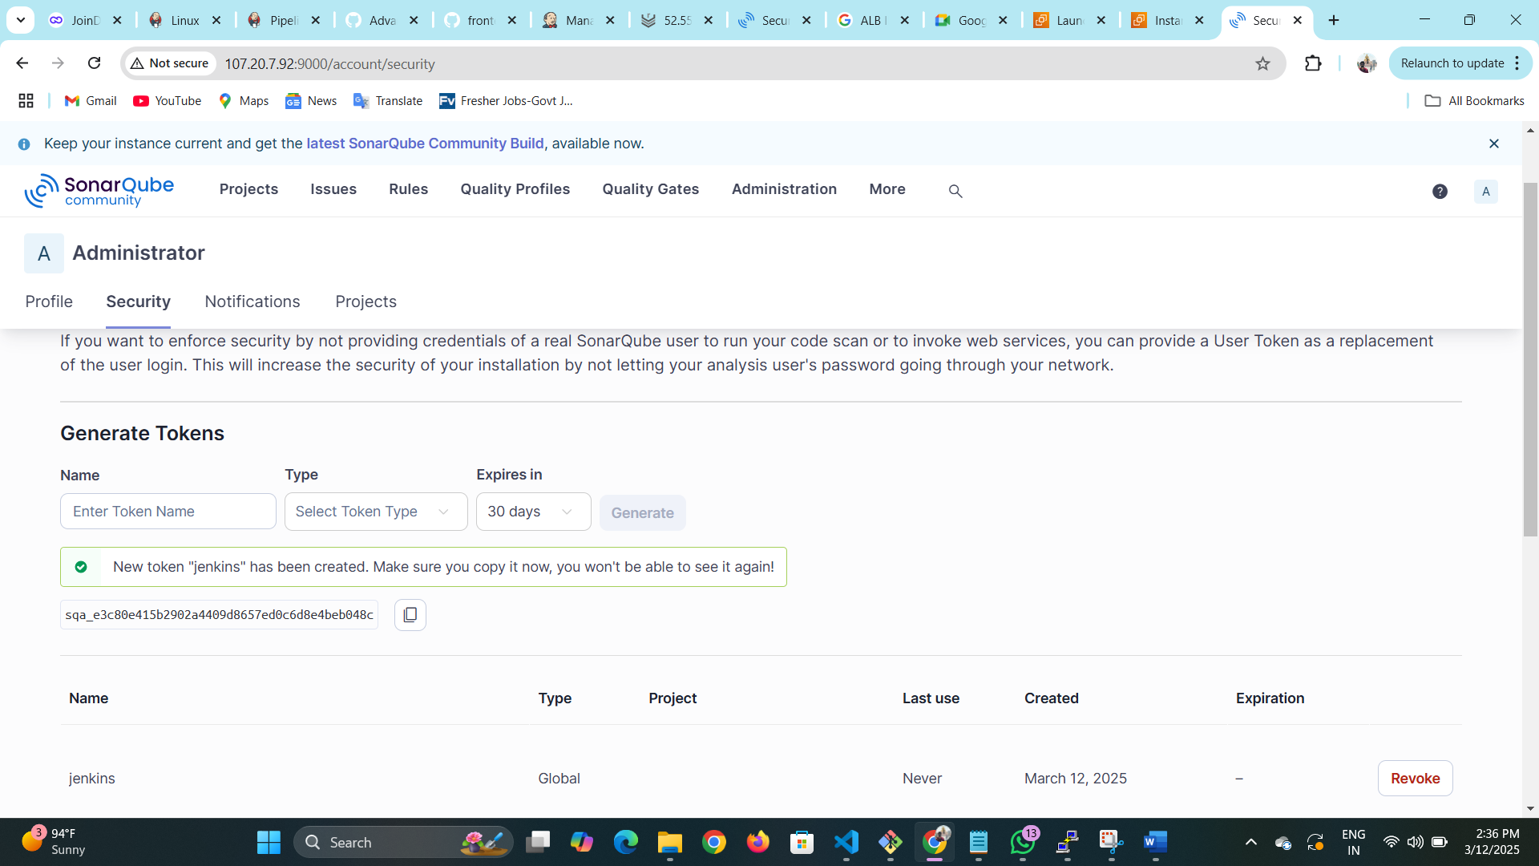

Generate a token copy token to your note pad

To continuous integration with Jenkins we need to do some setup in Jenkins

Need to install first plugins Sonarqube

* Go to tools there add latest sonarqube vesion give a name we need to add this name at Jenkins pipeline

* Go go manage-jenkins/system and do below configurations need to give a valid name we will use in Jenkins pipeline

Server authentication token press add

What ever we copied secret token from sonarqube paste it here and give valid name need to give in Jenkins -pipeline

 stage('Sonar Scan'){

            environment {

                scannerHome = tool 'sonar-6.0'//referring scanner CLI

            }

            steps {

                script {

                    withSonarQubeEnv('sonar-6.0') { //referring sonar server at manage-jenkins/systems

                        sh "${scannerHome}/bin/sonar-scanner"

                    }

                }

            }

        }

Syntax of SonarQube for jenkinspipeline