### Introduction Sequence:

1. git commit; git commit

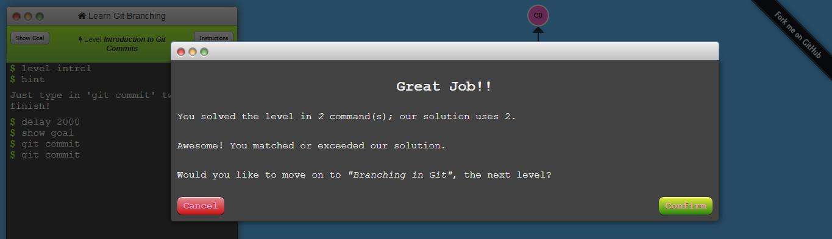

2. git branch bugfix; git checkout bugFix

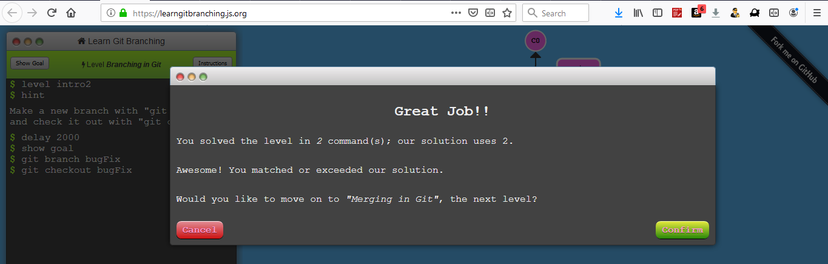

3. git branch bugfix; git checkout bugfix; git commit;

git checkout master; git commit; git merge bugFix 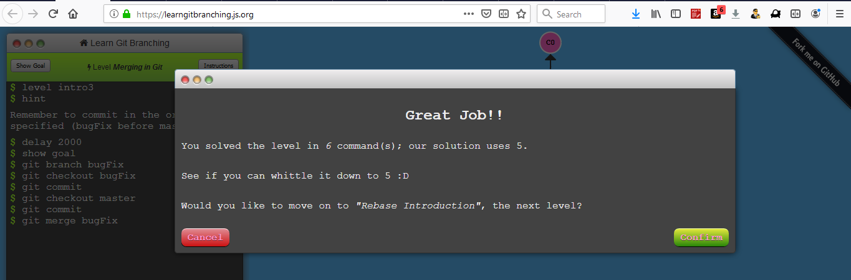

4. git branch bugfix; git checkout bugfix; git commit;

git checkout master; git commit; git checkout bugfix;

git rebase master 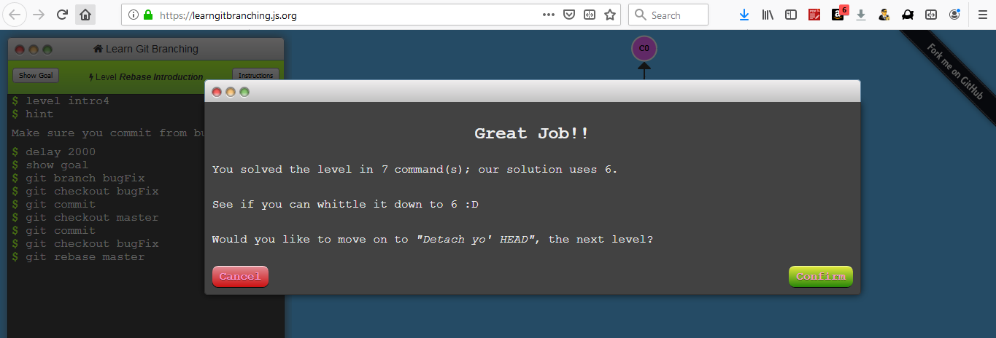

### Ramping Up

1. git checkout C4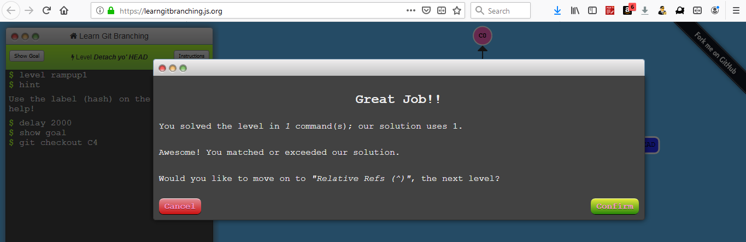

2. git checkout bugfix^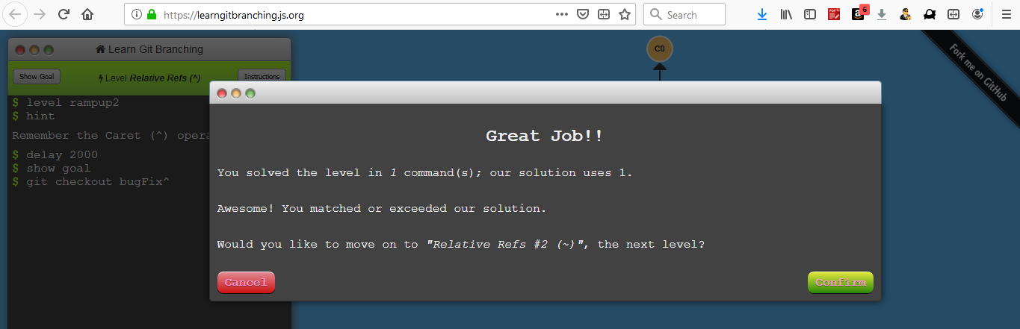

3. git branch -f master checkout C6; git branch -f master checkout C0; git checkout HEAD~1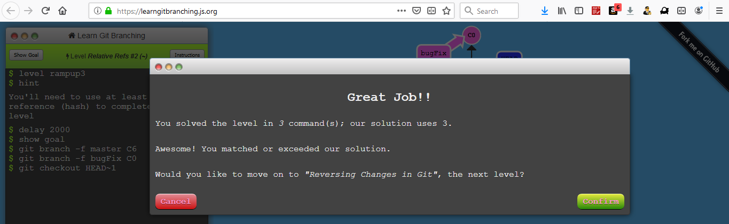

4. git reset local~1; git checkout pushed; git revert pushed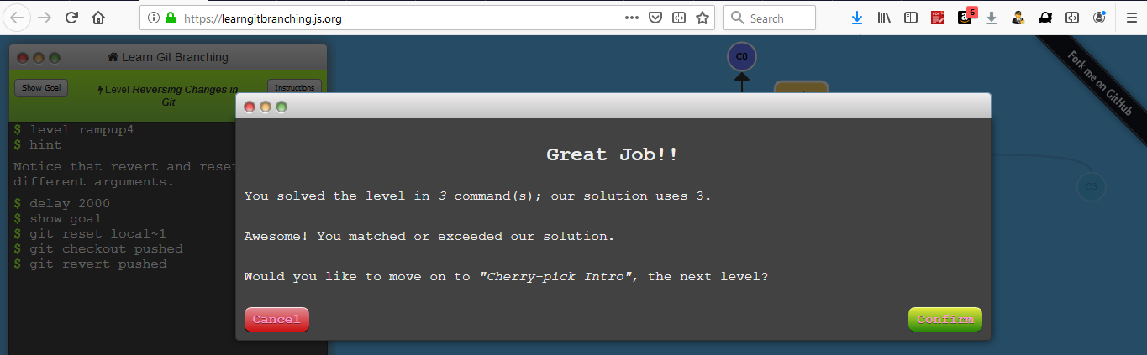

### Moving Work Around:

1. git cherry-pick C3 C4 C7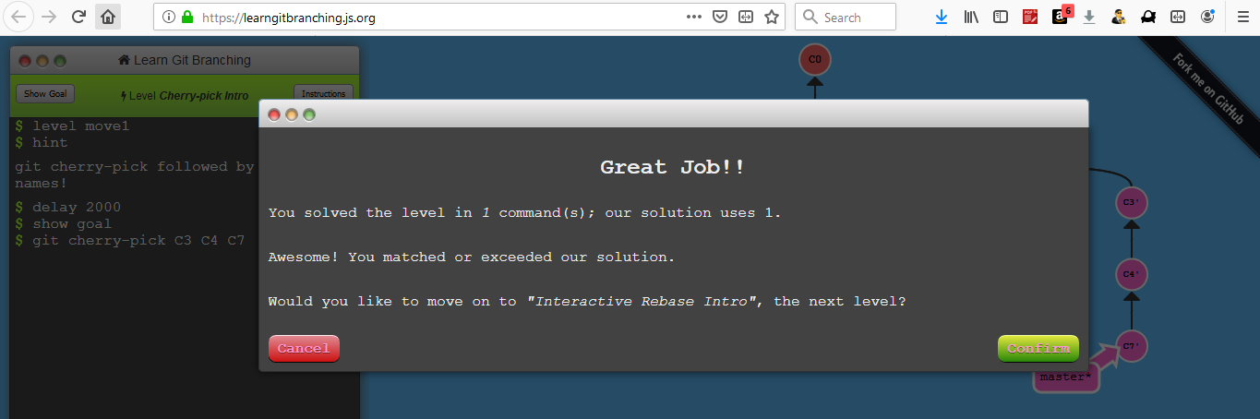

2. git rebase -i HEAD~4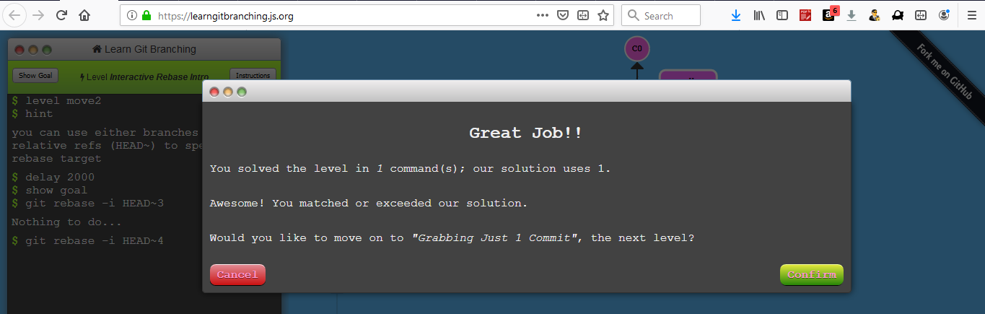

### A Mixed Bag

1. git checkout master; git cherry-pick bugFix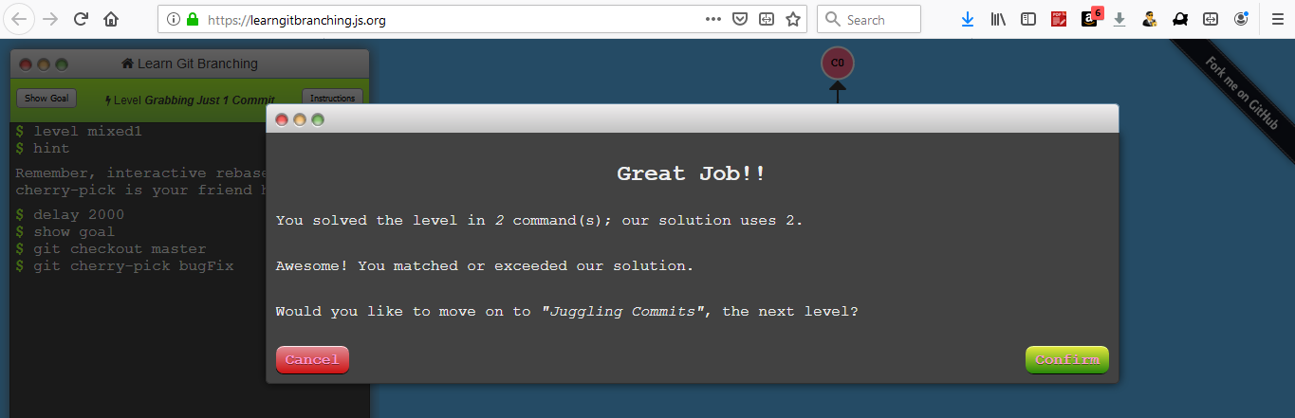

2. git rebase -i caption~2 –aboveAll; git commit --amend;

git rebase -i caption~2 –aboveAll; git branch -f master caption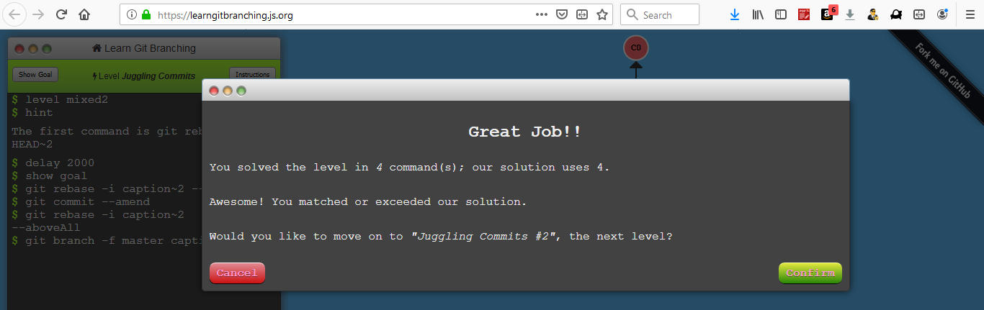

3. git checkout master; git cherry-pick C2; git commit –amend; git cherry-pick C3 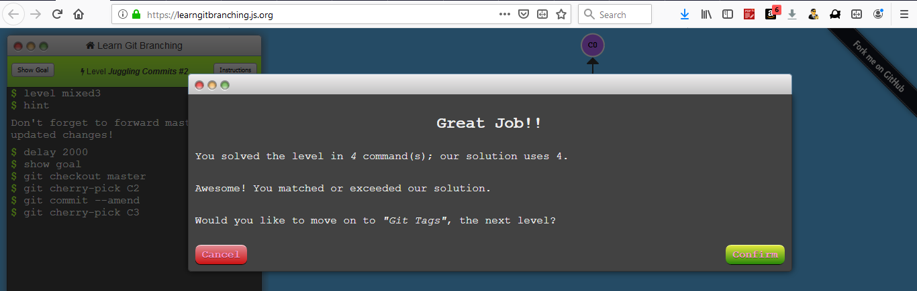

4. git tag v1 C2; git tag v0 C1; git checkout C2 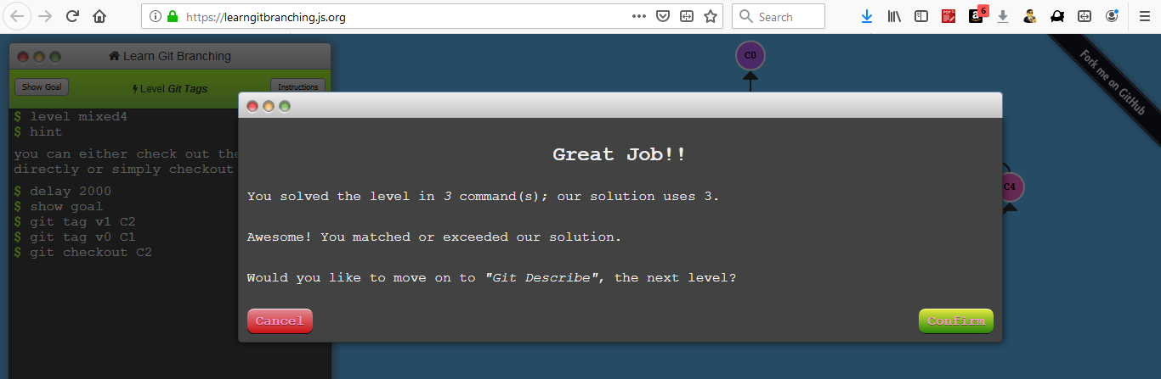

5. git describe C3; git commit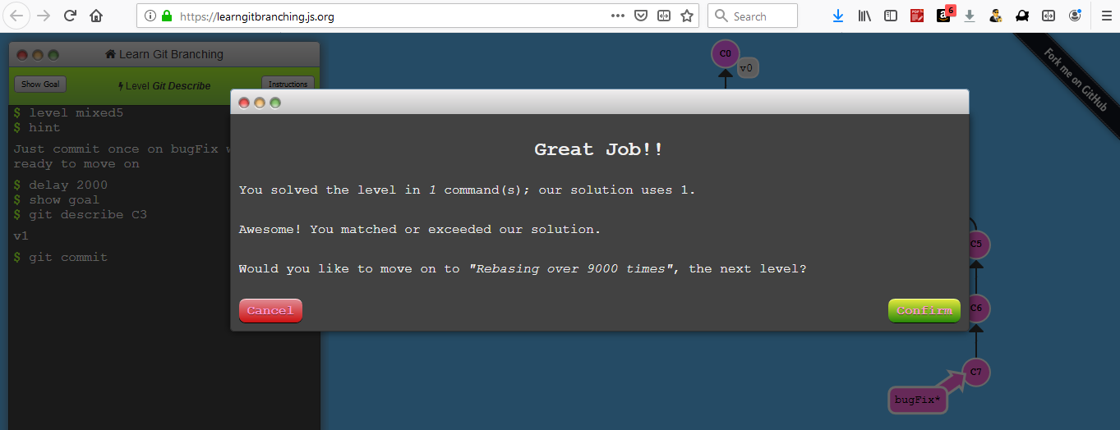

### Advanced Topics

**1.** git rebase master bugfix; git rebase bugfix side; git rebase side another; git rebase another master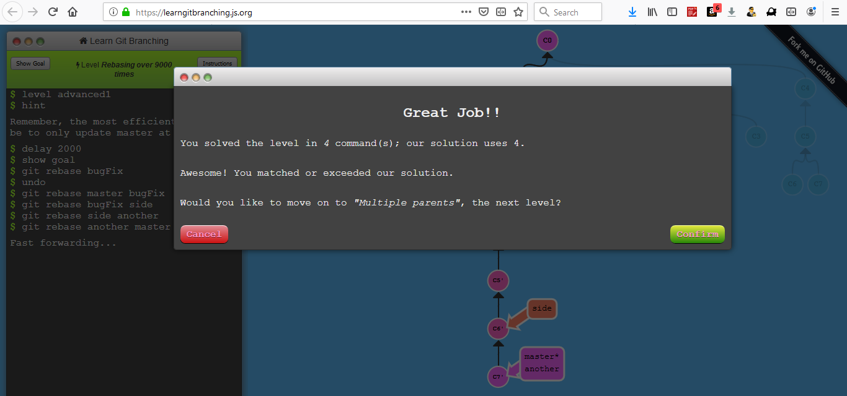

**2.** git branch bugWork master~^2^ 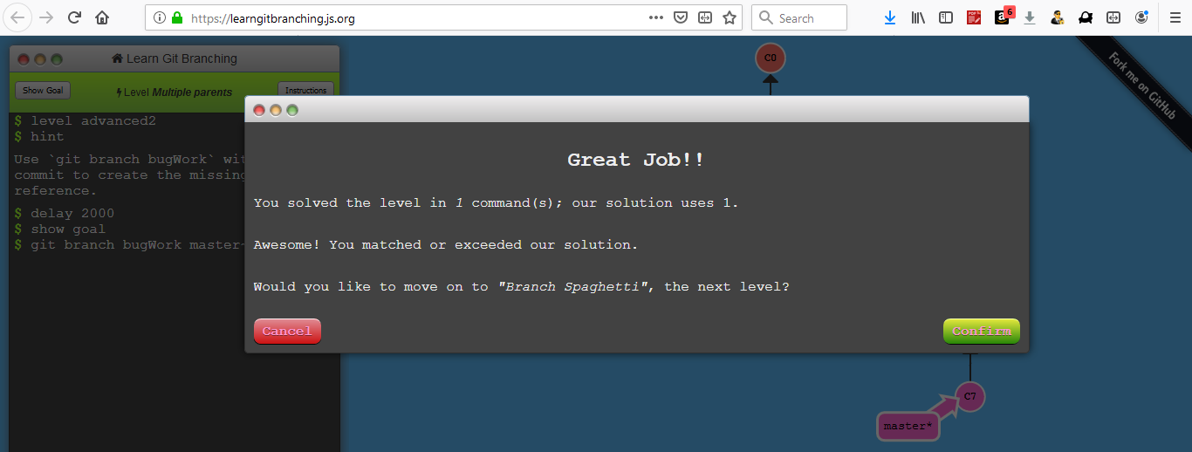

**3.** git checkout one; git cherry-pick C4 C3 C2; git checkout two; git cherry-pick C5 C4 C3 C2; git branch -f three C2

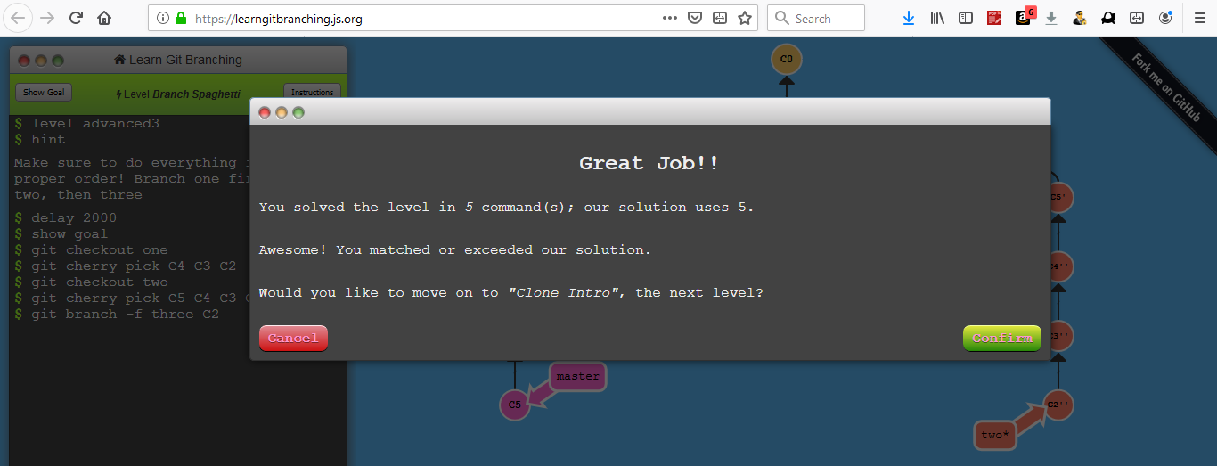

**All exercises:**

