1. Introduction 3
1.1 Aim 3
1.2 What is JMS ? 3
1.3 Scope of Project 4
1.4 Method of Implementation 4
1.4.1 Work Plan 4
1.4.2 Hardware /Software Specifications 5
2. EAI (Enterprise Application Integration) 6
2.1 System Architecture 7
Fig 1:Architecture of JMS Based EAI 7
3.Project Analysis: 8
3.1 Sequence Diagram for EAI : 8
4.Project Design 8
4.Project Design 9
4.1 EA 1 – HRIS (Human Resource Information systems) 9
4.2 JMS Provider (Sun Application Server) 10
4.3 EAI (Enterprise Application Integration ) 11
4.4 EA 2 – EFIS (Enterprise Financial Information systems) 11
5.Code Snippets 14
5.1 HRIS Employee record XML file schema: 14
5.2 EFIS Employee record XML file schema: 16
5.3 EAI XSLT File used to transform HRIS data to EFIS data: 17
5.4 SendSOAPMessageWithJMS Java class code: 18
6. Technical Tools / IDES utilized for this projects are 23
6.1 IDEs: 23
6.2 APIs used are: 23

Abstract
EAI – Enterprise Application Integration is fast becoming the norm for every industry. With huge amount of investments made by every company in its IT infrastructure, it becomes necessary for a company to keep all its software applications in a coherent though independent manner.
EA - enterprise application, denotes any software application which has an impact across an enterprise. There are several such enterprise application product categories including ERP(Enterprise Resource Planning) products like SAP, CRM(Customer Relationship Management) products like Seibel CRM and PLM(Product Lifecycle Management) products like e-Matrix etc.
The current project aims to present a simulation of an enterprise which has a two separate enterprise applications which need to be integrated seamlessly.
For the simulation purposes two applications HRIS(Human Resource Information Systems) and EFIS(Enterprise Finance Information Systems) have been developed each of which are JMS complaint. These two applications are integrated using an EAI application which is also a JMS (Java Messaging Service) based application.
The core functionality of the EAI product is to receive crucial messages(like employee addition/deletion) from the HRIS, as a JMS message with SOAP attachment, and send another JMS message with transformed data(using XSLT) as SOAP attachments in a format acceptable to EFIS.
This simulation covers complete sequence of steps in a real time scenario. It provides a message driven integration based on industry standards like JMS and SOAP and includes features data transformation using XSLT, XML based content model etc.

1. Introduction

1.1 Aim

JMSBasedEAI application aims at simulating an integration solution between two enterprise applications using a message driven architecture based on JMS messages and SOAP attachments.
The main drive for this project is to show that for EAI solutions, JMS along with SOAP formulates a very good platform. While JMS provides for real time integration without comprising on the expectation that the integration would be loosely coupled , SOAP attachments ensure that the data is a universally acceptable formats , XML, allowing for certain industry standard formats ex: PDX(Product Data Exchange).

1.2 What is JMS ?
Messaging is a method of communication between software components or applications. A messaging system is a peer-to-peer facility: A messaging client can send messages to, and receive messages from, any other client. Each client connects to a messaging agent that provides facilities for creating, sending, receiving, and reading messages.
Messaging enables distributed communication that is loosely coupled. A component sends a message to a destination, and the recipient can retrieve the message from the destination. However, the sender and the receiver do not have to be available at the same time in order to communicate. In fact, the sender does not need to know anything about the receiver; nor does the receiver need to know anything about the sender. The sender and the receiver need to know only what message format and what destination to use. In this respect, messaging differs from tightly coupled technologies, such as Remote Method Invocation (RMI), which require an application to know a remote application’s methods.
Messaging also differs from electronic mail (e-mail), which is a method of communication between people or between software applications and people. Messaging is used for communication between software applications or software components.
The Java Message Service is a Java API that allows applications to create, send, receive, and read messages. Designed by Sun and several partner companies, the JMS API defines a common set of interfaces and associated semantics that allow programs written in the Java programming language to communicate with other messaging implementations.
The JMS API enables communication that is not only loosely coupled but also
- Asynchronous and
- Reliable

1.3 Scope of Project
The scope of the project can be derived the following operation which define the boundary and range for the application:

- Application should be able to receive JMS messages from an enterprise application.
- Data transformations on the data received through JMS message attachments using XSLT using should be provided.
- Application should be able to send JMS messages to another enterprise application with transformed data as a SOAP attachment.
In essence the application should provide features for data transport and functional integration across two, independent ,JMS compliant, enterprise applications. Also the application should be amenable to any future data changes in either of the applications by ensuring that it uses XML as content model and XSLT for all the data transformations.

1.4 Method of Implementation

1.4.1 Work Plan
The software development life cycle (SDLC) for this project comprises of the following phases:
• Software Requirements – case study of an EAI application
• Object Oriented Analysis and Design
• Coding and Unit Testing
• System Testing

1.4.2 Hardware /Software Specifications
The proposed system is developed on the below stated specifications:
- Hardware:
  - Pentium 4 processor
  - 256MB of memory
  - 10 MB of hard drive space
- Software:
Java, JMS, JSP, XML, XSLT, SAX, (J2EE technologies), J2EE 1.4 SDK, Sun App Server 8

2. EAI (Enterprise Application Integration)
Enterprise Application Integration refers to integrating applications internally within the organization.
There are several categories of EAI available:
- User interface level
- Method level
- Application interface level
- Data level
JMSBasedEAI falls into the category of Application Interface level EAI, we will restrict this introduction to the Application interface level EAI for simplicity reasons
Some of the features of application interface level EAI are :
- It is a leveraging of the interfaces exposed by custom or packaged applications.
- EAI developers leverage these interfaces to access both business processes and simple information.
- Using these interfaces, developers will be able to bundle many applications together, allowing them to share business logic and information across them.
- It is most applicable to packaged applications such as SAP, etc which have standard interfaces exposed specifically for integration purposes.

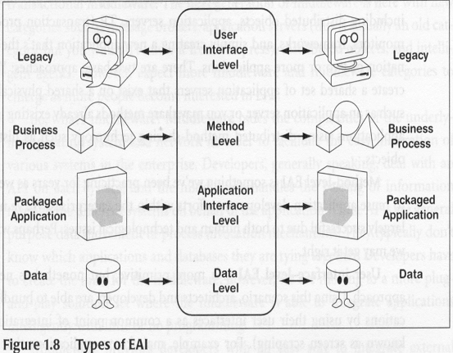

2.1 System Architecture

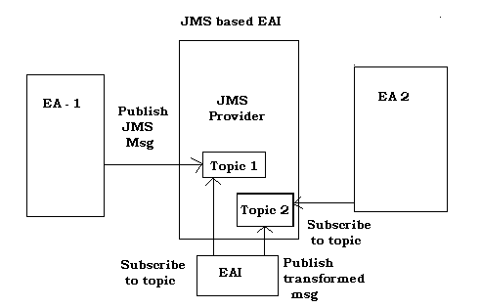

Fig 1:Architecture of JMS Based EAI
The above system has three 4 logical components
- EA1 : Enterprise Application 1 which in this project is named HRIS (Human Resource Information Systems).HRIS publishes messages onto Topic 1.
- JMS Provider : The application server vendor which provides for JMS facility. In this project this is Sun Application server 8 .
- EAI : Enterprise Application Integration solution sits on top of the application listening to JMS topic – Topic1 and publishing the transformed data received on Topic1 queue to Topic 2
- EA2 : Enterprise Application 2 which in this project is named EFIS (Enterprise Finance Information systems).HRIS listens to Topic 2 which contains HRIS data transformed and posted as a message by EAI.

3.Project Analysis:

3.1 Sequence Diagram for EAI :

Create employee records
EA 1
JMS Provider
EAI
EA 2

Publish records to Topic1

Employee record sent to EAI

Transform HR record to Finance record
Publish JMS message to Topic2
Employee record sent to EA 2

4.Project Design

The current project consists of four major modules which are:
- EA 1: (Enterprise Application 1 - HRIS)
- JMS Provider: (Application Server)
- EAI : (Enterprise Application Integration solution)
- EA 2: (Enterprise Application 2)

4.1 EA 1 – HRIS (Human Resource Information systems)

For simplicity purposes This module consists of a bare minimum set of operations and is not aimed to represent real time business scenarios under this module.

The operations considered within this module are

- Creation of an employee record
- Viewing an employee record
- Editing an employee record
- Deleting an employee record

Also under following events a JMS message would be posted to the JMS provider

- Creation of an employee record
- Deletion of an employee record

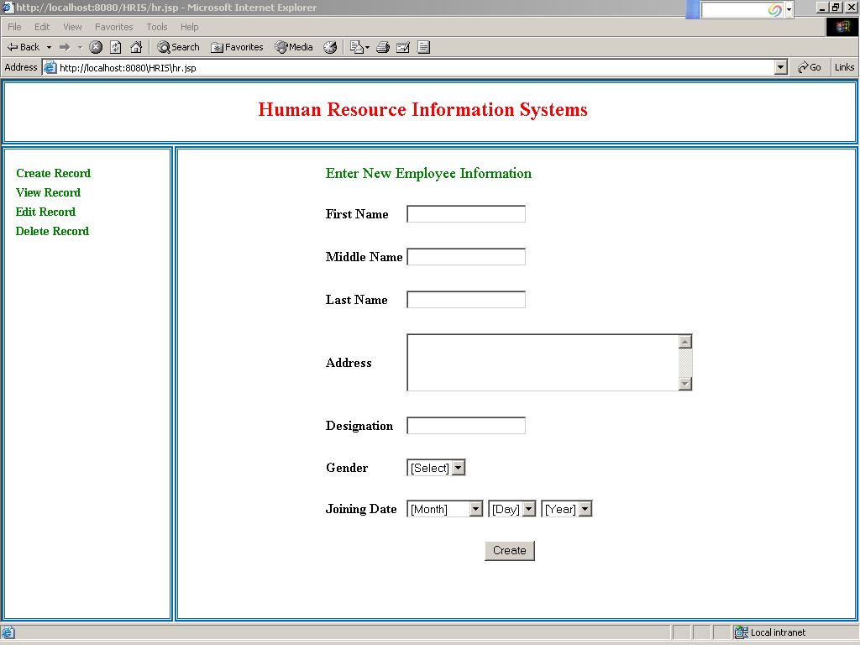

4.2 JMS Provider (Sun Application Server)
JMS Provider is typically an application server providing the features of JMS Topics and Queues. For the project purposes Sun Application Server 8 has been used and the following JMS topic s have been used on this server:
- Jms/TopicConnectionFactory
- Jms/TopicConnectionFactory1
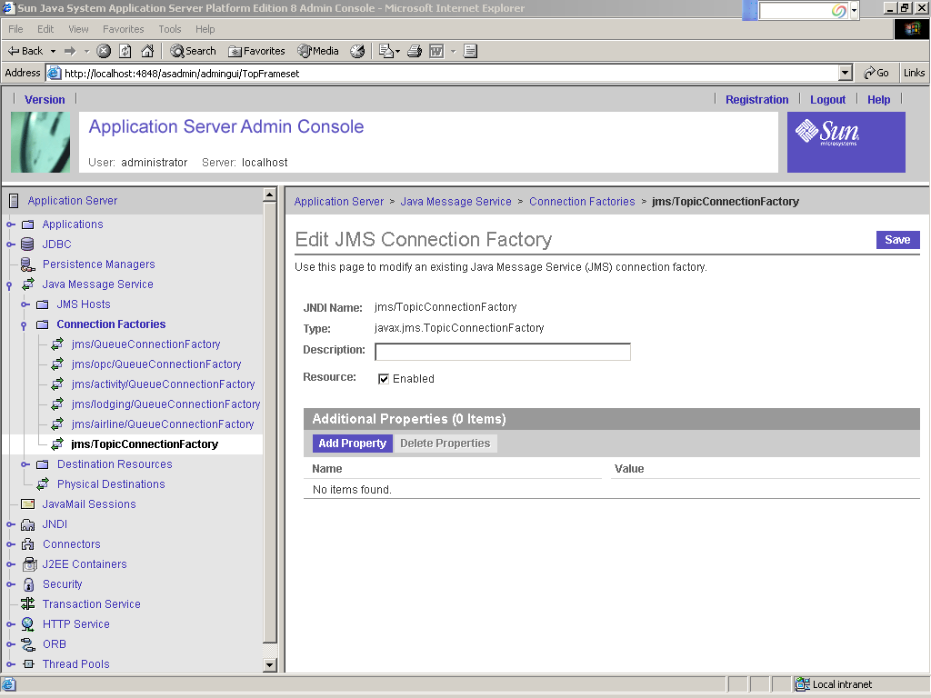

4.3 EAI (Enterprise Application Integration )
This is the main component of the project which synchronizes the two application s HRIS and EFIS using JMS Topics on the JMS provider

4.4 EA 2 – EFIS (Enterprise Financial Information systems)
For simplicity purposes This module consists of a bare minimum set of operations and is not aimed to represent real time business scenarios under this module.

The operations considered within this module are

- Viewing an employee record
- Editing an employee record
- View to see Pending records which are already created in HRIS and are ready to be created in EFIS.

Also under following events a JMS message would be received from the the JMS provider

- Creation of an employee record in HRIS
- Deletion of an employee record in HRIS

And corresponding creation/deletion operations are performed in this module in the background

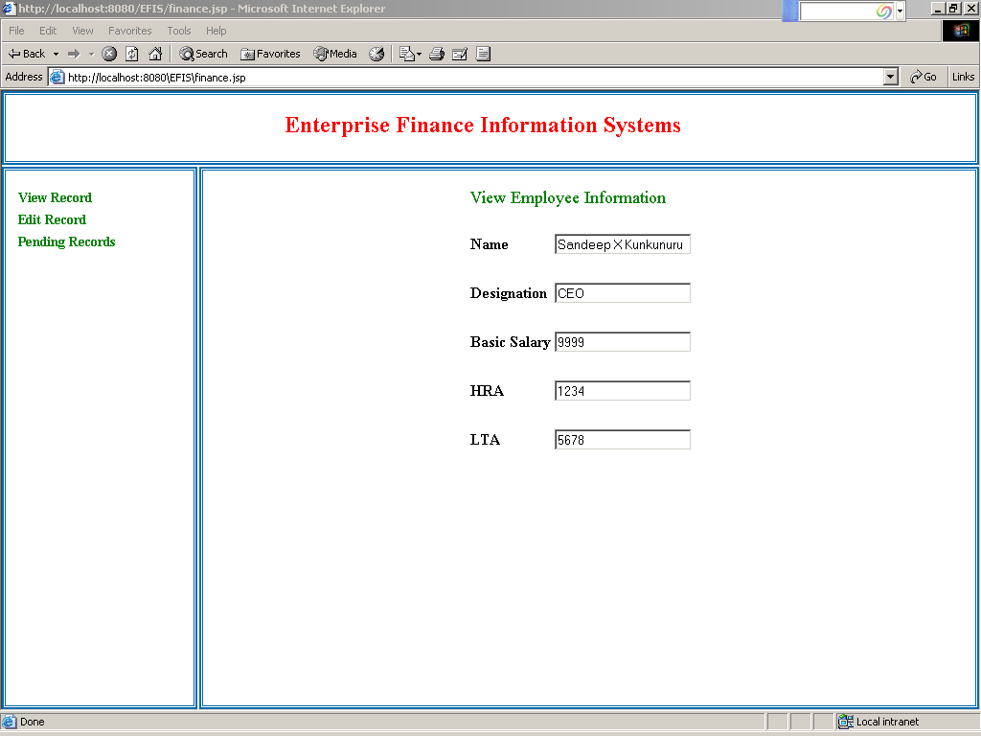

To summarize the following are the sequence of operations in the project
- HRIS user would access the system through a web browser and create employee records
- When a employee record is created in HRIS , a JMS message would be posted to the Sun App server’s JMS topic (jms/TopicConnectionFactory) along with the employee record as an attachment
- The JMSBasedEAI solution would listen to the topic and access the attachment file which would be transformed using XSLT.
- The transformed XML file would be posted as an attachment to a JMS message on another JMS topic (jms/TopicConnectionFactory1).
- EFIS module would access the JMS message from the topic queue on the JMS provider simultaneously would create a template base record in its module as well as mark the record as pending .
- An EFIS user would open the look at pending records and edit these records to enter the financial details like Basic Salary, HRA and LTA etc.
- Once the record is updated the pending record is deleted and the employee record is now considered a part of the module.

Note:
- The same application can be extended to enhance the functional integration across these two modules by providing for handling more number of situations like
  - An Employee has left the company and his record is n o more valid then HRIS would delete the record and send out a JMS message, receiving which EFIS would delete the record in its modules

5.Code Snippets

5.1 HRIS Employee record XML file schema:
<?xml version="1.0" encoding="UTF-8" standalone="yes"?>
<!--W3C Schema generated by XMLSpy v2006 sp1 U (http://www.altova.com)-->
<xs:schema xmlns:xs="http://www.w3.org/2001/XMLSchema" elementFormDefault="qualified">
<xs:element name="Address" type="xs:string"/>
<xs:element name="Designation">
<xs:simpleType>
<xs:restriction base="xs:string">
<xs:enumeration value="CEO"/>
</xs:restriction>
</xs:simpleType>
</xs:element>
<xs:element name="Employee">
<xs:complexType>
<xs:sequence>
<xs:element ref="FirstName"/>
<xs:element ref="MiddleName"/>
<xs:element ref="LastName"/>
<xs:element ref="Address"/>
<xs:element ref="Designation"/>
<xs:element ref="Gender"/>
<xs:element ref="JoiningDate"/>
</xs:sequence>
</xs:complexType>
</xs:element>
<xs:element name="FirstName">
<xs:simpleType>
<xs:restriction base="xs:string">
<xs:enumeration value="Sandeep"/>
</xs:restriction>
</xs:simpleType>
</xs:element>
<xs:element name="Gender">
<xs:simpleType>
<xs:restriction base="xs:string">
<xs:enumeration value="m"/>
</xs:restriction>
</xs:simpleType>
</xs:element>
<xs:element name="JoiningDate">
<xs:simpleType>
<xs:restriction base="xs:string">
<xs:enumeration value="11 - 19 - 2003"/>
</xs:restriction>
</xs:simpleType>
</xs:element>
<xs:element name="LastName">
<xs:simpleType>
<xs:restriction base="xs:string">
<xs:enumeration value="Kunkunuru"/>
</xs:restriction>
</xs:simpleType>
</xs:element>
<xs:element name="MiddleName">
<xs:simpleType>
<xs:restriction base="xs:string">
<xs:enumeration value="X"/>
</xs:restriction>
</xs:simpleType>
</xs:element>
</xs:schema>

5.2 EFIS Employee record XML file schema:
<?xml version="1.0" encoding="UTF-8" standalone="yes"?>
<!--W3C Schema generated by XMLSpy v2006 sp1 U (http://www.altova.com)-->
<xs:schema xmlns:xs="http://www.w3.org/2001/XMLSchema" elementFormDefault="qualified">
<xs:element name="BasicSalary">
<xs:simpleType>
<xs:restriction base="xs:short">
<xs:enumeration value="9999"/>
</xs:restriction>
</xs:simpleType>
</xs:element>
<xs:element name="Designation">
<xs:simpleType>
<xs:restriction base="xs:string">
<xs:enumeration value="CEO"/>
</xs:restriction>
</xs:simpleType>
</xs:element>
<xs:element name="Employee">
<xs:complexType>
<xs:sequence>
<xs:element ref="Name"/>
<xs:element ref="Designation"/>
<xs:element ref="BasicSalary"/>
<xs:element ref="HRA"/>
<xs:element ref="LTA"/>
</xs:sequence>
</xs:complexType>
</xs:element>
<xs:element name="HRA">
<xs:simpleType>
<xs:restriction base="xs:string">
<xs:enumeration value="1234"/>
</xs:restriction>
</xs:simpleType>
</xs:element>
<xs:element name="LTA">
<xs:simpleType>
<xs:restriction base="xs:short">
<xs:enumeration value="5678"/>
</xs:restriction>
</xs:simpleType>
</xs:element>
<xs:element name="Name">
<xs:simpleType>
<xs:restriction base="xs:string">
<xs:enumeration value="Sandeep X Kunkunuru"/>
</xs:restriction>
</xs:simpleType>
</xs:element>
</xs:schema>

5.3 EAI XSLT File used to transform HRIS data to EFIS data:
<?xml version="1.0" encoding="UTF-8"?>
<xsl:stylesheet version="1.0" xmlns:xsl="http://www.w3.org/1999/XSL/Transform" xmlns:xsi="http://www.w3.org/2001/XMLSchema-instance" xmlns:xs="http://www.w3.org/2001/XMLSchema" exclude-result-prefixes="xs">
<xsl:output method="xml" encoding="UTF-8" indent="yes"/>
<xsl:template match="/Employee">
<Employee>
<xsl:variable name="var_employee" select="."/>
<xsl:for-each select="FirstName">
<xsl:variable name="var_firstName" select="."/>
<xsl:for-each select="$var_employee/MiddleName">
<xsl:variable name="var_middleName" select="."/>
<xsl:for-each select="$var_employee/LastName">
<xsl:variable name="var_lastName" select="."/>
<xsl:variable name="temp_result1" select="concat($var_middleName, $var_lastName)"/>
<xsl:variable name="temp_result2" select="concat($var_firstName, $temp_result1)"/>
<Name>
<xsl:value-of select="$temp_result2"/>
</Name>
</xsl:for-each>
</xsl:for-each>
</xsl:for-each>
<xsl:for-each select="Designation">
<Designation>
<xsl:value-of select="."/>
</Designation>
</xsl:for-each>
<xsl:variable name="constant" select="'0'"/>
<BasicSalary>
<xsl:value-of select="$constant"/>
</BasicSalary>
<HRA>
<xsl:value-of select="$constant"/>
</HRA>
<LTA>
<xsl:value-of select="$constant"/>
</LTA>
</Employee>
</xsl:template>
</xsl:stylesheet>

5.4 SendSOAPMessageWithJMS Java class code:

package com.ou.mtechminiproject.sandeep.finance;

import javax.xml.soap.SOAPMessage;
import javax.xml.soap.SOAPPart;
import javax.xml.soap.SOAPEnvelope;
import javax.xml.soap.SOAPBody;
import javax.xml.soap.SOAPElement;
import javax.xml.soap.MessageFactory;
import javax.xml.soap.AttachmentPart;
import javax.xml.soap.Name;

import java.net.URL;
import javax.activation.DataHandler;

import com.sun.messaging.xml.MessageTransformer;
import javax.jms.TopicConnectionFactory;

import javax.jms.TopicConnection;
import javax.jms.JMSException;
import javax.jms.Session;
import javax.jms.Message;
import javax.jms.TopicSession;
import javax.jms.Topic;
import javax.jms.TopicPublisher;

import java.util.*;
import java.io.*;

/**
* This example shows how to use the MessageTransformer utility to send SOAP
* messages with JMS.
* <p>
* SOAP messages are constructed with javax.xml.soap API. The messages
* are converted with MessageTransformer utility to convert SOAP to JMS
* message types. The JMS messages are then published to the JMS topics.
*/
public class SendSOAPMessageWithJMS {

TopicConnectionFactory tcf = null;
TopicConnection tc = null;
TopicSession session = null;
Topic topic = null;

TopicPublisher publisher = null;

/**
* default constructor.
*
* @param topicName a String that contains the name of a JMS Topic
*
*/
public SendSOAPMessageWithJMS(String topicName) {
init(topicName);
}

/**
* Initialize JMS Connection/Session/Topic and Publisher.
*
* @param topicName a String that contains the name of a JMS Topic
*
*/
public void init(String topicName) {
try {
ServiceLocator servicelocator = new ServiceLocator();
tcf = servicelocator.getTopicConnectionFactory(JNDINames.TOPIC_CONNECTION_FACTORY);
tc = tcf.createTopicConnection();
session = tc.createTopicSession(false, Session.AUTO_ACKNOWLEDGE);
topic = servicelocator.getTopic(topicName);
publisher = session.createPublisher(topic);
} catch (JMSException jmse) {
jmse.printStackTrace();
} catch(ServiceLocatorException se) {
se.printStackTrace();
}
}

/**
* Send SOAP message with JMS API.
*/
public void send () throws Exception {

/**
* Construct a default SOAP message factory.
*/
MessageFactory mf = MessageFactory.newInstance();
/**
* Create a SOAP message object.
*/
System.out.println ("Create a SOAP message");
SOAPMessage soapMessage = mf.createMessage();
/**
* Get SOAP part.
*/
SOAPPart soapPart = soapMessage.getSOAPPart();
/**
* Get SOAP envelope.
*/
SOAPEnvelope soapEnvelope = soapPart.getEnvelope();

/**
* Get SOAP body.
*/
SOAPBody soapBody = soapEnvelope.getBody();
/**
* Create a name object. with name space http://www.sun.com/imq.
*/
Name name = soapEnvelope.createName("HelloWorld", "hw", "http://www.sun.com/imq");
/**
* Add child element with the above name.
*/
SOAPElement element = soapBody.addChildElement(name);

/**
* Add another child element.
*/
element.addTextNode( "Welcome to Sun Web Services." );

/**
* Create an atachment with activation API.
*/

URL url = getUrlFromPropsFile();
System.out.println ("Attaching the file from URL: " + url);

DataHandler dh = new DataHandler (url);
AttachmentPart ap = soapMessage.createAttachmentPart(dh);
/**
* set content type/ID.
*/
ap.setContentType("text/html");
ap.setContentId("cid-001");

/**
* add the attachment to the SOAP message.
*/
soapMessage.addAttachmentPart(ap);
soapMessage.saveChanges();

/**
* Convert SOAP to JMS message.
*/
System.out.println ("Convert the message to JMS message");
Message m = MessageTransformer.SOAPMessageIntoJMSMessage( soapMessage, session );

/**
* publish JMS message.
*/
System.out.println ("Publish the message");
publisher.publish( m );
}

/** Read server and port from soaptojms.properties file
*
*/

public URL getUrlFromPropsFile() throws Exception {
InputStream props = SendSOAPMessageWithJMS.class.getResourceAsStream("soaptojms.properties");

Properties P = new Properties();
P.load(props);

return (new URL(P.getProperty("url")));
}

/**
* Close JMS connection.
*
* @exception JMSException
*/
public void close() throws JMSException {
tc.close();
}

}

6. Technical Tools / IDES utilized for this projects are

6.1 IDEs:
- JDeveloper for Java
- EditPlus for JSPs
- Ant for binding class files
- Altova XML SPY and MAPForce for XML and XSLfiles

6.2 APIs used are:
- activation.jar
- imqxm.jar
- javax.jms.jar
- jaxm-api.jar
- jms.jar
- saaj-api.jar
- saaj-impl.jar

7. Summary
This project is objectively based to showcase the ability of new age J2EE technology JMS and its application in EAI arena. Also it hopes to provide a first hand insight into related technologies like SOAP, JSP, XML, SAX etc.

