

SIMATS ENGINEERING
Saveetha Institute of Medical and Technical Sciences Chennai- 602105
Student Name:M.Sandeep Reg. No.:192525095
Course Code:CSA1522 Slot:C
Course Name: Cloud Computing & Big Data Analytics
Course Faculty:DR.P.Rajaram

Project Title:
Module Photographs: (3 photographs –Module Photo, Individual student contribution module work in the project and presentation image)
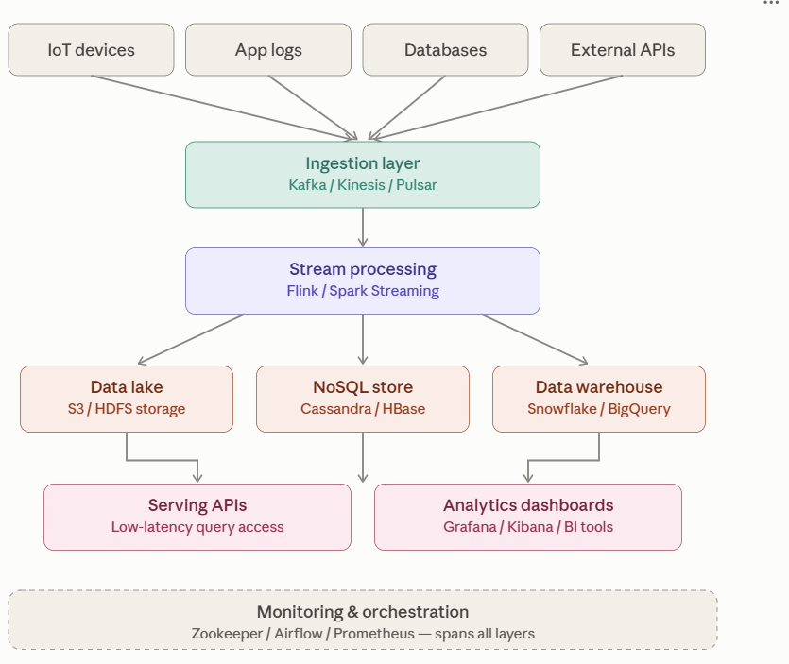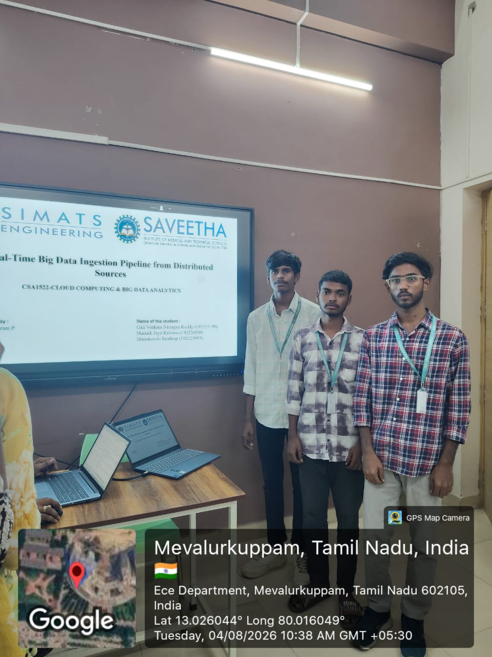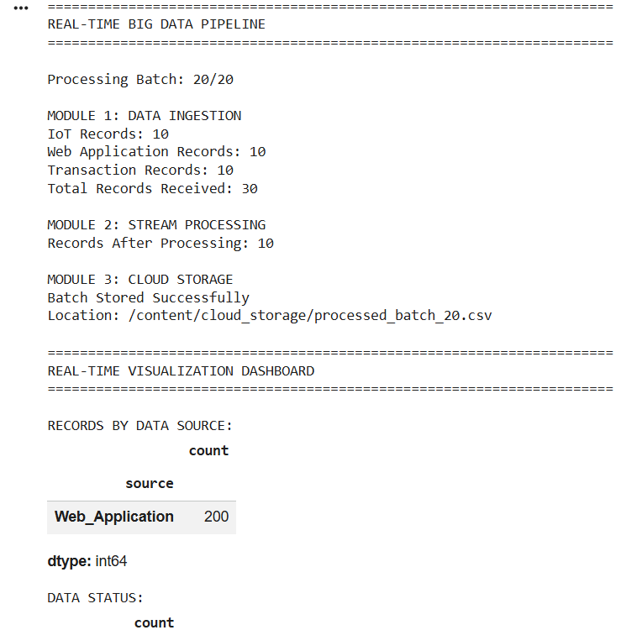
Project Description: (here you write what you did in this project (contribution) including Model Description
Real-Time Big Data Ingestion Pipeline from Distributed Sources is a data engineering project designed to collect, process, store, and visualize large volumes of data generated from multiple distributed sources in real time. The system provides a unified pipeline for handling data from sources such as sensors, applications, log files, APIs, and databases.
The project continuously receives incoming data and processes it using a stream-processing mechanism to perform filtering, transformation, validation, and aggregation. The processed data is then stored in scalable cloud or distributed storage systems for further analysis. A visualization dashboard is used to display real-time information, trends, and important insights.
The proposed system consists of three major modules: Multi-Source Data Ingestion, Stream Processing & Transformation, and Cloud Storage & Visualization. The pipeline reduces manual data processing, improves data availability, supports real-time analytics, and provides a scalable solution for handling high-volume distributed data.

Student Signature Guide Signature

