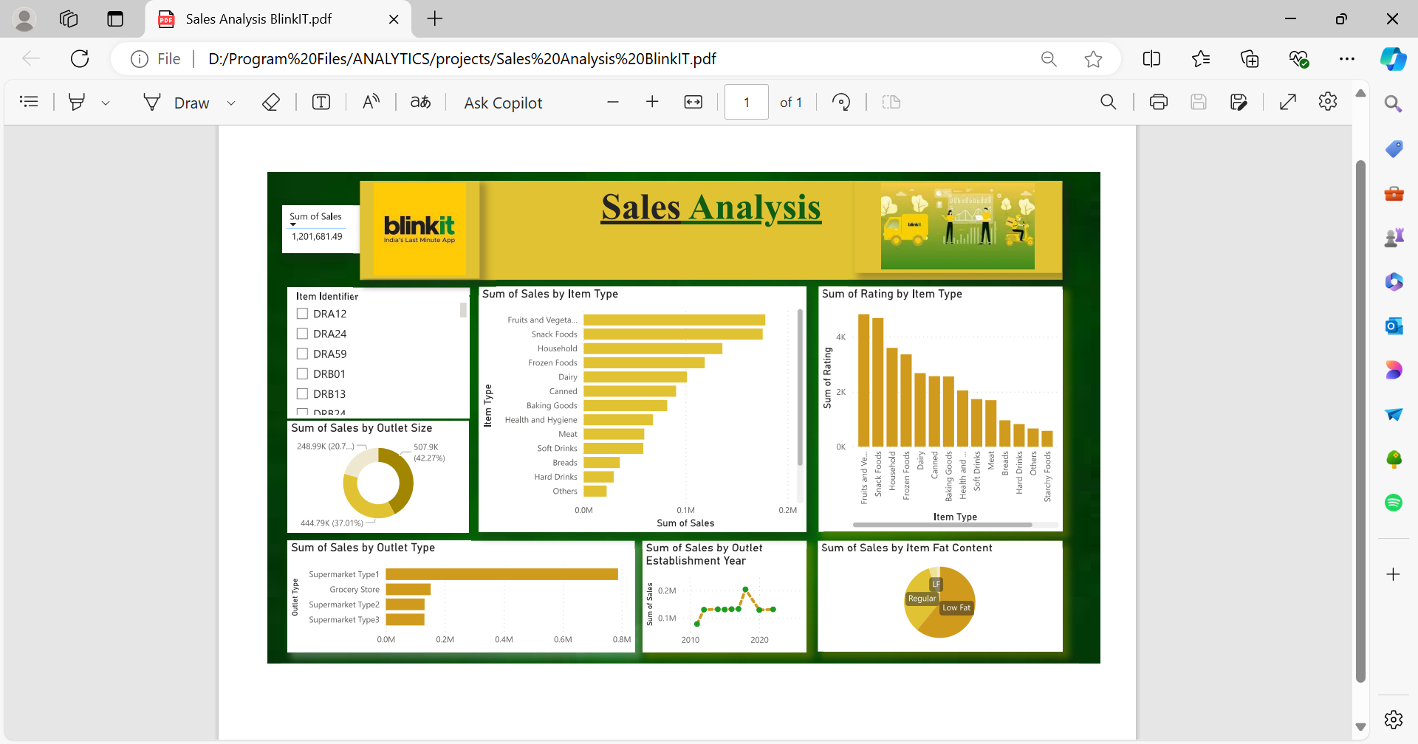

**\*\*Title: "Turning Data into Actionable Insights at BlinkIT"\*\***

During my recent project at BlinkIT, I was tasked with analyzing sales data to identify trends and opportunities for growth. I knew this wasn't just about crunching numbers—it was about uncovering the story hidden within the data.

I began by organizing the data into a comprehensive dashboard that visually represented key metrics like sales by item type, outlet size, and location. One of the most intriguing insights was the strong performance of low-fat products across various outlet types, indicating a growing consumer preference for healthier options. Additionally, I noticed that while larger outlets in Tier 1 locations brought in the most sales, smaller outlets in Tier 2 and 3 areas were rapidly gaining traction.

These insights weren't just interesting—they were actionable. I proposed that BlinkIT increase its focus on low-fat product lines and consider expanding successful smaller outlets to meet rising demand in underrepresented areas. My analysis didn't just stop at the data; it led to strategic recommendations that could drive future growth.

This project reinforced my belief in the power of data to not only inform but also transform business decisions. It was a rewarding experience, and I'm excited about the prospect of bringing this analytical approach to your team.