PROJECT REPORT
Title:
Set Up an Apache Web Server, Host an HTML Page, Access it Remotely, Check Logs & Configure Firewall Rules
Student Name:
Mentimi sandeep babu
1. Introduction
A web server is a software service that delivers web pages to users over a network. Apache HTTP Server is one of the most widely used open-source web servers due to its flexibility, security, and reliability. In this project, we install and run an Apache server in Kali Linux, host a custom webpage, access it from another computer on the network, examine access logs, and apply firewall rules to manage access.
2. Objectives
• To install and start the Apache web server on Kali Linux.
• To create and host a custom webpage.
• To access the hosted webpage from another computer within the network.
• To monitor web server logs to track access details.
• To configure firewall rules allowing and denying specific IP addresses.
3. Tools Used
Tool / Software | Purpose
Kali Linux | Operating System
Apache2 | Web Server hosting software
Terminal / CLI | Commands execution & configuration
Web Browser | To view hosted webpage
Another PC / Mobile | Remote access test
UFW Firewall | Access management rules
4. Implementation Steps

Step 1 – Install & Run Apache Web Server
- Update the system:
sudo apt update
- sudo apt upgrade -y
2. Install Apache:
sudo apt install apache2 -y
3. Start and enable Apache service
sudo systemctl start apache2
sudo systemctl enable apache2
4. Verify by opening: http://localhost/

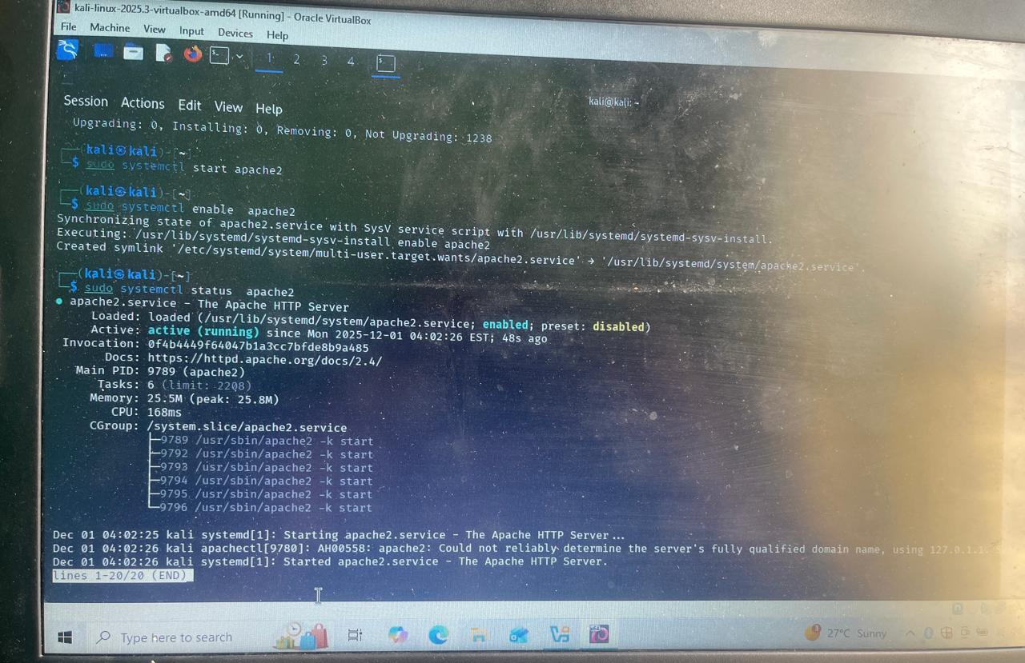

Step 2 – Host Your Own HTML Webpage
1. Navigate to web root:
cd /var/www/html/
2. Backup or remove default index:
sudo mv index.html index.html.bak
3. Create a new index.html:
sudo nano /var/www/html/index.html
Example HTML content:
<!DOCTYPE html>
<html>
<head><title>Welcome</title></head>
<body>
<h1>Welcome to my Apache server</h1>
<p>Hosted by: __________________</p>
</body>
</html>

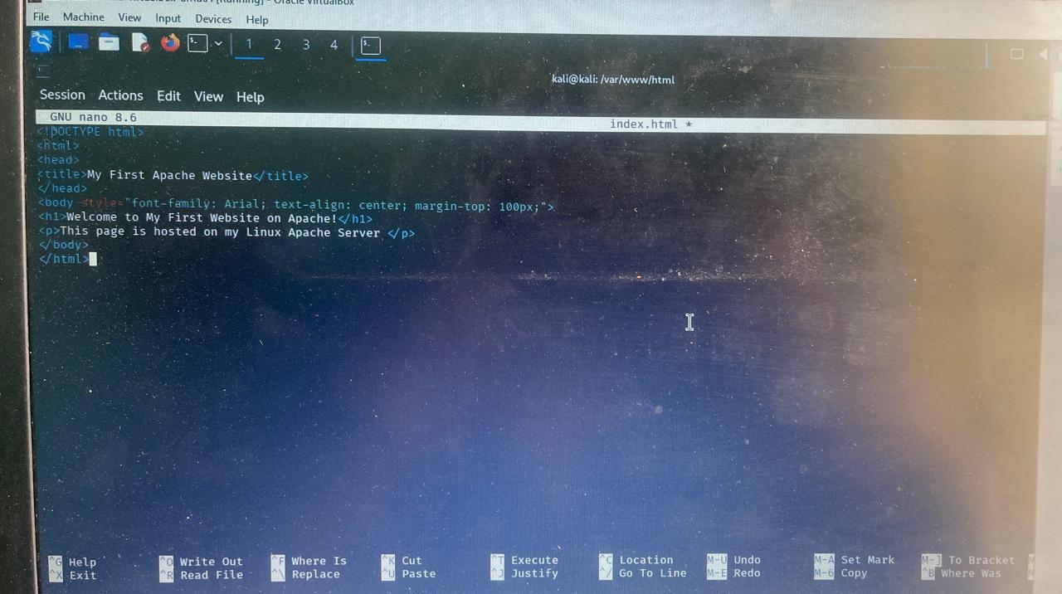

Step 3 – Access Website From Another System
- Find server IP address (example):
ipconfig or ip a
2. From another device on the same network open:
http://<server-ip>/
3. Confirm the page loads and take screenshot.

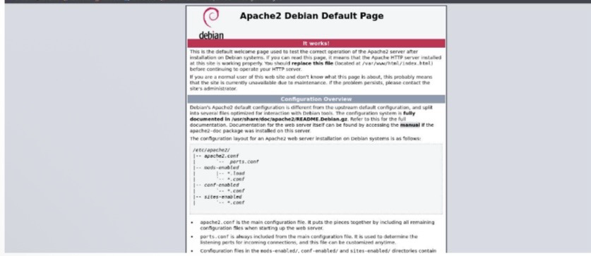
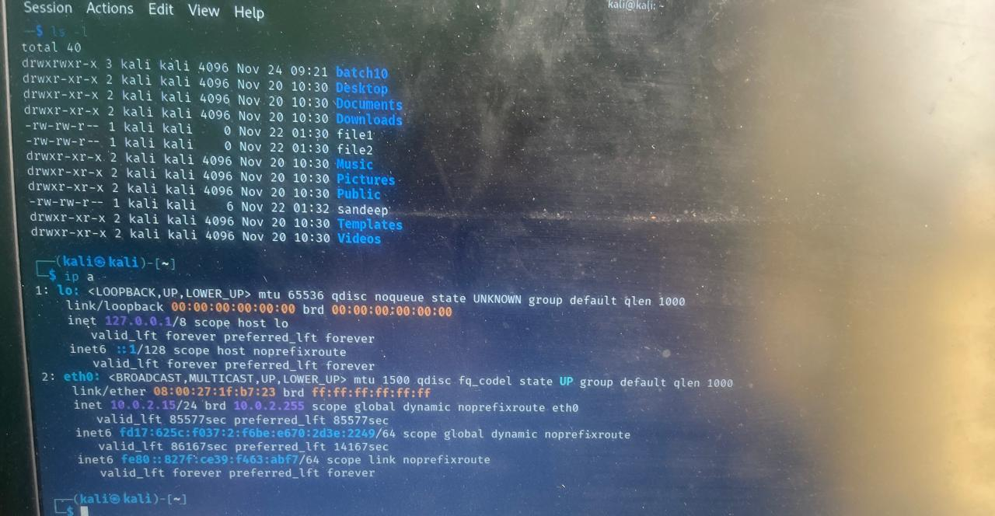

Step 4 – View Apache Access Logs
- Logs location:
/var/log/apache2/
2. Open access log:
sudo less /var/log/apache2/access.log
3. Observe entries that record client IP, timestamp, request method, resource, response code, and user-agent.
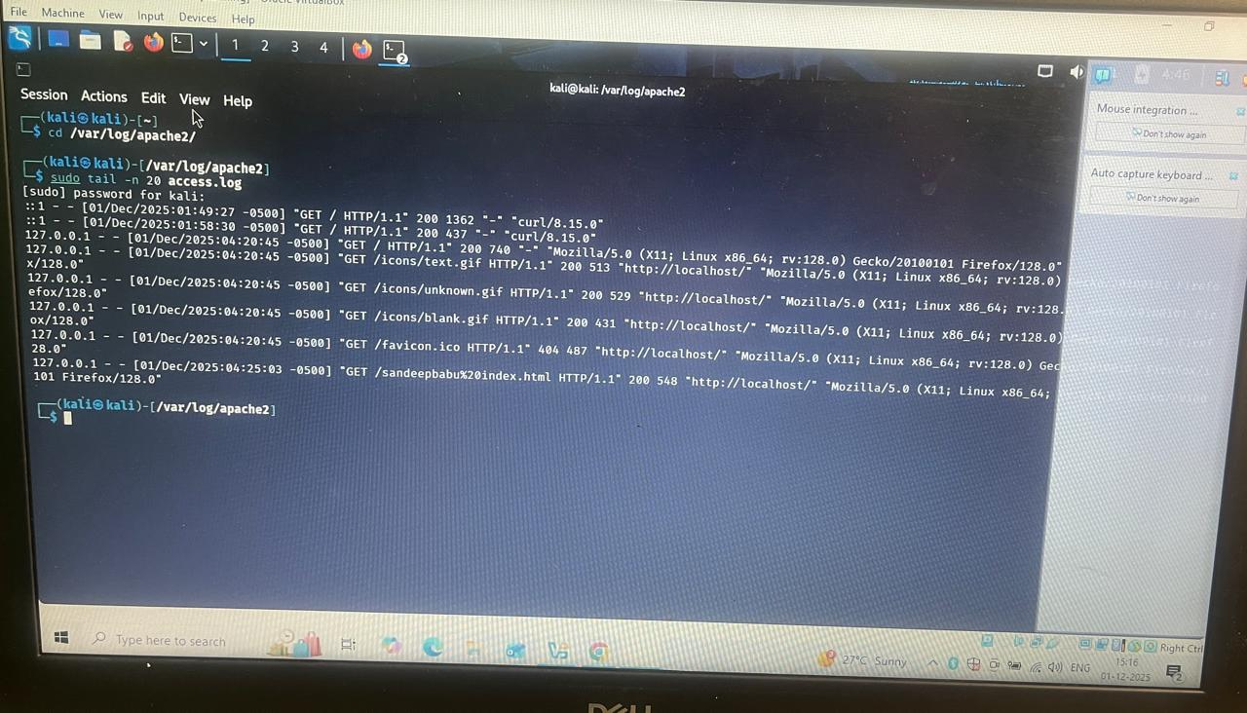

Step 5 – Configure Firewall (UFW)
- Check UFW status:
sudo ufw status numbered
2. Allow a specific IP (replace <IP_TO_ALLOW>):
sudo ufw allow from <IP_TO_ALLOW> to any port 80
3. Deny a specific IP (replace <IP_TO_DENY>):
sudo ufw deny from <IP_TO_DENY> to any port 80
4. Reload / verify rules:
sudo ufw reload
sudo ufw status numbered
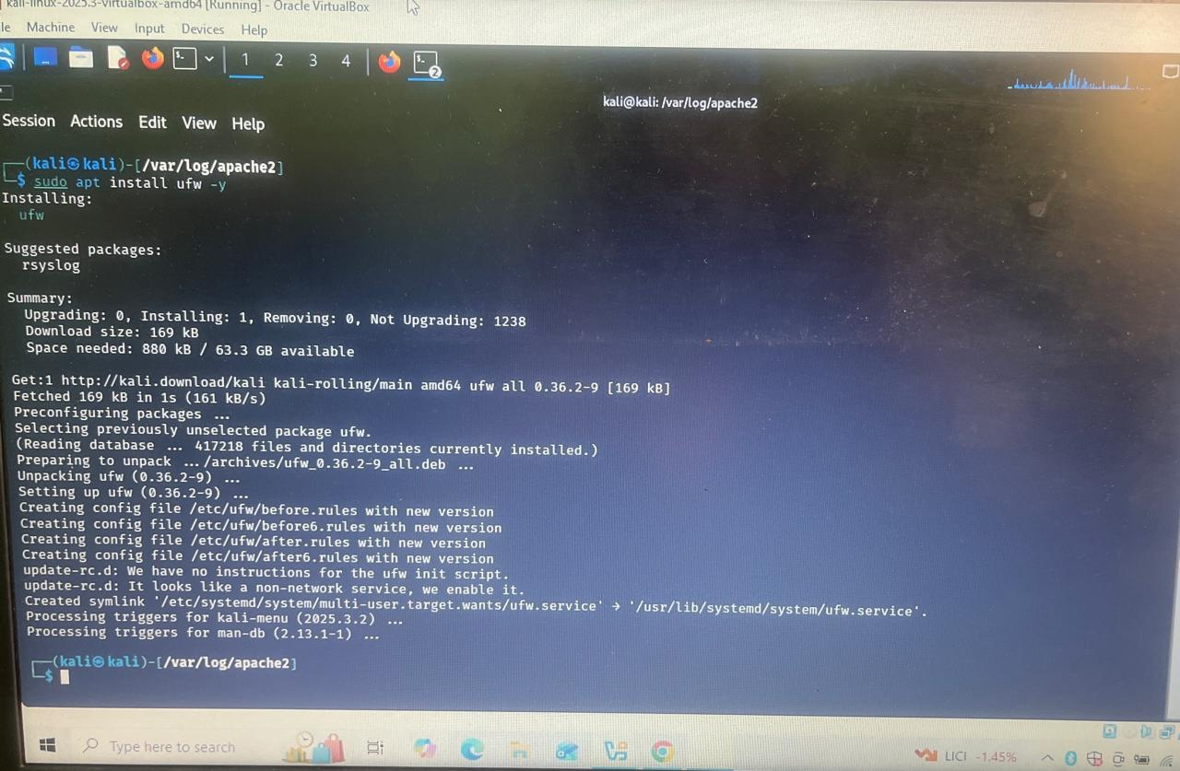

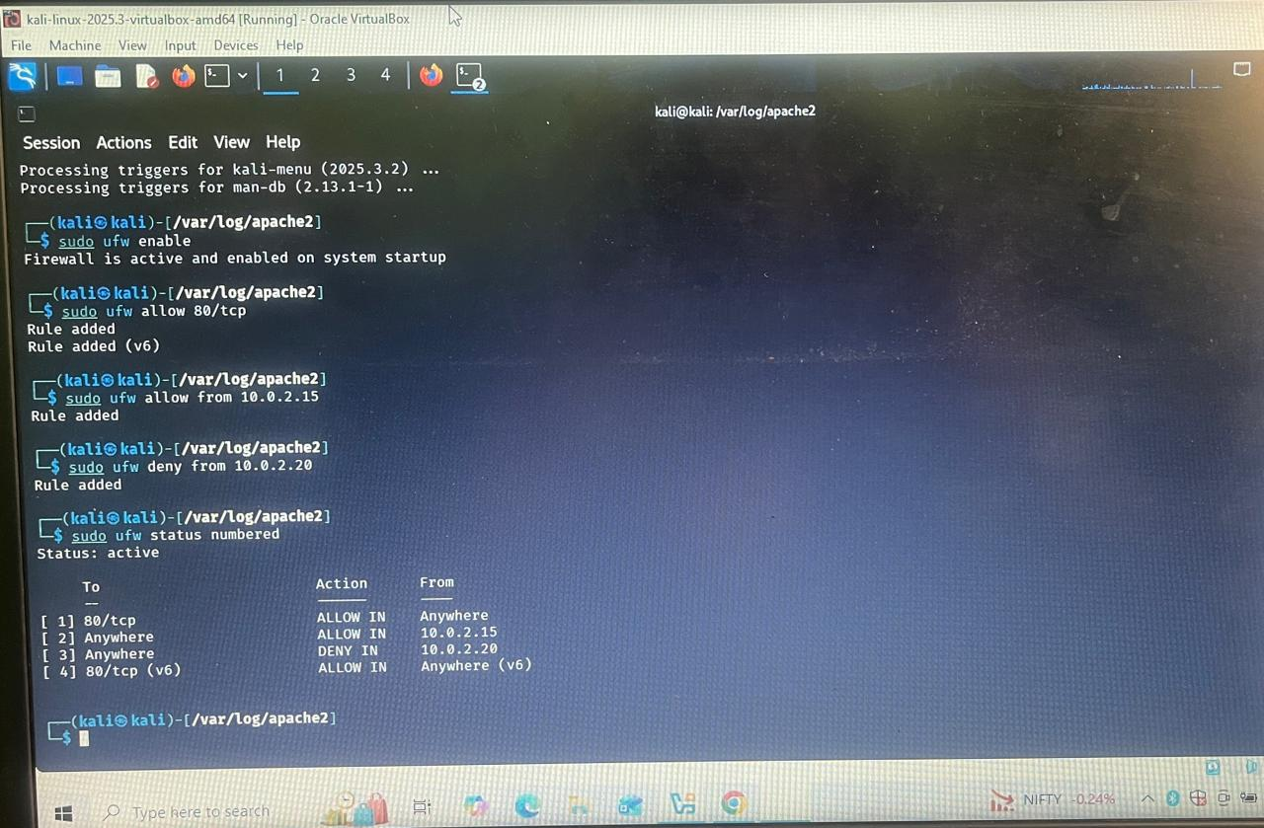

Inshot:

Web servers respond to HTTP requests and serve web content to clients on a network. Hosting a webpage requires placing the site files in the web root (e.g., /var/www/html/) and ensuring the web server is running. Access logs record client IPs, requests, timestamps and response codes which are useful for debugging and analytics. Firewalls (UFW) allow administrators to restrict or permit access to services by IP and port, improving security. By completing this project, you learn practical server setup, basic site deployment, simple access control, and log inspection.
5. Conclusion
This project demonstrated the end-to-end process of setting up an Apache web server, deploying a simple webpage, accessing it from another machine, monitoring logs, and enforcing firewall rules. These fundamentals are essential for managing web services and maintaining network security.
Prepared by : Mentimi sandeep babu
Date: 02/12/2025

