Install firewall

Install Maria db

Configure Maria db

Start Mariadb

Configure firewall

Configure database

Load data

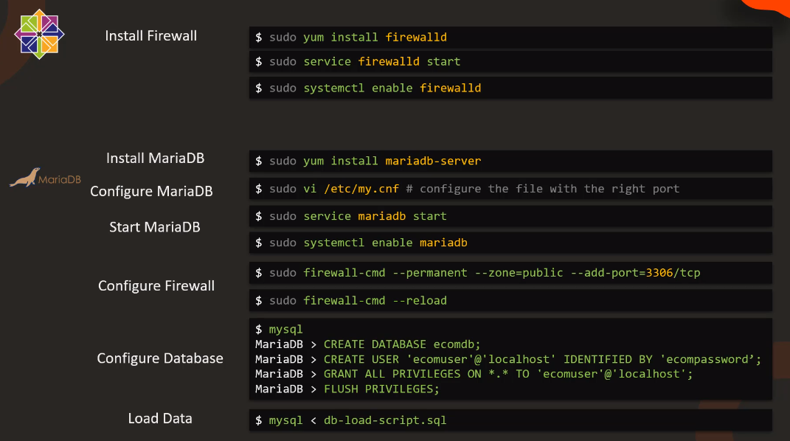

Install httpd

Install php

Configure firewall

Configure httpd

Start httpd

Download Code

Test

