1. **Introduction**

**So you’re a believer.**

You believe there are profits to be made in stocks. You believe you don’t have to pay a high-profile Wall Street banker to make money. You believe the average Joe can earn a healthy fortune using the right system. And you are dead-set on figuring that system out.We agree with you. We believe that with the right tools, anyone can make consistent money in stocks.

And we are going to give you those tools.

**A Simple Toolkit for Reliable Returns**

In this simple-to-follow, eight-page guide, ChartAdvisor introduces you to five of the most powerful, profitable patterns in stocks.

These stock patterns pave the way 10%, 15%, even 20% gains for each winning trade. True, not the 2000% some people are touting. But it’s darn good money, made using an established strategy, and attainable at relatively low risk. It’s realistic money. And you don’t have to trust your hard-earned cash to some broker’s favorite fad.

In the next few pages, you’ll learn all the skills you need to recognize proven money-making stock patterns, and you’ll get to see these patterns in action.

"*I've used a variety of ... systems, and lost 25% of my portfolio over a 2-3 year period crazily trading hundreds of stocks. When I began using ChartAdvisor and sticking to the rules it made all the difference. The stress of watching stocks is gone, I can do my job without constantly worrying, and I've made a 26% return on my portfolio just in the last three months on just a few trades!*"

~ B. Hiebert, Canada

We’ll also introduce you to our ChartAdvisor system – Three Simple Steps to Stock Profits. Whether you decide to continue with ChartAdvisor or not, after reading this guide, you’ll …

**Discover How To:**

1. Identify profitable stock patterns

2. Minimize your risk

3. Maximize your return in up and down markets

**Make money on the stock market**

You’ll learn how to make big money on stocks using a technical analysis toolkit that has been wielded successfully for hundreds of years. That’s no exaggeration.

That makes these patterns some of the most time-tested strategies in finance. You can feel secure that you are trusting your investments to a highly refined system – not a new craze or an analyst’s hunch.

There are hundreds of patterns in stock charts that traders can look for, but at ChartAdvisor, we focus only on the most trusted.

1. **The Symmetrical Triangle**

Profitable Pattern Number One

**The Symmetrical Triangle: A Reliable Workhorse**

You’ll recognize the symmetrical triangle pattern when you see a stock’s price vacillating up and down and converging towards a single point. Its back and forth oscillations will become smaller and smaller until the stock reaches a critical price, breaks out of the pattern, and moves drastically up or down.

The symmetrical triangle pattern is formed when investors are unsure of a stock’s value. Once the pattern is broken, investors jump on the bandwagon, shooting the stock price north or south.

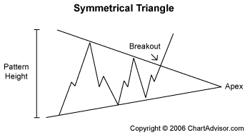

Symmetrical Triangle Pattern

To form your symmetrical triangle pattern, draw two converging trendlines that bound the high and low prices. Your trendlines should form (you guessed it) a symmetrical triangle, lying on its side.

**How to Profit from Symmetrical Triangles**

Symmetrical triangles are very reliable. You can profit from upwards or downwards breakouts. You’ll learn more about how to earn from downtrends when we talk about maximizing profits.

If you see a symmetrical triangle forming, watch it closely. The sooner you catch the breakout, the more money you stand to make.

Watch For:

* Sideways movement, a period of rest, before the breakout.
* Price of the asset traveling between two converging trendlines.
* Breakout ¾ of the way to the apex.

Set Your Target Price:

As with all patterns, knowing when to get out is as important as knowing when to get in. Your target price is the safest time to sell, even if it looks like the trend may be continuing.

For symmetrical triangles, sell your stock at a target price of:

* Entry price plus the pattern’s height for an upward breakout.
* Entry price minus the pattern’s height for a downward breakout.

**ChartAdvisor Symmetrical Triangles in Action**

ChartAdvisor has a long history of identifying symmetrical triangle patterns. Over the last two and one-half years, ChartAdvisor has brought to its readers over 20 symmetrical triangle patterns. That’s an average of one every month and a half.

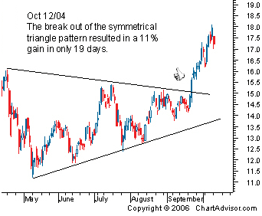

Our readers earned an amazing 40% profit on our Nortel Networks Inc (NT) pick. Those who followed our call on Rochester Medical Corp (ROCM) in September of 2004 earned 15% in 33 days. And in October of 2004, our members earn 11% in 19 days when ChartAdvisor noticed Pan American Silver Corp (PAAS).

Our members earned 11% in 19 days on the PAAS symmetrical triangle pattern.

If you’re not sure you can recognize a symmetrical triangle on your own, be sure to visit ChartAdvisor.com daily for out Charts of the Day.

1. **Ascending/Descending Triangle**

Pattern Number Two

**Ascending and Descending Triangles: The Traditional Bull and Bear**

When you notice a stock has a series of increasing troughs and the price is unable to break through a price barrier, chances are you are witnessing the birth of an ascending triangle pattern.

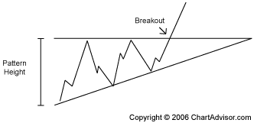

Ascending Triangle Pattern

Confirm your ascending triangle pattern by drawing a horizontal line tracing the upper price barrier and a diagonal line tracing the series of ascending troughs.

The descending triangle is the bearish counterpart to the ascending triangle.

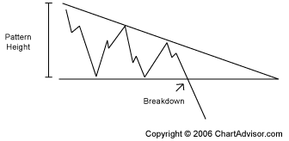

Descending Triangle Pattern

Confirm your descending triangle by drawing a horizontal line tracing the lower price barrier and a diagonal line tracing the series of descending troughs.

The ascending and descending patterns indicate a stock is increasing or decreasing in demand. The stock meets a level of support or resistance (the horizontal trendline) several times before breaking out and continuing in the direction of the developing up or down pattern.

**How to Profit from Ascending and Descending Triangles**

Ascending and descending triangles are short-term investor favorites, because the trends allow short-term traders to earn from the same sharp price increase that long-term investors have been waiting for. Rather than holding on to a stock for months or years before you finally see a big payday, you can buy and hold for only a period of days and reap in the same monster returns as the long-time stock owners.

As with many of our favorite patterns, when you learn to identify ascending and descending triangles, you can profit from upwards or downwards breakouts. That way, you’ll earn a healthy profit regardless of where the market is going.

Watch For:

* An ascending or descending pattern forming over three to four weeks.

Set Your Target Price:

For ascending and descending triangles, sell your stock at a target price of:

* Entry price plus the pattern’s height for an upward breakout.
* Entry price minus the pattern’s height for a downward breakout.

**ChartAdvisor Ascending and Descending Triangles in Action**

Ascending and descending triangles are some of our most popular patterns, because their features are so clear and the breakouts are almost always fast and furious.

Flanders Corp (FLDR) earned our readers 28% in 18 days. Dominos Pizza (DPZ) jumped 12% in 20 days after we pinpointed the breakout point on June 13, 2005.

Another of our winning picks in 2005, Dril-Quip Inc (DRQ) jumped 12% in just 6 days. On Boyd Gaming (BYD), investors following our pick earned a whopping 29% in 35 days.

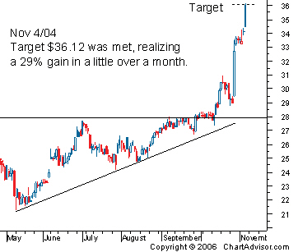

Our readers earned 29% in 35 days on the BYD ascending triangle pattern.

As a ChartAdvisor regular you would have reaped incredible profits on the 60 ascending and descending triangle picks we’ve made since our program’s beginning.

We features an average of two of these cash cows per month, making them one of the most prevalent and predictable patterns in your toolbox.

1. **Head and Shoulders**

Profitable Pattern Number Three

**Head and Shoulders: A ChartAdvisor Staple**

The head and shoulders pattern is a prevailing pattern among short sellers, investors who profit from downtrends. After three peaks, the stock plummets, offering a textbook, high-return opportunity to traders who catch the trend early.

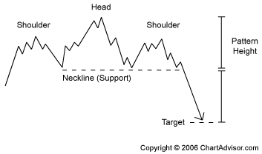

Head and Shoulders Pattern

Head and shoulder patterns are characterized by a large peak bordered on either side by two smaller peaks. Draw one trendline, called the neckline, connecting the bottom of the two troughs.

The first trough is a signal that buying demand is starting to weaken. Investors who believe the stock is undervalued respond with a buying frenzy, followed by a flood of selling when traders fear the stock has run too high. This decline is followed by another buying streak which fizzles out early. Finally, the stock declines to its true worth below the original price.

**How to Profit from the Head and Shoulders Pattern**

* Short sell as soon as the price moves below the neckline after the descent from the right shoulder.

**Set Your Target Price:**

For the head and shoulders pattern, buy shares at a target price of:

* Entry price minus the pattern’s height (distance from the top of the head to the neckline).

**ChartAdvisor Head and Shoulders Pattern in Action**

Profiting from a downtrend can seem counterintuitive at first, but ChartAdvisor.com readers soon learn the benefits of being able to profit in up OR down markets.

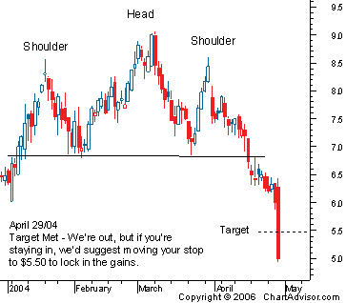

This head and shoulders pattern on PAWC shot up an astonishing 27% in just 33 days.

1. **Double/Triple - Bottom/Top**

Profitable Patterns Number Four and Five

**Triple and Double Bottoms and Tops: Reversals upon reversals**

When you see a W or M pattern forming, you may have just discovered a money-making double bottom or double top pattern. These patterns are common reversal patterns used to suggest the current stock trend may be likely to shift.

But don’t panic if your double bottom or double top patterns do not develop as you had originally thought. You haven’t lost your chance for cash. If your W or M pattern reverses for a fourth time, you could now be working with the profitable triple bottom or triple top.

**Double Bottom Pattern**

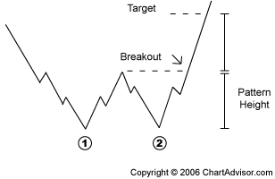

Double Bottom Pattern

A small peak is surrounded by two equal troughs.

Purchase When:

* The price exceeds the middle-peak price.

Watch For:

* A price increase of 10% to 20% from the first trough to the middle peak.
* Two equal lows, not to differ by more than 3% or 4%.

Set Your Target Price:

For the double bottom pattern, sell your stock at a target price of:

* Entry price plus the pattern’s height (distance from the peak to the bottom of the lowest trough).

**Double Top Pattern**

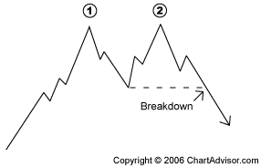

Double Top Pattern

A small trough is surrounded by two equal peaks.

Short Sell When:

* The price drops below the middle-trough price.

Watch For:

* A price decrease of 10% to 20% from the first peak to the middle trough.
* Two equal highs, not to differ by more than 3% or 4%.

Set Your Target Price:

For the double top pattern, buy shares at a target price of:

* Entry price minus the pattern’s height (distance from the trough to the top of the highest peak).

**Triple Bottom Pattern**

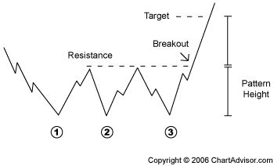

Triple Bottom Pattern

Three equal troughs amid a series of peaks.

Purchase When:

* The price exceeds the resistance established by the prior peaks.

Watch For:

* A series of three identical troughs at the end of a prolonged downtrend.

Set Your Target Price:

For triple bottom patterns, sell your stock at a target price of:

* Entry price plus the pattern’s height (distance from the resistance to the bottom of the lowest trough).

**Triple Top Pattern**

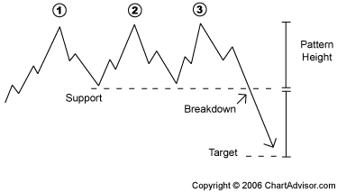

Triple Top Pattern

Three equal peaks amid a series of troughs.

Purchase When:

* The price falls below the support that formed from the prior troughs.

Watch For:

* A series of three peaks at relatively the same level.

Set Your Target Price:

For triple top patterns, buy shares at a target price of:

* Entry price minus the pattern’s height (distance from the support to the top of the highest peak).

**Now You Know**

The five most profitable stock patterns:

* symmetrical triangle
* ascending and descending triangles
* head and shoulders
* double top and double bottom
* triple top and triple bottom

You’re halfway through your ChartAdvisor toolbox. But you still need a couple more nuts and bolts to ensure high-dollar profits in the market. Before you’re ready to invest, you’ll want to learn how best to cut your losses and maximize your returns.

**6. Minimizing Risk**

**How to Minimize Your Risk**

No investment advisor likes to admit it, but no stock picking system is perfect. Sometimes, the stocks we think will explode, don’t. Sometimes, the stocks we feature lose money.

There may not be a foolproof system to predicting the stock market, but we do have a foolproof system for managing risk. ChartAdvisor follows one of the safest risk reduction systems available.

Using these three simple steps, you can reduce the risk in your stock picking plan:

**Three Ways to Take Risk Out of the Stock Market**

1. **Screen Your Picks.**

This might seem obvious, but patterns that look like they are developing into predictable trends do not always follow through. After combing over thousands of stock charts a day, ChartAdvisor will often not fetures a single stock.

1. **Get In. Get Out.**

ChartAdvisor preaches setting realistic target exit prices for all stocks. We lock in high returns while the stock is high, and we get out before the market has a chance to change its mind.

1. **Set Tight Stop Losses.**

This step is absolutely critical to minimizing your risk in the stock market. If a sure-fire winner turns out to be a fizzled-out dud, your system needs to have a built-in, abandon-ship trigger. That is, you need to know when to cut your losses and move on to brighter prospects.

ChartAdvisor sets its stop-loss trigger around 3%. So if a trade starts to go sour, you will almost never lose more than 3% of your investment.

“*I am glad I took a second look at ChartAdvisor. I keyed in your data from the 2nd of Feb 04 into a spread sheet with 20% of capital allocated to each symbol and came up with the 38% annualized return which is better than a poke-in-the-eye-with-a-sharp-stick, considering "the market" has been a sideways affair since the starting date.*

*What I must mention is how inspired and relaxed I am after an in-depth study of your real trading account making that amount of return... I can more fully appreciate the much-lectured "cut your losses short now", seeing just how early it pays to get out when the trade goes against you, rather than the "give-it-room" systems I have tried.*"

-P. Cameron, New Zealand

**7. Maximizing Profit**

**How to Maximize Your Return In Up or Down Markets**

Remember at the beginning of this report when we said we’d show you the Three Simple Steps to Stock Profits?

We already learned about step one: picking profitable stock patterns. We’ve also covered step two: minimizing your risk. Now we’ve come to the final step that makes the ChartAdvior system so unique: how to profit from stocks, even when the stock goes down.

It’s a common misconception that traders can only make money when the price of a stock rises.

*Investors can make money anytime they can predict a stock’s future movement – up or down.*

**It’s time to learn about short selling.**

Short selling is the secret to making cash in a down market. Here’s how it works:

1. **Identify a stock pattern that suggests a stock is headed down.**

Example: The Cleveland Cliffs descending triangle pattern in April of 2005 was perfect for short selling.

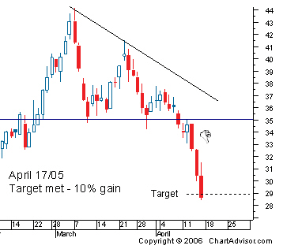

1. **Borrow shares of the soon-to-decline stock from your brokerage.**

Example: Let’s say, right before the Cleveland Cliffs pattern (above) breaks out and moves downwards, you borrow 100 shares of the stock.

1. **Immediately sell these borrowed shares.**

Example: You immediately sell these borrowed shares of Cleveland Cliffs at the price just below the support line: $70 per share, 100 shares = $7,000. You are now sitting on $7,000. But, of course, you still owe the brokerage 100 shares, which you don’t currently have anymore.

1. **Wait for the stock to drop to your target price.**

Example: You wait for the stock to reach the target price, which in this example, is $63 per share.

1. **Buy the shares at the target price.**

Example: You use the $7,000 you made earlier to purchase 100 shares at $63 per share. That costs you $6,300 dollars and leaves you with an extra $700 in your account.

1. **You return the shares to your brokerage.**

Example: Return the 100 shares of Cleveland Cliffs to your brokerage.

1. **Enjoy your profits.**

Example: You earned $700, a 10% profit on $7,000. And even better, you made $700 when the price of CLF declined and all other investors were losing money!

**8. Conclusion**

**Time to Get Started!**

You’re ready. You know everything you need to make big money on stocks, and you can put all of these tools to work now. Start flipping through stock charts, and see if you can identify the right patterns. Then use our easy-to-follow principles of risk management and short selling to ensure you are squeezing the most out of every one of your investment dollars.

Of course, doing this yourself is a lot of work. And you could save dozens of hours a week if you follow the daily updates at Chart Advisor for FREE.

http://www.chartadvisor.com/freereport/report_index.aspx