**INTRODUCTION**

1. **Scrum**: The most popular project management and project development **agile** **methodology**.
2. Three main parts of Scrum - **Principles**, **aspect** and **processes**. – Pri-as-pro
3. Scrum is applicable to
   1. Projects in any industry, of any size or complexity. (From small projects or teams with as few as **six** team members to complex projects up to several hundred team members.)
   2. Products, services or any other results to be delivered to stakeholders.
4. There are **six Scrum principles** which are the foundation on which Scrum framework is based.
5. There are **five scrum aspects -** **organization**, **business justification**, **quality**, **change** and **risk**.
6. There are **19 processes** involved in carrying Scrum project. Theses 19 processes are part of **five** **Scrum phases**: **Initiate**, **Plan and Estimate**, **Implement**, **Review and Retrospect** and **Release**.
7. Each process is associated with input and output and various tools used in each process.
8. Overview of Scrum
   1. Projects are impacted by constraints of time, cost, scope, quality, resource and organizational capabilities which make them difficult to plan, execute, manage, and ultimately succeed.
   2. Therefore it is imp for organization to select and practice appropriate project management methodology.
   3. Key strength of Scrum lies in its use of cross-functional, self-organized and empowered teams who divide their work into short, concentrated work cycles called **Sprints.**
   4. Fig. Scrum flow for one sprint

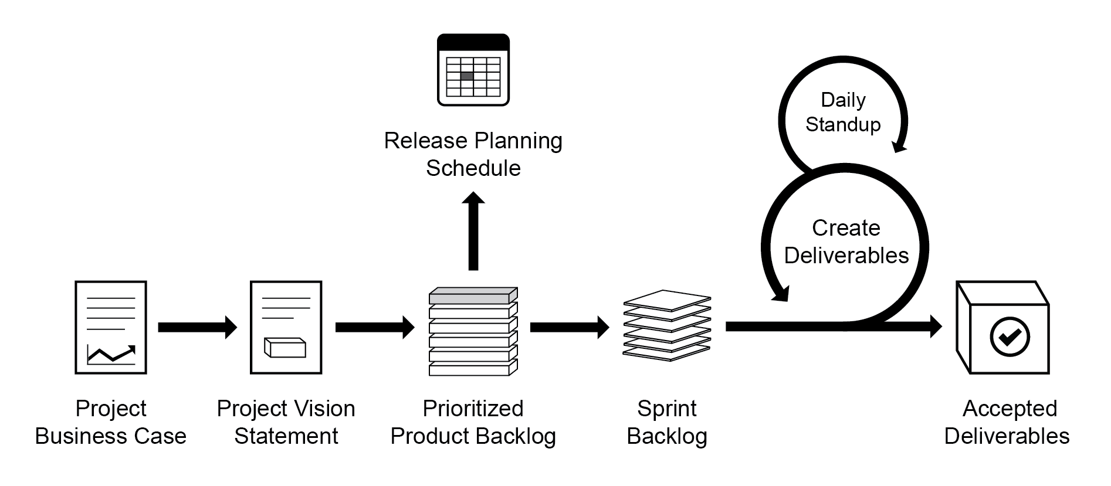

* + 1. Scrum cycle begins with stakeholder meeting, during which **project vision** is created.
    2. The product owner then creates **Prioritized Product Backlog** which contains **prioritized business and project requirements** written in the form of **User Stories**.
    3. Each Sprint begins with **Sprint Planning Meeting** during which high priority User Stories are considered for inclusion in the Sprint.
    4. A Sprint generally last between one and six weeks and involves scrum team working to create shippable **Deliverables** or **product increments**.
    5. During Sprint, short, highly focused **Daily Standup Meetings** are conducted where team members **discuss daily progress**.
    6. Towards end of the Sprint a **Sprint Review Meeting** is held during which the Product Owner and relevant stakeholders are provided **demonstration of Deliverables**.
    7. The Product Owner accepts Deliverables only if they meet the predefined **Acceptance Criteria**.
    8. The Sprint cycle ends with **Retrospect Sprint Meeting** where team discusses ways to improve processes and performance as they move forward into subsequent Sprint.
  1. Brief history of Scrum:
     1. In the mid 80’s, **Hirotaka Takeuchi** and **Ikujiro Nonaka** defined a flexible and all-inclusive product development strategy where the development team works as a unit to reach a common goal. They described an innovative approach to product development that they called a holistic or “rugby” approach, “where a team tries to go the distance as a unit, passing the ball back and forth.”
     2. **Ken Schwaber** and **Jeff Sutherland** elaborated on the Scrum concept and its applicability to software development in a presentation at the Object-Oriented Programming, Systems, Languages & Applications (OOPSLA) conference held in 1995 in Austin, Texas.
  2. Why use Scrum? Some of key benefits of using Scrum
     1. **Adaptability**: Iterative delivery makes project **adaptable and open** to **incorporating changes**.
     2. **Transparency**: All information radiators like a **Scrumboard** and **Sprint Burndown Chart** are shared leading to open work environment.
     3. **Continuous Feedback:** Continuous feedback is provided through the **Conduct Daily Standup** and Demonstrate and Validate Sprint Processes.
     4. **Continuous Improvement:** The **Deliverables** are **improved progressively Sprint by Sprint**, through **Prioritized Product Backlog** processes.
     5. **Continuous delivery of value: Iterative process** enables continuous delivery of value through the Ship Deliverable process as frequently as customer requires.

|  |  |
| --- | --- |
| Scrum | JhombaJhombi, Tussle |
| Manifesto | Jahirmama. व्यक्तीचा अगर पक्षाचा तत्त्वे, धोरण, हेतू इ.स्पष्ट करणारा जाहीरनामा |
| Retrospect | सिंहावलोकन - गतगोष्टींचे अवलोकन किंवा विचार |
| Empirical | प्रायोगिक |
| Adaptability | परिस्थितीशी जुळवून घेतात, Ability to manage with current situation. |
| Aspect | पैलू |