Heaps:

---------

Heap is an almost complete binary tree.

Representation of tree in an array.

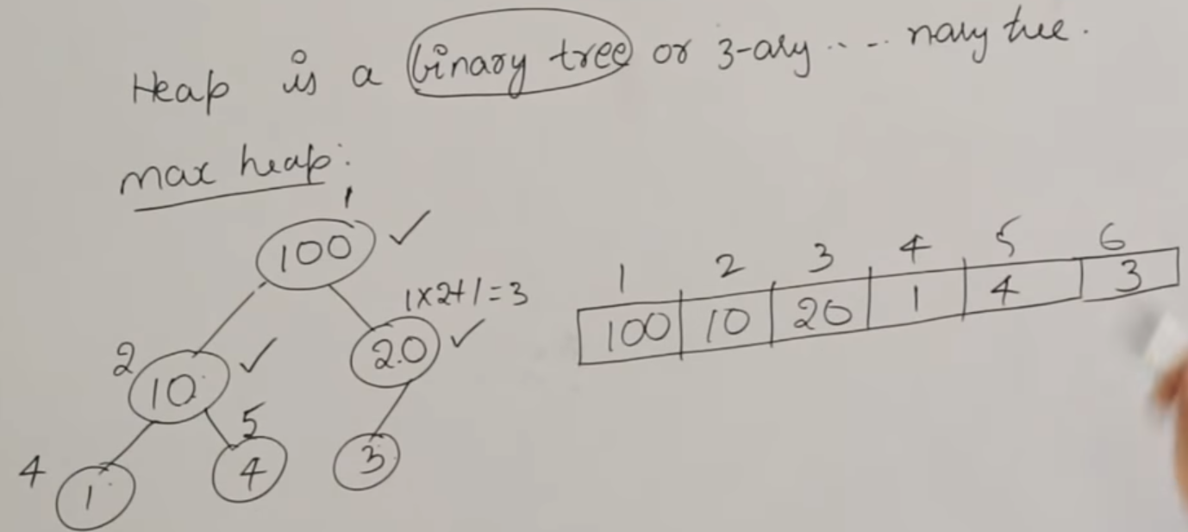

Find out the max heap in the following sequences:

