WorkflowController | Exposes REST APIs to start and manage workflow execution.
WorkflowService | Coordinates workflow requests and converts workflow results into API responses.
WorkflowEngine | Core orchestration engine that executes workflow nodes, handles approvals, retries, rollback, and replanning.
WorkflowContext | Maintains the complete state and information shared across workflow stages.
WorkflowGraph | Defines workflow nodes and their dependencies.
WorkflowGraphNode | Represents an individual node in the workflow graph along with its dependencies.
WorkflowNode | Base abstraction for an executable workflow stage.
WorkflowConfiguration | Creates and wires the workflow graph and workflow engine using Spring configuration.
WorkflowResult | Represents the final result of a workflow execution.
WorkflowCheckpoint | Captures workflow state so it can be restored during rollback.
WorkflowState | Defines the individual stages/states of the workflow.
WorkflowStatus | Defines the lifecycle status such as RUNNING, WAITING_FOR_APPROVAL, COMPLETED, ROLLED_BACK, etc.
WorkflowScenario | Represents GREENFIELD, BROWNFIELD, and AMBIGUOUS requirements.
ApprovalGate | Controls whether human approval is required before sensitive workflow actions.
PolicyGuardrail | Applies execution rules before a workflow stage is allowed to run.
RetryPolicy | Controls the maximum number of retry attempts for failed stages.
SafeStopController | Allows workflow execution to be safely stopped.
WorkflowMetricsService | Tracks workflow execution and reliability metrics.
WorkflowReplanningService | Identifies affected downstream stages and supports dynamic replanning.
RequirementAnalysisNode | Analyzes and classifies the incoming requirement.
TaskDecompositionNode | Converts the requirement into actionable engineering tasks.
ArchitectureNode | Defines the proposed application architecture.
ImplementationNode | Represents the implementation stage of the engineering workflow.
RiskAnalysisNode | Identifies functional, lifecycle, and concurrency risks.
TestingNode | Represents validation and testing of the implementation.
DocumentationNode | Represents preparation of project and technical documentation.
ReleaseReadinessNode | Performs the final release-readiness validation.
UrlController | Provides REST endpoints for URL-shortener operations.
UrlShortenerService | Contains the core URL-shortening business logic.
AnalyticsService | Handles URL access and analytics information.
UrlRepository | Provides storage and retrieval of shortened URLs.
GlobalExceptionHandler | Provides centralized handling of application exceptions and API errors.

Testing:
Create:
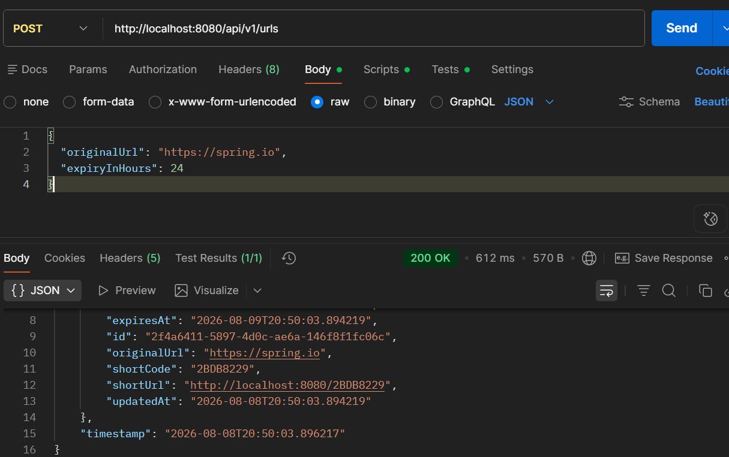
Get url detailes using shortcode
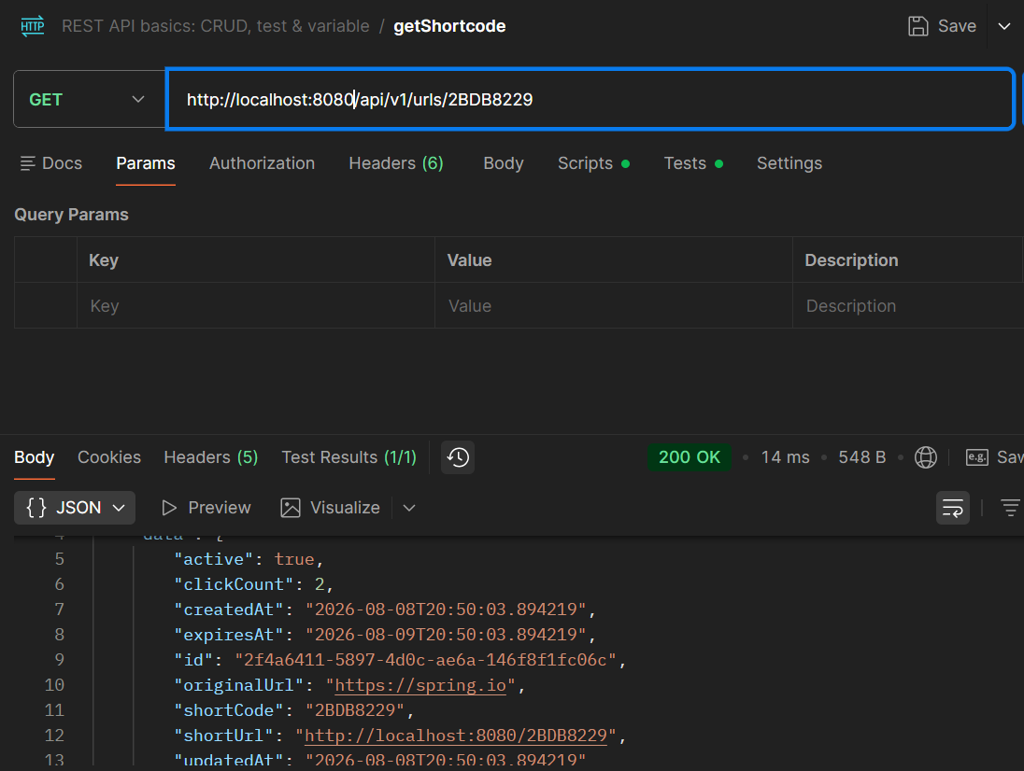
Redirect:
http://localhost:8080/2BDB8229
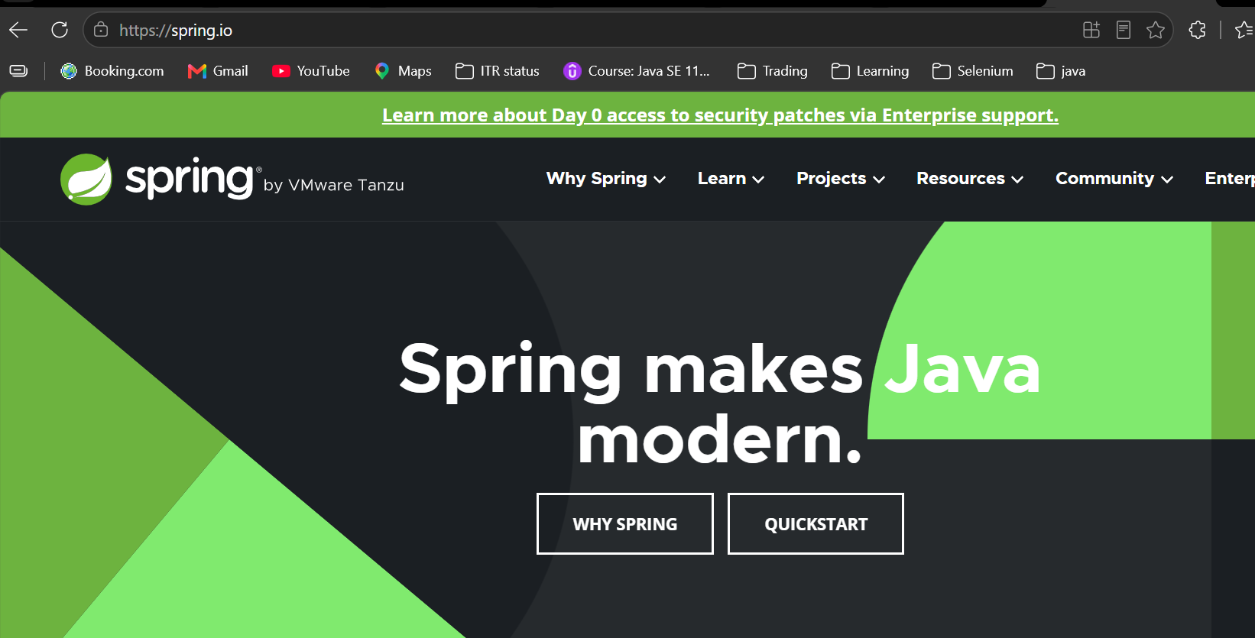
Check analytics:
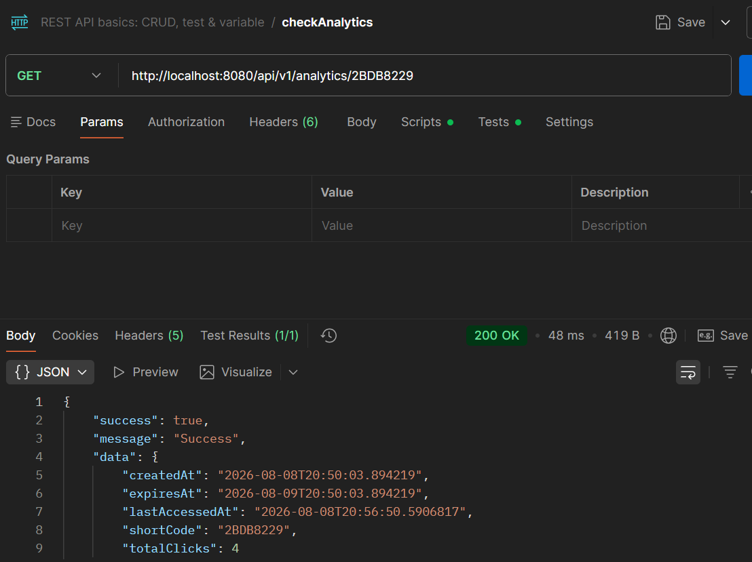
Update:
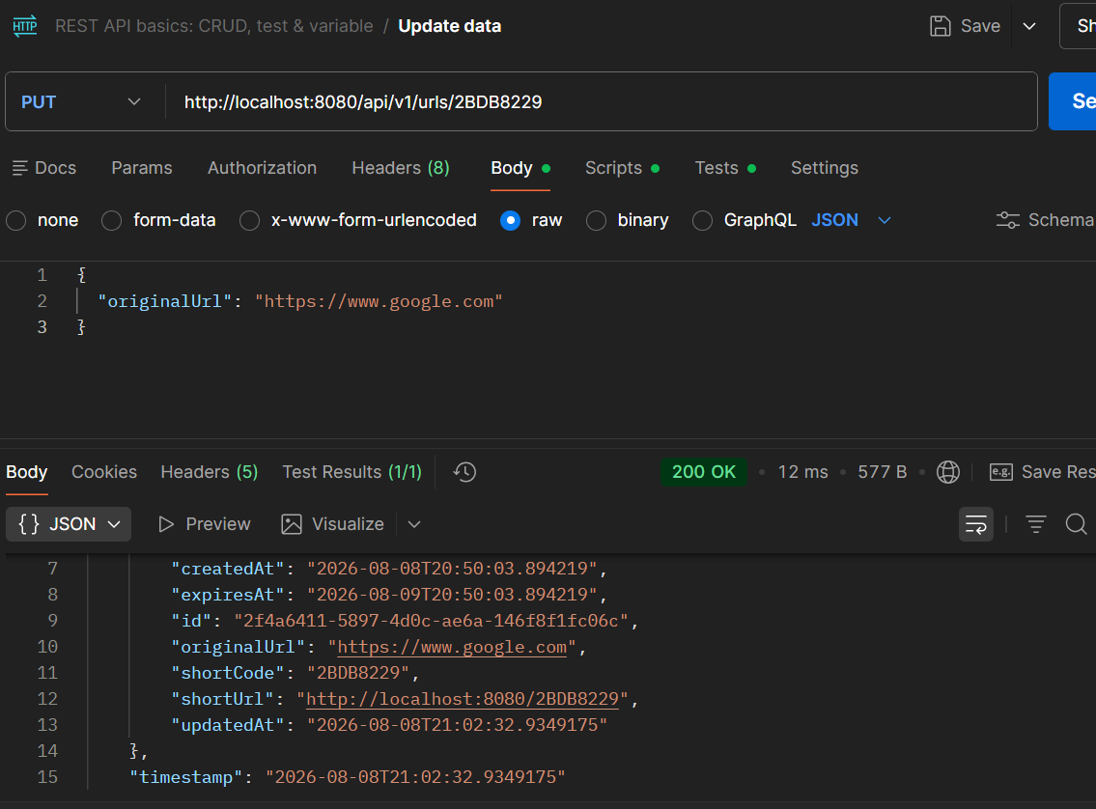
Redirect check:
url: http://localhost:8080/2BDB8229
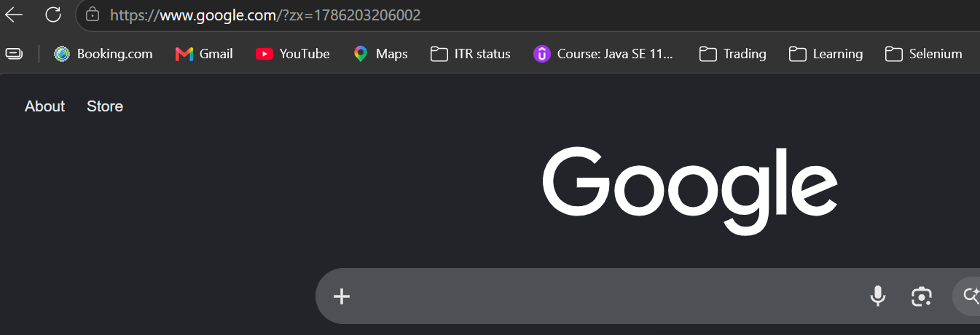
Delete:
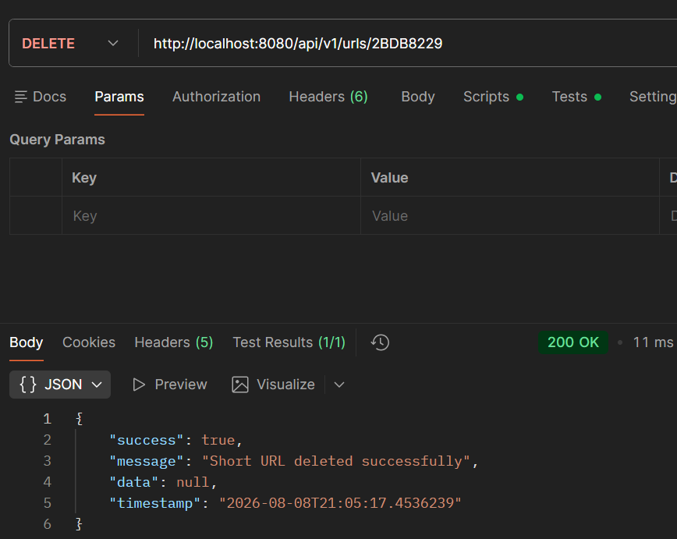
404 exception:
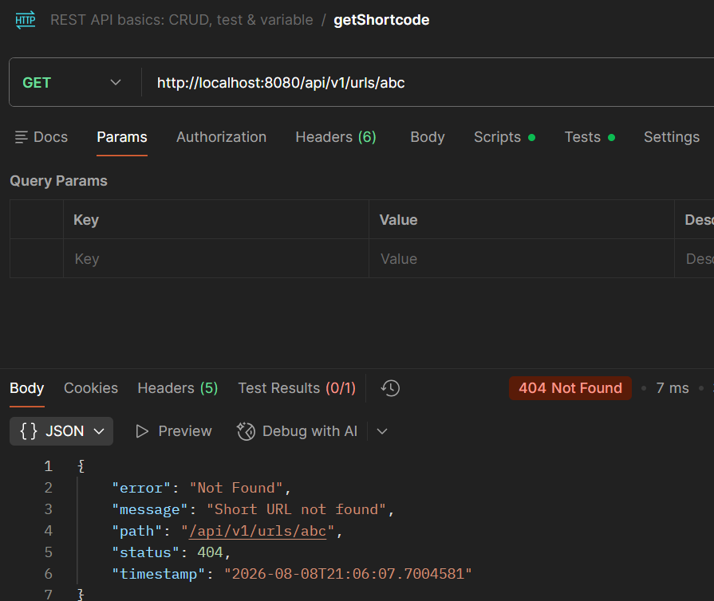
400 exception:
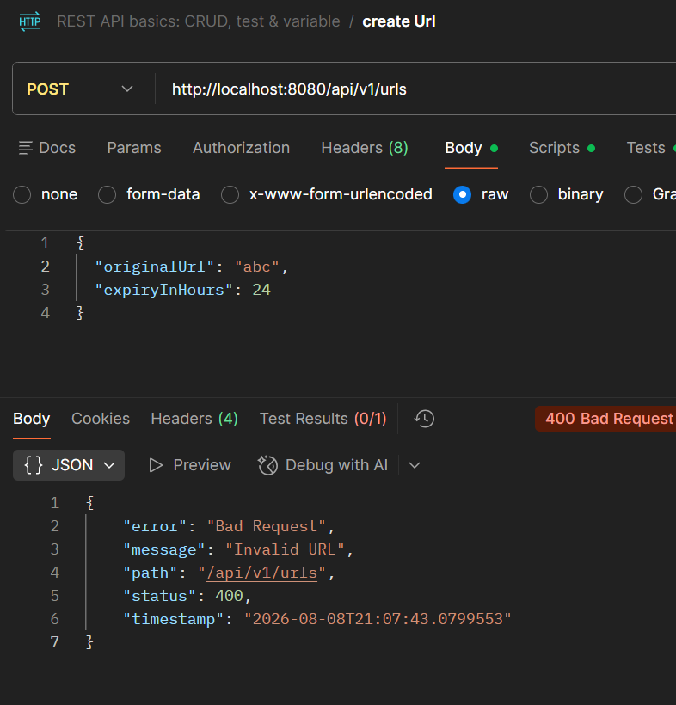
Workflow:
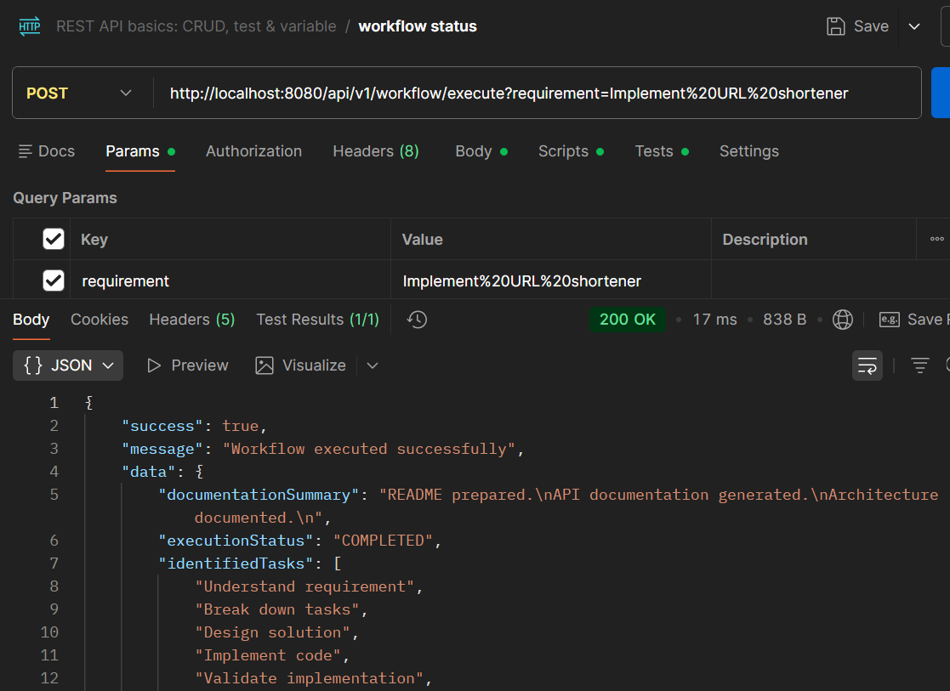

Greenfield Scenario:
Requirement
↓
Task decomposition
↓
Architecture
↓
┌──────────────┬──────────────┐
Implementation Risk Analysis
↓
Testing / Documentation
↓
Release readiness
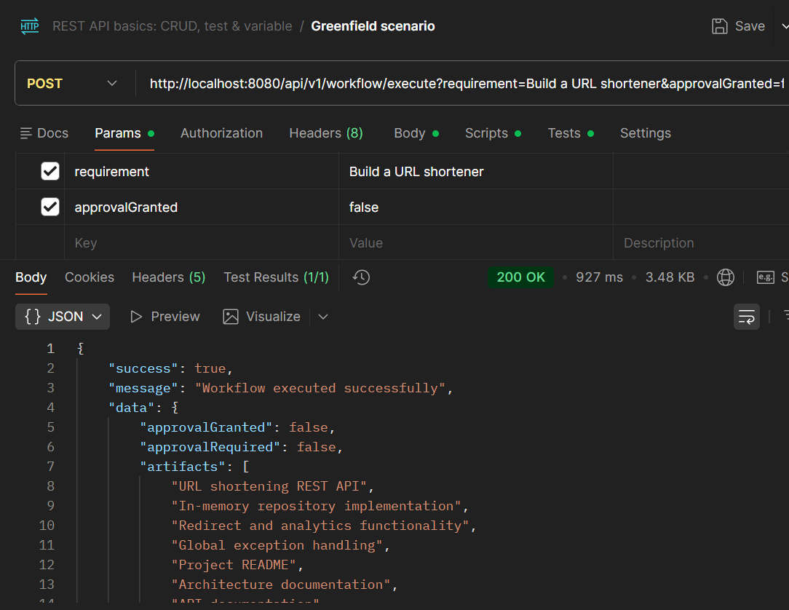
Brownfield scenario without approval:
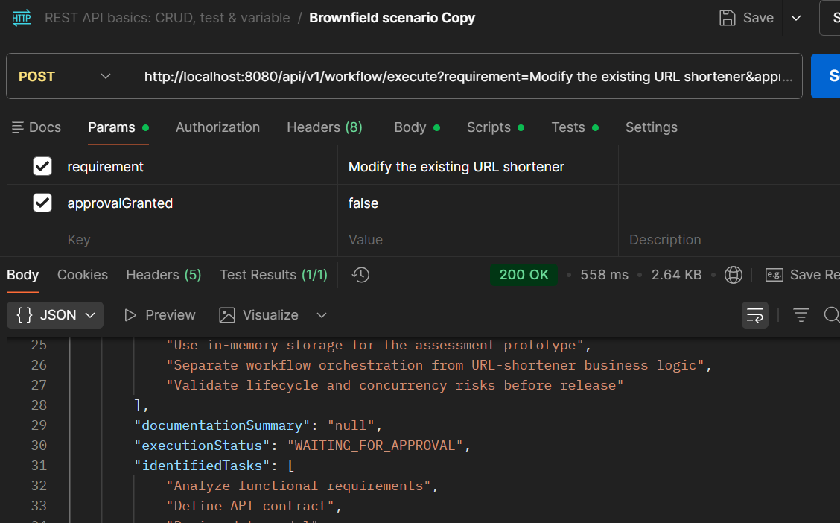
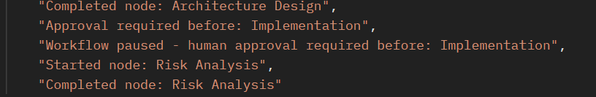
Brownfield with approval scenario:
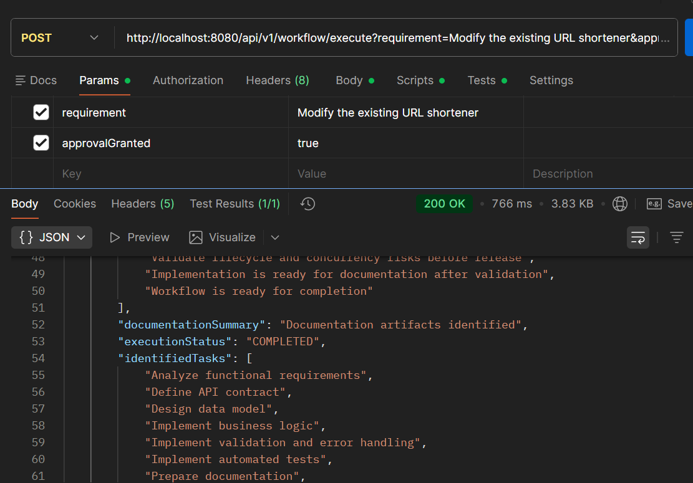
Ambigious scenario without approval:
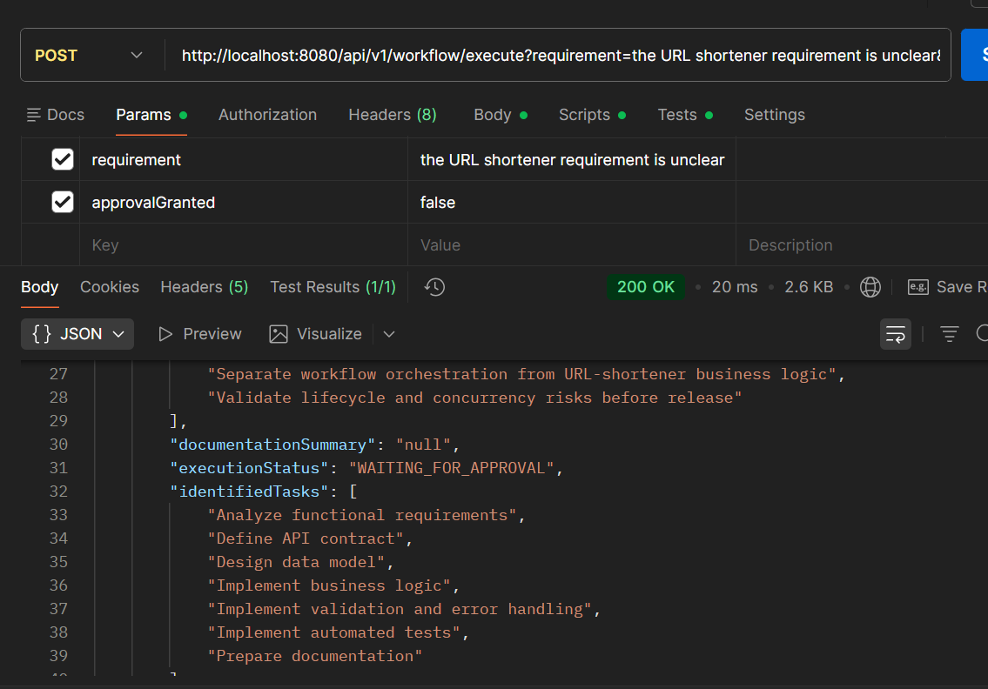
Ambigious scenario with approval:
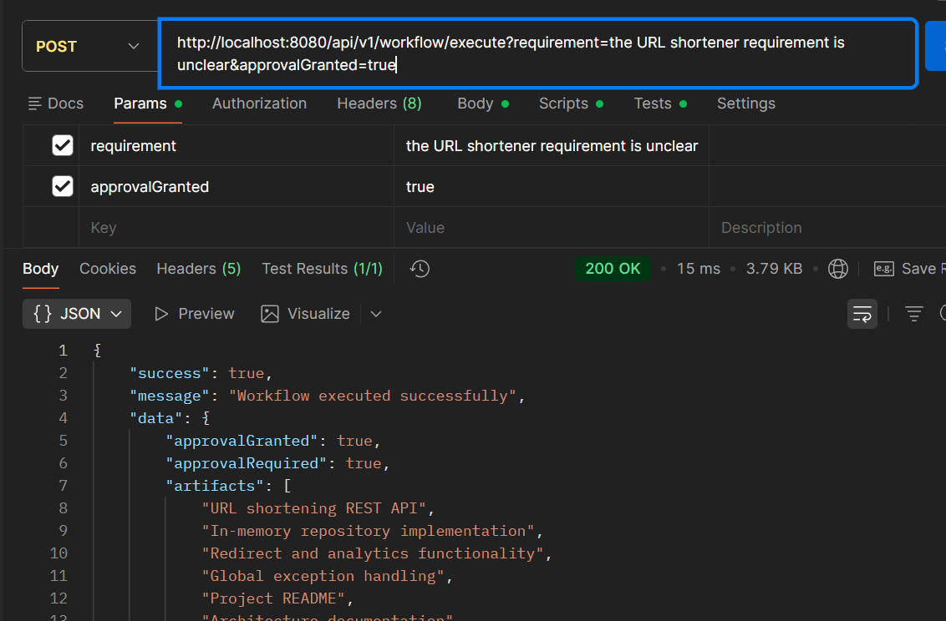
Test invalid empty requirement:
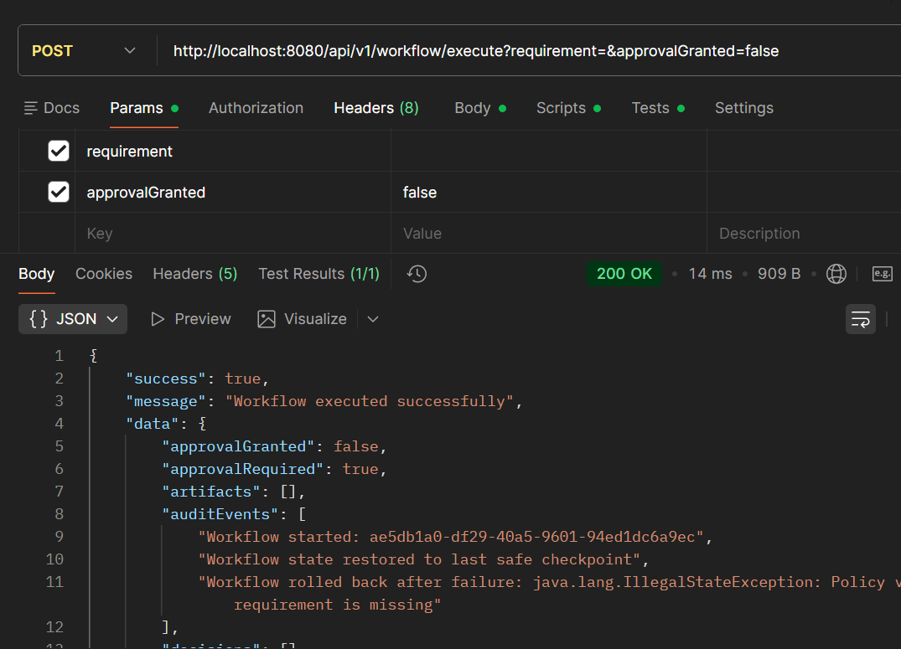
Workflow metrics: after testing greenfield, brownfield with approval and Brownfield without approval scenario. 