- python –version
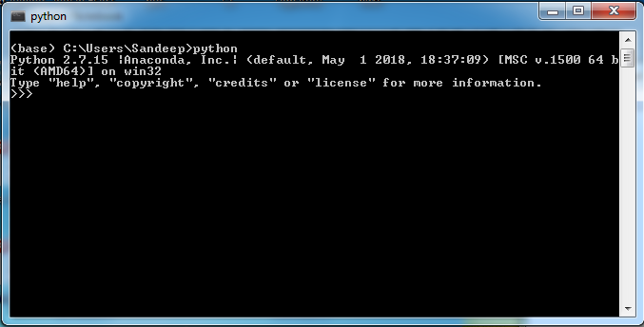
- jupyter tests pages done in the in class notes including the matplotlib
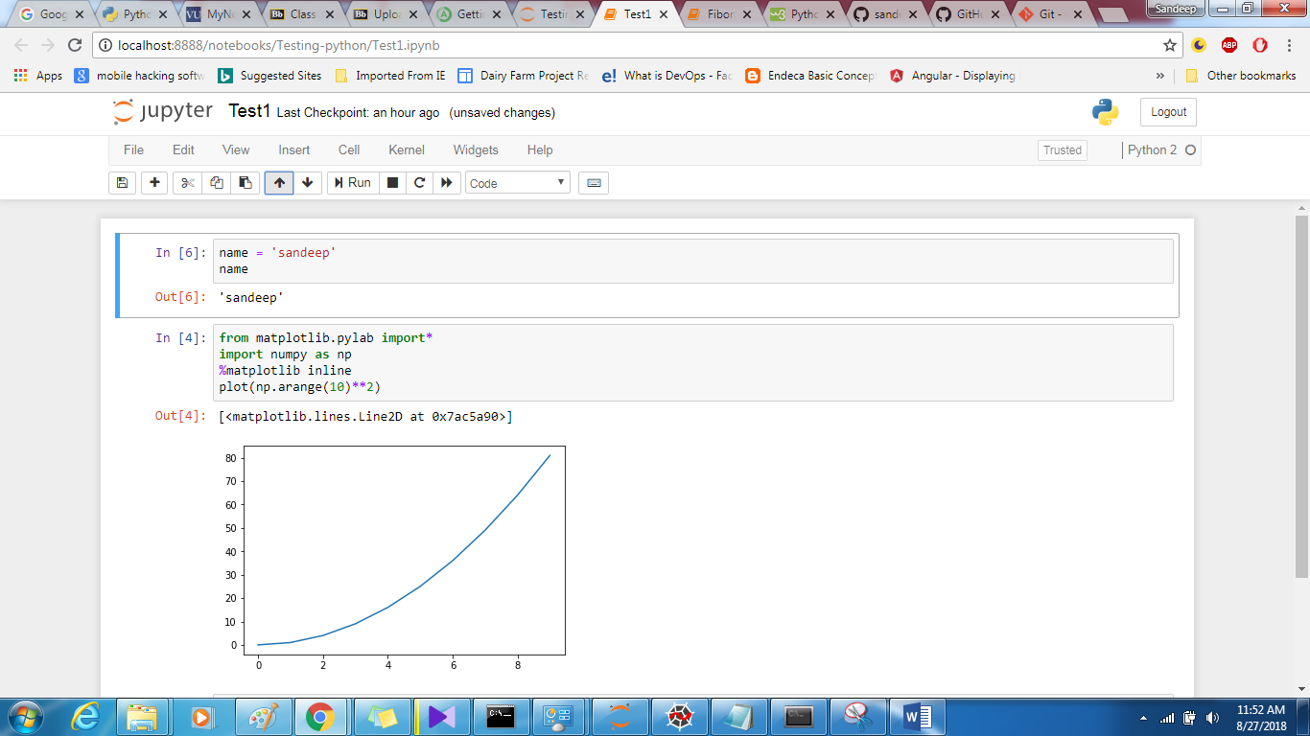

- Spyder test

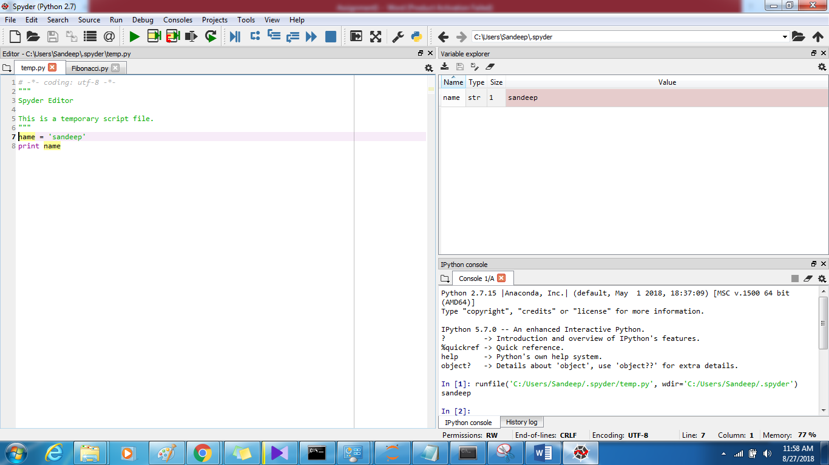

4. Generate the first 10 Fibonacci sequence numbers using a python program ( use a while or for loop ):

- Using Spyder or VScode

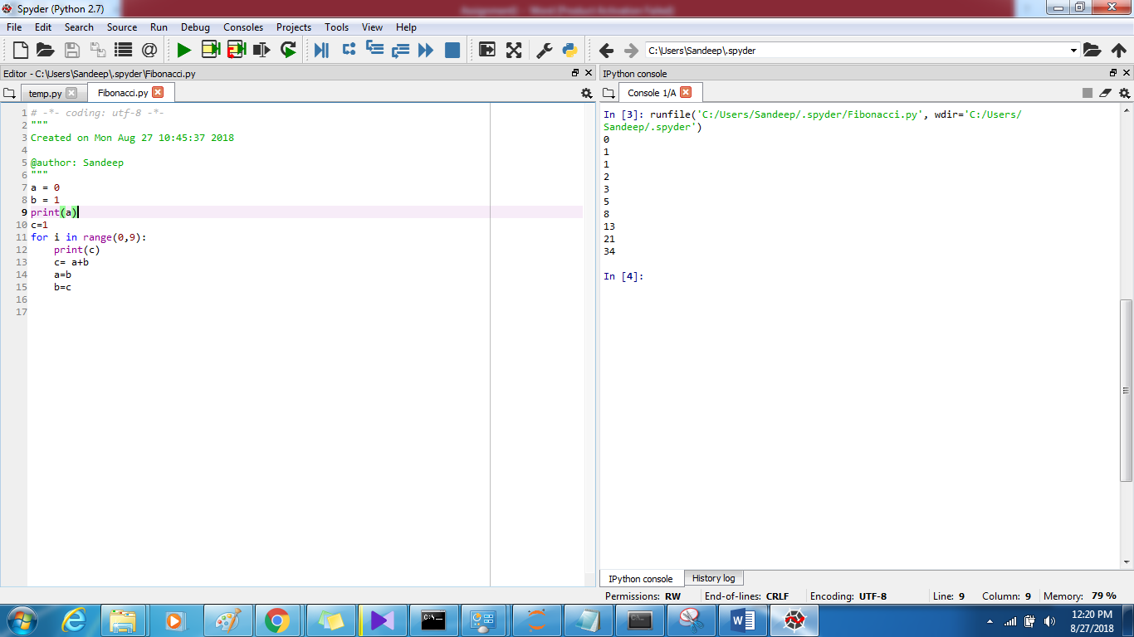

- Using jupyter notebook

