Claude Orchestration Accelerator
Internal Team Guide — Setup, Architecture & Usage
Enterprise Integration & AI Engineering
Version 1.0 | August 2026
Prepared by: Sandeep Pachauri

Table of Contents

1. Overview & Purpose
The Claude Orchestration Accelerator is an internal monorepo that lets engineering teams build Claude-powered pipelines without writing repetitive integration code for every new AI-driven process. It packages four recurring concerns — authentication, structured logging, prompt management, and model routing/fallback — behind a single call, so that building a new AI process becomes a matter of writing configuration (YAML) rather than boilerplate glue code.
It ships as three installable Python packages plus a scaffolding CLI that generates a ready-to-run starter project pre-wired with all dependencies:
- claude-orchestration-accelerator — prompt resolution, process registry, environment resolution, guardrails, MCP scoping, file upload, batch support
- claude-model-router-accelerator (model-router/) — ordered model execution with automatic fallback across pluggable backends
- claude-project-accelerator (project-accelerator/) — the master execute(payload) entry point and the cpa scaffold CLI
It also depends on two pre-existing accelerators from a sibling repository:
- claude-auth-accelerator — resolves credentials (OAuth session vs. API key) per environment
- ClaudeSDKLoggerAccelerator — JSON-line tracing for every model call

1.1 Who This Guide Is For
This guide serves two audiences. Engineers who will build pipelines on top of the accelerator should focus on Sections 4–7 (setup, configuration, sample code). Architects and leads evaluating whether to adopt or extend the accelerator should also read Sections 2–3 (architecture and design rationale).

1.2 Repository Location
Primary repo: https://github.com/sandeeppachauri/claude-orchestration-accelerator
Sibling dependency repo: https://github.com/sandeeppachauri/Accelerators
Default branch: main.

2. Architecture
The accelerator is organized as a layered stack. Caller code never talks to the model SDKs directly — it calls a single execute() function, which delegates to the orchestration layer for configuration/prompt resolution and to the model router for execution against the chosen backend (Claude Agent SDK or the raw Anthropic Messages API).
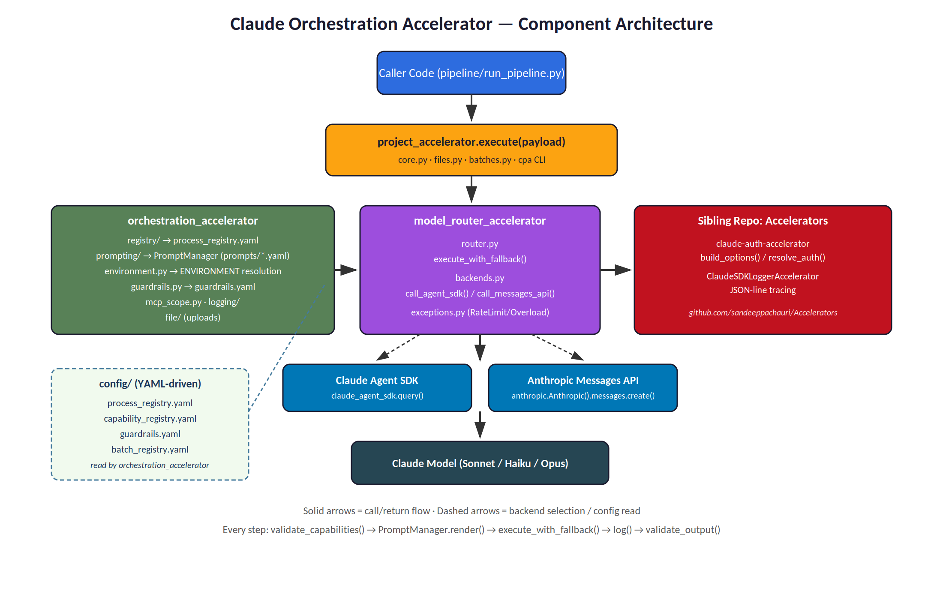
Figure 1 — Component architecture: caller, orchestration layer, model router, and backend/model layer.

2.1 Component Responsibilities
Component | Responsibility
project_accelerator | Master execute(payload) entry point; file upload & batch execution; cpa scaffold CLI
orchestration_accelerator | Process/step registry, prompt rendering & validation, environment resolution, guardrails, MCP scoping, logging wrapper
model_router_accelerator | Ordered model execution with fallback on rate-limit/overload; pluggable backend dispatch
claude-auth-accelerator (sibling) | Resolves credentials per environment — OAuth session (local/dev) or API key (staging/prod)
ClaudeSDKLoggerAccelerator (sibling) | Best-effort JSON-line tracing of every model call

3. End-to-End Execution Flow
Every call to execute() follows the same nine-step sequence, repeated once per step defined in the process. This consistency is what allows new AI processes to be added purely through configuration.
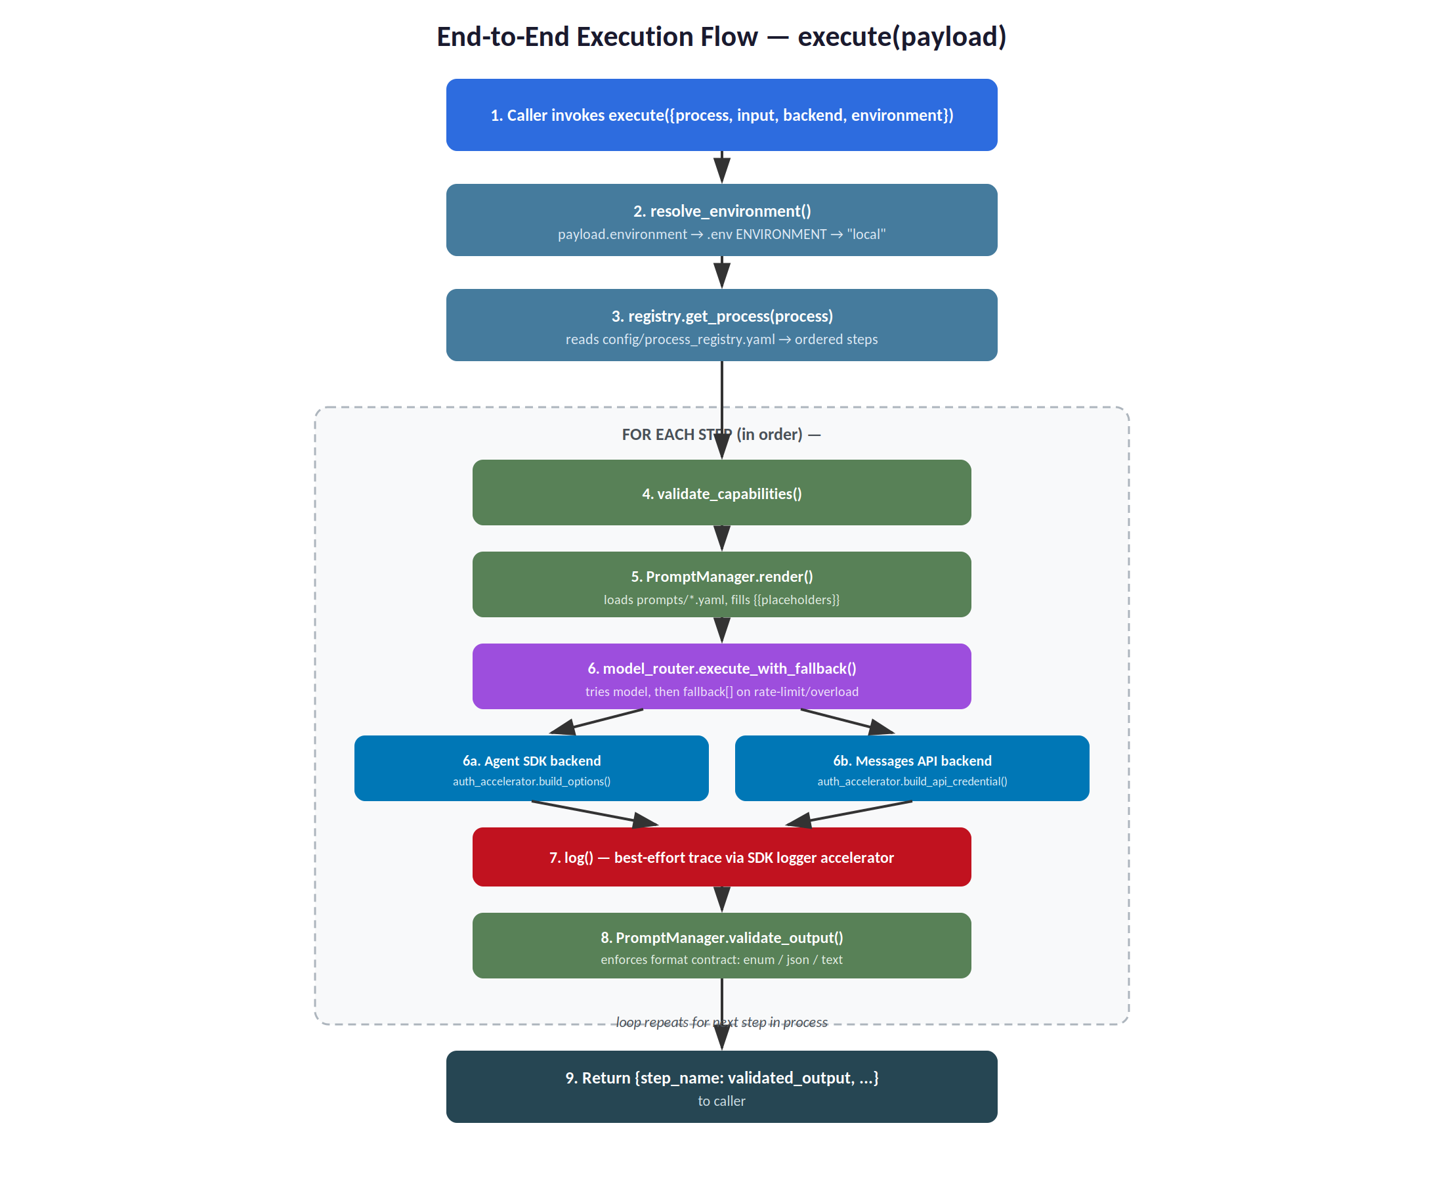
Figure 2 — Execution flow from caller invocation through to validated output.

3.1 Step-by-Step Description
- 1. Caller invokes execute() with a payload containing process, input, backend, and optionally step and environment.
- 2. resolve_environment() determines the active environment: payload value → .env ENVIRONMENT → "local" default.
- 3. registry.get_process() reads config/process_registry.yaml and returns the ordered list of steps for the requested process.
- 4. For each step, validate_capabilities() checks any extra keys against config/capability_registry.yaml's per-backend whitelist, raising UnsupportedCapabilityError early if a key isn't supported by the chosen backend.
- 5. PromptManager.render() loads the step's prompt YAML from prompts/, fills {{placeholder}} tokens from the input dictionary, and returns the system/user prompt content.
- 6. model_router_accelerator.execute_with_fallback() calls the configured model; on a rate-limit or overload error it retries against each entry in the step's fallback list, in order, using either the Agent SDK backend or the Messages API backend.
- 7. log() emits a best-effort JSON-line trace of the call via the SDK logger accelerator.
- 8. PromptManager.validate_output() enforces the step's declared format contract (enum, json, or text).
- 9. Once all steps complete, execute() returns a dictionary mapping each step name to its validated output.
The batch path (execute_batch()) follows a parallel flow: it reads config/batch_registry.yaml to map a batch_id to a (process, step) pair, submits one real Anthropic Message Batches API job (Messages API backend only), polls for completion, and validates each result the same way.

4. Setup & Installation

4.1 Prerequisites
- Python 3.10 or later (developed/tested on 3.14)
- pip
- The sibling Accelerators repo, for local development installs
- An ANTHROPIC_API_KEY, or an active `claude login` session, for making live model calls

4.2 Path A — Full Local Clone (for developing the accelerators)
Use this path if you need to modify the accelerator packages themselves, or want the full test suite available locally.
git clone https://github.com/sandeeppachauri/claude-orchestration-accelerator.git
cd claude-orchestration-accelerator
python -m venv .venv
.venv\Scripts\activate
git clone https://github.com/sandeeppachauri/Accelerators.git ..\Accelerators
pip install -e ..\Accelerators\claude-auth-accelerator
pip install -e ..\Accelerators\ClaudeSDKLoggerAccelerator
pip install -e ".[dev]"
pip install -e "model-router[dev,agent_sdk,messages_api]"
pip install -e "project-accelerator[dev]"
Verify the install:
python -c "import orchestration_accelerator, model_router_accelerator, project_accelerator; print('ok')"
cpa --help
Run the test suite (fully mocked — no credentials required):
pytest . model-router project-accelerator
Expected result: 14 tests pass at the repo root, 10 in model-router, 9 in project-accelerator.

4.3 Path B — Zero-Clone Usage (just scaffold a new pipeline project)
If you only need to start a new AI pipeline project and don't need the accelerator source itself, run the scaffold CLI directly via pipx without cloning anything:
pipx run --spec "git+https://github.com/sandeeppachauri/claude-orchestration-accelerator.git#subdirectory=project-accelerator" cpa new --project-name my-app

4.4 Scaffolding a New Project
cpa new --project-name my-app --venv
cd my-app
pytest tests/test_sample_pipeline.py
python pipeline/run_pipeline.py ticketClassification "sample ticket text"
This generates a starter project containing: prompts/*.yaml, process_registry.yaml (with sample ticketClassification and onboarding processes), a .env file (ENVIRONMENT=local, DEFAULT_MODEL=claude-sonnet-5), logger_config.json, pipeline/run_pipeline.py, a full .claude/ skeleton (CLAUDE.md, skills, agents, rules), and tests/test_sample_pipeline.py.

4.5 Guided Setup (Claude Code skill)
Inside Claude Code, the setup-accelerator skill (.claude/skills/setup-accelerator/SKILL.md) interviews the user, runs cpa new on their behalf, edits the generated process_registry.yaml and prompts to match, offers a smoke test, and reports back.

4.6 Why the Scaffolded .claude/ Folder Ships With Every Project
Every project generated by cpa new includes a pre-built .claude/ folder — agents, rules, hooks, skills, and settings.json — copied from this repo's own scaffold_data/. This is not boilerplate to delete after scaffolding; it is what keeps Claude Code, when used as a coding assistant inside a generated project, from writing invalid configuration. Keep it.
The core problem it solves: config/process_registry.yaml, capability_registry.yaml, guardrails.yaml, and batch_registry.yaml are project-specific YAML contracts with sharp, non-obvious edges — for example, the agent_sdk and messages_api capability key sets are disjoint, not a shared superset, and guardrails are fail-open when a step key is omitted. Without documented schemas, an AI assistant (or a new engineer) has no way to know these rules and will produce plausible-looking but invalid config — exactly the failure mode that UnsupportedCapabilityError and prompt validation exist to catch at runtime. The .claude/ scaffold catches it earlier, before the edit is even made.

4.6.1 .claude/rules/ — Schema Contracts, Auto-Attached by File Path
Five rule files give a field-by-field schema for each config file, each with a paths: frontmatter glob (e.g. paths: ["**/config/process_registry.yaml"]) that Claude Code uses to automatically surface the right rule document whenever the matching config file is open — no engineer has to remember to attach documentation manually.
Rule File | Governs | Key Guidance
process-registry.md | process_registry.yaml | id/description/steps contract; any step key beyond prompt/model/fallback/system_prompt is a capability passthrough
capability-registry.md | capability_registry.yaml | Per-backend whitelist schema — the agent_sdk and messages_api allowed key sets are disjoint, not a shared superset
guardrails-registry.md | guardrails.yaml | Guardrail type schema (redaction, rate_limit); an omitted step key means no guardrails — fail-open
mcp-scope.md | mcp_servers / allowed_tools / skills step keys | Neither key is a guardrail; documents fail-open/narrowing semantics for MCP tool access
batch-registry.md | batch_registry.yaml | Batches are messages_api only — there is no agent_sdk batch surface

4.6.2 .claude/agents/ — An Enforcement Subagent, Not Just Documentation
registry-reviewer.md defines a read-only subagent (scoped to Read, Grep, Glob only) dedicated to auditing process_registry.yaml diffs: it checks that every steps entry has a matching config block, every referenced prompt file actually exists, fallback is a list, and there are no orphaned blocks — while being explicitly instructed not to invent problems that aren't there. This gives every engineer the same structural review on every registry change, regardless of who made the edit.

4.6.3 .claude/hooks/ — Guardrails Against Silent Doc Drift
Two hooks are wired in settings.json:
- PreToolUse (matcher "*") → log_pre_tool_use.sh — an illustrative example showing that a hooks entry can point at a plain shell script (not the real production logging wrapper).
- PostToolUse (matcher Edit|Write) → remind_doc_sync.sh — on edits to *.py, *process_registry.yaml, *batch_registry.yaml, or prompts/*.yaml, prints a non-blocking reminder to review whether docs/architecture.md, HOWTO.md, or README.md need updating.
This pairs with the pre-commit check_scaffold_sync.py (documented in .claude/CLAUDE.md), which fails a commit if this repo's own scaffold_data/ copy of the config schemas drifts out of sync with the real ones — the two are versioned and co-located specifically so drift is detectable.

4.6.4 .claude/skills/ and CLAUDE.md — Faster Onboarding
CLAUDE.md is a one-file map of the five-package system (auth, logger, orchestration, model-router, project-accelerator), the execute(payload) entry point, and config precedence, cross-linked to each rule file. A new engineer's first Claude Code session in a scaffolded repo starts already knowing this, rather than reverse-engineering it across multiple files. setup-accelerator (a real, working skill — not the stub referenced elsewhere in early planning docs) walks a new project through initial configuration end to end.

4.6.5 Bottom Line
Deleting .claude/ does not just remove convenience defaults — it removes the mechanism that keeps AI-generated (and human-written) YAML valid against contracts that are easy to get subtly wrong: disjoint backend key sets, fail-open guardrail semantics, and step/config parity. Keep the scaffold, and treat rules/*.md as living documentation — update them in the same commit whenever a config schema changes, so Claude Code (and the next engineer) never drifts from what the code actually enforces.

4.7 Credential Resolution by Environment
Environment | Credential Source | Compatible Backends
local / dev | Ambient `claude login` OAuth session | Agent SDK only
staging / prod | ANTHROPIC_API_KEY from that environment's .env or secret store | Agent SDK and Messages API

4.8 Common Setup Issues
Symptom | Likely Cause / Fix
ModuleNotFoundError | Sibling Accelerators repo path is wrong or not installed with `pip install -e`
AuthResolutionError | No credential resolved — set ANTHROPIC_API_KEY or run `claude login`
cpa: command not found | Wrong virtual environment active, or project-accelerator not installed

5. Configuration Reference
All runtime behavior is driven by YAML files in config/. New AI processes are typically added by editing these files rather than writing new Python code.

5.1 process_registry.yaml
Defines each process as an ordered list of steps. Each step specifies its prompt file, primary model, an ordered fallback list, and any backend-specific capability keys that should pass through untouched to the model call.
classify:
prompt: classify.yaml
model: claude-haiku-4-5-20251001
fallback: [claude-sonnet-5, claude-opus-4-8]
max_turns: 1 # capability passthrough -- reaches the model call untouched
Two sample processes ship out of the box: ticketClassification (steps: classify, extract, respond) and onboarding (steps: welcome, verify, finalize), plus a templatingDemo process that demonstrates {{key}} placeholder substitution.

5.2 capability_registry.yaml
A per-backend whitelist of extra keys a step is allowed to pass through to the model call. An unlisted key raises UnsupportedCapabilityError before any API call is made.
Backend | Allowed Capability Keys
agent_sdk | max_turns, thinking, max_thinking_tokens, effort, permission_mode, fallback_model
messages_api | temperature, top_p, max_tokens, thinking, stop_sequences

5.3 guardrails.yaml
Defines named guardrail instances (for example a redactPII guardrail using regex patterns), resolved against the GUARDRAIL_TYPES registry in orchestration_accelerator/guardrails.py.

5.4 batch_registry.yaml
Maps a batch_id to a (process, step) reference in process_registry.yaml, along with environment, poll_interval_seconds, and poll_timeout_seconds. This file governs batch-run mechanics only — it never duplicates model or prompt configuration.

5.5 Optional Install Extras
Extra | Effect
.[logging] | Wires in ClaudeSDKLoggerAccelerator tracing
.[batch] | Pulls in anthropic>=0.40.0, required for batch mode

6. Sample Code

6.1 Minimal Usage — Calling execute()
Source: examples/run_ticket_classification.py
from auth_accelerator.exceptions import AuthResolutionError
from project_accelerator import execute
def main() -> None:
try:
result = execute({
"process": "ticketClassification",
"input": "The app crashes every time I try to log in.",
"backend": "agent_sdk",
"environment": "local",
})
except AuthResolutionError as exc:
print(f"No credential resolved ({exc}). Set ANTHROPIC_API_KEY or run `claude login`.")
return
for step, output in result.items():
print(f"[{step}] {output}")

6.2 Prompt With No Placeholders — Enum Output Contract
Source: prompts/classify.yaml
step: classify
version: 1
format:
type: enum
allowed_values: [billing, technical, general]
case: lower
system_prompt: |
You are a support-ticket classifier.
FORMAT: respond with exactly one word, lowercase, and nothing else:
billing, technical, or general.

6.3 Prompt With Placeholders
Source: prompts/ticket_triage.yaml — placeholders are filled by PromptManager.render() from the input dictionary passed to execute().
system_prompt: |
You are a support triage assistant. Every ticket you see belongs to a
{{customer_tier}}-tier customer -- weigh urgency accordingly.
user_prompt: |
Ticket ID: {{ticket_id}}
Customer: {{customer_name}}
Tier: {{customer_tier}}
Ticket body: {{body}}

6.4 Verifying Your Installation
python -c "import orchestration_accelerator, model_router_accelerator, project_accelerator; print('ok')"
cpa --help
pytest . model-router project-accelerator

7. Existing Documentation Index
The repository already contains detailed reference documentation. This guide is an onboarding companion to these, not a replacement — consult them for full detail.
Document | Location | Covers
Root README | README.md | Capabilities table, environment config, runtime placeholders, file upload/batch overview, sub-project index
Setup Guide | docs/SETUP.md | Full install/test/deploy guide with troubleshooting (source for Section 4 of this guide)
Package README | docs/README_package.md | orchestration_accelerator package-level documentation
Model Router README | model-router/README.md | Router-specific usage and configuration
Project Accelerator README | project-accelerator/README.md | execute(), cpa CLI, file/batch APIs
Schema references | .claude/rules/*.md | process-registry.md, capability-registry.md, batch-registry.md, mcp-scope.md, guardrails-registry.md
Design Doc | Master_Accelerator_Plan.md | Canonical architecture/design rationale — recommended reading for architects (Section 1.1 audience)

8. Status & Notes
- Phase 1 (core accelerator stack: auth, logging, prompt management, model routing, scaffolding) is implemented and in use.
- Phase 2 (the guided setup-accelerator Claude Code skill) is currently a stub — use the manual cpa new flow until it lands.
- Editable installs (pip install -e) mean most source changes are picked up live; only pyproject.toml dependency changes or new console-script entry points require a reinstall.
- All existing tests are fully mocked and require no live credentials, making the suite safe to run in CI or on a laptop with no API key configured.
For questions, issues, or contribution guidelines, refer to the repository's README.md and open an issue against the relevant package (root, model-router, or project-accelerator) in GitHub.

