

Safety Plan Lane Assistance

**Document Version: 2.0**

**Final Version 2.0, Released on 2019-05-29**

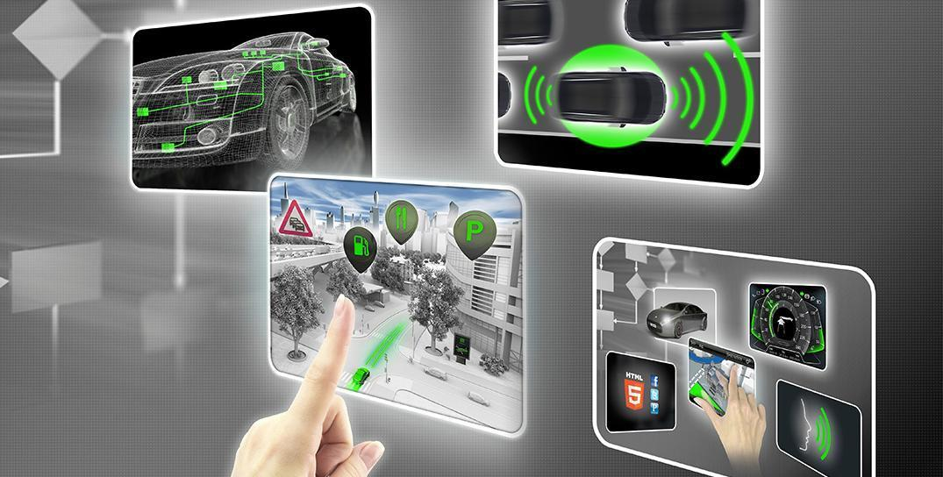

# Document history

|  |  |  |  |
| --- | --- | --- | --- |
| Date | Version | Editor | Description |
| 29-May-2019 | 1.0 | Sandeep Patil | Initial Version |
| 30-May-2019 | 2.0 | Sandeep Patil | Updated details in the individual chapters |
|  |  |  |  |
|  |  |  |  |
|  |  |  |  |

# Table of Contents

Document history

Table of Contents

Introduction

Purpose of the Safety Plan

Scope of the Project

Deliverables of the Project

Item Definition

Goals and Measures

Goals

Measures

Safety Culture

Safety Lifecycle Tailoring

Roles

Development Interface Agreement

Confirmation Measures

# Introduction

## Purpose of the Safety Plan

The purpose of safety plan is to identify high risk involved in the Lane Assistance System and to lower them to reasonable levels. This is done by identifying hazards, measuring risks. These risks are further lowered using Systems Engineering.

## Scope of the Project

For the lane assistance project, the following safety lifecycle phases are in scope:

Concept phase

Product Development at the System Level

Product Development at the Software Level

The following phases are out of scope:

Product Development at the Hardware Level

Production and Operation

## Deliverables of the Project

The deliverables of the project are:

Safety Plan

Hazard Analysis and Risk Assessment

Functional Safety Concept

Technical Safety Concept

Software Safety Requirements and Architecture

# Item Definition

**Lane Assistance System (LAS)** when enabled, continuously detects if the driver is unintendedly crossing lane. If the ego vehicle is crossing lane without the relevant direction indicator, the system shall give haptic feedback and provide counter torque to the steering wheel to bring back the ego vehicle in the lane.

The two main functions of LAS are as follows.

1. Lane Departure Warning

If the unintended lane departure is detected, the system vibrates the steering wheel to caution the driver about the behavior.

1. Lane Keeping Assistance

The system provides counter torque to the steering wheel to bring back the ego vehicle into the lane

The LAS consists of 3 subsystems

1. **Camera (CAM)** subsystem which is responsible for detection of Lane Departure and deciding if it was intended or not. It generates torque request for counter steering and also sends haptic signal for steering wheel for vibration.
2. **Electronic Power Steering (EPS)** subsystem which is responsible for calculating final torque by combining the torque request coming from the CAM subsystem and the Driver and providing it to the steering wheel
3. **Car Display Unit (CDU)** subsystem which is responsible for delplaying status of the the LDW and LKS function activation

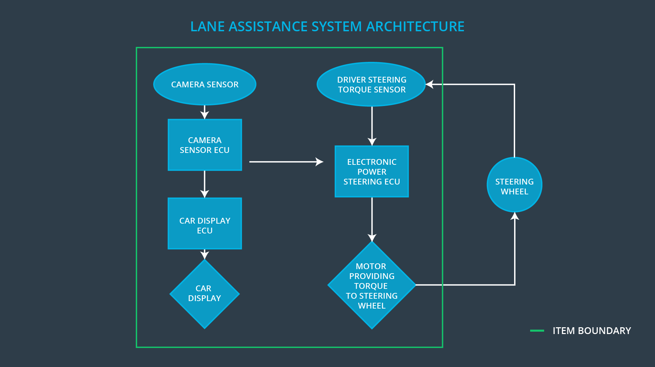

# Goals and Measures

## Goals

The major goal of this project is to identify and reduce risk to acceptable levels in the LAS which would cause injuries to a person.

## Measures

|  |  |  |
| --- | --- | --- |
| Measures and Activities | Responsibility | Timeline |
| Follow safety processes | All Team Members | Constantly |
| Create and sustain a safety culture | All Team Members | Constantly |
| Coordinate and document the planned safety activities | All Team Members | Constantly |
| Allocate resources with adequate functional safety competency | Project Manager | Within 2 weeks of start of project |
| Tailor the safety lifecycle | Safety Manager | Within 4 weeks of start of project |
| Plan the safety activities of the safety lifecycle | Safety Manager | Within 4 weeks of start of project |
| Perform regular functional safety audits | Safety Auditor | Once every 2 months |
| Perform functional safety pre-assessment prior to audit by external functional safety assessor | Safety Manager | 3 months prior to main assessment |
| Perform functional safety assessment | Safety Assessor | Conclusion of functional safety activities |

# Safety Culture

In our company, we follow a good safety culture which have below characteristics.

* **High Priority**

We give highest priority to the Safety among the competing constraints like cost and productivity

* **Accountability**

All the process we follow are tailored to ensure accountability by making sure the forward and reverse traceability from the design decision to the people and teams who made them

* **Rewards**

We motivate and support the achievements of functional safety

* **Penalties**

The organization discourage and penalizes shortcuts that jeopardize safety or quality

* **Independence**

We maintain independent team for design and develop of a product from the team who audit the work

* **Well defined processes**

All the management and design processes are defined clearly as per the ASPICE Level 3 certification

* **Resources**

Project is provided with necessary resource in terms of skilled employes and safety approved tools

* **Diversity**

Intellectual diversity is sought after, valued and integrated into processes

* **Communications**

Communication channels encourage disclosure of problems

# Safety Lifecycle Tailoring

The safety lifecycle phases that are in the scope of the project are as follows

* Concept phase
* Product development at the system level
* Product development at the software level

The following phases are out of the scope of this project

* Product development at the hardware level
* Production and Operation

# Roles

|  |  |
| --- | --- |
| Role | Org |
| Functional Safety Manager- Item Level | OEM |
| Functional Safety Engineer- Item Level | OEM |
| Project Manager - Item Level | OEM |
| Functional Safety Manager- Component Level | Tier-1 |
| Functional Safety Engineer- Component Level | Tier-1 |
| Functional Safety Auditor | OEM or external |
| Functional Safety Assessor | OEM or external |

# Development Interface Agreement

This section defines the roles, responsibilities between OEM and us (XYZ company) in developing LAS and workproducts in compliance with ISO 26262.

|  |  |
| --- | --- |
| **Role** | **Responsibility** |
| Functional Safety Manager | Item Level - Pre audit and plan the development phase at Item Level |
| Functional Safety Engineer | Item Level - Develops prototype, integrate subsystem into large system |
| Project Manager | Item Level - Allocates resources as needed |
| Functional Safety Manager | Component Level - Pre audit and plan development phase at component level for LAS |
| Functional Safety Engineer | Component Level - Develops prototype, integrate modules into components LAS |
| Functional Safety Auditor | External - Make sure the project conforms to the safety plan |
| Functional Safety Assessor | External - Judges if the project has increased safety |

# Confirmation Measures

The purpose of confirmation measure is to ensure that the project conforms to the Functional Safety standard ISO 26262 and also check if the project makes the vehicle really safer.

Confirmation review shall be performed to ensures that the project complies with ISO 26262. As the product is designed and developed, The review shall be done by an independent.

There shall be Functional safety audit to make sure that the actual implementation of the project conforms to the safety plan.

There shall be Functional safety assessment confirming that plans, designs and developed products actually achieve functional safety.

A safety plan could have other sections that we are not including here. For example, a safety plan would probably contain a complete project schedule.

There might also be a "Supporting Process Management" section that would cover "Part 8: Supporting Processes" of the ISO 26262 functional safety standard. This would include descriptions of how the company handles requirements management, change management, configuration management, documentation management, and software tool usage and confidence.

Similarly, a confirmation measures section would go into more detail about how each confirmation will be carried out.