

Software Safety Requirements and Architecture

Lane Assistance

**Document Version: 2.0**

**Released on 2019-06-02**

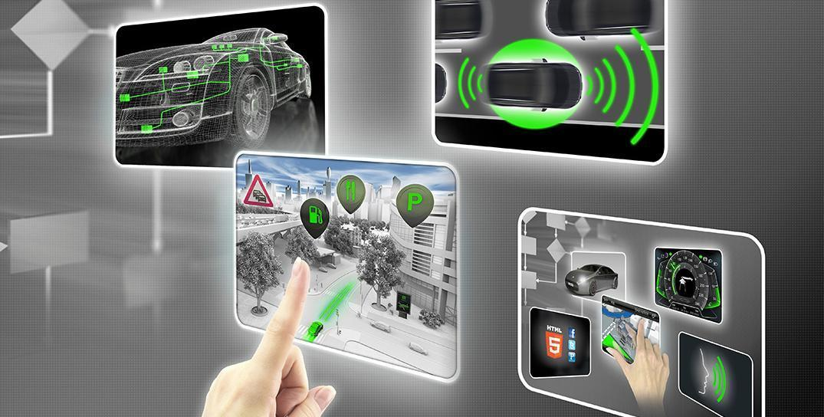

# Document history

|  |  |  |  |
| --- | --- | --- | --- |
| Date | Version | Editor | Description |
| 01.06.2019 | 1.0 | Sandeep Patil | Initial Version |
| 02.06.2019 | 2.0 | Sandeep Patil | Final Version |
|  |  |  |  |
|  |  |  |  |
|  |  |  |  |

# 

# Table of Contents

Document history

Table of Contents

Purpose

Inputs to the Software Requirements and Architecture Document

Technical safety requirements

Refined Architecture Diagram from the Technical Safety Concept

Software Requirements

Refined Architecture Diagram

# Purpose

The purpose of this document is to derive software level requirements at software component level and map them to software architecture.

# Inputs to the Software Requirements and Architecture Document

## Technical safety requirements

Technical Safety Requirements related to Functional Safety Requirement 01-01 are:

|  |  |  |  |  |  |
| --- | --- | --- | --- | --- | --- |
| **ID** | **Technical Safety Requirement** | **ASIL** | **Fault Tolerant Time Interval** | **Architecture Allocation** | **Safe State** |
| Technical  Safety  Requirement  01 | The LDW safety component shall ensure that the amplitude of the 'LDW_Torque_Request' sent to the 'Final electronic power steering Torque' component is below 'Max_Torque_Amplitude. | C | 50 ms | LDW Safety | LDW Torque = 0 |
| Technical  Safety  Requirement  02 | As soon as the LDW function deactivates the LDW feature, the 'LDW Safety' software block shall send a signal to the car display ECU to turn on a warning light. | C | 50 ms | LDW Safety | LDW Torque = 0 |
| Technical  Safety  Requirement  03 | As soon as a failure is detected by the LDW function, it shall deactivate the LDW feature and the 'LDW_Torque_Request' shall be set to zero. | C | 50 ms | LDW Safety | LDW Torque = 0 |
| Technical  Safety  Requirement  04 | The validity and integrity of the data transmission for 'LDW_Torque_Request' signal shall be ensured. | C | 50 ms | LDW Safety | LDW Torque = 0 |
| Technical  Safety  Requirement  05 | Memory test shall be conducted at start up of the EPS ECU to check for any faults in memory. | A | ignition cycle | Data transmission and integrity check | LDW Torque = 0 |

## Refined Architecture Diagram from the Technical Safety Concept

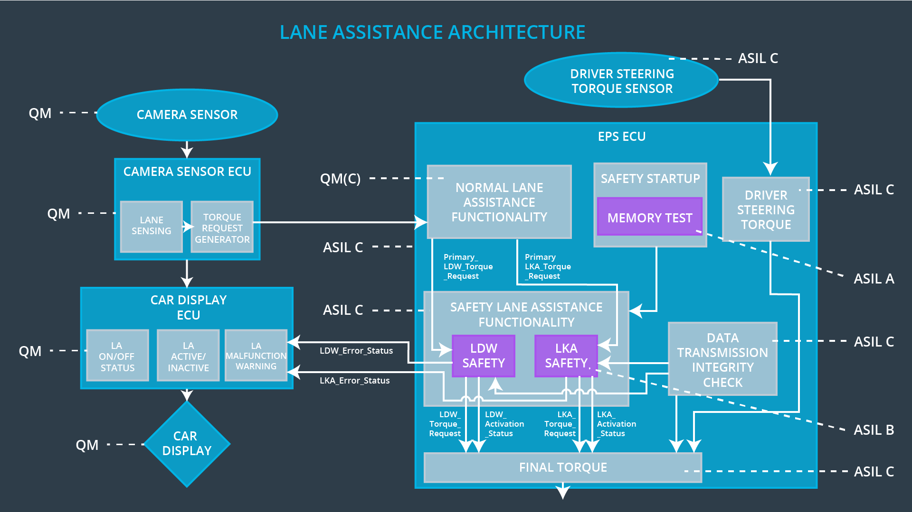

# Software Requirements

**Lane Departure Warning (LDW) Amplitude Malfunction Software Requirements:**

|  |  |  |  |  |  |
| --- | --- | --- | --- | --- | --- |
| **ID** | **Technical Safety Requirement** | **ASIL** | **Fault Tolerant Time Interval** | **Allocation to Architecture** | **Safe State** |
| Technical  Safety  Requirement  01 | The LDW safety component shall ensure that the amplitude of the LDW_Torque_Request sent to the Final Electronic Power Steering Torque component is below Max_Torque_Amplitude | C | 50 ms | LDW Safety | LDW torque output is set to zero |

|  |  |  |  |  |
| --- | --- | --- | --- | --- |
| ID | Software Safety Requirement | ASIL | Allocation Software Elements | Safe State |
| Software  Safety  Requirement  01-01 | The input signal “Primary_LDW_Torq_Req” shall be read and pre-processed to determine the torque request coming from the “Basic/Main LAFunctionality” SW Component. Signal “processed_LDW_Torq_Req” shall be generated at the end of the processing. | C | LDW_SAFETY_INPUT_PROCESSING | N/A |
| Software Safety Requirement 01-02 | In case the “processed_LDW_Torq_Req” signal has a value greater than “Max_Torque_Amplitude_LDW” (maximum allowed safe torque), the torque signal “limited_LDW_Torq_Req” shall be set to 0, else “limited_LDW_Torq_Req” shall take the value of “processed_LDW_Torq_Req”. | C | TORQUE_LIMITER | “limited_LDW_Torq_Req” = 0 (Nm=Newton-meter) |
| Software Safety Requirement 01-03 | The “limited_LDW_Torq_Req” shall be transformed into a signal “LDW_Torq_Req” which is suitable to be transmitted outside of the LDW Safety component (“LDW Safety”) to the “Final EPS Torque”component. Also see SofSafReq02-01 and SofSafReq02-02 | C | LDW_SAFETY_OUTPUT_GENERATOR | LDW_Torq_Req= 0 (Nm) |

|  |  |  |  |  |  |
| --- | --- | --- | --- | --- | --- |
| **ID** | **Technical Safety Requirement** | **ASIL** | **Fault Tolerant Time Interval** | **Allocation to Architecture** | **Safe State** |
| Technical  Safety  Requirement  02 | The validity and integrity of the data transmission for LDW_Torque_Request signal shall be ensured | C | 50 ms | Data Transmission Integrity Check | N/A |

|  |  |  |  |  |
| --- | --- | --- | --- | --- |
| **ID** | **Software Safety Requirement** | **ASIL** | **Allocation Software Elements** | **Safe State** |
| Software Safety Requirement 02-01 | Any data to be transmitted outside of the LDW Safety component (“LDW Safety”) including "LDW_Torque_Req" and “activation_status” (see SofSafReq03-02) shall be protected by an End2End(E2E) protection mechanism | C | E2ECalc | LDW_Torq_Req= 0 (Nm) |
| Software Safety Requirement 02-02 | The E2E protection protocol shall contain and attach the control data: alive counter (SQC) and CRC to the data to be transmitted. | C | E2ECalc | LDW_Torq_Req= 0 (Nm) |

|  |  |  |  |  |  |
| --- | --- | --- | --- | --- | --- |
| **ID** | **Technical Safety Requirement** | **ASIL** | **Fault Tolerant Time Interval** | **Allocation to Architecture** | **Safe State** |
| Technical  Safety  Requirement  03 | As soon as a failure is detected by the LDW function, it shall deactivate the LDW feature and the LDW_Torque_Request shall be set to zero | C | 50 ms | LDW Safety | LDW torque output is set to zero |

|  |  |  |  |  |
| --- | --- | --- | --- | --- |
| **ID** | **Software Safety Requirement** | **ASIL** | **Allocation Software Elements** | **Safe State** |
| Software Safety Requirement03-01 | Each of the SW elements shall output a signal to indicate any error which is detected by the element. Error signal = error_status_input(LDW_SAFETY_INPUT_PROCESSING), error_status_torque_limiter(TORQUE_LIMITER), error_status_output_gen(LDW_SAFETY_OUTPUT_GENERATOR) | C | All | N/A |
| Software Safety Requirement03-02 | A software element shall evaluate the error status of all the other software elements and in case any 1 of them indicates an error, it shall deactivate the LDW feature (“activation_status”=0) | C | LDW_SAFETY_ACTIVATION | Activation_status = 0 (LDW function deactivated) |
| Software Safety Requirement03-03 | In case of no errors from the software elements, the status of the LDW feature shall be set to activated (“activation_status”=1) | C | LDW_SAFETY_ACTIVATION | N/A |
| Software Safety Requirement03-04 | In case an error is detected by any of the software elements, it shall set the value of its corresponding torque to 0 so that “LDW_Torq_Req” is set to 0 | C | All | LDW_Torq_Req = 0 |
| Software Safety Requirement03-05 | Once the LDW functionality has been deactivated, it shall stay deactivated till the time the ignition is switched from off to on again. | C | LDW_SAFETY_ACTIVATION | Activation_status = 0 (LDW function deactivated) |

|  |  |  |  |  |  |
| --- | --- | --- | --- | --- | --- |
| **ID** | **Technical Safety Requirement** | **ASIL** | **Fault Tolerant Time Interval** | **Allocation to Architecture** | **Safe State** |
| Technical  Safety  Requirement  04 | As soon as the LDW function deactivates the LDW feature, the LDW Safety software block shall send a signal to the car display ECU to turn on a warning light | C | 50 ms | LDW Safety | LDW torque output is set to zero |

|  |  |  |  |  |
| --- | --- | --- | --- | --- |
| **ID** | **Software Safety Requirement** | **ASIL** | **Allocation Software Elements** | **Safe State** |
| Software Safety Requirement 04-01 | When the LDW function is deactivated (activation_status set to 0), the activation_status shall be sent to the car displayECU. | C | LDW_SAFETY_ACTIVATION, CarDisplay ECU | N/A |

|  |  |  |  |  |  |
| --- | --- | --- | --- | --- | --- |
| **ID** | **Technical Safety Requirement** | **ASIL** | **Fault Tolerant Time Interval** | **Allocation to Architecture** | **Safe State** |
| Technical  Safety  Requirement  05 | Memory test shall be conducted at start up of the EPS ECU to check for any faults in memory | A | Ignition Cycle | Memory Test | LDW torque output is set to zero |

|  |  |  |  |  |
| --- | --- | --- | --- | --- |
| **ID** | **Software Safety Requirement** | **ASIL** | **Allocation Software Elements** | **Safe State** |
| Software Safety Requirement 05-01 | A CRC verification check over the software code in the Flash memory shall be done every time the ignition is switched from off to on to check for any corruption of content. | A | MEMORYTEST | Activation_status = 0 |
| Software Safety Requirement 05-02 | Standard RAM tests to check the data bus, address bus and device integrity shall be done every time the ignition is switched from off to on (E.g.walking 1s test, RAM pattern test. Refer RAM and processor vendor recommendations ) | A | MEMORYTEST | Activation_status = 0 |
| Software Safety Requirement 05-03 | The test result of the RAM or Flash memory shall be indicated to the LDW_Safety component via the “test_status” signal | A | MEMORYTEST | Activation_status = 0 |
| Software Safety Requirement 05-04 | In case any fault is indicated via the “test_status” signal the INPUT_LDW_PROCESSING shall set an error on error_status_input (=1) so that the LDW functionality is deactivated and the LDWTorque is set to 0 | A | LDW_SAFETY_INPUT_PROCESSING | Activation_status = 0 |

# 

# Refined Architecture Diagram

