# AWS RDS Set Up

Step 1: Go to AWS Management Console ( aws.amazon.com ) by logging.

Step 2: Search or Click on AWS RDS

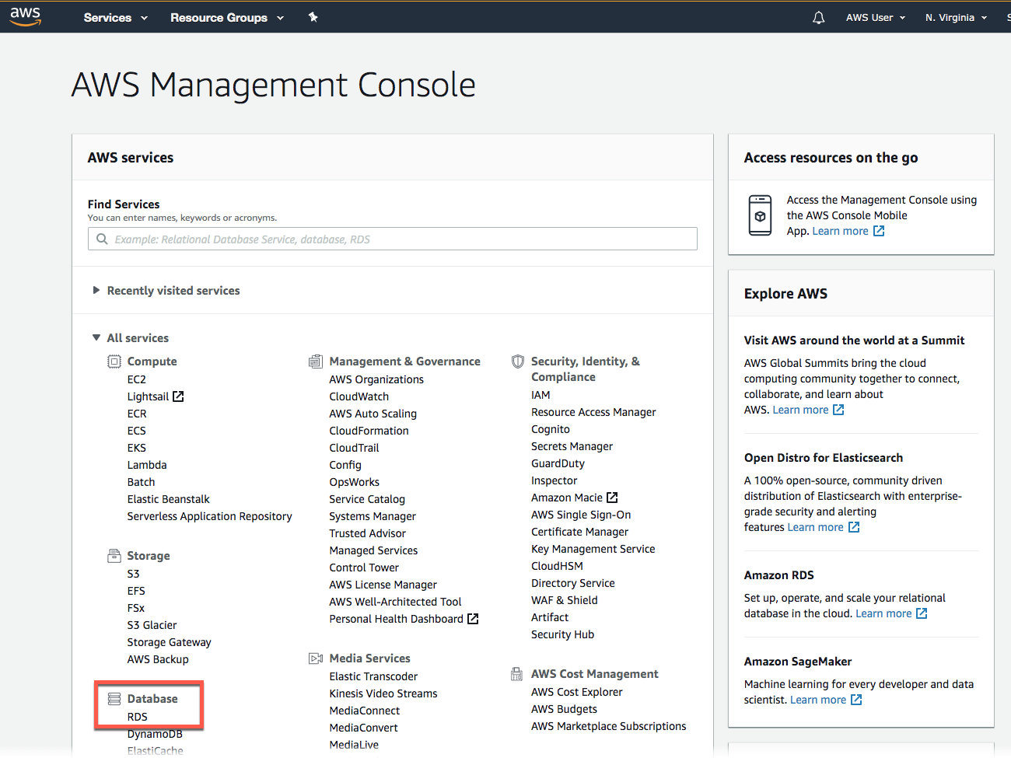

Step 3: On AWS RDS Page Click on Create Database at AWS RDS Dashborad

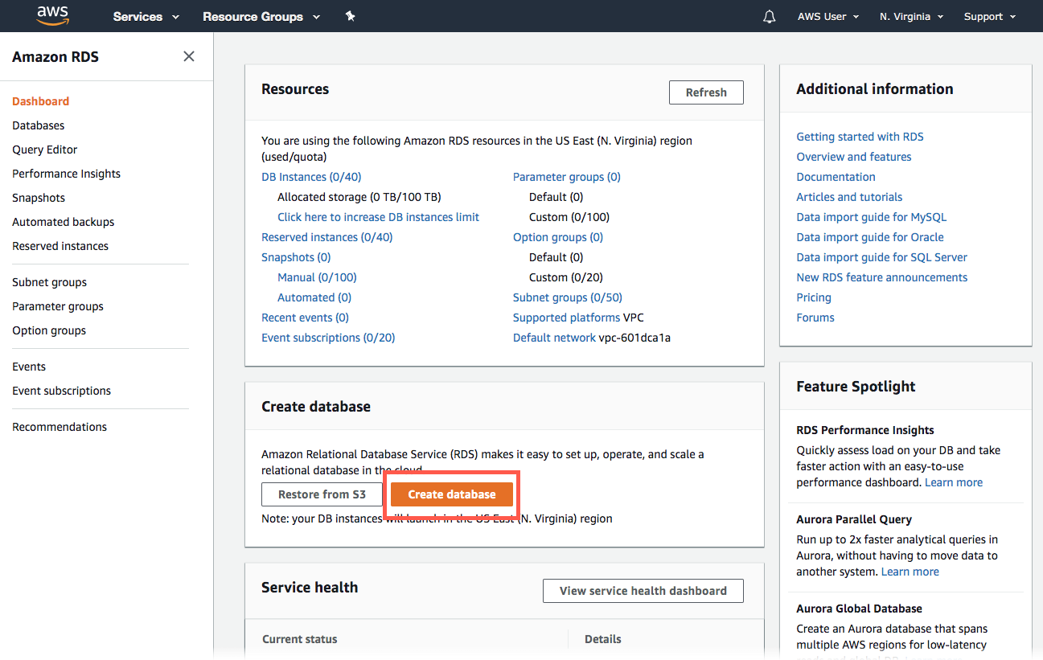

Step 4: Now Click on Standard Create and Select MySql Option and Free Tier Template.

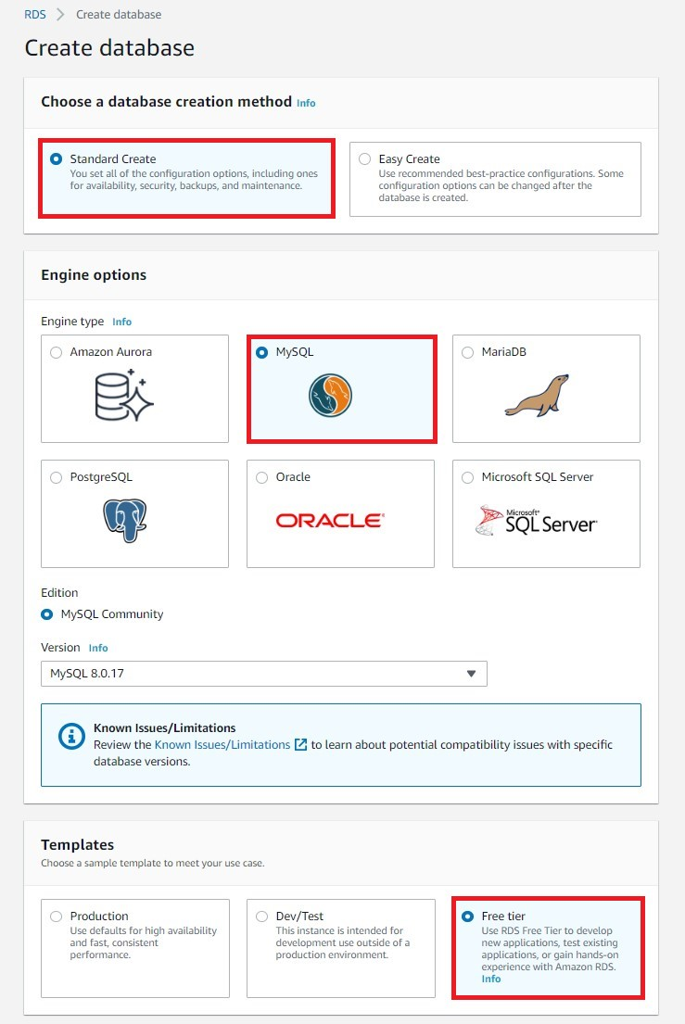

Step 5: Type Your Instance Identifier and Your Username And Password For accessing Database from your Local Machine, And Please Store Username and Password somewhere.

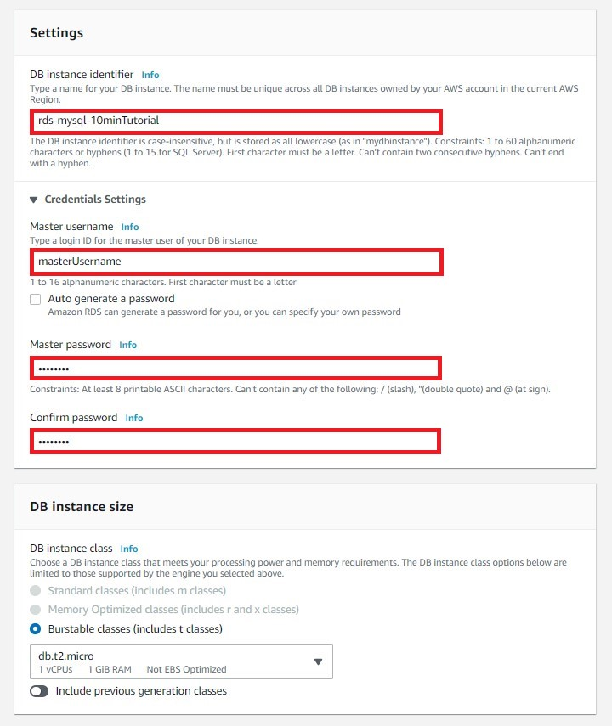

Step 6: Select Your Storage Type and Click on Publicly accessible and then Click Create New VPC Security Group.

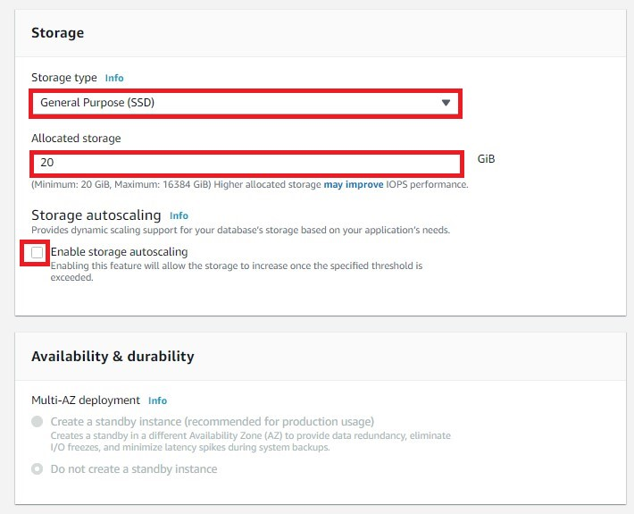

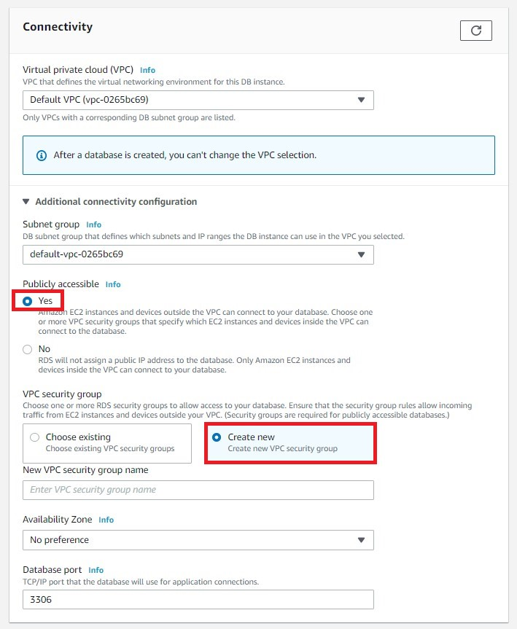

Final Step Click on Create Database.

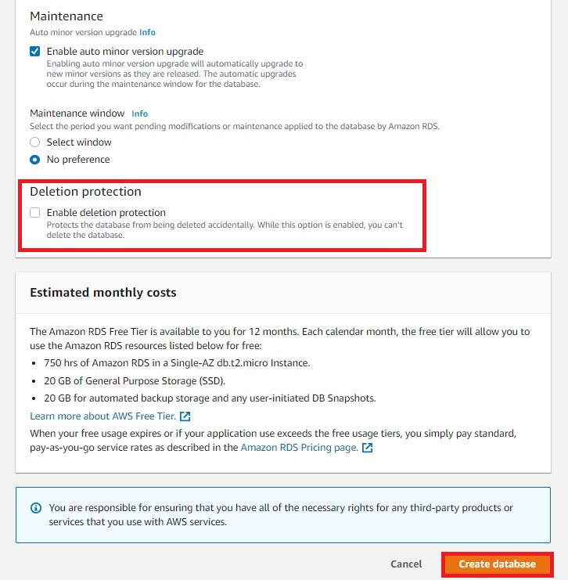

Django Setup With AWS RDS

Step 1: Open Your AWS RDS Console and Navigate to the Database you Created, From this Copy the Endpoint and Port and Store it somewhere.

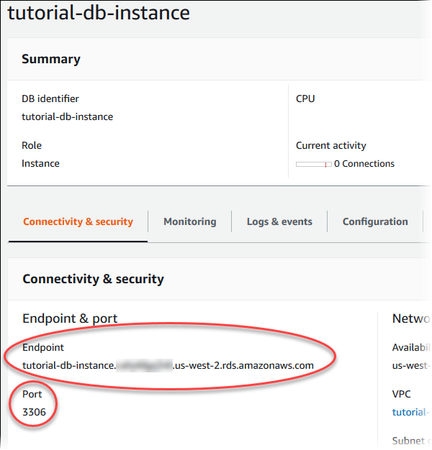

Step 2: Now Open up your Django Project Go to ecommerce Folder Go To ecommerce App and Open Settings.py and Change your Credententials here.

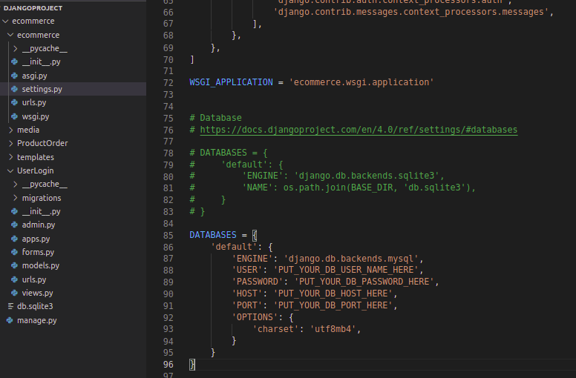

Step 3: Create A Virtual Environment and activate the virtual environment at your root project folder.

pip install virtualenv

python -m virtualenv env

. env/bin/activate

Step 4: Install Dependencies

pip install -r requirements.txt

Step 5: Now to Navigate to your ecommerce Project and Run Following Commands

python manage.py makemigrations

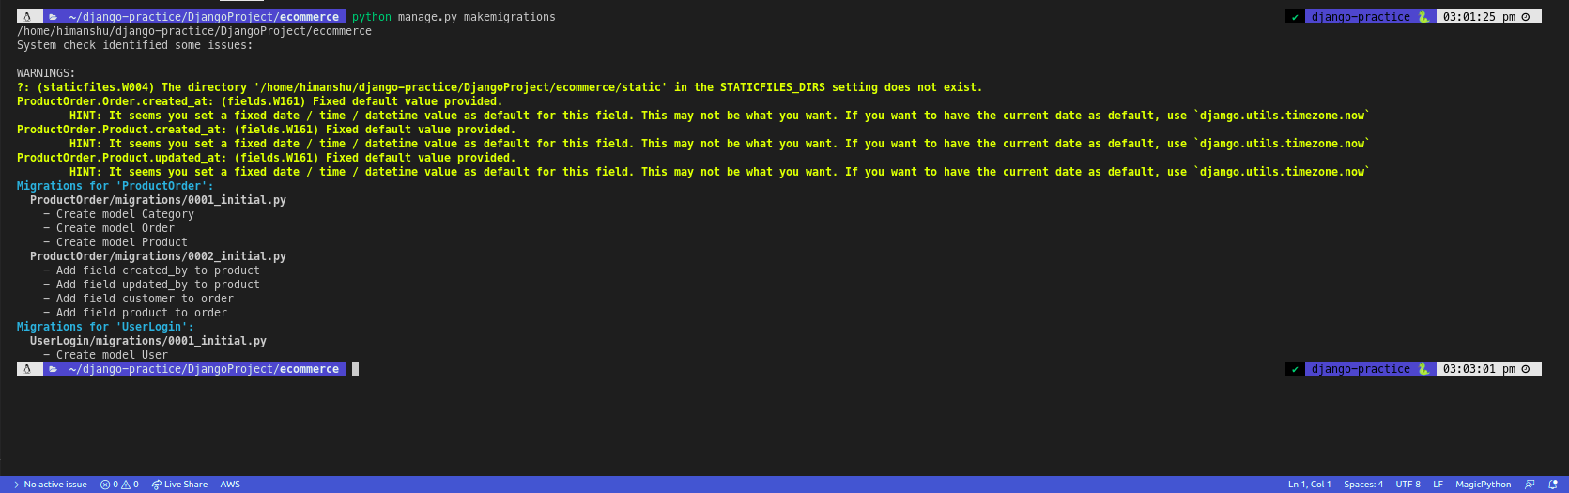

python manage.py migrate

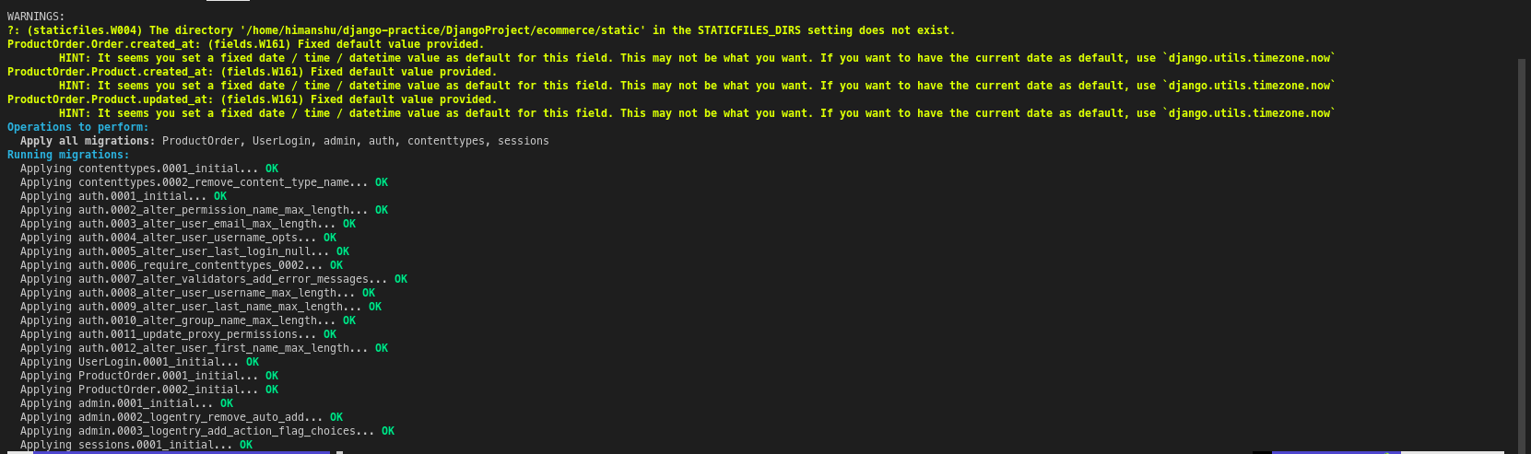

python manage.py createsuperuser

-> Enter your Email

-> Password

-> Confirm Password

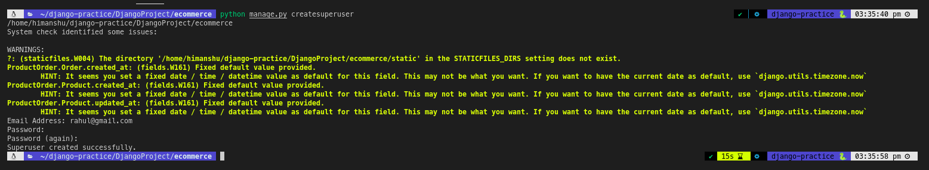

Step 6: Start Your Django Server Now

python manage.py runserver

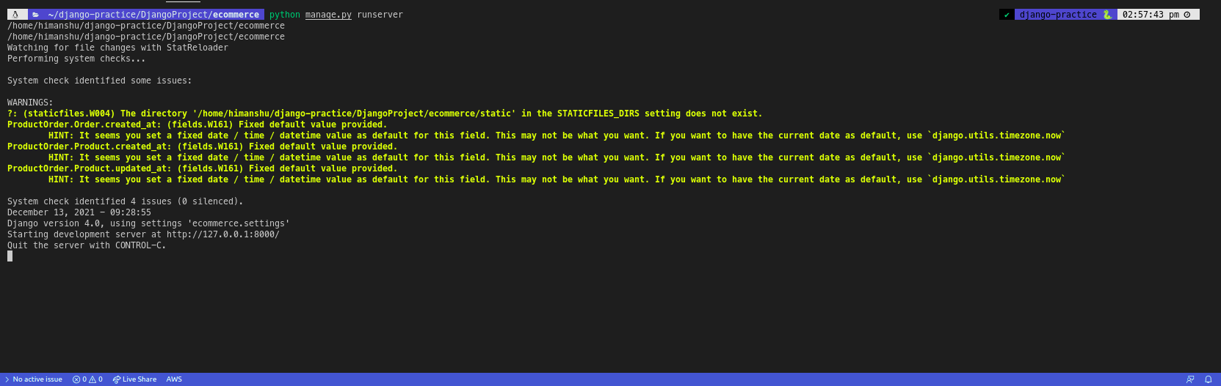

And Open your locahost:8000 and login into ecommerce website and Click on Profile and then Click on Admin. (it will navigate you to on Admin Dashboard)

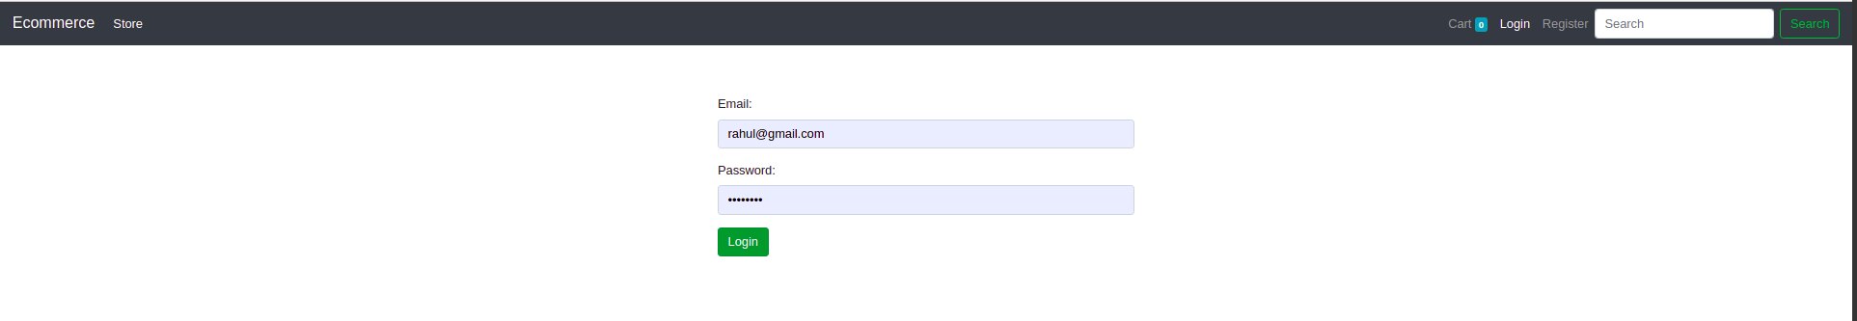

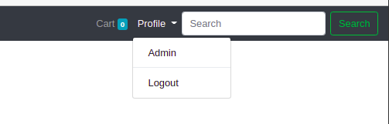

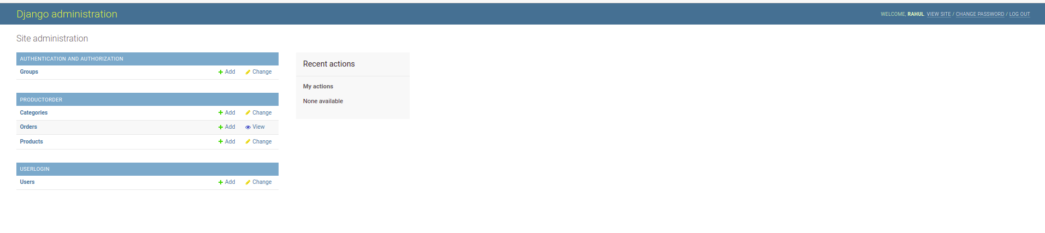

Step 7: Add Product Categoies and Product of your Choice

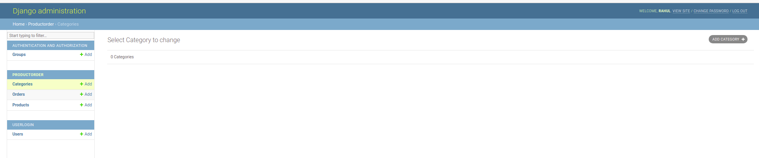

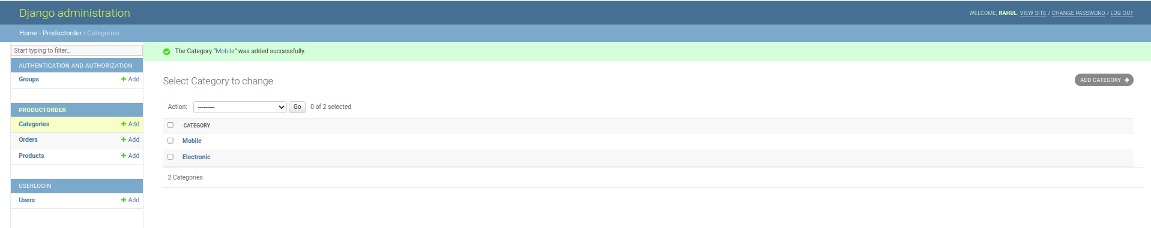

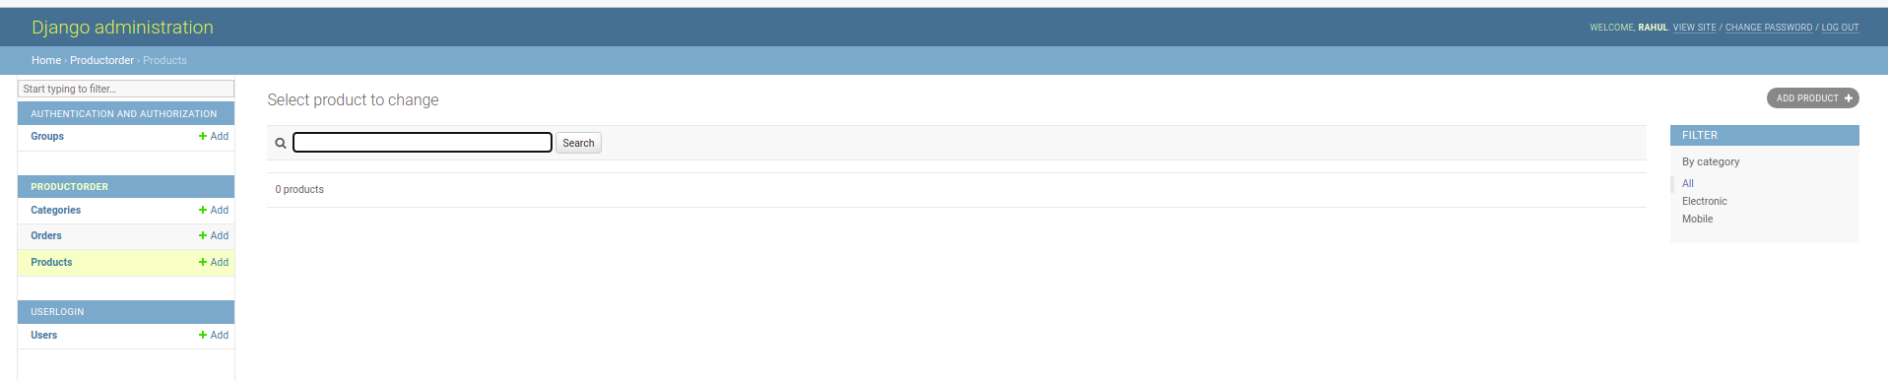

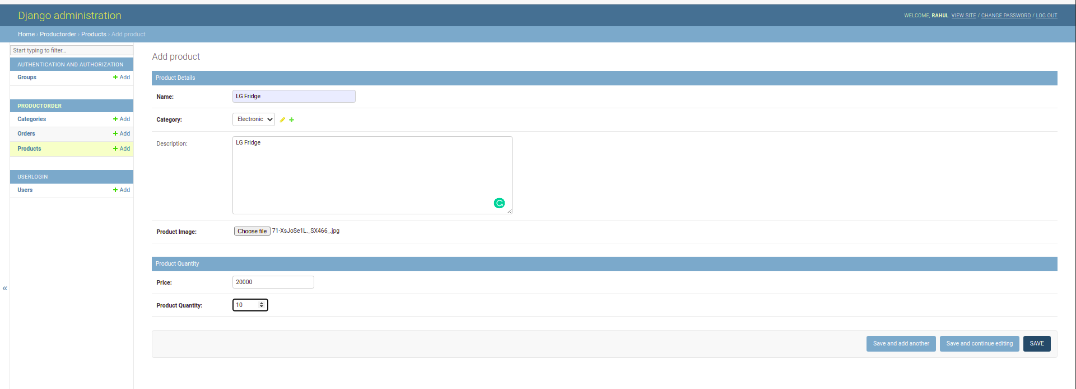

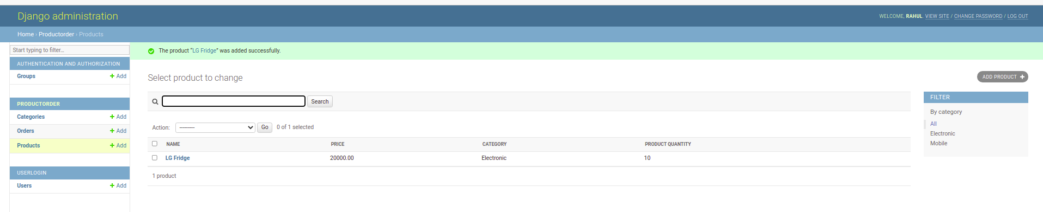

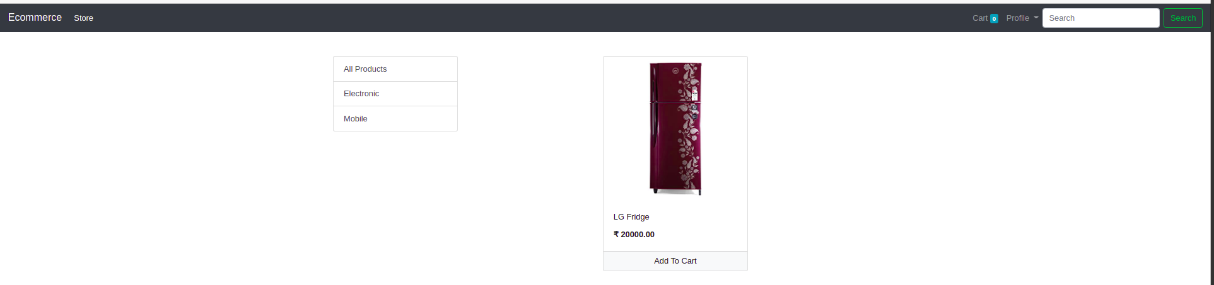

Step 8: Add to cart and Navigate to Cart Section

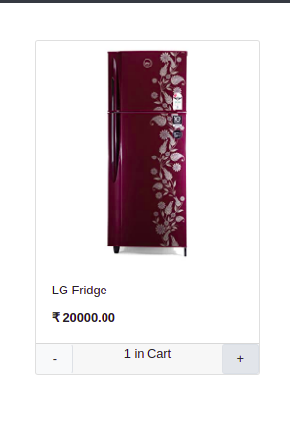

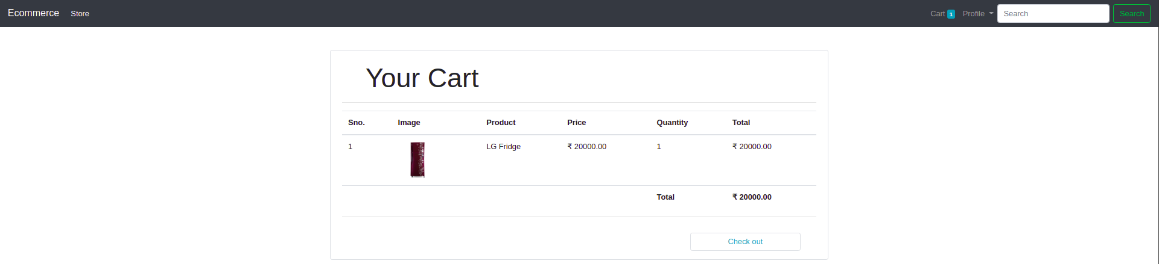

Step 9: Checkout and Fill Billing Details

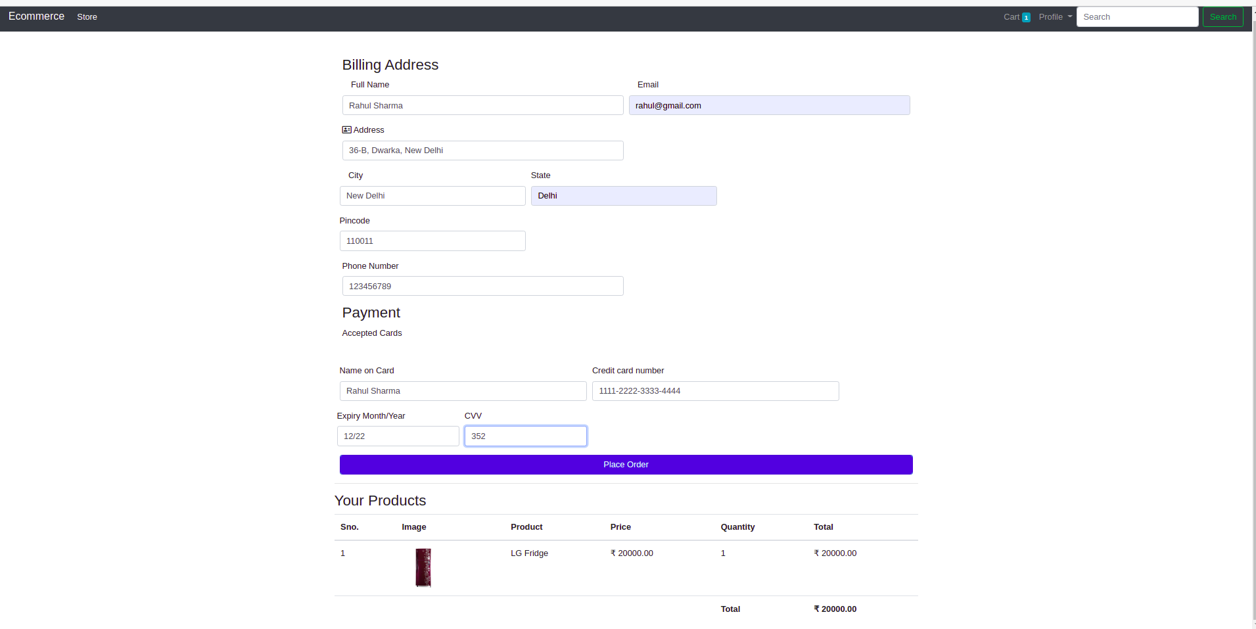

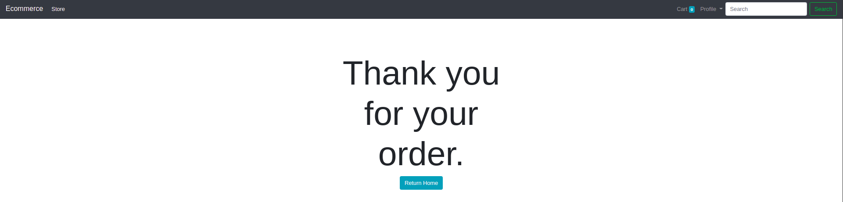

Step 10: After Adding Categories and Products, Navigate Back localhost:8000, Enjoy Your Ecommerce Website.

